**McKnight Crossings Church of Christ**

**October 4, 2021 Shepherding Meeting**

Attendees:

Lane Hamm, Brad Stevens, Keaton Jones, Don Fitzgerald, Jeff Kryder, Steve Haupt, Glen Devania, Bret Blackford (secretary), Louis West, Wole Okunade, Steve Awtrey

There were two (2) separate Elder meetings on this day:

1. 6:00-7:00pm special meeting to address open priorities
2. 7:00-9:00pm regular monthly meeting

**Meeting 1**: Called and chaired by Brad Stevens. Loose agenda to discuss open items.

1. **Special Elder meeting to discuss priorities**

Saturday October 16, 8-11:30 (location TBD: we still need a facilitator and clear agenda)

* 1. Decide what are priorities for MX. What do we want? What are the goals for the church?
  2. How do we have a more collaborative leadership between staff and elders?

1. **Jeff Kryder transition**

See Attachment A

1. **New elder(s)**

Brad Stevens to invite John Earnhart to start meeting with the elders.

**Meeting 2** (regular monthly elder meeting)

Staff (left meeting after agenda item #5): Jeremy Picker, Machalie Brown

**Agenda** (details below):

1. Unity in Diversity
2. People
3. Next Gen Updates
4. Elder / Staff Tuesdays
5. Food Pantry Update
6. Letter from Erich McPherson
7. MX Vision and Priorities
8. Pick Future Meeting Times
9. **Unity in Diversity:** Louis & Joyce West, Brett & Kari Ferguson, Paul & Jodi Mitchell

The representatives of the Unity in Diversity group shared how they have been impacted by racism and some things we could do as a congregation to try and address the situation. Reviewed Unity in Diversity goals noted in Attachment B. This document is truthful but it lacks the heart, spirit, and soul of the conversation. Document intended to be a catalyst for future conversations.

A few key statements/takeaways from the various conversations:

* Racial/ethnic unity must be a priority for the church. Not a priority on its own but woven into all other priorities.
* Rock Hill is 30% non-white (<https://datausa.io/profile/geo/rock-hill-mo/>)
* If you can’t recognize people’s hurt and pain you cannot help.
* “The Color of Compromise: The Truth about the American Church’s Complicity in Racism” helped changed Kari Ferguson’s perspective.
* If MX shutdown and closed the doors today who in our community would miss us? What are we known for?
* Jesus is the only true answer

1. **People**

Discussed various visits, concerns, and new members (Ron Orick)

1. **Next Gen Update**

Michalie updated on Youth Group – see Attachment D.

1. **Elder / Staff Tuesdays**

Schedule is noted at Attachment C.

1. **Food Pantry Update**

Bob Conally has retired from running the pantry and Barb Eickele will be taking over. There will be a retirement party for Bob Wed. October 6, 2021 at the MX church parking lot.

Barb had mentioned the Food Pantry has reduced the number of families served and the amount of food distributed. This is possibly due to COVID keeping people in and other sources of food being offered by the government and NGOs. Bot Scouts plan to do a food drive this year and Food Pantry should benefit from that.

1. **Letter from Erich McPherson**

Unfortunately, Bret Blackford was careless and inadvertently sent Erich’s letter to some of the staff when discussing the letter with the elders. This caused two problems: 1) it broke the trust with Erich McPherson, who intended his comments to be confidential and shared only with the elders, and 2) it caused unease with some of the staff. Dave Weiler and Lane Hamm met with the staff on Tuesday, October 5, 2021 to help with damage control. They listened to the staff and provided encouragement.

Erich’s letter does bring up topics that the elders still need to discuss. Time did not allow to properly address comments, concerns, and possible changes.

Erich’s letter attached below:



1. **MC Vision and Priorities**

This was part of the 6:00pm **Meeting 1** discussed above.

1. **Pick Future Meeting Times**

During the Saturday half-day special elder meeting we will discuss the possibility of increasing the frequency of meetings. Possibly adding another meeting on the 3rd Monday of the month.

=========================================

Summary of open items from prior discussions:

* Elder / Staff Relationships: Elders will visit office on Thursday’s based on rotation schedule
* Jeff Kryder Transition:
  + Jeff to determine end date
  + Jeff to eventually focus on Leadership Development
  + Elders: What is vision for Jeff’s replacement?
* Sabbatical: is this beneficial now and for who?
* From Machalie:
  + Teachers - Right now, I am teaching 3 times a week. Sunday, Theo/SLT and Wednesdays. Who can I bring in to help me? Will you help me?
  + Mentors - Who can take our students out to lunch? Studies recommend that students need 5 adults (besides their parents) pouring into them.
  + Classes - We need teachers for MXkids to be able to resume classes
* Food Pantry Video: In January we discussed a video that will document all the good that the pantry does, all the people it serves, and the current need to keep the shelves stocked.
* Eldership:
  + Meetings: Should we transition away from Sr Minister (Jeff Kryder) being Chair and have Elder rotation?
  + Types: Administrative, Pastoral, Vision
  + Appointing Process: Need to define process and when/how to recruit younger elders
  + Staff or Eldership lead church?  We currently lead to staff led but need to decide.
* Gender Issues: Do we want to get in front of this issue now?
* Erich McPherson questions (attached above)

**Note**: I have attempted to collect some of the key conversations and documents on a website located here … <https://www.shepherd.mx.mxcoc.xyz/elders.html>. As the contents are sensitive I have password protected the site.

Credentials to access:

ID: **Shepherd**

Password: **servant**

Let me know if there are other documents you’d like to see included.

=============================

Elders (distribution list for minutes):

|  |  |  |
| --- | --- | --- |
| Name | Phone | email |
| Steve Awtrey | 314-374-3276 | [steve.awtrey@gmail.com](mailto:steve.awtrey@gmail.com) |
| Bret Blackford | 314-402-7086 | [Bret_Blackford@yahoo.com](mailto:bret_blackford@yahoo.com) |
| Glenn Davania | 314-822-0321 | [rGlenn88@hotmail.com](mailto:rglenn88@hotmail.com) |
| Don Fitzgerald | 314-791-5038 | [donaldFitzgerald@att.net](mailto:rdonaldfitzgerald@att.net) |
| Lane Hamm | 314-269-4049 | [lane_hamm@yahoo.com](mailto:rlane_hamm@yahoo.com) |
| Steve Haupt |  | [steve@rotolite-stl.com](mailto:steve@rotolite-stl.com) |
| Keaton Jones | 314-270-9632 | [keaton.jones@sbcglobal.net](mailto:keaton.jones@sbcglobal.net) |
| Wole Okunade | 314-429-8832 | [alokunade@wustl.edu](mailto:alokunade@wustl.edu) |
| Brad Stevens | 314-962-5370 | [bStevens@shandselbert.com](mailto:bstevens@shandselbert.com) |
| Steve Walker |  | [srainey6@yahoo.com](mailto:srainey6@yahoo.com) |
| Dave Weiler | 314-729-0327 | [dave-n-amy-weiler@juno.com](mailto:dave-n-amy-weiler@juno.com) |
| Louis West | 314-308-5284 | [joyceDickersonWest@gmail.com](mailto:joycedickersonwest@gmail.com) |
| Jeff Kryder | 314-537-6912 | [jKryder@mcknightcrossings.org](mailto:jkryder@mcknightcrossings.org) |

**Attachment A**

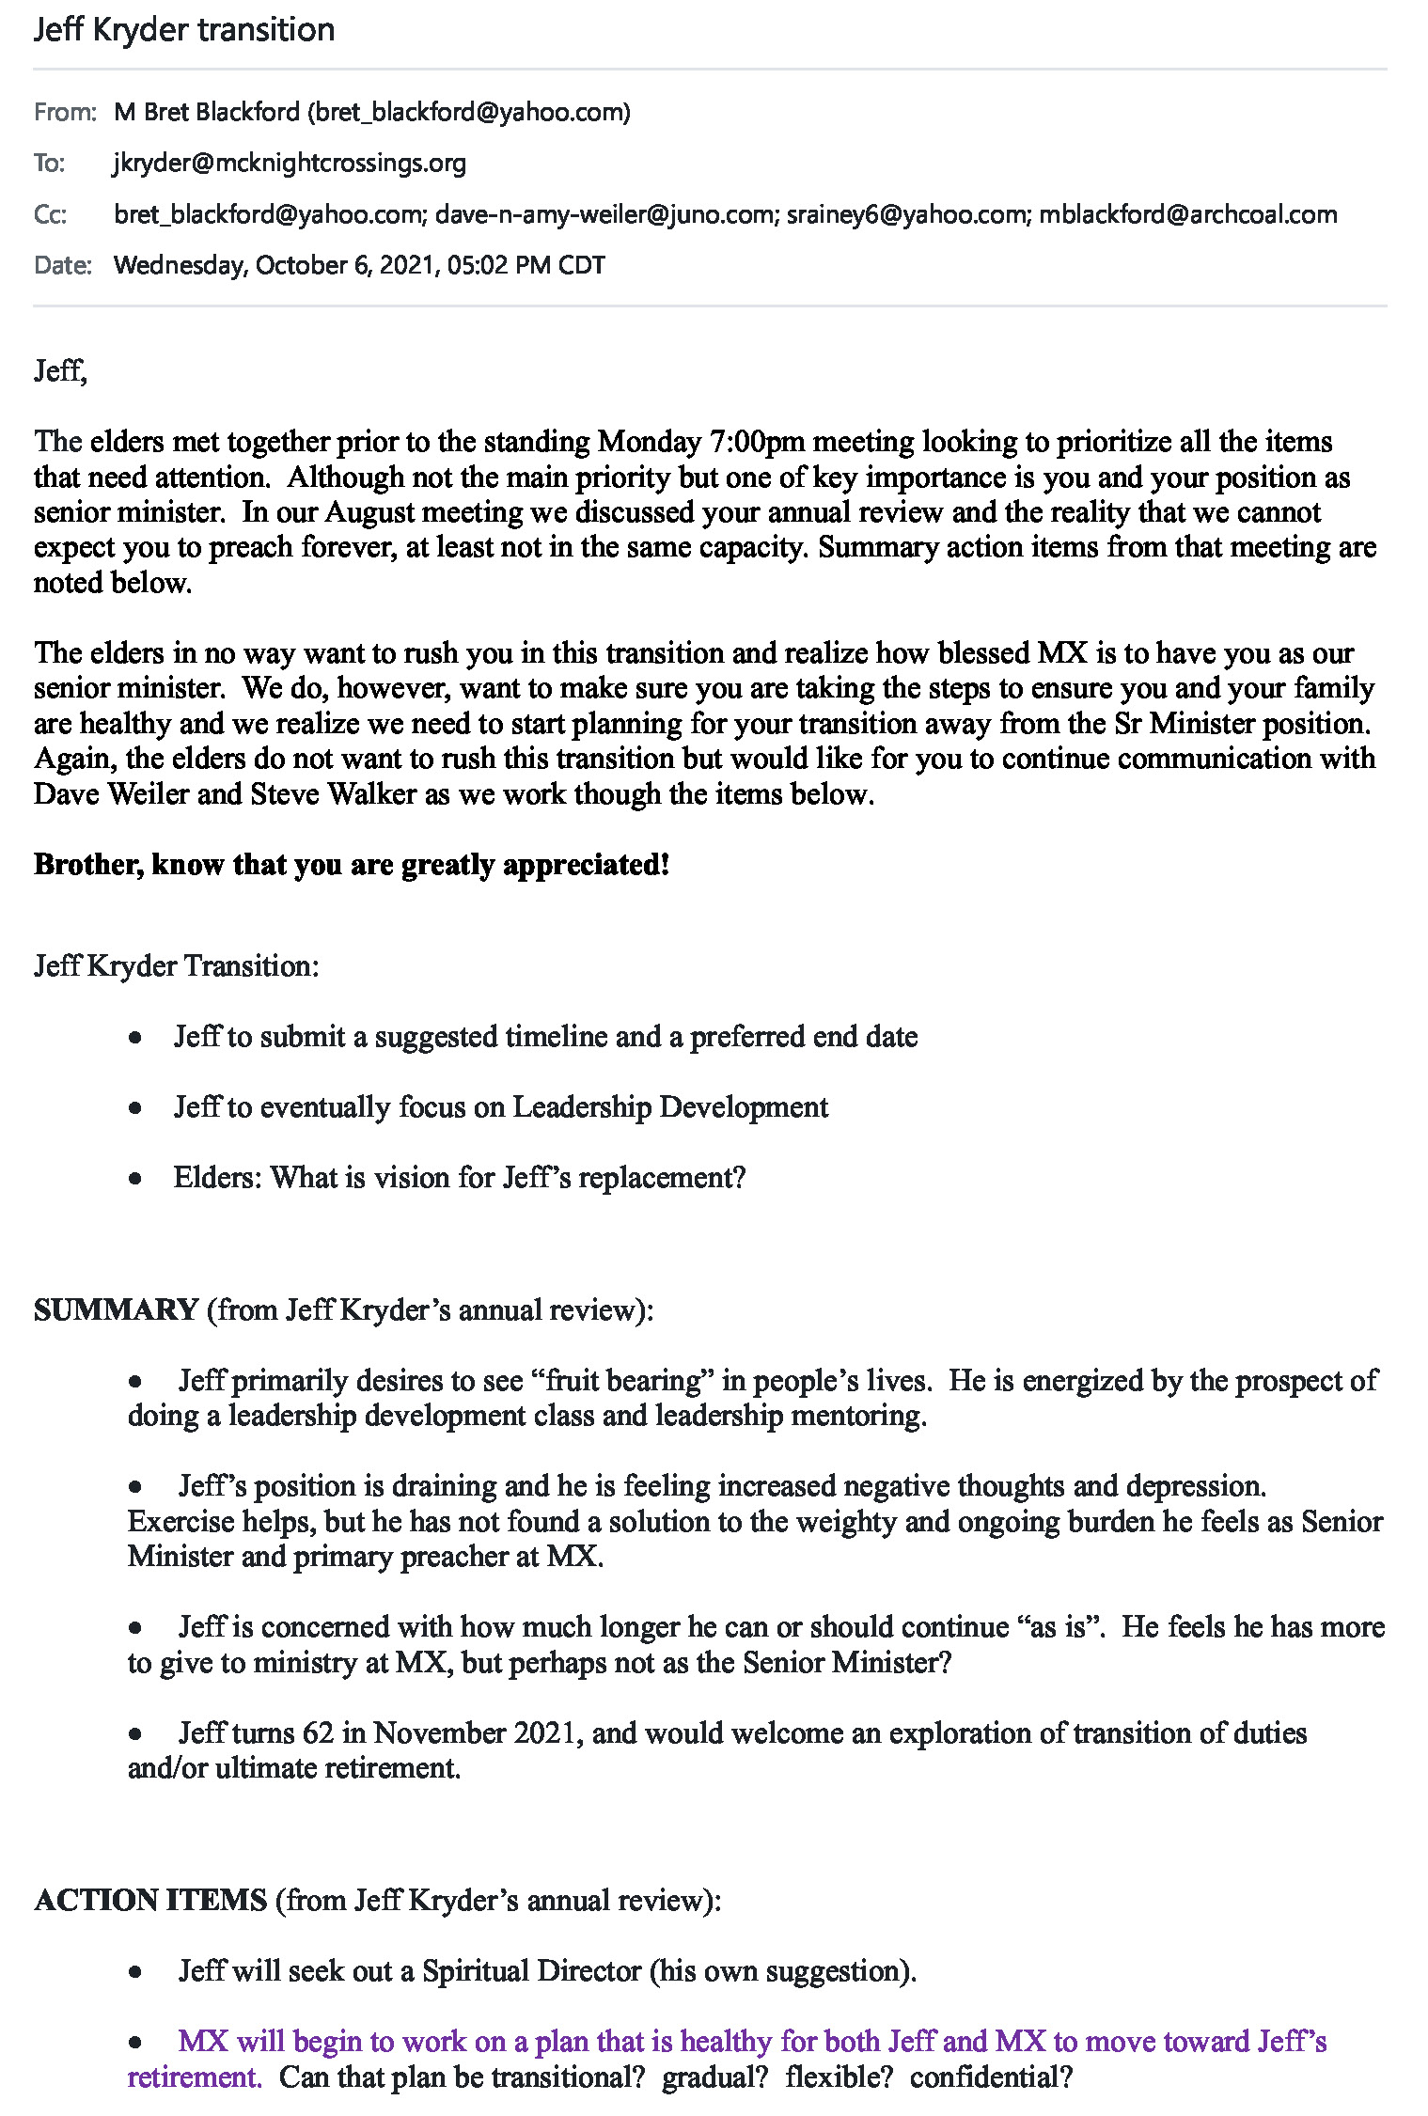

**Attachment B**

**Unity in Diversity at MX (September 2021)**

*I am in them and you are in me. May they experience such perfect unity that the world will know that you sent me and that you love them as much as you love me.*

* *John 17:23 NLT*

We welcome diversity and healing into our fellowship at MX and our outreach into neighboring communities, through the reconciling work of Jesus and the power of the Holy Spirit.

What are our goals?

* For God to be glorified.
* For the church to be a credible witness to our neighbors of unity and diversity.
* For believers to be the bridge between people divided by racial and cultural differences, bringing healing and transformation to individuals and communities.

**Area 1: Personnel**

* Offer training for staff and elders on race, racism, and cultural competency.
* Offer training for Ministry Leaders. This can include: Greeters, Safety, Ushers, Food Pantry, and Bible Class teachers.
* *This training to be requested by the Elders and its completion overseen by the Elders.*

**Area 2: Worship Services and Ministries**

* Ministries are regularly reviewed to ensure they reflect the commitments of the church regarding race, culture, and diversity.
  + Sunday Worship.
    - People of color are in publicly visible roles on Sunday mornings (During worship, Greeters, Ushers, Bible class teachers, etc.)
    - Worship is regularly prepared in collaboration with a person of color.
* Communication of programs and services will reflect our commitments to be a multicultural church.
  + Public messaging (Sunday announcements, email, website, Facebook, etc.) and artistic displays reflect diversity.

**Area 3: Members and Community**

* Have a consistent schedule of training to turn up the voices of the marginalized, and requesting that those in the dominant culture listen, learn, and empathize.
* Post every other week in MX email, website, and Facebook to help with awareness.
* Make Intentional efforts for the church to reflect on the racial composition of the neighboring communities.
* Outreach efforts to be intentionally inclusive of people of color.
* Organize a group which makes a commitment to have monthly dinner with families of a different background (post-covid).
* Find appropriate banners to place on our property.
* Additional Opportunities:
  + Visit, worship, or share a ministry with predominantly African-American Church (North City Church, Ferguson, West Central, or Louis’s cousin in Meacham Park).
  + Offer opportunities where white people are in the minority.
  + Visit museums and places of historical interest that educate on the African American experience (tour of underground railroad, East St. Louis, Alton)
  + Establish two groups – one to look outward to community, and one to look inward at church.
  + Have Block Party designed around Juneteenth. Pre-market this event. For instance, have a snow cone machine in North Webster the week before.
  + Begin another Color of Compromise group to continue to widen awareness.

**Area 4: Organizational Structure**

* Elder composition includes people of color, ensuring that decisions by Elders are reviewed by people of color.
* People of color are being actively groomed for leadership.

For your consideration and feedback:

* What are the most important or first priorities?
* Can we do training on leadership level and grass roots activities at same time?
* What might be the time-tables?

**Attachment C**

**Office Visit - Elder Rotation for Brief Office Visit and /or Lunch / Coffee with the Staff**

Yahoo/Inbox

**Jeff Kryder** <jkryder@mcknightcrossings.org>

**To:**Brad Stevens (work),Dave & Amy Weiler,Glenn Davania,Jeff Kryder,Keaton Jonesand 9 more...

**Cc:**Dolores Miller

Tue, Aug 31 at 11:34 AM

**Office Visit -Elder Rotation for Brief Office Visit and /or Lunch / Coffee with the Staff**

* The assigned day will be Tuesday, if possible, as the staff are at the offices on this day.  There is a Next Gen Meeting in the morning at 10:30, and the entire Staff meets at 1:30.
* See your visit as a call of encouragement.
* Could feel a bit awkward initially.
* Can be brief.
* Check on how the staff is doing personally, what they are working on, what support they need, and offer a prayer and / or a Scripture.
* The Ministry Staff (Jeremy, Heather, Michalie, Jeff, and sometimes Jeannie) generally have more flexibility to grab a coffee or lunch, than the administrative staff (Elizabeth, Dolores, Tom, and sometimes Jeannie), if you are inclined to go out.
* Can try to touch base with everyone who is there, or if the Spirit leads, take a few extra minutes with one or two.
* Making a pastoral call on a member along with a staff person earns extra credit!

Here is the list and your initial date.  Contact Dolores if you need to select another date.

~~Sep 7 - Keaton Jones~~

~~Sep 14 - Don Fitzgerald~~

~~Sep 21 - Glenn Davania~~

~~Sep 28 - Bret Blackford~~

~~Oct 5 - Lane Hamm~~

Oct 12 - Steve Haupt

Oct 16 - Wole Okunade

Oct 26 - Dave Weiler

Nov 2 - Steve Walker

Nov 9 - Steve Awtrey

Better Together,

Jeff

--

**Jeff Kryder**

**Senior Minister**

**McKnight Crossings Church of Christ**

**Attachment D**

From Machalie Brown

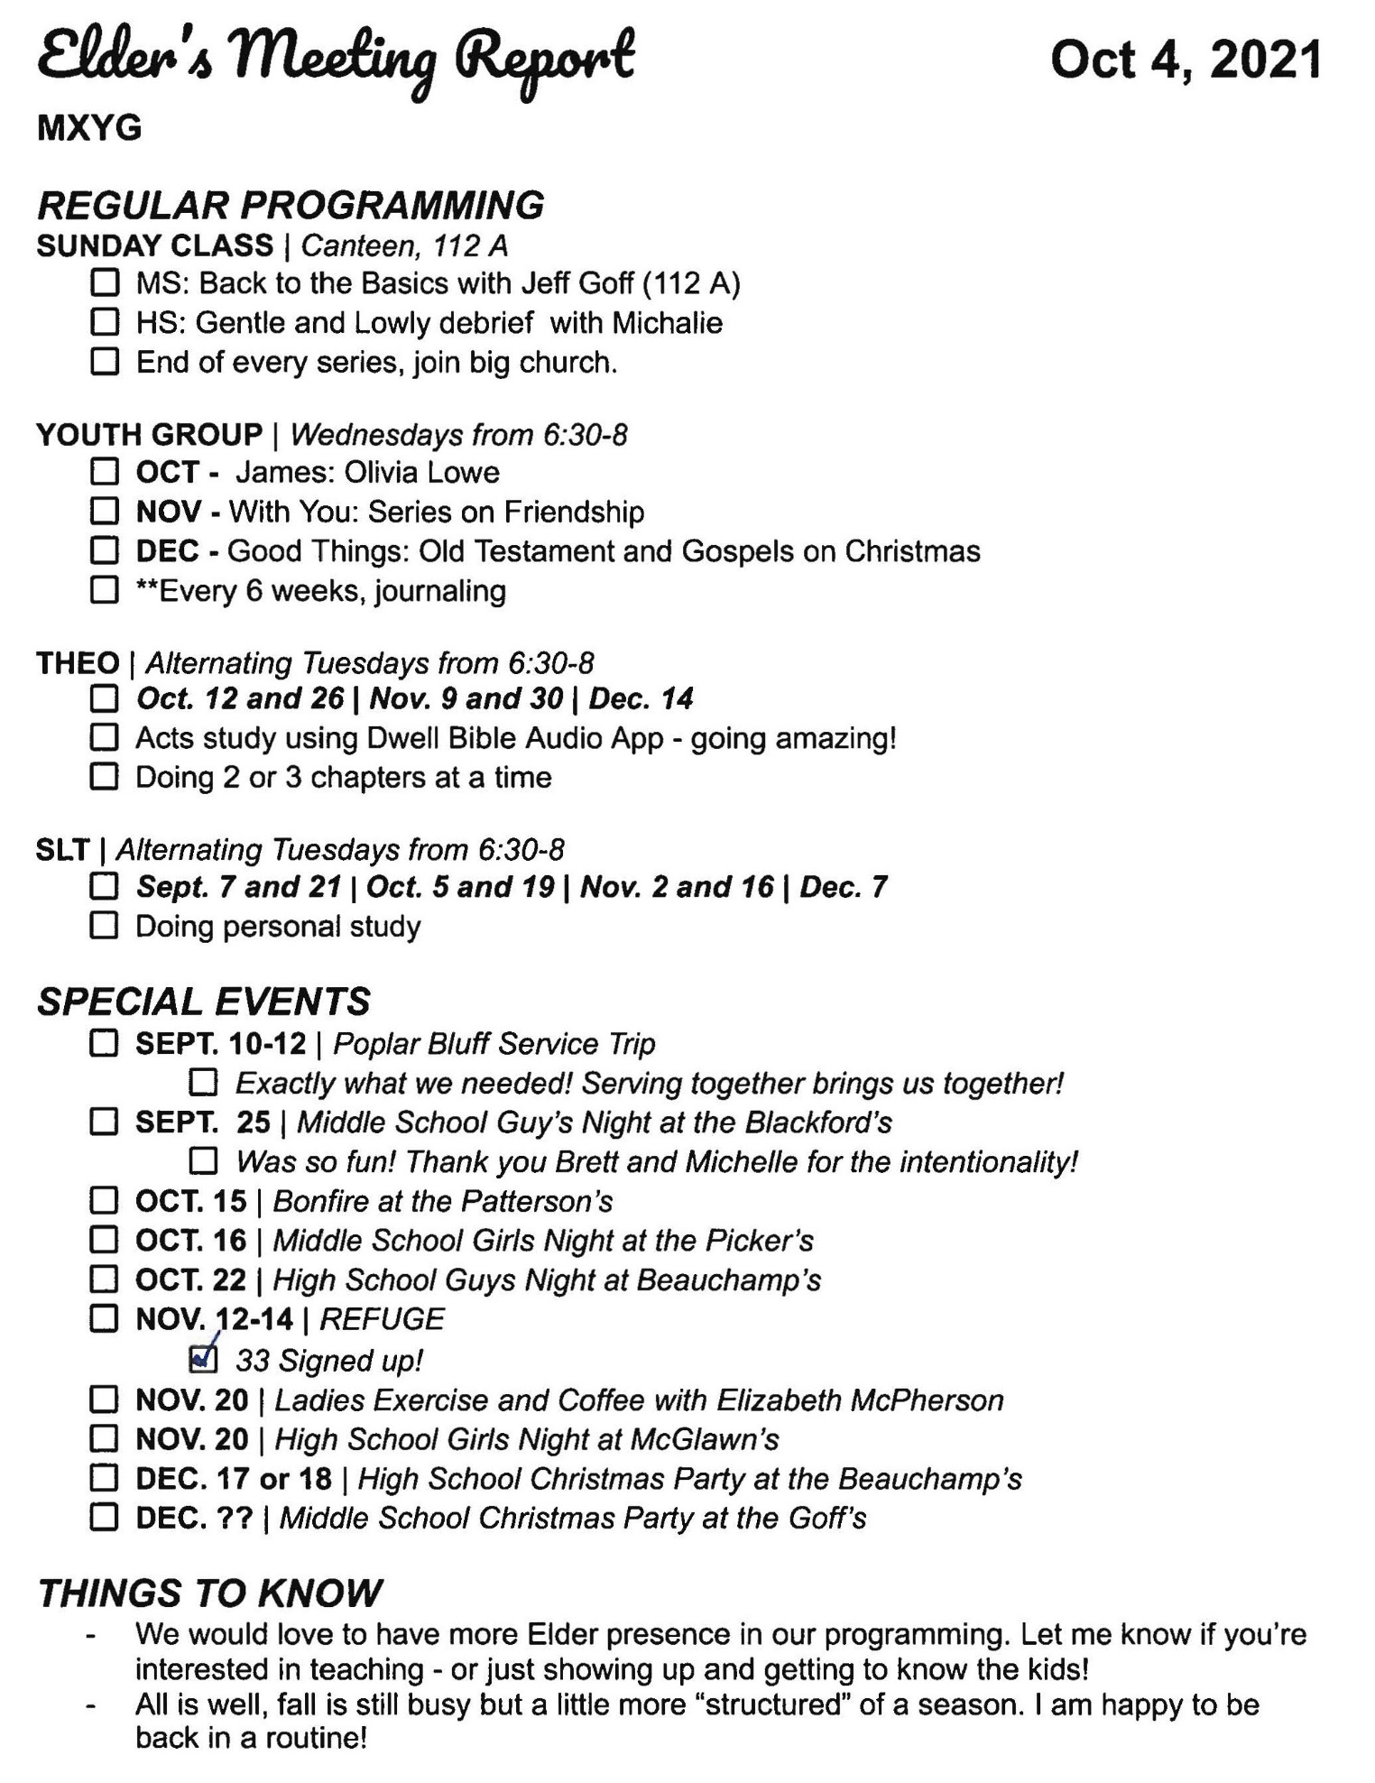

**Attachment D**

