MX Elder Meeting: 12/13/2021

Attendees: Jon Earnhardt, Wole, Brad S., Lane Hamm, Michalie Brown, Steve Awtrey, Jeremy Picker, Bret Blackford, Don Fitzgerald, Steve Walker, Keaton Jones, Steve Haupt, Lois West & Dave Weiler (on-line)

Agenda:

- Ministry Update – Barb Eickele: Food Pantry 6:00-6:15
- Family Concerns – Discuss Needs of the Congregation 6:15 – 6:45 a. Member Review Process b. Ted Crigler
- Minister/Staff Update – Michalie Brown 6:45 – 7:15
- Old Business 7:20 – 7:35 a. Sermon Series b. Elder Office Days c. Fellowship – 1/2/22
- New Business 7:35 – 8:35 a. Vision Elders Priority Recommendations i. Priorities ii. Budget b. Staff Reviews – Lane
- Assign Follow-up / Communication Items 8:35-8:40

==================================

- Ministry Update:

Barb (Charles) Eickele: see email at Attachment A

Family Needs:
Jerry Mickey concerned about safety committee. There may be 12 on the team and 5-6 reliable. Mostly Jerry Mickey fills in. He is burnt out and wanting to step down. He misses worship and does not feel safety is affected. Jerry thinks we need 3-5 people on a Sunday to make it work.

Q: Is the safety team a good idea or a vulnerability/liability?
- Jon Earnhardt: With reopening after COVID not the same need as before. May need to recalibrate teams.
- Jon Earnhardt: Will contact Jerry to discuss the ministry and get a recommendation on what this ministry needs given current state of MX.

Ministries:
Q: Do we have a list of the various ministries and who is involved, or at least the ministry leader? Jeremy Picker to get this list together. done – see Attachment D
Q: What about tape at the building on pews? Don Fitzgerald will discuss with the committee. Don will email a recommendation to the Road to Reopening Committee. done – in weekly wed email see Attachment C
Can we allow people to self-select? Have pews with tape and allow separation and have pews where we can pack in all pews. Possibly take tape down in middle rows.

- Family Concerns:

Connie Smith - has a mass on her lung. She was tested and NOT cancer !!
Brian Hannell’s dad passed away Friday.
Thomas - Jeremy’s buddy - his wife is keeping their daughter from him. Daughter is 1 year old. Thomas has been impacted by MX (and the recent sermon) but Thomas is going through some hard times.
Chuck Helt - health doing well and able to sing!
Chris & Sherifa White - have been out of pocket for a while. If you are a member of this family we need you.
Tornados - can MX do anything to help? A special contribution? The thought is to wait for things to settle and see what is needed.
Jerry and Lana Fox - have been attending regularly lately. They will be lighting the advent candle.
Tim & MarryAnn Nicholson - new members

- Member Review: Jeannie, Jeremy & Elizabeth have been updating the member list. Brad will share more with Elders only

b. Ted Crigler - will do Communion on the December 26th. Steve Awtrey shared Ted’s background. We should set up a table for Ted and have cards, etc. for Ted. This could be a day when we are able to honor the work Ted has done and his desire to be a minister. Ted will start working with Highland on January 1, 2022. Steve will work on communicating this (via email and announcements). Steve will also draft something for Jeremy to put on Facebook.

- Ministry/Staff Updates:

Michalie Brown - will resign in Late May 2022. Michalie thinks to tell congregation in Feb 2022
- Much discussion on when and how to communicate to the Youth Group and the congregation.

- Old Business
  - Sermons - see preaching schedule on-line here
  - Elder Office Days - see on-line here
  - Fellowship 1/22/2022 - Steve Awtrey will ask staff to assist with the fellowship snacks/coffee

- New Business
  - Vision Elders – see Attachment B
    - Priorities
      - NextGen
        - 1) Children’s Ministry
        - 2) Youth Ministry
      - Community
      - Healthy Staff
        - 1) Children’s - a need but not as high a priority as Youth
          - a) Start-up CIO mentality
          - b) Passion for ministry, children & families
          - c) Education background
          - d) Real world experience, not fresh out of school
          - e) A preschool directory
        - 2) Youth - 1st Priority
          - a) Find out if Michalie has potential options/leads on a replacement. Steve Awtrey and Lane Hamm will talk with Michalie about possibly extending beyond May 2022 (work through the summer with a couple interns). Also ask if Michalie wants to make the announcement.
            - i) Paul Stone? He still has another year to finish his degree.
            - ii) Once we start looking for a replacement the word is out on Michalie retirement.
Q: How do we communicate to congregation re Michalie’s retirement? Possibly early January?
Don Fitzgerald: We need to nail down a time to make an announcement. It is already mid-December. January 9, 2022 would be a good day for the announcement.
Q: Where does Jeremy fit?
Q: What about Matt Earnhardt? At least temporary during summer. Jon Earnhardt will talk with Matt and gauge interest as a possible summer intern.
- 3) Growing the Family
- 4) Pulpit
- 5) What is Jeremy Picker’s role? What about Jeannie’s role? Staff needs to be more cooperative and pick up the slack where needed.
a) Dave Weiler indicated Jeremy was willing to pick up the slack where needed.
    - Budget

  - Staff Reviews - Lane Hamm

Senior Pastor on sabbatical. Youth Minister resigned. Children’s Minister resigns - is there a problem?

Staff is not toxic but dysfunctional. They do not talk much to each other and work behind closed doors. Don Fitzgerald.: he attended staff meeting and found it to be shallow. Staff meeting was more of a business meeting.

As elders we need to decide what we want/need Jeff Kryder to do when he returns. How do we build a team of the office staff?? Can Jeremy Picker help build a team? The NextGen meetings seem similarly shallow. Jon Earnhardt: How do we put some structure I place? How do we engage in team building that can continue? Questions for staff: What are you working on? Where are you stuck? What gives you problems?

Question: If we wanted to hire a new full-time Youth Minister and a Children's Minister would the budget support the expense?
Dave Weiler: Yes.

Dave Weiler reviewed *draft* 2022 budget. Separate Excel spreadsheet attached to this email.

Steve Haupt and Steve Walker will chair the committee looking for a Children’s Minister. Elder sponsor for committee to interview and hire. Responsible for:
    - Getting committee together
    - Possibly talk with Erick McPherson
    - Talk with Valerie Creech if she has contacts

Dave Weiler: 3 big hiring opportunities. An opportunity to hire a minority, at least be deliberate in looking for diversity.

Brad Stevens: we need more training on giving. We have a surprisingly large number who do not give. We need to teach the members and teach our children. Brad recommend we punt this discussion until the next shepherd meeting.
Don Fitzgerald: Dangerous to tie specific people to who is/isn’t giving. We should increase teaching at church and at home.
Keaton: God’s word is clear that we are intended to give. It is blessed for the Christian and for the individual on the reviving end. Jeremy: ministries and how involved Jon Earnhart : Safety committee Don Fitz 1

- Assign Follow-up:
- Jeremy Picker – get list of Ministries and people involved – done See Attachment
- Steve Awtrey – assist in moving partitions to the Food Pantry
- Steve Awtrey – draft something to be added to MX email (announcement re Ted Crigler graduation and new job.
- Steve Awtrey – ask staff to assist with the Jan. 22, 2022 fellowship after worship
- Steve Awtrey & Lane Hamm: see if Machalie is willing to extend through summer, at least part-time.
- Jon Earnhart – will contact Jerry Mickey to discuss the Safety Team.
- Jon Earnhart – talk with Mat Earnhart about possibly working with Youth Group over summer (along with 2 interns) started conversation
- Don Fitzgerald – ask Road to Reopening team if we can open a few pews (take off blue tape) and allow people to self-select where they feel comfortable sitting on Sunday. done See Attachment C
- Steve Haupt & Steve Walker – put together and chair a team to help look for a new Children’s Minister.

Other Comments worth Noting:
Congregation may want to know if there is a problem with our staff: We have our Senior Minister on sabbatical, our Children’s Minister has resigned, our Youth Minister will resign.
- Shepherds need to craft a response. We may not need to add this to an announcement but we need to have something ready in our back pocket should question come up.

Staff Cohesiveness:
How can we encourage greater comraderie amongst the staff? How can we put structures in place to encourage team building and cooperation?

New Staff Opening:
- We have the funds to hire two new staff positions – Youth Minister and Childrens Minister
- We have three possible opening – we should be deliberate in looking for diversity.

Giving:
- Many in congregation do not tithe regularly or at all
- We need more teaching on giving
- Should not tie membership to giving but we should see a lack of giving as spiritual immaturity.

Attachment A: MX Food Pantry

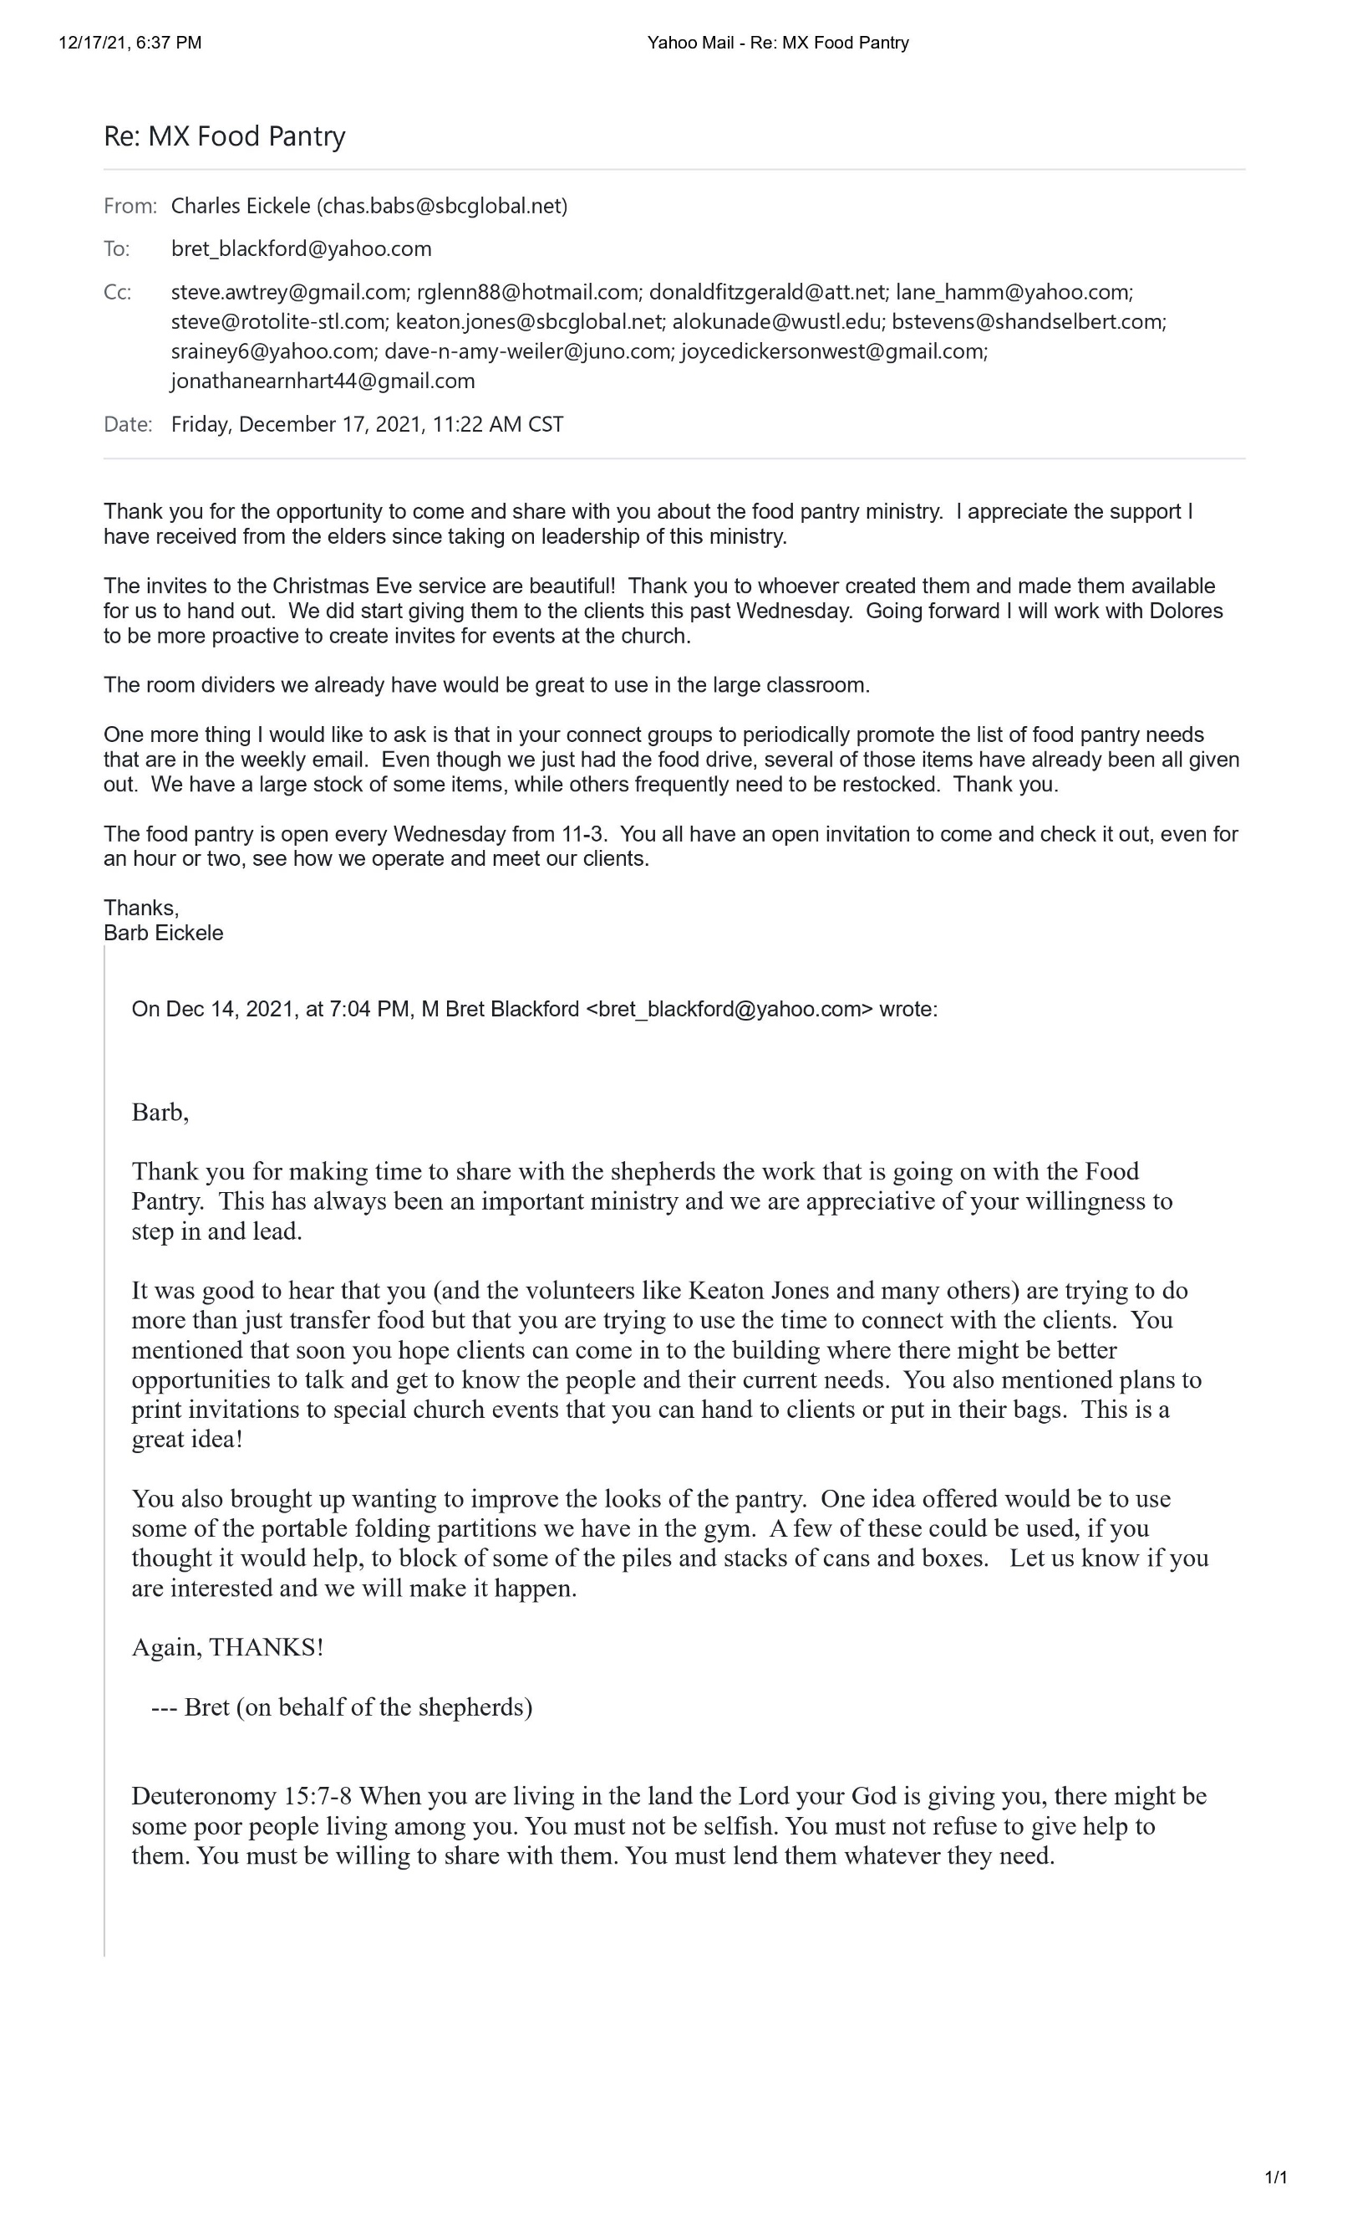

Attachment B: Vision Elder Meeting Notes

Vision Elders
12/06/21 Meeting
MX Priorities
Attendees:
Dave Weiler
Jeff Kryder
Steve Awtrey
Lane Hamm

Opened the meeting with an exercise in which each individual wrote down their own view of priorities individually.

Dave | Jeff | Steve | Lane
Bible (Back to Basics) | Children’s  (Welcoming/New People/Growing) | Community Building | NexGen (Youth/Children)
Prayer (Back to Basics) | Fellowship / Community | Reason to Come Back | Family/Involvement/Community
NexGen: Youth/Children | Staff Clarity | Youth Ministry | Outreach / Local Missions
Plan for Healthy Staff | Renovation (Tech/Auditorium) | Young Couples
 |  | Unity (Diversity Included)
 |  | Discipleship
 |  | Develop Strong Staff

After Reviewing and Discussing our thoughts the following priorities were determined.
- NexGen
  - Children’s Ministry
  - Youth Ministry
- Community
- Healthy Staff
We used these priorities to clarify our staff priorities which we propose are as follows.
- Children’s
- Youth
- Growing the Family (Internal & from external) / Worship
- Pulpit
As we move forward with new hires, we will view each opening as an opportunity to build a diverse ministry team.
Our first stated hiring priority is to find a full-time children’s ministry leader.
This individual would ideally have the following:
- Start-up CEO mentality – Creative, flexible, visionary, willing to do the admin tasks required to support the work
- Passion for ministry, children and families
- Education background
- Real world experience, not fresh out of school
- (A preschool director)
We propose the following steps.
- Form a Search Committee
  - Identify Elder sponsor
  - Identify Leader
  - Recruit committee of invested members/parents
  - Refine Job Description
  - Kick off search in January
- Find a part-time temporary resource to continue class scheduling and ministry maintenance

Other steps to be taken were discussed.
- Fortify Youth Ministry
- Fully Develop Job Description and Role of Family/Worship role (Lane & Jeremy)
- Capture Technology drags fueling Jeff’s concerns (Lane & Jeremy)
- Begin search for Pulpit Ministry transition candidate Q3/Q4 of 2022
- Understand staff needs beginning with Review process (Lane)

Attachment C: Weekly Wed. email with note about pew seating

Auditorium Seating Changes

Due to an increasing number of members and guests returning to the building for worship services the current seating arrangements are being revised. Beginning this Sunday, December 19, two of the four sections of pews will have open seating (not sectioned off with blue tape). We invite those who are comfortable with an open seating arrangement to take advantage of this area. We continue to suggest everyone wear masks while inside the building for the safety of everyone, especially our young children and other unvaccinated members and guests.
The remaining two sections of pews will continue to have rows taped off to provide the social distancing between rows we have had over the past several months.
We will continue to monitor the ever-changing status of this COVID environment and continue to seek the safety of all our members and guests.
Don Fitzgerald
for the Road to Reopening Committee

Attachment D: MX Ministries
(also on-line here)

Ministry | Desc. | Lead | Members
Christian Formation | > Classes  > Library
Boundless Room |  | Jodi Mitchel
Building & Grounds |  | Bret Blackford
Fellowship
Finance/Budget |  | Jeannie Britzmann | Dave Weiler  Brad Stevens  Ben Merhringer
Hospitality |  | Becky Kryder
Kids Crossings | > Nursery  > Kids Worship  > Kids Classes | Heather Goff
Praise Team |  | Jeremy Picker
Prayer Ministry |  | Wole Okunade
Safety Team |  | Jerry Mickey  Rick Sally
Senior Ministry |  | Janice Davania
Teen Ministry |  | Michalie Brown
Technology & Audio Visual |  | Jeremy Picker
Unity & Diversity |  | Joyce & Louis West  Todd & Beth Mayberry
Video |  | Jeremy Picker
Website |  | Elizabeth McPherson
Worship |  | Jeremy Picker
ACTS |  | AJ Bennet
Camp Ne-O-Tez |  | Steve Jones
Connect Groups |  | Dale Simpson
Greeting |  | Fredy Griffith
Benevolence
Missions |  |  | Jeff Fogarty  Jeff McGlawn  Jim Griffith
Local/ Urban Missions/ Outreach
Food Pantry |  | Barb Eickele

Attachment D: Elder Contact Info.

Elder Contact Info.:

Steve Awtrey | steve.awtrey@gmail.com | (314) 374-3276
Bret Blackford | Bret_Blackford@yahoo.com | (314) 402-7086
Glen Devania | rGlenn88@hotmail.com | (314) 822-0321
Don Fitzgerald | donaldFitzgerald@att.net | (314)791-5038
Lane Hamm | lane_hamm@yahoo.com | 314-269-4049
Steve Haupt | steve@rotolite-stl.com
Keaton Jones | keaton.jones@sbcglobal.net | (314) 270-9632
Wole Okunade | alokunade@wustl.edu | (314) 429-8832
Brad Stevens | bStevens@shandselbert.com | (314) 962-5370
Steve Walker | srainey6@yahoo.com
Dave Weiler | dave-n-amy-weiler@juno.com | (314) 729-0327
Louis West | joyceDickersonWest@gmail.com | (314-308-5284
Jon Earnhart | jonathanearnhart44@gmail.com | 636-485-6289
Jeff Kryder | jKryder@mcknightcrossings.org | 314-537-6912

