**12.27.2021 MX Elder Meeting**

Attendees: Keaton Jones, Wole Okunade, Louis West, Brad Stevens (chair), Glenn Devania, Dave Weiler, Bret Blackford (notes), Don Fitzgerald

*Note*: Meeting started at 6:00 PM CST but Bret had to leave at 7:00. Notes below reflect discussion during that time. Dave Weiler will need to fill in any additional key items missed.

*Bret made an initial statement recognizing that this past Sunday, December 26, 2021 we had a woman preach the Sunday sermon. This is a seminal event for our faith tradition.*

Dave Weiler then led a discussion through current issues. Noting that these are just discussions with no decisions being made until the regular elder meeting scheduled for January 3, 2022.

1. **Replacing Heather Goth with a Children’s Minister** (not Coordinator).

* Currently not many children attending in person but still many on the roster (see Attachment A)
* Focus on young children is expected to help draw/retain young families
* We have Gwen Walker willing to fill-in while we search for a full-time Children’s Minister.

1. **Michalie Brown leaves in May 2022.**

* Not sure if Matt Earnhart will want to assist over the summer.
* Matt currently involved with KLIFE (<https://hpklife.com/what-is-klife>)
* We will have two summer interns
* Michalie will develop the summer calendar before she leaves.
* Jeremy Picker willing to step-in as needed. Jeremy is also considering applying for the Youth Minister position full-time. This would result in other opening for worship, etc. Jeremy wants to help anchor the ministry staff and be part of the solution going forward.
  + Lane Hamm meeting with Jeremy 1.6.2022

1. **Announcement of Machalie resignation**

* General thought was earlier is better: 1.9.2022 preferable to 1.16.2022
* Discussed framing the announcement as a positive thing. We are happy for Machalie and have been blessed to have her serve our teens for the past several years. Machalie has served well and will be missed but we have plans in place to keep the momentum going with the Youth Group
* Some discussion on treating this like a normal announcement. Make the announcement at end of Sunday worship and then dismiss to classes. Youth can then pick-up discussion with Michalie at that time.

1. **Dolores Miller** and secretarial responsibilities. Dolores is slowing down and MX should consider discussing her transition to retirement and finding a replacement. No immediate rush.
2. **Elizabeth McPherson** work load. Elizabeth works hard and long and we need to make sure she does not burn herself out. We need to have someone discuss how she feels about her workload and if it is maintainable for the long-term.
3. **Glenn Devania resigned from the Eldership** (see Attachment B)

* Louis West and Dave Weiler reminded Glenn that even after his name is removed from the bulleting as being a Shepherd with a capital “S” he will still be a shepherd.

Reminder: Additional information is available on Google docs [***here***](https://docs.google.com/spreadsheets/d/1GbanwBsEyVhAvG6CSIFeTGQtE6kJsac2xR4erx7SL54/edit#gid=0) (<https://docs.google.com/spreadsheets/d/1GbanwBsEyVhAvG6CSIFeTGQtE6kJsac2xR4erx7SL54/edit#gid=0>) . The link is to Google docs spreadsheet which list the following information:

* Tuesday Staff/Elder schedule
* Elder meeting dates and Chair (Brad Stevens looks to be Chair for 1.03.2022 mtg)
* Preaching Schedule (Jeremy preaching 1.02.2022 with Wole making Elder response)
* List of MX ministries

**Attachment A.1**

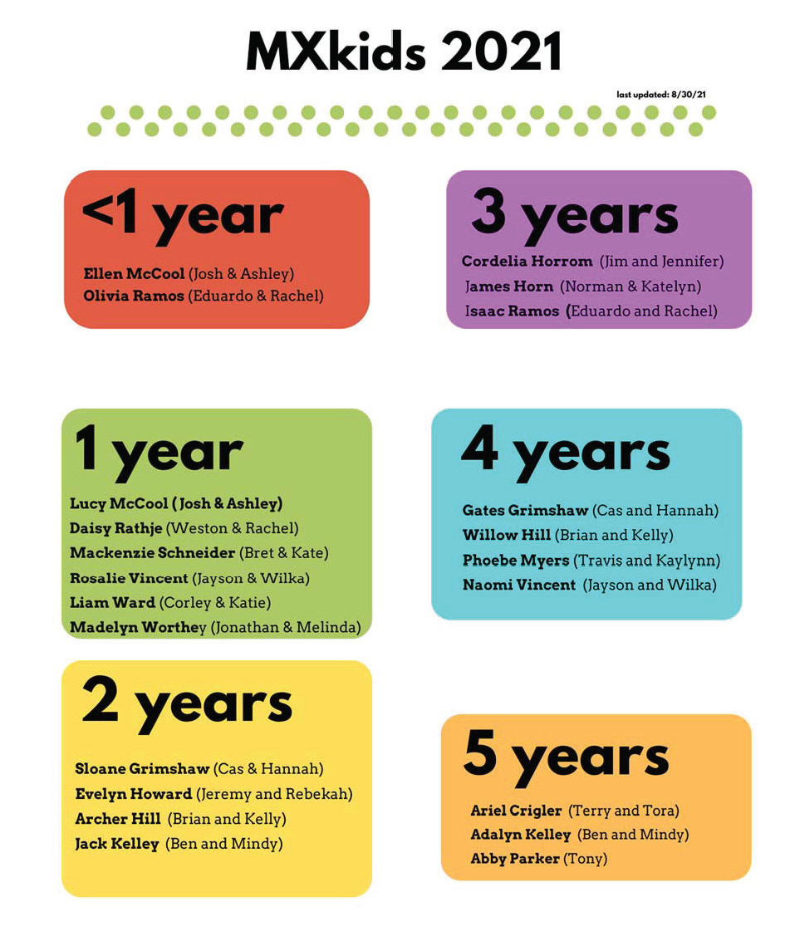

**Attachment A.2**

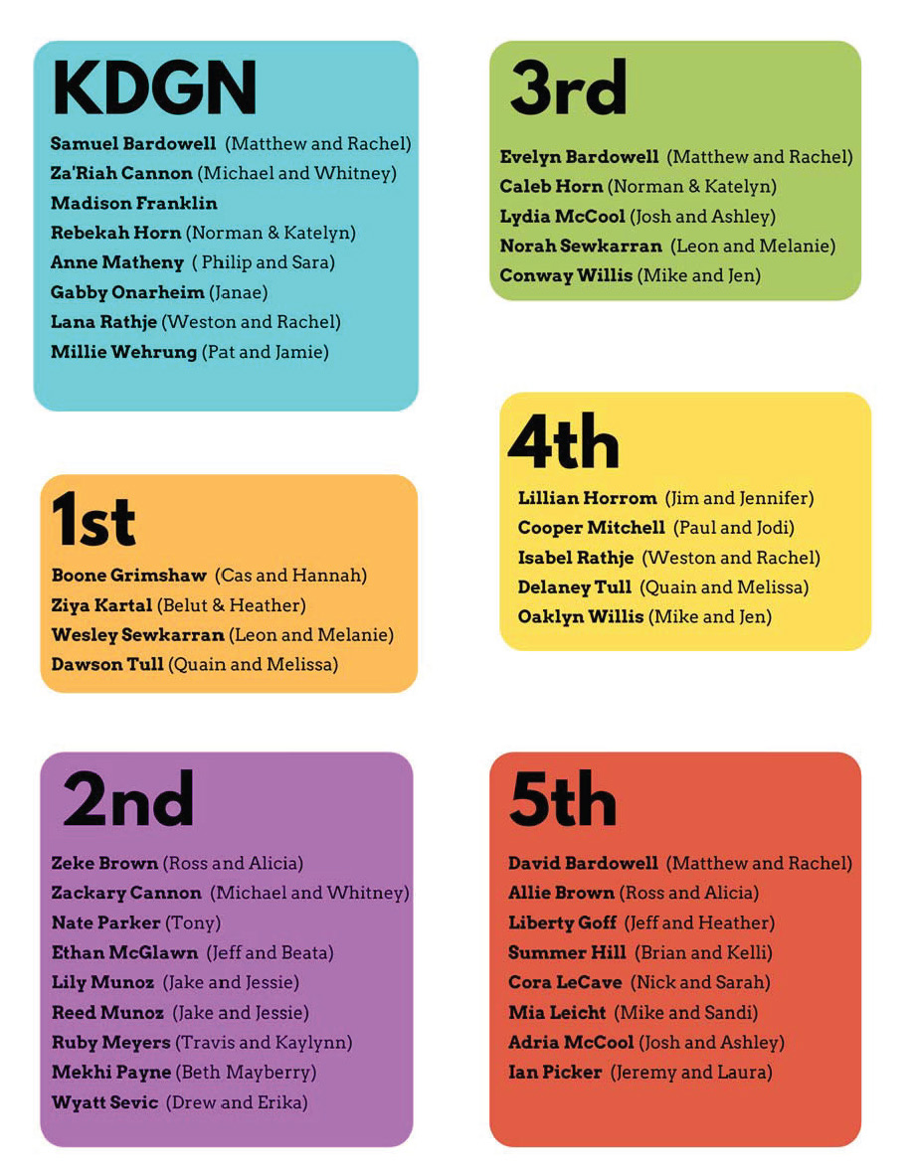

**Attachment B**

