11.15.2021

Monday, November 15, 2021

6:12 PM – 9:15 PM

Attendees: All shepherds with exception of Steve Awtrey. Jeff Kryder was also absent. Joyce West and Jeremy Picker also attended first part of meeting.

Below are my notes from our last meeting. Again, these are mostly a transcription of the discussion.

**Here are some key items**:

During Jeff Kryder’s sabbatical (12/13/2021-2/14/2022):

* Jeremy Picker will be point person for staff
* Steve Awtrey will be the point person for the shepherds
* Make sure shepherds attend the Tuesday staff meetings [sign up [***here***](https://docs.google.com/spreadsheets/d/1GbanwBsEyVhAvG6CSIFeTGQtE6kJsac2xR4erx7SL54/edit#gid=0)]
  + Jeremy will set agenda with input from shepherd attending that week and cc agenda to all shepherds.
* Review Jeff Kryder’s sabbatical plan (attached at end of these notes). It is currently vague in goals, is this ok or do we want more structure in the plan up front?

================================================

**People**

Ben Mehringer - Leukemia

Maria Holmes - overwhelmed with work and family

Stephanie Hauper funeral this Wed. - Steve Awtrey will perform the service

Markita Franklin - baby boy about 6-weeks ago. Jeremy Picker talking with her.

Dan Creech - worshiping someplace else - not sure how this impacts Valerie. Some have encouraged her to worship with her husband.

================================================

**Louis West** - **wanting to get plugged back in to the elder meetings**. Meeting at the building works well with Louis.

================================================

**Diversity**

**Louis West** concerned about the current political and social environment. Racism is still problematic, like with voter suppression. Louis feels this is important to the leadership of MX and we should not put our head in the sand. Louis does not want the racial issues that exist in society to impact the church.

**Joyce West** - We as a church are peddling in quicksand. It is discouraging and heavy. *Unity in Diversity Events* - gets a lot of positive movement but soon everything is forgotten and momentum is lost. We need to be making moves to becoming a multicultural church. Joyce does not feel like things are moving. It has to start at the top, with the elders. MX should be a place where people who are different can come and feel welcome and not treated like a stereotype.

* **Steve Walker** - important to have training so you can see how you are involved in racism. You don’t know what you don’t know. Training is important to allow people to expand their understanding.

**Joyce West & Next Steps** - Talking with Steve Awtrey.

* **Dave Weiler** shared some of what he is learning (Color of Compromise session). Dave is struggling with what we at MX should discuss in church or from the pulpit. Squeamish about inappropriate Critical Race Theory and similar but there are things we CAN do.

* **Jeremy Picker** - from a staff point of view - how do we get back into North Webster and get involved w/families there. Looking at some type of Juneteenth celebration with these neighborhoods. Also looking at other steps/options (VBS, etc.). Trying to break through the awkwardness.

* **Louis West** - how did Jesus deal with racism? Christ challenged racism.

* **Lane Hamm** - we fully support this effort. We are making this a conscious effort but perhaps we are not doing enough. [Question to Joyce West:] What do you want to see?
  + **Joyce** - have the elders do the Color of Compromise training. .

* **Keaton Jones** - Get several men together to help the families that come to the Food Pantry. We want to connect with them and help them with their homes, etc.

* **Steve Walker** - we have ***Diversity*** as one of our core values.

================================================

Dave Weiler - **budget update**

Working on 2022 budget. Almost put together. Will be presented to the elders soon.

Auditorium Project:

**Jeremy Picker** - make things easier and more reproducible. Both for audio and video. There are a lot of options for being on-line. Prefers streaming at this point (may change later). Streaming is clunky. We are working with one (1) camera. We should try and erase some of the distractions with live-stream.

================================================

**Jeff Kryder - sabbatical**

* Jeremy Picker - he wants to help and take on the right things. Jeremy getting mentoring from Dusty Rush. Jeremy wants this opportunity to see what might be areas where he can expand his role. Jeremy will be leading the ***staff*** and ***NextGen*** meetings. Jeremy wants clarity in his roles. This will allow him to plan upcoming projects and understand what his commitments are in all areas.
  + Jon Earnhardt - is there a process for everything that needs to get done? If there are issues and balls dropped then fingers will point to Jeremy. We want to set Jeremy up for a win, so we need to get clarity on areas that need attention.

When Jeff Kryder returns how do we put up some guard rails to keep Jeff healthy?

Last Saturday it was decided that …

* We like Jeremy Picker being the point person
* Make sure elders are at Tues staff mtgs. [see calendar [***here***](https://docs.google.com/spreadsheets/d/1GbanwBsEyVhAvG6CSIFeTGQtE6kJsac2xR4erx7SL54/edit#gid=0)]
  + Jeremy to align agenda with elder for that week. Also cc agenda to all elders.
  + Bret to get a Google form set up so elders [**Note**: form available [***here***](https://docs.google.com/spreadsheets/d/1GbanwBsEyVhAvG6CSIFeTGQtE6kJsac2xR4erx7SL54/edit#gid=0)]
* Steve Awtrey will be the point person for all things during sabbatical

* Bret to follow-up with Jeff Fogarty about preaching. Perhaps talk about Missions.

[**Note**: Jeff Fogarty is willing to preach on Missional Feb. 13, 2022]

================================================

Next meeting 11/29 at 6PM - Steve Awtrey

* Focus on Sabbatical plan and document (from Steve)
* Sermon series in Jeff’s absence
* Classes
* Elders on Tuesdays

Dec 2021 - Lane Hamm

Jan 2022 - Brad Stevens

 [**Note**: Future shepherd meeting schedules and chair is available [***here***](https://docs.google.com/spreadsheets/d/1GbanwBsEyVhAvG6CSIFeTGQtE6kJsac2xR4erx7SL54/edit#gid=0)]

================================================

Leadership model when Jeff Kryder returns

**Jeff Kryder criticism**: Do we, as elders, need to communicate to the congregation that we need to get feedback from the congregation, send to elders not Jeff Kryder. Jeff needs thick skin but the elders need to buffer Jeff from these negative comments. Directional issues should go to the elders.

**Matthew Bardewell has comments on NextGen and his vision**. Perhaps get a few people like Matthew and others in that stage of life to discuss NextGen and their priorities. Make sure our plans are relevant to our body and other young families that will hopefully be part of MX in the future.

**Attachment A.1** – draft plan of Jeff Kryder sabbatical (as of 11/11/2021)

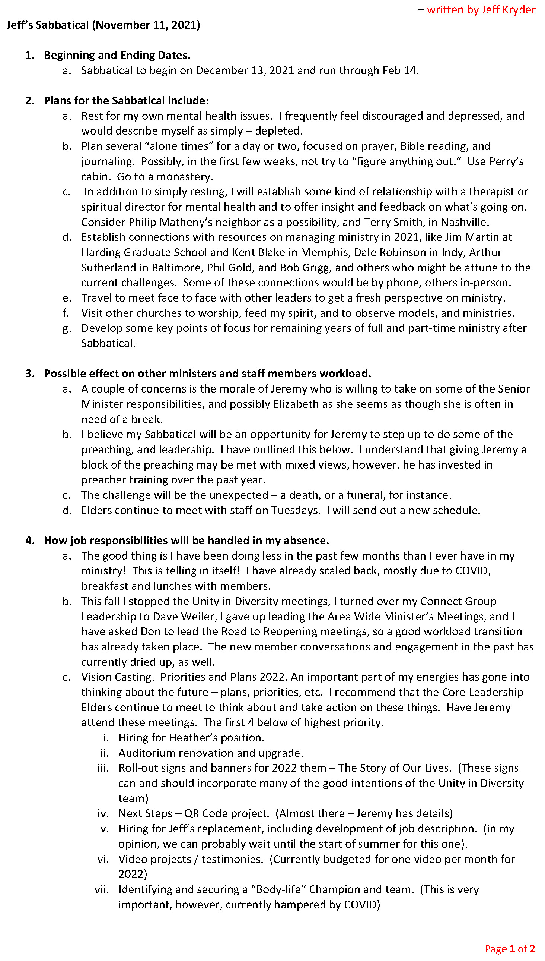

**Attachment A.2**

