﻿**McKnight Crossings Church of Christ**

**August 30, 2021 Shepherding Meeting**

Attendees:

Lane Hamm, Heather Goff, Jeremy Picker, Brad Stevens, Keaton Jones, Don Fitzgerald, Jeff Kryder, Steve Haupt, Machale Brown, Glen Devania, Bret Blackford (secretary)

Wole joined remotely

**Agenda** (details below):

1. People - Shepherding, New Members.

2. Next Gen Updates.

3. Fall Series, Plans, Bible Classes, and Connect Groups.

4. Ministry Developments (Food Pantry, Art Ministry, Pickleball, and some new possibilities)

5. Kari Ferguson.

6. Proposal for Elder / Staff relationships.

7. Staff Considerations.

**1. People Update (**see **Attachment A)**

* Don Fitz called Bill Bassett and got no response, no answer. He may be moving on.
* Heather and Mindy Kelley - looking at churches closer to home
* Wagners came 1x to teach
* Jeramy getting with Craig Hamby (Alley going to Youth Group)
* Norma Janes wary of getting out
* Jan Watkins wary of getting out
* Jan Patricks worry of getting out
* Drew Knotts attending ladies class
* Elhomme Calixte works most weekends and spends the othrs with daughter
* Rather have been hosting small group w/Bardewells
* Lane Hamm to get with Katie Ward
* Jim Davania - Keaton trying to contact
* Jeremy Picker texted Jane Jackson
* Stephanie (& Bob) Hopper - infusion went well so optimistic about next steps
* Ron Milligan could use help fixing his main bathroom. Tile falling and Joni needing to shower in basement and she is unstable on stairs.

**2. Next Gen**

* HEATHER - talking about young kids, classes, schedules, etc. (see **Attachment C**)
* Val Creech - looking at working with MX NextGen 1-5th grade to do ARTS ministry (music, art, etc.)
* Macalie – (see **Attachment D**) Middle School somewhat struggling.  Going to do age specific hangout nights.
* Hope/plan is to start classes in October (including nursery workers). One adult class in the gym (possibly) - *NOT* in the auditorium.

**3. Fall Series** - “[Gentle and Lowly](https://www.amazon.com/Gentle-Lowly-Christ-Sinners-Sufferers/dp/1433566133/ref=asc_df_1433566133/?tag=hyprod-20&linkCode=df0&hvadid=416902034635&hvpos=&hvnetw=g&hvrand=10513371064926593821&hvpone=&hvptwo=&hvqmt=&hvdev=c&hvdvcmdl=&hvlocint=&hvlocphy=9022896&hvtargid=pla-896744331242&psc=1&tag=&ref=&adgrpid=94182732936&hvpone=&hvptwo=&hvadid=416902034635&hvpos=&hvnetw=g&hvrand=10513371064926593821&hvqmt=&hvdev=c&hvdvcmdl=&hvlocint=&hvlocphy=9022896&hvtargid=pla-896744331242)” the book by Dane C. Ortlund

Sermon series about 9-12 weeks (through Thanksgiving)

This Sunday there will be a mtg after church for about 10 minutes to discuss plan for nest series and how to use in small groups.

Jr High and High School will also be going through the book.

Basic Premise: Our understanding of God - we don’t believe who God says he is.  Do we trust God?  Do we know God?  What does it mean that Jesus is “Gentle and lowly”?

*In Matthew 11, Jesus describes himself as “gentle and lowly in heart,” longing for his people to find rest in him. This book reflects on his words, diving deep into Bible passages that speak of Christ’s affections for sinners and encouraging believers as they journey, weary and faltering, toward heaven.*

**4. Ministry Development**

* BARB Eikley taking over Food Pantry

**Q**: Thanksgiving meal in 2021?  Can we have something for patrons in gym this year?

* Art Ministry
* Pickle Ball going to Thursdays
* New Possibilities - establish a care ministry to take care of housebound and others out of touch.  Something to complement what the Elders do with phone calls and reaching out.  People need to know they are remembered. This can be directed to the list of widows and others. **Q**: Do we have a list of these people??

**5. Kari Ferguson** – no discussion

**6. Elder / Staff Relationships**

An elder just stop by the office and chat and say hello and pray with the staff individually or in group.  Next week possibly a new elder stop in to see how things are going.  Build some report during that time.

 - Jeff Kryder will come up with a rotation plan (see **Attachment E**)

Dave Weiler and Steve Walker met with Jeff Kryder - discussed annual review/evaluation (See **Attachment F**)

* Ideally, Jeff Kryder would like to be in a Leadership Development role that would include at times preaching (not weekly).
* “*MX would be blessed by Leadership Development”* - Dave Weiler
* Jeff Kryder to bring a proposal to the Elders.
* As the Elders, what is our vision for Jeff’s replacement?
* Jeff Kryder sabbatical is an action item. Attached is prior discussion on pros & cons:



**Attachment A**

|  |  |
| --- | --- |
| **People Follow-up (Aug 21 2021)**  **Have not returned to building since pandemic**  Val Creech  Leon Sewkarran  Bob, Jerry Mickey, and Jeannie  New Teens  Rick Salley  Tim and Mary Ann  Travis and Kailyn  Colleen Murphy  Velma Buie   1. Bill Bassett 2. ~~Susie Burge~~ 3. Elhomme Calixte 4. ~~WC AND Virginia Conley~~ 5. ~~Jack and Nell Crawford~~ 6. Terry and Tora Crigler 7. Jim and Alisha Davania 8. ~~Alice Ferry~~ 9. Carrie Flick 10. Markita Franklin 11. Ernestine Gathing 12. Steve and Karen Gordon 13. Craig and Heather Hamby 14. ~~Sandy Hammon~~ 15. Gloria Hanson 16. Sara Henagean 17. ~~Tom and Maria Holmes~~ 18. ~~Mike Hudgens~~ 19. Janee Jackson 20. Norma Janes 21. Ben and Mindy Kelley 22. ~~Brent and Betsy Kelley~~ 23. Dru Knotts 24. ~~Mike and Sandi Leicht~~ 25. Bruce Lohman 26. ~~Todd and Beth Mayberry~~ 27. Bea Moon 28. Cletia Anne Payne | 1. Linda Punshon 2. Katherine Pyatt 3. Weston and Rachel Rathje 4. Steve and Rebecca Schene 5. ~~Ed and Debbi Schwarz~~ 6. ~~Joe Shelley~~ 7. ~~Don and Lillian Seese~~ 8. Nick and Sarah Segbers 9. Drew and Erika Sevic 10. ~~Connie Smith~~ 11. Mary Spavale 12. LeGrand and Carrie Strickland 13. Tim Tate 14. ~~Larica Tucker~~ 15. Janet Truss 16. ~~Richard and Betty Vaughn~~ 17. Kevin and Kara Vick 18. Chris and Gena Wagner 19. Jan Watkins 20. Katie and Corley Ward 21. ~~Louis and Joyce West~~ 22. ~~Jonathan and Melinda Worthey~~   **Returned 1x or 2x only**   1. Jerome and Marie Allen 2. John and Brittni Calhoun 3. Kara Karraker 4. Tiffany Henagean 5. Micheal Cannon 6. ~~Peggy Hope~~ 7. ~~Dan and Valerie Creech~~ 8. ~~Jerry and Lana Foxe~~ 9. ~~Philip and Sara Matheny~~ 10. ~~Paul and Jodi Mitchell~~ 11. ~~Alex Humphrey~~ 12. Jim and Jennifer Horrom 13. ~~Jeremy and Rebekah Howard~~ 14. ~~Jim and Denise McCoy~~ 15. ~~Adam Shelley~~ |

**Attachment B**

RECENT GUESTS

August 30, 2021

**Collitta Murphy {6S+)**

Sl87 King St

Imperial, MO 63052

314 368-5641

[**ColleePM4@gmail.com**](mailto:ColleePM4@gmail.com)

**----------------------------------------------------------**

**Tim & MaryAnn Nicholson** (65•)

**7 Heathercroft Ct**

Chesterfield, MO 63017

636-532·1761

[**nisun@sbcglobal.net**](mailto:nisun@sbcglobal.net)

**----------------------------------------------------------**

Ron Orick (56-65)

**8871 Flamingo**

**Brentwood, MO 63144**

479-653-8585

[**rOrick@gmail.com**](mailto:rOrick@gmail.com)

**----------------------------------------------------------**

**John Barrett** (65+)

**10554 Litz Ave.**

**St. Louis, MO 63074**

314-614-2387

[**Jbsd2014@gmail.com**](mailto:Jbsd2014@gmail.com)

**Attachment C.1**

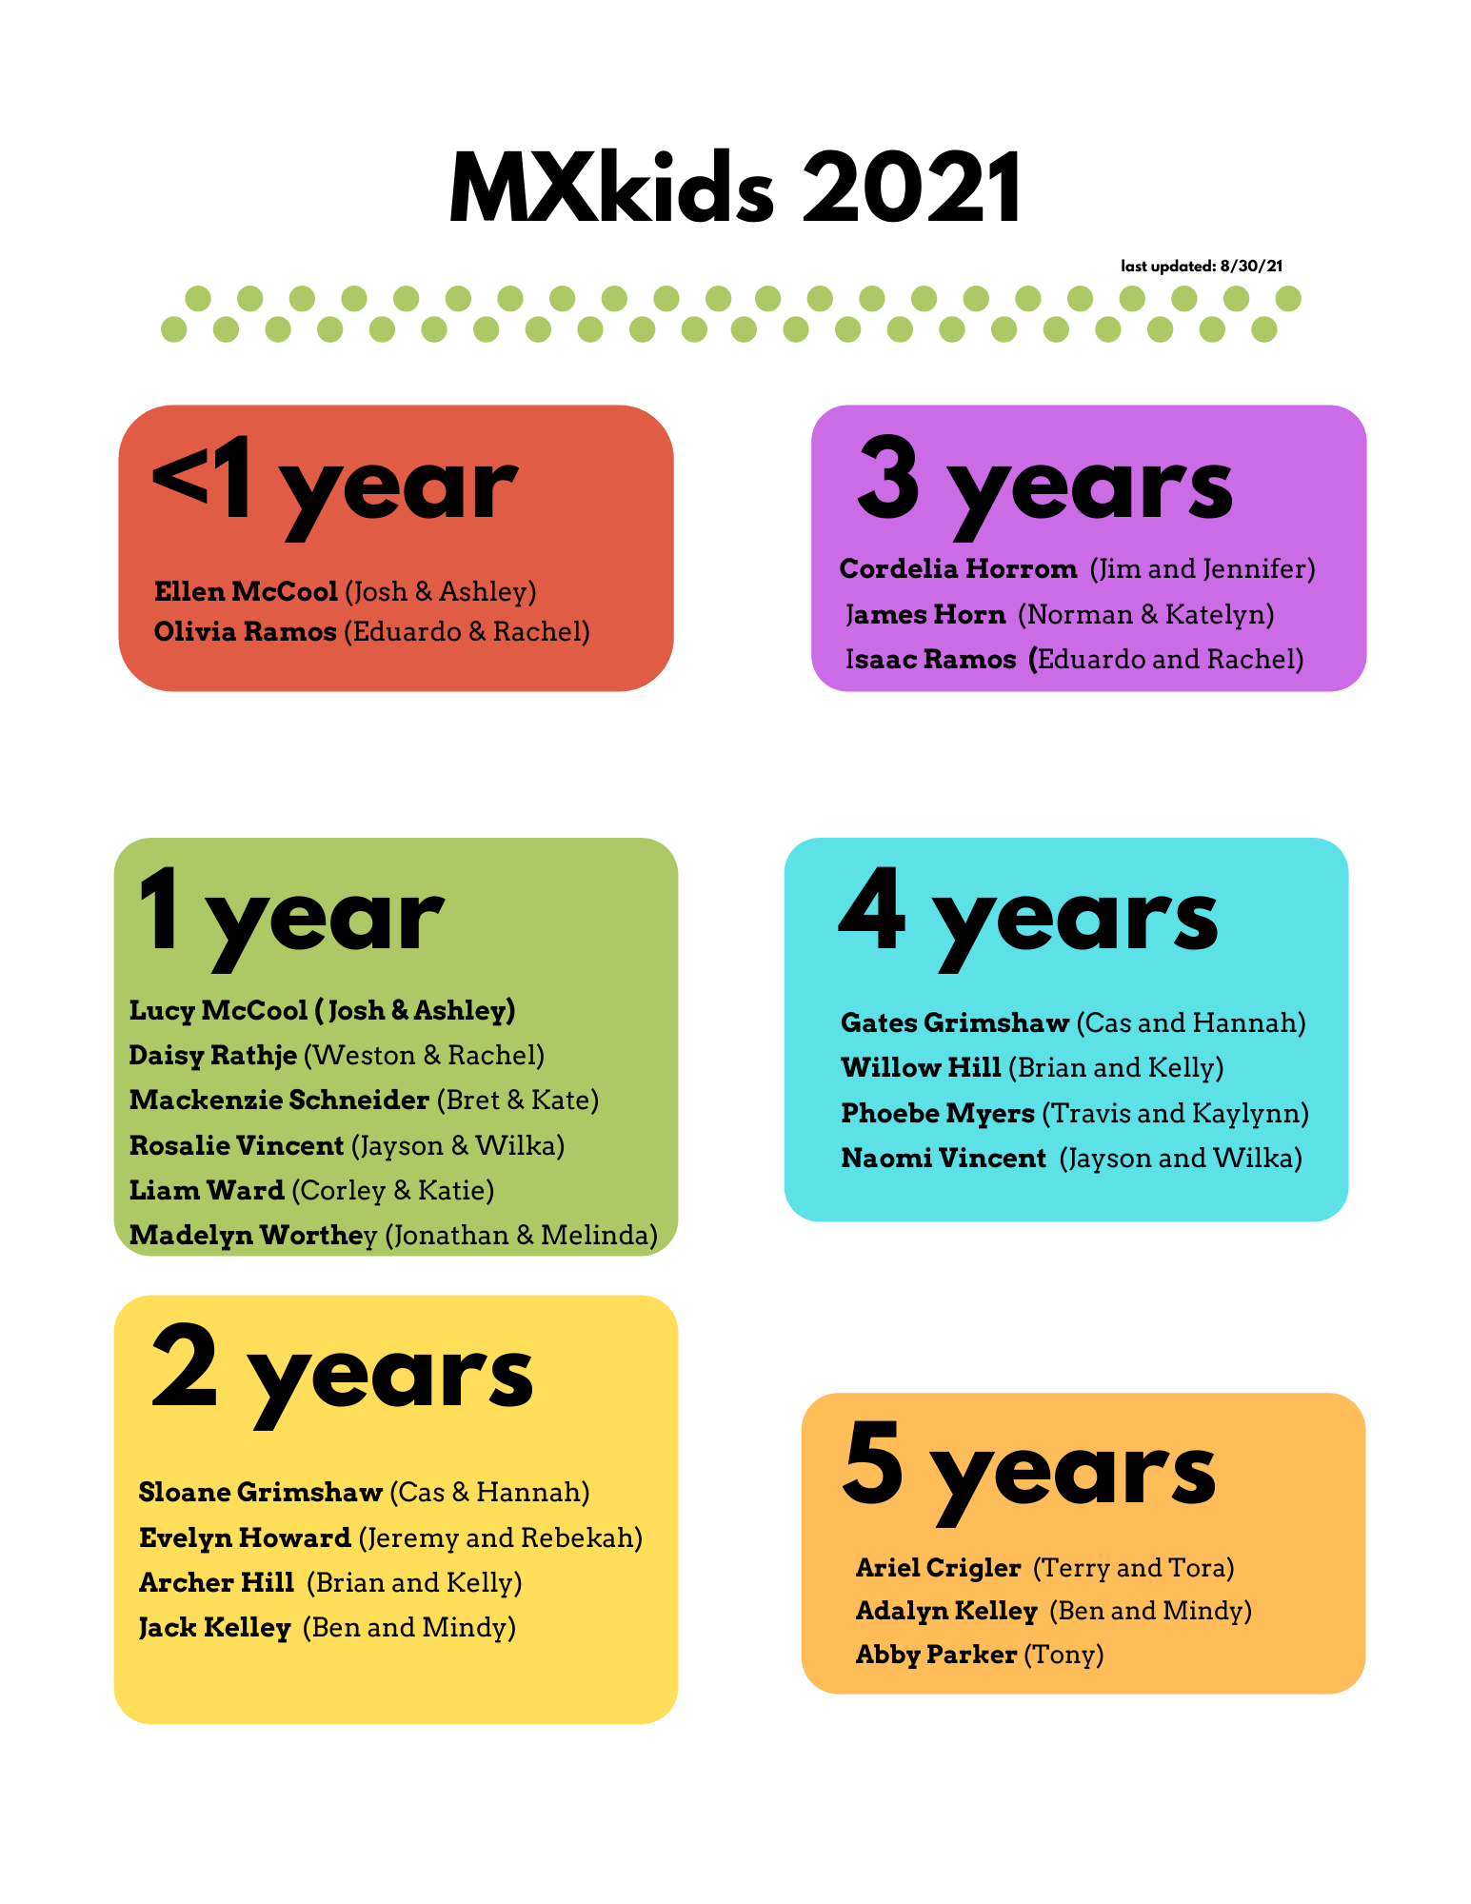

**Attachment C.2**

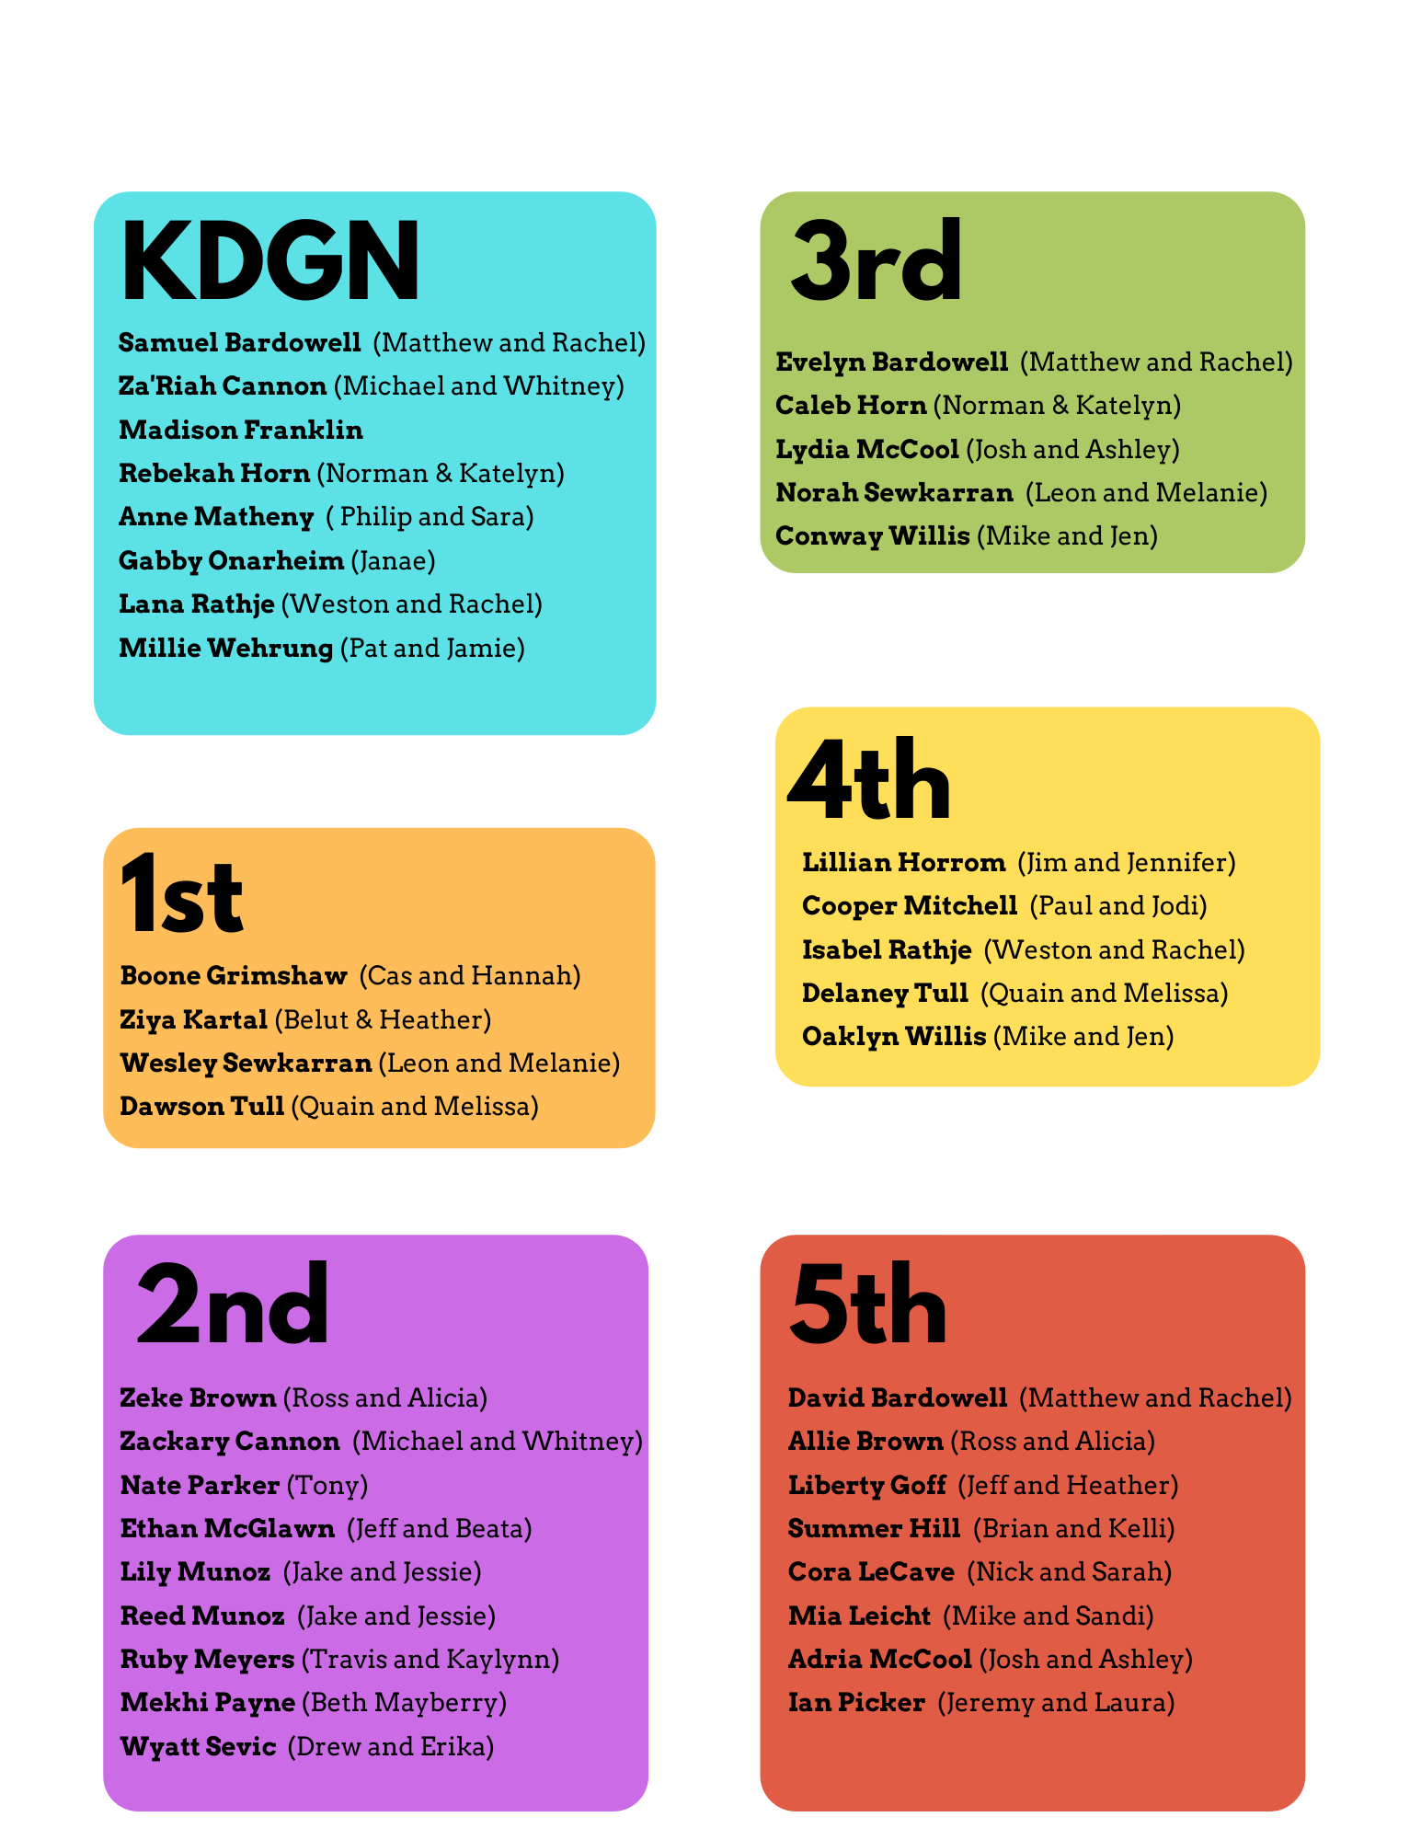

**Attachment D**

Elder’s Meeting Report **8/30/21**

**MXYG - Michalie Brown**

***REGULAR PROGRAMMING***

**SUNDAY CLASS** | *4th Floor*

* We will be studying the same things as “big church”.
* About once a month we will join the main service.

**YOUTH GROUP** | *Wednesdays from 6:30-8*

* **SEPT -** Rad: A series on the book of James and loving others
* **OCT -**  I have Questions: Old Testament study on doubts and questions
* **NOV** **-** With You: Series on Friendship
* **DEC -** Good Things: Old Testament and Gospels on Christmas

**THEO** | *Alternating Tuesdays from 6:30-8*

* ***Sept. 14 and 28 | Oct. 12 and 26 | Nov. 9 and 30 | Dec. 14***
* Possibly Acts?

**SLT** | *Alternating Tuesdays from 6:30-8*

* ***Sept. 7 and 21 | Oct. 5 and 19 | Nov. 2 and 16 | Dec. 7***
* Still deciding on deep study. Recommendations welcome.

***SPECIAL EVENTS***

* **SEPT. 10-12** | *Poplar Bluff Service Trip*
* **SEPT. 25** | *Middle School Guy’s Night at the Blackford’s*
* **OCT. 15** | *Bonfire at the Patterson’s*
* **OCT. 16** | *Middle School Girls Night at the Picker’s*
* **NOV. 12-14** | *REFUGE*
* **NOV. 20** | *Ladies Exercise and Coffee with Elizabeth McPherson*
* **DEC. 17 or 18** | *High School Christmas Party at the Beauchamp’s*
* **DEC. ??** | *Middle School Christmas Party at the Goff’s*
* **TBD** | *Encounter Worship Night (Area Wide Event)*
* **TBD** | *Rock Climbing? (Or other recreation event)*
* **TBD** | *Open Gym / Games*
* **TBD** | *High School Guys Night at Beauchamp’s*
* **TBD** | *High School Girls Night at McGlawn’s*

***THINGS TO KNOW***

* New Small Groups! Each school year, we break out into new small groups. This year, we have Busted Forces, The Seals, and Healthy Circle. They will stay in these groups for the whole school year, and have the opportunity to accumulate points from our games and scripture memory opportunities. The purpose of small groups is to get students more intimately connected with people they may not naturally gravitate to. Each week, they share about their life and have the opportunity to discuss the lessons in depth. Each small group is led by 3 high school SLT leaders.
* We will not be attending Winterfest this year. Instead, we will take the middle school to “Believe” and we will do a DIY High School weekend Retreat at either Lake of the Ozarks or in Branson (unless I can find a better suited High School Conference before then).

***WHAT I NEED FROM THE ELDERS***

* Professional:
  + Teachers - Right now, I am teaching 3 times a week. Sunday, Theo/SLT and Wednesdays. Who can I bring in to help me? Will you help me?
  + Mentors - Who can take our students out to lunch? Studies recommend that students need 5 adults (besides their parents) pouring into them.
  + Classes - We need teachers for MXkids to be able to resume classes!
* Personal:
  + Friends my age! :) I see a gap in our young adult age group, and as I think about the longevity of my time at McKnight - this is something I’m worried about.

***PRAYER REQUESTS***

* **For our students**:
  + That they will make their relationship with God a priority, that they will take a look at their own lives and make the changes that Christ calls us to make. That they will be inclusive of each other, and that they will allow the gospel to transform them a little more each day.
* **For me** - That I lead with intentionality and prioritize Kingdom work over program work.
* **For our volunteers** - we are so thankful for them!
  + For future volunteers - that God would bring us the right people!
* **For our spring semester** - that I will plan it with direction and intention, listening to the direction of the Holy Spirit.

**NOTE: Excel spreadsheet of current student list attached:**



**Attachment E**

**Office Visit - Elder Rotation for Brief Office Visit and /or Lunch / Coffee with the Staff**

Yahoo/Inbox

**Jeff Kryder** <jkryder@mcknightcrossings.org>

**To:**Brad Stevens (work),Dave & Amy Weiler,Glenn Davania,Jeff Kryder,Keaton Jonesand 9 more...

**Cc:**Dolores Miller

Tue, Aug 31 at 11:34 AM

**Office Visit -Elder Rotation for Brief Office Visit and /or Lunch / Coffee with the Staff**

* The assigned day will be Tuesday, if possible, as the staff are at the offices on this day.  There is a Next Gen Meeting in the morning at 10:30, and the entire Staff meets at 1:30.
* See your visit as a call of encouragement.
* Could feel a bit awkward initially.
* Can be brief.
* Check on how the staff is doing personally, what they are working on, what support they need, and offer a prayer and / or a Scripture.
* The Ministry Staff (Jeremy, Heather, Michalie, Jeff, and sometimes Jeannie) generally have more flexibility to grab a coffee or lunch, than the administrative staff (Elizabeth, Dolores, Tom, and sometimes Jeannie), if you are inclined to go out.
* Can try to touch base with everyone who is there, or if the Spirit leads, take a few extra minutes with one or two.
* Making a pastoral call on a member along with a staff person earns extra credit!

Here is the list and your initial date.  Contact Dolores if you need to select another date.

Sep 7 - Keaton Jones

Sep 14 - Don Fitzgerald

Sep 21 - Glenn Davania

Sep 28 - Bret Blackford

Oct 5 - Lane Hamm

Oct 12 - Steve Haupt

Oct 16 - Wole Okunade

Oct 26 - Dave Weiler

Nov 2 - Steve Walker

Nov 9 - Steve Awtrey

Better Together,

Jeff

--

**Jeff Kryder**

**Senior Minister**

**McKnight Crossings Church of Christ**

**Attachment F**

**CONFiDENTiAL**

Jeff Kryder’s Annual Review with Steve Walker and Dave Weiler

**August 20, 2021** (should typically happen in February each year after other staff reviews are completed)

We had a very healthy and wide ranging conversation over lunch at Breadco.

**SUMMARY**:

* Jeff’s devotional life is solid and he enjoys many aspects of his core responsibilities. His duties are very broad, touching multiple areas of ministry at MX. He and his gifts are valued and respected.
* Jeff primarily desires to see “fruit bearing” in people’s lives. He is energized by the prospect of doing a leadership development class and leadership mentoring.
* Jeff’s position is draining and he is feeling increased negative thoughts and depression. Exercise helps, but he has not found a solution to the weighty and ongoing burden he feels as Senior Minister and primary preacher at MX.
* Jeff is concerned with how much longer he can or should continue “as is”. He feels he has more to give to ministry at MX, but perhaps not as the Senior Minister?
* Jeff turns 62 in November 2021, and would welcome an exploration of transition of duties and/or ultimate retirement.

**ACTION ITEMS:**

* Jeff will seek out a Spiritual Director (his own suggestion).
* Jeff will explore a sabbatical as proposed by Steve Awtrey.
* Jeff will end his leadership of his small group. He has been leading for approx. 10 years.
* Jeff will end his leadership of the Area Ministers Meetings. He has been leading for approx. 10 years, they are currently paused.
* Invite Elders to attend the weekly MX staff meetings – perhaps a monthly rotation.
* MX will begin to work on a plan that is healthy for both Jeff and MX to move toward Jeff’s retirement. Can that plan be transitional? gradual? flexible? confidential?