**MX Shepherds Meeting**

February 07, 2022

Attendees: Brad Stevens (chair), Wole Okunade, Jon Earnhart, Bret Blackford (notes), Keaton Jones, Don Fitzgerald, Steve Awtrey

1. Lane and Steve Awtrey

**Jeremy, and Michalie attended first part of meeting to discuss all things involved with the youth group including:**

**Attachments A** & **B** addresses the following:

* Plans through the end of the summer
* Jeremy as the interim youth minister
* Jeremy as a candidate for the full time youth minister (not discussed)
* Summer intern(s)
* Formation of youth group committee

Jeremy discussed some “Faith in Action” possibilities:

* Meeting 2/8 with adult care facility by MX to discuss service/volunteer projects
* Looking to partner with Webster Rock Hill Ministries - <http://wrhm.org/>
* Bread Shed in Polar Bluff - <https://www.breadshed.org/>. Sometime mid-week in summer
* Colorado – talking with Terry Bartlough (?) about a possible YG trip

Jeremy looking into two interns for the summer

Feb 27 is a parent meeting to discuss the above items

Youth Ministry search committee – still being formed.

2. Bret Blackford

**Safety team update** including members who would still be involved, how we might revise it, and discuss if really still needed

Bret Blackford is working with Jon Earnhart on updating the security procedures and utilizing technology to provide adequate safety for Sunday. More detail to come when initial changes get discussed and tested.

3.  Bret Blackford

**Live streaming issues**. Had more problems again last Sunday (01/30/2022).

Jeremy Picker and Bret Blackford continue to work on the reliability of the Sunday live-stream. The quality of the livestream will be addressed later. A few things that are in the works:

* Jeremy will be migrating our hosting site from Facebook to YouTube in hopes of finding a more stable and user accessible platform.
* Bret will work with Jeremy to hard-wire the Sunday equipment to the network instead of using wifi. This should add more reliability to the network connectivity and reduce any possible wifi disruptions.
* Level-set expectations: Live streaming will never be perfect and we should expect some hiccup about every 1 in 15 Sundays (about 1 Sunday a quarter). These hiccups could be due to our streaming platform (YouTube/Facebook), our computers, our streaming software or our on-site streaming hardware (SlingStudio Hub).
* End-User Issues: It is difficult to diagnose live stream issues on a Sunday. Often we will have some viewers complain while others have a fine experience. This usually indicates the issue is on the end-user side. It could be due to bad internet connection, old equipment, or a number of other issues.

4.  Steve Awtrey and Don Fitzgerald

**McKnight staffing next steps (using Dale Robinsons as consultant)**

Steve Awtrey and Don Fitzgerald have reached out to Dale Robinson about consulting services. They will follow-up with Dale and discuss a formal engagement to have Dale evaluate the current staffing and provide recommendations to the MX elders.

NOTE: As elders we discussed that we should only bring in a consultant if we were ready to acts on feedback, including staff realignments. All elders agree.

5.  Lane Hamm

**Comments on staff review and personal observations**

(There was much general discussion amongst the elders on this topic which is difficult to summarize in my notes. The elders expressed concern and discussed the individual members of the staff as well as the overall effectiveness of the staff).

Lane met with each of the staff (with the exception of Jeff Kryder, who was evaluated earlier by Dave Weiler and Steve Walker).

A few key takeaways:

* Staff are generally happy
* Staff work independently with very little teamwork. Staff stay in their lanes with limited collaboration.
* Most of the staff is self-directed. That is, they work on areas they feel are important.
* Communication between ministry and office staff lacking. (Minitry: Jeff K., Jeremy P., Heather G., Michalie B. | Staff: Elizabeth M., Jeannie B., Dolores M., Tom H.)
* Jeff Kryder may be an excellent preacher and teacher but seems ill suited as a Senior Minister with responsibilities for leading staff and administration.

6. Steve Walker (absent)

**Children’s minister update**

* Search committee still being formed

7. **New Business**???

* Prayer concerns were discussed along with some life changes for Steve Awtrey and Lane Hamm.
* Reminder that **Jeff Kryder will return from sabbatical on February 14**.

8. **Items for discussion at next meeting** Feb 15 at 6:00pm.

* Steve Haupt to chair Feb meetings
* Dave Weiler to chair March meetings
* Elders will continue to lead these elder meetings. Jeff Kryder will be invited to attend but nor expected to chair or set agenda

1. How to reconnect members who have been absent

2. Church governance

3. **Jeff Kryder sabbatical comments and 3 year plan**

**Below from the 08.30.2021 mtg. notes** (See **Attachment F**)

Dave Weiler and Steve Walker met with Jeff Kryder - discussed annual review/evaluation (See **Attachment F**)

* Ideally, Jeff Kryder would like to be in a Leadership Development role that would include at times preaching (not weekly).
* “MX would be blessed by Leadership Development” - Dave Weiler
* Jeff Kryder to bring a proposal to the Elders.
* As the Elders, what is our vision for Jeff’s replacement?

4. AJ send off in May

5. Glen Davania recognition / Jon Earnhardt apprenticeship

**Attachment A**

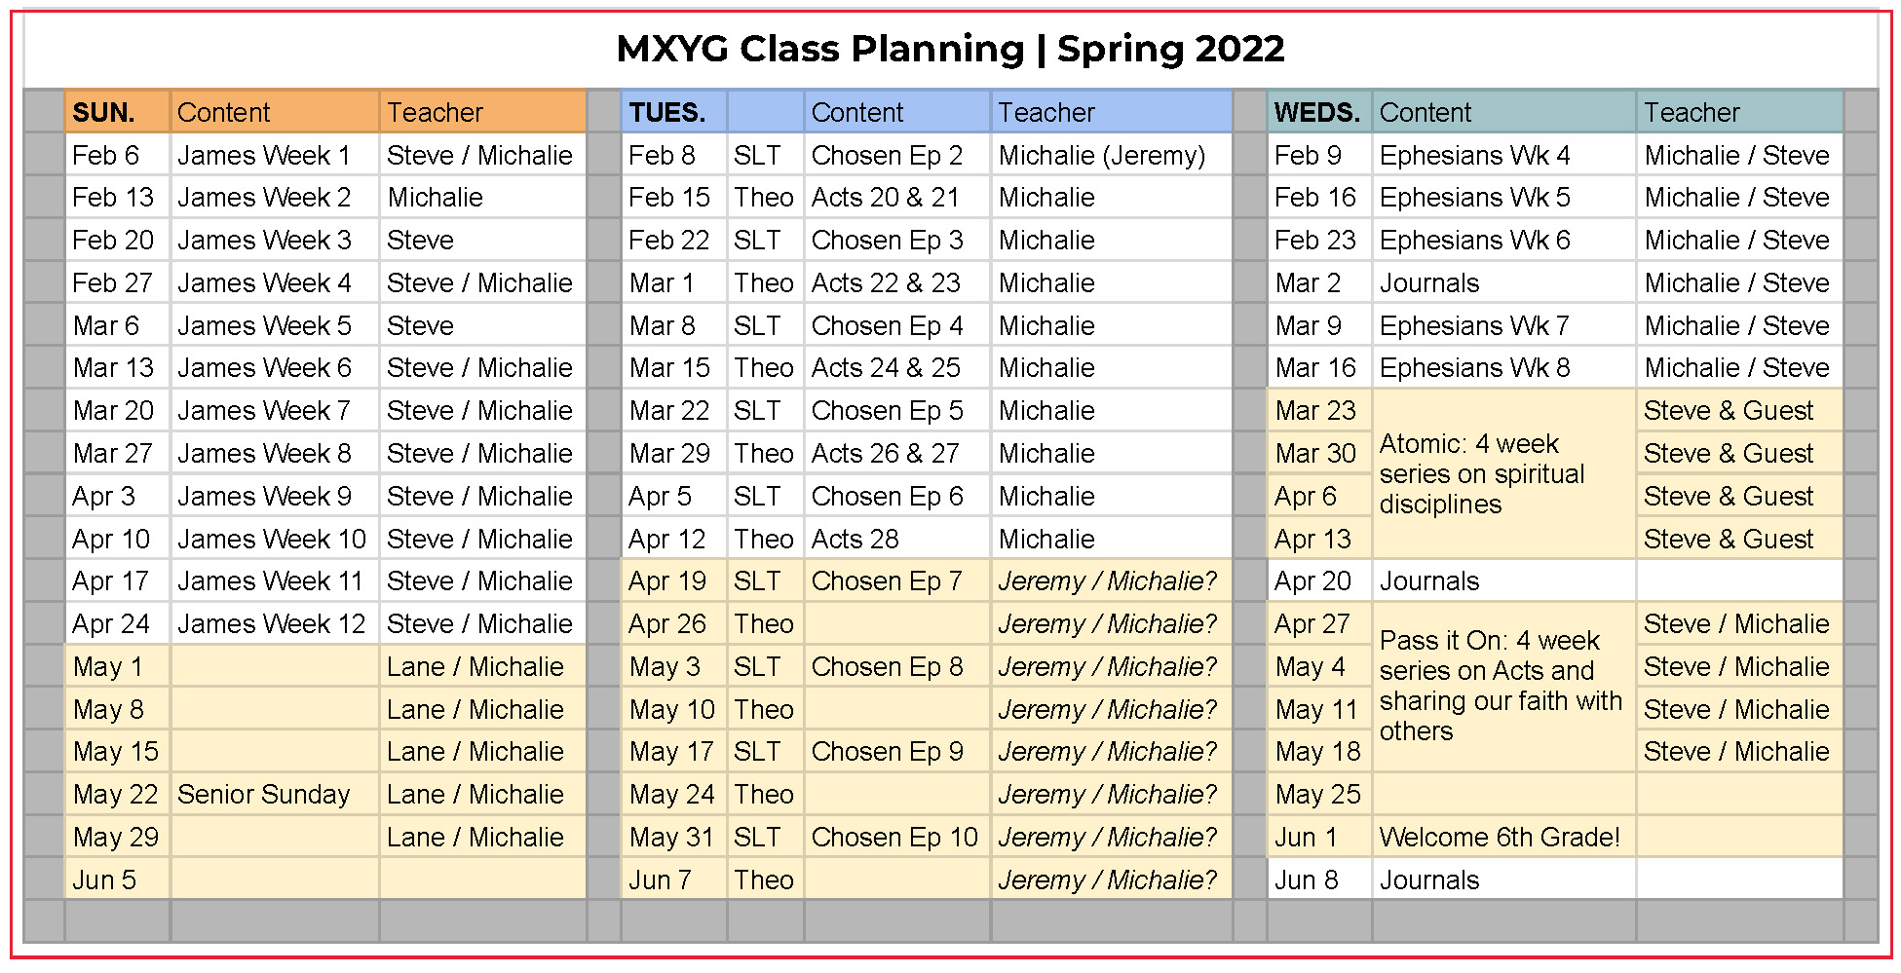

**Attachment B**

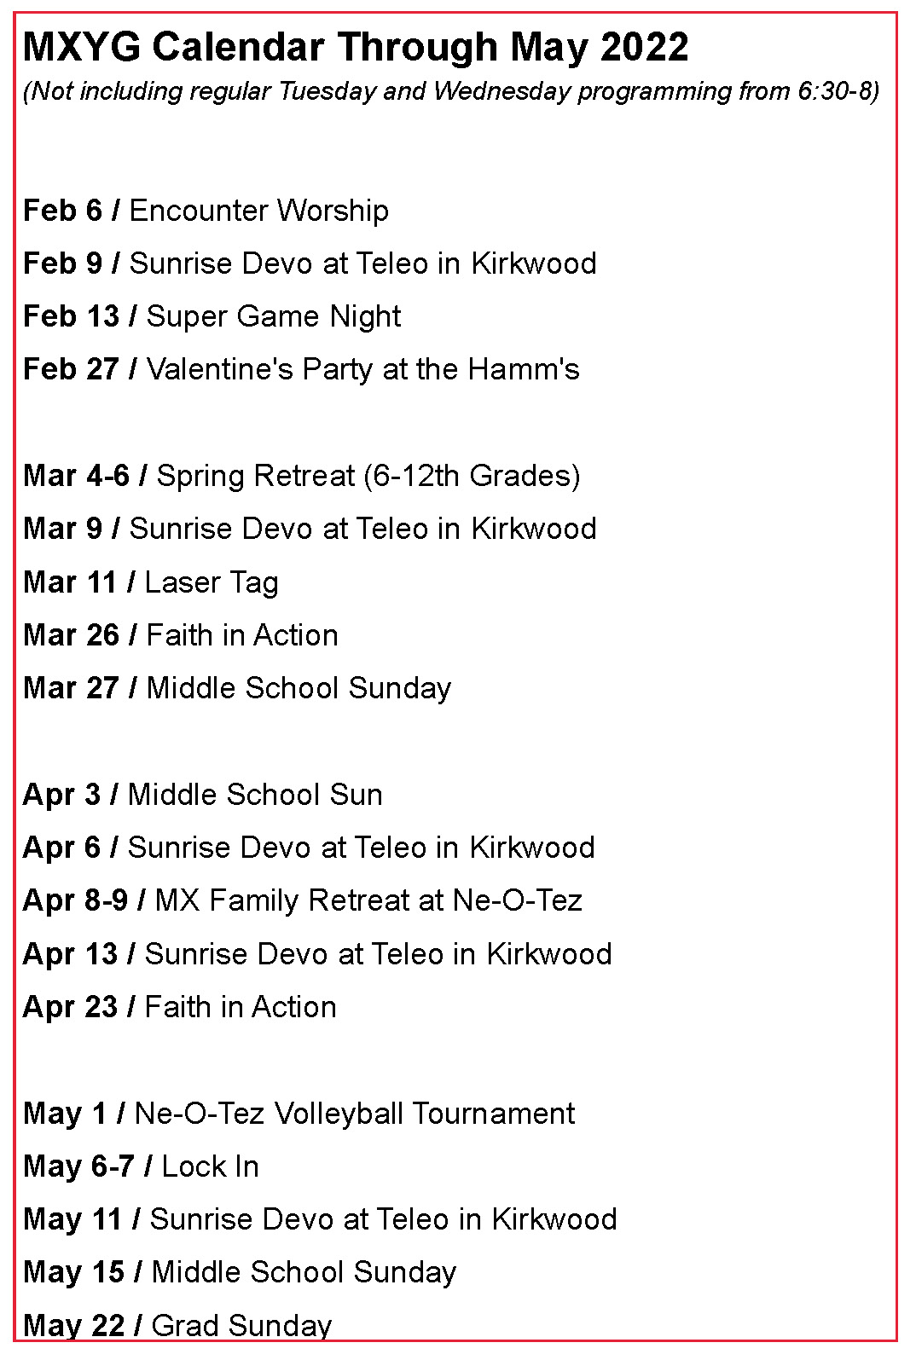

Below from the 08.30.2021 mtg. notes

