Senior Minister Search
Candidate – John Blackmore
March 2025

Contents
Contact with Candidate: 11
Section 1: Sermon and Teaching – How engaging and relevant was the sermon? 11
Section 1: Sermon and Teaching - Was the message clear and biblically sound? 13
Section 2: Connection with the Congregation - How well did the candidate relate to different groups in our church? 14
Section 2: Connection with the Congregation - Was the candidate approachable and personable? 15
Section 3: Overall Impression - Do you feel the candidate would be a good fit for our church? 16
Additional Thoughts or Concerns 17
Excel Spreadsheet of Google Form Survey 17
Follow-up letter from John Blackmore 18
First for the entire church 18
For the Shepherding couples 18

Bio:
John currently lives in Sullivan, Missouri with his wife, Laura, and has two adult sons.
- Resume - here
- Cover Letter - here
- Sermons - here

McKnight Sermon:
John Blackmore preached to the McKnight Crossings Sunday church on, March 9, 2025. The sermon was on “Know Your Mission”, and the video is available on YouTube here - https://www.youtube.com/watch?v=tF7vjMZmq60&t .

John Blackmore – Verbal/Email Feedback Summary
March 9 weekend feedback

Below are comments received verbally or via email (not collected on survey form - https://docs.google.com/forms/d/1eNnW5VTXMVsrVmduWoZNZu-O9PEMKlVM8NBETgFs8sk/edit .

From | Comments
Matthew Bardowell | Dear Elders,  I wanted to send you an email to express my thoughts on John Blackmore. I urge you not to offer John the lead minister position.  I was with the kids during the sermon, but I have now listened to his sermon on YouTube. I did attend his Sunday School Class, and I spoke with him afterwards to ask a few questions. I like John as a person, and, of course, I regard him as a brother in Christ. But I think it's important to separate that from whether he is the right fit for our church. And I don't believe he is the right fit.  I would love to get together with you all, to discuss my thoughts in more depth, but for now, let me offer the following outline of my concerns.  1. His sermon showed a lack of discipline. At this stage in a minister's career, I would expect a fairly well-structured presentation of the gospel with some particular focus. There was a good deal of wandering and rambling and a fair bit of self-indulgence in the extemporaneous manner of his delivery. We want a lead minister who can offer a message that is compelling to visitors and edifying to the body of Christ. Based on his presentation, I don't think we could reasonably expect this if we were to hire him. As I'm sure you know, people are usually on their very best behavior in an interview setting. The length of John's sermon and class show, at best, a lack of discipline and, at worst, a concerning lack of humility to modify his approach to suit the needs of our congregation. John seemed to be aware that he goes long; he just didn't seem to care. It's this disregard that concerns me about his ability to humbly accept parameters.  2. His Sermon and Sunday School class raised some cultural red flags. I spoke to a few of you to ask whether John would be comfortable with the way we do things at MX, specifically meaning the ways MX differs from other Churches of Christ. The folks I spoke with assured me that he would be fine, but John said some things that gave me reservations about how well he would fit within the culture of our congregation. First, I would ask him directly whether he believes that the decision the church has reached on women's roles is an error. In his Sunday School class, he framed our stance of women's roles as "something you are working through." I don't think this is accurate. It is a decision this church has made after study and prayer. Yes, we are open to the promptings of the Spirit on matters we feel are decided, but I felt it was disingenuous to frame our stance on women's roles as something in progress, and it may hint that he hopes we are malleable enough for him to shape as he deems right.  In his sermon, he expressed sadness that we were three generations out from being a Christian nation. By this, he seemed to mean that we have drifted from God's ways in the past three generations, when cultural Christianity was prevalent. But we must be clear-eyed on this point. Cultural Christianity is not necessarily true Christianity. What was happening in this nation three generations ago? I doubt that those who had to eat in segregated restaurants would say that they lived in a Christian nation. This mentality is concerning because it longs for a past that looked like Mayberry. A past in which most people went to church on Sundays but could maintain their petty prejudices under the sanction of the church. We must look forward, not backwards. Either John has embraced this idea or he is unaware of the implications. Whatever the case, it makes him poorly suited to lead our congregation.  For these reasons, I don't think John is the right candidate to lead MX into the future. In the coming years, we, as a church, will no doubt be faced with many challenges. We need someone with a clear-eyed awareness of those challenges and someone who is equipped to lead us through them. I also want to say that, in my view, we had three excellent candidates for this position who sadly turned it down. I did not have these reservations about any of those candidates. I truly felt that we could not really have gone wrong in deciding between the last two candidates. I feel that we can go wrong here, and I would not approach you with these concerns if I didn't feel they were significant.  Let me close by saying how grateful I am to each of you. I know this has been a hard job. I know the road to finding a new minister has been bumpy and that there have been many setbacks. I imagine that everyone is ready to be finished with this job search. I hope that we as a church do not become desperate. Stay the course. Stay true to your vision for this position. God will meet this need. Please know that I am here and willing to help as needs arise.  Please let me know if you would like to meet to discuss this further. I'd be happy to speak with you.  Love you guys,  Matthew
Steve Jones | We listened to John’s sermon driving home from Ozark MO today. Almost made it to St Charles before he wrapped it up!😜  Sounded good and I didn’t fall asleep at the wheel but per his comment maybe we need a clock in auditorium.  I’m a little concerned about his age as I’m sure you don’t want to be searching again in a few years. Is he willing to move and is he in our price range?
Jayson Vincent | On Mar 9, 2025, at 7:03 PM, Jayson Vincent <Jayson.t.vincent@gmail.com> wrote:  ﻿Thank you very much Brother Steve's (Walker & Awtrey) for the efforts to plan, invite, support, pray & more for the senior minister search, and for welcoming John & Laura this weekend.  We especially appreciate the opportunity for Wilka & I both to join, which required us bringing Naomi & Rosalie.  The way that John was willing to listen & apologize and dialogue after Gwen's thoughts was a highlight for us. Listening and adjusting are vital for our next servant in that role. There was also a great example set (for Jayson) in supporting my wife in a scenario such as yesterday. Thank you for that, always learning from you guys.  We also valued their flexibility & willingness to follow God as missionaries. And we valued their interest in continuing to participate in missions.  And we highly valued their focus on God's mission and God's word as a priority and a uniter, and we valued that they team together.  We thought it was a great sign that John acknowledged that someone like Nathan will have a better idea about how to reach more individuals his age than he himself would, and his willingness to do church differently if the next generation so leads so, and as a good thing.  We thought it was a great sign that Laura had already identified and spent time in the French organization a few miles away from MX.  There are experiences and perspectives that he is unable to fully understand or relate to, and he has that in common with many, and we felt his openness to learning & listening is likely. I think for all of us, there are experiences and perspectives that we can't understand or relate to. I feel that yourself and others already know this, but for us, as we grow older and reflect on our own experiences, we are learning this more & more. A minister's opportunity in this is to value relationships and to believe in the loving & saving & transforming power of Jesus, His Spirit, and His gospel. It's difficult to find a perfect candidate in this (rather, impossible) but we felt good about their chances.  We our sharing that we would support John joining as senior minister at mx.  We imagine you're processing thoughts from lots of members, and we appreciate your time on reading ours, as well as on all the leadership and service you guys continue to provide.  We're excited about where God's Spirit leads you, no matter what.  Alongside in prayer and in Christ,  Jayson & Wilka Vincent
Suzanne Kaelble | Hi Dave and all the elders,  I am wanting to give my response, for lack of a better word, to watching the service on YouTube this morning. I appreciated his enthusiasm. He seems to have a heart for missions. A couple things caused concern. I was confused by if he is very familiar with churches of Christ. He seemed to be coming from some kind of musical void with his reaction to the congregational singing. First he was surprised we had a piano (which would be a normal response from someone raised in a church of Christ) but then he didn’t seem familiar w the 4-part harmony of “Love One Another”. I didn’t sense any kind of appreciation on his part for the beauty of the song.  Probably what concerned me the most was his use of the phrase “evangelical Christian ”. In no way do I consider myself to be a part of what, in our country, is currently the evangelical Christians. To me, a person who calls himself or herself an evangelical Christian, implies a group of people that support a different picture of who I see the person of Jesus as being.  I also basically had some difficulty following the sermon. I know he prefaced it by saying he only had this one opportunity to say everything he wanted to say, so he certainly said a lot. He bounced around a lot with his topics.  I put a quote from Harriet Stowe on Facebook a while back. It said, paraphrased: I don’t know much about politics. What I read in my bible is I’m to care for the sick, the poor, the imprisoned. That’s the Bible I follow.  I know that you all were able to get a more well-rounded feel for him. I’m not comfortable with the possibility of him as the lead preacher for McKnight Crossings church of Christ based on his sermon today.  I don’t know if I expressed my reasons very clearly but I can’t think of any other way to say them.  Because God loves us all,  Suzanne Kaelble
Andy Clapper | Hi Elders,  Thanks for hosting a wonderful set of opportunities for the MX Congregation to hear from the new Minister candidate. As a part of the MX church, we felt it our responsibility to provide our feedback for your consideration:  Firstly, we enjoyed learning that John has St. Louis roots and is committed to the health of our metro area. That being said, we found John's message regarding the core principle of "missions" to be a bit convoluted, and it raised concerns about his approach to future Services and as the "face" of the Church. Despite preaching for ~50 minutes and covering scripture from Genesis to Revelations, we left the auditorium feeling a little bit lost as to how John would lead our church in the principle he chose to showcase for his interview. We were disappointed that as a missionary of 10 years, he really didn't share much about his experience and how he would apply those lessons to McKnight's congregation. To put it plainly, John didn't really show us the vulnerability I would have expected him to demonstrate in this opportunity, and it concerned us with how he'll connect with the congregation as a whole. Additionally, some of the things that he said seemed either culturally insensitive or less aware than we would expect for the congregation that MX has.  We are really excited about the potential to fill this role, and we know it has been a long road. However, this specific candidate does not "feel like McKnight" to us. Certain elements of John's presentation referenced very legalistic interpretations of the scripture, and used third party experiences (rather than personal ones) to make points. Although none of that is necessarily a bad thing, it does raise additional questions for us about ability to connect with other and fit inot the culture of community in the Service that the Church has worked so hard to foster.  I'm sure if John is selected for the role that we will grow to know and love his approach, but with this very limited exposure and the importance of the decision, we thought it prudent to share our thoughts.  Thanks,  Andy & Grace
Rachel Bardowell | Dear Elders,  I wanted to provide some feedback on the minister candidate. Firstly, thank you for your tireless efforts during the search process as I know it has gone on for longer than anticipated. I also appreciate your willingness to receive and consider the perspectives of various members. Our small group has been praying consistently for you all and about the process since we heard of Jeff’s plans to retire. I would like to share some concerns, however, that I have about this candidate that I did not have for any of the prior candidates.  I would like to start with the elephant in the room, which was the length of both the sermon and the class. Matthew and I were with the kids that day and I was surprised to hear him mention within his opening remarks when I went back to listen to the sermon, that he thought the people with the kids wouldn’t be happy with him. This tells me that he has chronic issues with time management in his speaking- which he has insight to, but after years of experience has not developed the skills to focus his remarks. This communicates, perhaps unintentionally, a lack respect for other people’s time or an inability to heed instructions. As an additional example, during class time, I recall Steve Walker telling him we could take 20 minutes for class since we were running late, but John again continued for twice this amount of time.  There were some remarks during the sermon that also made me question whether he would be the right choice for our congregation. The first of these remarks was about men being the head of the household, which lacked nuance. He made one or two other remarks that were more subtle that made me wonder if he was aligned with our practice and conclusions about how women serve in the church. I would request that you ask him directly about his opinions on this matter if this has not been discussed already. Other remarks that made me concerned that he would not be a good fit for our church included several negative comments about other denominations. I have always loved that we have welcomed members from different denominational backgrounds which I think has been in part because we have avoided sectarian rhetoric. Some of his comments about people attending church less in the modern day could have been viewed as romanticizing mid century American Christianity which is problematic in a city with deep racial injustices such as St Louis.  Overall, I doubt that John would be the right person to help us grow at this time in our history. I thought he was very friendly and is someone I would enjoy speaking to about his life experiences and I respect him as my brother in Christ. I appreciate the chance to candidly share my concerns, I will be praying for the process and your decisions.  Rachel
Steve Haupt | Hi guys,  If I was still an elder, he’d be starting next week. Lots of pluses:  - Scriptural lesson (easy to listen to and understand)  - Good presentation (spoke to us instead of at us)  - Outgoing and personable  - Plenty of experience  - Lives close by so is familiar and comfortable with this area of country  - He’s available and wants the job  - He’s affordable I’m assuming  - He can start soon  - His wife is “very” personable  - He has enough energy for 5+ more years  He’s not perfect….who is?  If there is an absolutely perfect candidate, he’s not available or affordable.  For as long as you’ve been actively looking, I believe you finally found the best candidate for McKnight.  Good job; now close the deal and move onto something easier🤪.  Blessings,  Steve
Glenda Smith | I felt that the first 20 to 25 minutes of his sermon was very good, but unfortunately after that my attention span is gone. If his normal sermons are that long, I am not in favor of hiring him.
Betty Vaughn | To: Elders of MX Church  From: Betty Vaughn  Date: March 14, 2025  Re: John Blackmore  I have spent a lot of time thinking and praying about John as lead minister at MX Church. I was unsettled after listening to John’s sermon and attending the class on Sunday morning. I needed to know if this was the norm for John’s teaching and preaching. Steve Walker kindly provided me with the link so I could listen to more of John’s sermons. I have listened to several of his sermons over the last couple of days so I could form a more knowledgeable opinion.  John and Laura are a very likeable, warm, and approachable couple. John certainly knows Bible book, chapter, and verse. He is confident in his Bible knowledge, and on Saturday evening stated he felt like he had more to tell. I love that they are so mission minded and want to take the gospel wherever they go.  These are my concerns:  · The sermon on Sunday morning was long.  o John did not honor the time frame we work with at MX.  § He made the comment about being on bonus time but the only ones who would be unhappy were those with the kids.  § The sermon ran over into the class time. By the time he got started, there were only ten minutes left for the class. Again, he disregarded the time and continued.  o When I listened to the sermons online, there were several that ran 45 minutes or longer.  § The impression I got from the sermons were that Bible class was before the sermon, so he did not have a set end time for his sermons.  · The points of the sermon were good. This was a message that needs to be heard. But this is what I have noticed in all the sermons I listened to:  o There is a, for lack of a better word, sameness about his sermons. That is not to say they are bad or lack good points.  o His sermons tend to lean on the ‘horizontal’ relationships and very little on the ‘vertical’ relationship.  § I have not heard the words grace, mercy, or trust in his sermons.  § He provides a lot of scripture, but the application is just words to me…not connected to the Holy Spirit helping, guiding, or leading in truth.  · John uses humor a lot in his sermons. That is not bad. We all need to have a sense of humor. Sometimes his remarks seemed a bit flippant to me.  · In listening to the sermon Sunday and online, I felt transported back to my days at the DeSoto Church of Christ where I heard a lot from Paul but nothing about grace. It was all about making me a better person by what I did and how I acted. Of course, that is important. But again, we need the vertical. How do we allow Jesus to transform us? It is by his Spirit and not by our own.  o I eventually left the DeSoto Church with negative feelings and many questions that went unanswered until God planted me at McKnight in January 2008. I had a new life breathed into my spirit. When McKnight and Mid County merged, things were even better. Spiritually, I would never be where I am now if I had stayed at DeSoto. Years later Richard and I visited there. Again, I felt transported back in time.  I understand this has been a difficult journey for all of you. I continue to pray for your physical, emotional, and spiritual well-being. I pray for you to be filled with wisdom from the Holy Spirit as you make your decision.  I am a ‘glass half full” gal. But I cannot see John being a good fit at MX. There are too many at MX who have evolved beyond the ‘horizontal’ relationship messages. They are good to hear periodically but not as a message in some form every Sunday. I am not sure I would be ‘spiritually fed’ if John were hired as lead minister at MX.
Becky Kryder | Dear Elders,  Sending you my thoughts on our latest minister candidate, John Blackmore.  I am a definite "No" on his candidacy.  Although I believe he is a good guy, I feel that he would be a better fit at a more conservative, perhaps more rural church. From our Saturday night Question and Answer Time to his inordinately long sermon, I had glimpses into his theology and was uncomfortable with what felt like "a mile wide and an inch deep" thoughts. Much of what he referenced seemed to come out of the 90's. As far as connecting to and leading the Next Gen, I do not believe John has the qualities to accomplish that mission.  I thank you for the slow and sometimes painful work of seeking out a new lead minister, but let's not settle.  Please continue the search.  Thank you.  Becky Kryder
Jeff Kryder | Dear Elders,  Thank you for staying the course on the Lead Minister search! I am aware that you have given countless meetings and weekends in pursuit of the right guy. While we were warned that it could be a hard road, still most of us would have thought we would have solved the riddle by now.  McKnight is a wonderful church. We are a place that has moved forward with women's roles, has Shepherding Couples, freely uses instrumental music, has an active Children's and Teens Ministry, a diverse multi-ethnic background of people, an outstanding facility, in the heart of one of America's great unchurched cities. We are a terrific opportunity for the right minister!  More immediately, I liked John Blackmore and his wife, Laura, as persons. I like his love for evangelism and his indicators that he was good with people; though I did not necessarily witness a strong "awareness of the other" in his 1-1 interactions.  While I believe he is intelligent and educated enough, his style felt anti-intellectual. He labeled himself this way on Saturday night. While we don't need or necessarily want a professor, we want someone who can take us further on the spiritual journey in this secular world, in our church of multivariable and multi-ethnic complexity, in the shadow of major universities, with highly educated professionals, and in the yearning of many of our members who have traversed the shallow waters many times before, longing for deeper guides.  While I know I have preached worse sermons, I found his to be long, loose, and familiar. For me both sermon and class contained seemingly accurate information, however I personally struggled to stay engaged.  I think his mindset and approach is traditional. This is not wrong, so much as "off" a bit for our congregation. I was disappointed that he kept on going with the class, after knowing the ending time.  All of this might be overlooked, if he can connect with the younger generations. However, I lack confidence that he would speak and relate well to the younger generations. A big part of my choice to retire was an awareness that we need someone to reach and stir 20 and 30 year olds. I do not think he helps that cause.  Therefore, I could not see him, with any degree of confidence, as the Lead Minister at McKnight.  Thanks for listening and considering.  -- Jeff
Philip Matheny | Hello McKnight Elders,  We appreciate you considering the input from everyone as you make this big decision. We’re praying the Holy Spirit guides you.  Writing an email is easier than the Google form as I am currently riding a bus back to the capital of Burkina Faso.  First of all, I want to let you know I already have a relationship with John and have even worked with him for a time through Sheltering Wings. So I’ll be answering these questions in the context of all my experience with John, as well as having heard his sermon Sunday.  Sermon and teaching - Engaging and relevant:  Yes, John has a huge gift in this area. Every time I’ve heard him speak or teach it has been very good.  Sermon and teaching - Clear and Biblically sound:  Again, this area is one of John’s strengths. His deep knowledge of the Bible and ability to clearly communicate it are excellent.  Connection with congregation - Relate to different groups:  Overall, John is a great people person. I was not able to witness how well he engaged different groups within the church.  Connection with congregation -Approachable and personal-able:  John’s warm personality can make almost anyone immediately feel welcomed.  Is John a good fit for our congregation -  Despite all of John’s good qualities, I cannot state strongly enough that he is not a good fit for our church. In my experience, John tends to do what he wants to do, despite direction from others. A small example of this is his not respecting the time frames given to him to preach and teach on Sunday.  He worked with Sheltering Wings for about a year. In this time I made these observations:  In leading short term mission trips, I have indirectly witnessed him make questionable decisions compromising the security of those he was responsible for.  In many conversations with him, he frequently joked about money and how to get more of it, sometimes by questionable methods. This was concerning to me from early in my relationship with him.  Additional thoughts -  I want to recommend that you talk with Dave Thomas, my director at Sheltering Wings. Not only was he also John’s supervisor for a short time, but he was also a very close friend of John’s and served as an elder of Sullivan Christian Church when John was the lead pastor there. I’ve asked Dave permission to share his number with you, which he gave, and said he’s willing to tell you about his longer experience with John as a pastor. 314-277-0100  Of course God is able to help everyone get onto a better road, and I have prayed this is true of John and that my reservations about him are no longer valid.  May God give you all wisdom and discernment!  in Christ,  Philip
Vicki Roberts | Please hire John Blackmore before he gets away! He held my interest and set some goals for me. Jim wants sermons to be shorter, but he held my attention.  Thank you, Vicki Roberts

John Blackmore – Google Forms Survey
Below information summarized from the Google Forms Survey sent to McKnight congregation in various email and bulletin communications - https://docs.google.com/forms/d/e/1FAIpQLSeaAK4dVym7h4fz4zy-Tt22dBSIzoniwJ6jmW5h1gDw-icGqQ/viewform?usp=sharing .

Contact with Candidate:

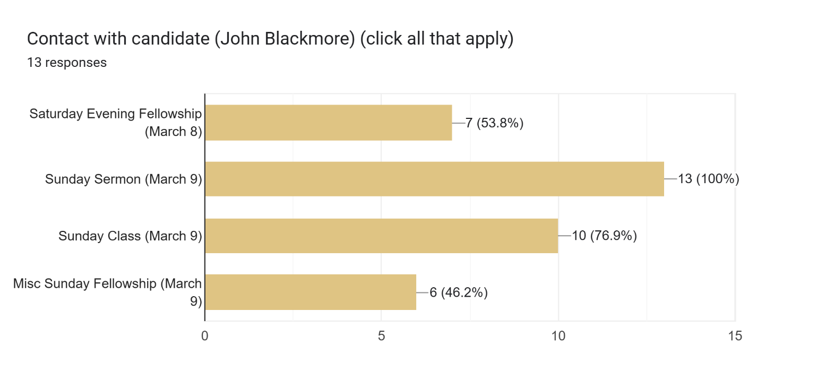

Section 1: Sermon and Teaching – How engaging and relevant was the sermon?

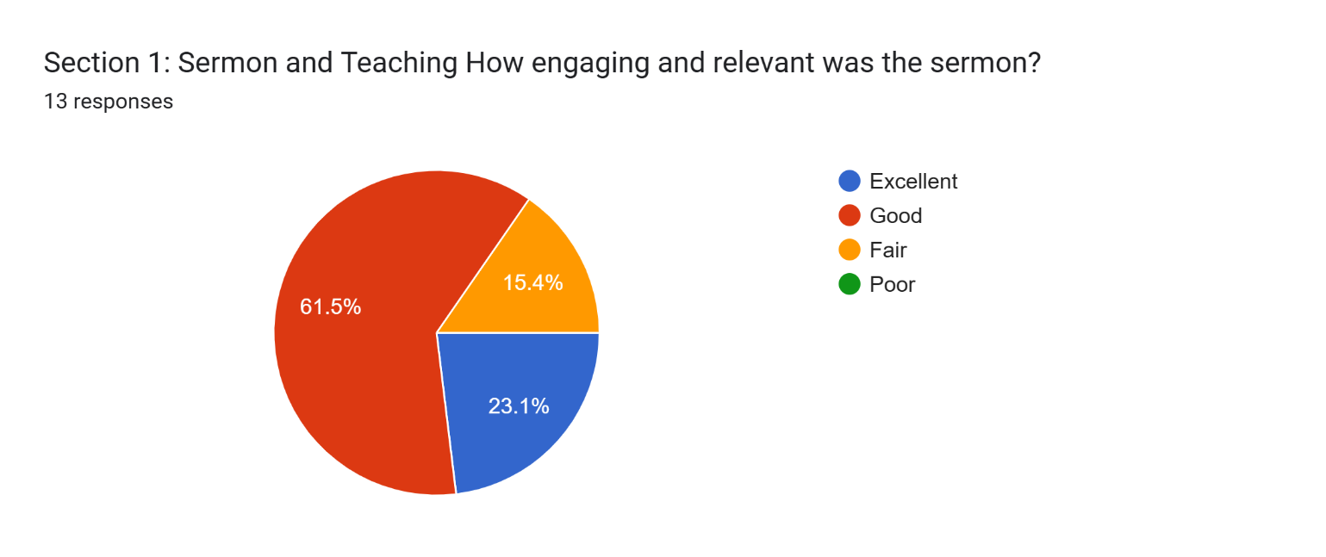

Section 1: Sermon and Teaching
How engaging and relevant was the sermon?
11 responses

His content and delivery was engaging. However, relevant is a serious question in terms of several points of current needs. Examples are as follows: 1)our congregation is varied in so many ways culturally, racially, and politically; 2) there is need for mending of some personal and interpersonal problems and we need to know how to care for each other; and 3) we need clarification and guidance on how we can grapple, in a Christian way, with the issues of social justice that are immediate. His lessons were very good but more relevant to being ready to go out and witness to others while we also are in pressing need to serve one another.

Great! I like that he was able to connect Susie’s thoughts. I appreciated the connections.

Relevant in that Mcknight is in a mission field.

He speaks really well and draws in many different groups of people.

I felt the sermon was good and efifying

It was ok not as grabbing as the previous contenders.

Sermon was 52 minutes. If it were only 30 I would say it was excellent. HOWEVER, I do think John did a good job with the message making it relatable and easy to digest. The thoughts were clear and supported the main point of the sermon.

After the sermon and class Sunday I felt hesitant to make an endorsement for John as our new lead minister. It wasn't simply that it went too long. The message, while couched in good terminology about the importance of being missional and seemingly divided into 3 simple points, was so meandering and unfocused in its delivery that I had trouble gleaning the main message or discerning clearly what John was saying.

Too long, but plenty of scriptural references and was engaging.
He was very engaging but hard to follow after 15-20 minutes. Sermon was too long.

I had trouble identifying the main point.

Section 1: Sermon and Teaching - Was the message clear and biblically sound?

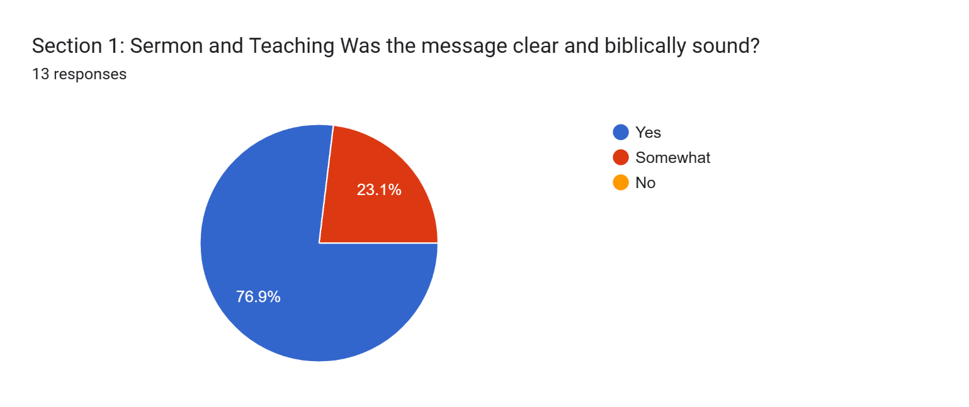

Section 1: Sermon and Teaching
Was the message clear and biblically sound?
Add any comments here ...
9 responses

While I needed to hear how to deepen my relationship with God, I did hear very sound information about how we started. He did his homework well about out mission statements.

The breadth of adaptability calls for some special attention.

My takeaway was to add more daily time in the Bible which I've done so far this week - actionable.

I had no issues with this

Yes, but seemed basic.

Biblical i could not find anything wrong.

Nothing made me think otherwise

Yes - I felt that John has learned how to present deep theological thoughts in an understandable and relatable manner.

He went back and forth in his message. I think he felt he had one shot and wanted to say too much.

From what I can recall, the message seemed biblically sound. I had some trouble with the lack of clarity. He served a spiritual buffet. I would have preferred a three course meal with emphasis on the entree.

Section 2: Connection with the Congregation - How well did the candidate relate to different groups in our church?

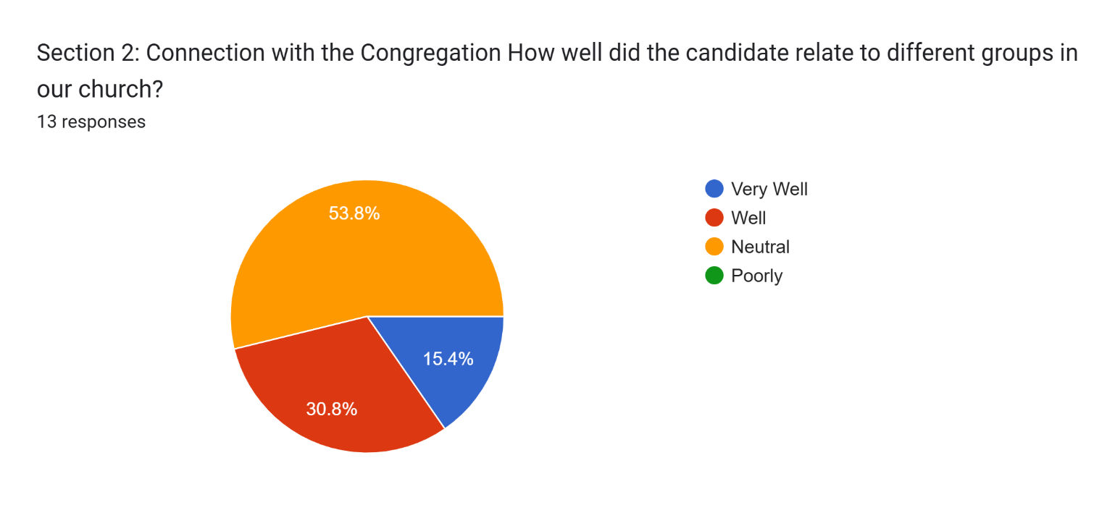

Section 2: Connection with the Congregation
How well did the candidate relate to different groups in our church?
9 responses

I did not see any reaching out to the black and brown members of our church. Nor did I see approaches to him from these members and I wondered if they did not feeI comfortable with him. I didn't see evidence of awareness of what issues are salient. Not that I needed a detailed essay. Some initiation towards them would have registered. I wanted to hear his interest in each of those that he met, like asking about the individuals' lives when he met them.

I only saw the sermon. I didn’t sense any “unequalness” in his presentation
Connected with some. Not sure of his connection with others. He said he liked things simple. That might be an indicator of his style.

I would say for having a "fan club" he did a good job of not spending all his time with them but talked to the church body well even as I was next to the Vincent girls he came up and talked to them Sunday am

Based on responses to date it appears he completely missed missed our younger families…that’s concerning to me

I think John's main strength is his ability to communicate in different settings, from large groups to one-on-one. These skills would be useful at McKnight where we could use some help building community.
Seemed to be varied feelings and reactions

This is probably one of his strengths, connecting with people. He and Laura were very relatable and easily connected with people.

I can appreciate how difficult it can be to connect with a congregation on your first visit. It is even more difficult to make that connection when the congregation is diverse. Rather than asking questions to learn more about us, he appeared to be more interested in letting us know how much research he had done on MX. He seemed more interested in telling us what he already knew about the body rather than learning firsthand.

Section 2: Connection with the Congregation - Was the candidate approachable and personable?

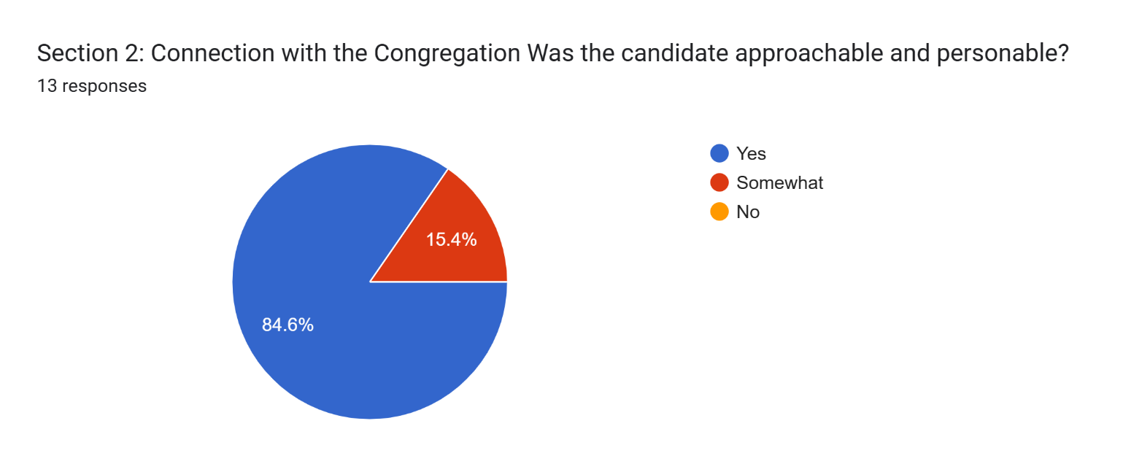

Section 2: Connection with the Congregation
Was the candidate approachable and personable?
7 responses

I think his personality is very fine. He would be a good person to know. I just don;t think he could lead us towards both internal and external ministries.

Again, just saw the sermon

Very approachable whether 1st time or original member

John is an extravert and enjoys talking to people. He also seems to do a good job connecting with individuals.

John and Laura were friendly and talkative.

I thought he was easy to approach, and he played a little basketball with a few teens in the gym before the elder prayer session.

He was very personable. Very down to earth and easy to relate to.

Section 3: Overall Impression - Do you feel the candidate would be a good fit for our church?

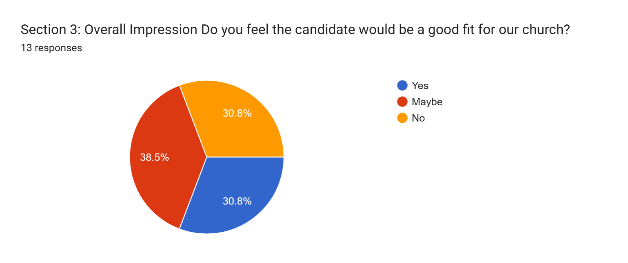

Section 3: Overall Impression
Do you feel the candidate would be a good fit for our church?
11 responses

He is very learned about the bible and could give some very good classes. He is technically but not actually qualified. It is because we are a very unusual group and we have unusual talents and unusual needs. I would need someone who helps me apply christian values in these days when we may be called upon outside of McKnight to get policies in place to help people who need most help, like in the sermon on the mount!
He seems like he’d be approachable.
Did not get the impression he was a minister to share the gospel with those who required 'meat". Probably good with those who rely on "mil" at this point
I feel this looks like the different we were looking for at the beginning fitting the Evangelist/Preacher role that we have been missing
Really felt good about John & Laura initially but again based on responses so far I feel like if we chose them we would be diametrically opposed to our original goals about appealing to the next generation.
I was hoping for someone much younger to attract more younger members. Why is he leaving his current position so close to retirement? Nothing against an older minister, but 70 ish, is not a good choice. We have no clue as to how much longer he would be around unless he is just going to be an interim minister.
John understands our faith tradition and has a great deal of practical knowledge and experience. He is also good at communicating and does not seem to be burnt out , jaded, or ready to slow down.
I trust our leadership and the leading of the Holy Spirit, and I could work with John if he is hired. But since you are asking my opinion, it doesn't feel like a great fit to me.
Enthusiastic and evangelistic. These outweigh any concerns about his age.
I put maybe because there are many parts in his ministry skills that would be valuable. He is a seasoned minister, a good public speaker, biblically sound but I just am not sure we are I. The same place theologically. We may be headed in the same direction but not sure if he is there. It might be hard to lead if he is not there.
Having giftedness, experience or a sense of mission in one of the following three things are important to me. 1) Can he relate to the younger generations and them to him. 2) Does his sermon or message resonates with seekers or the unchurched. 3) He is focused on equipping the body to be disciples. He may be well-suited to perform #3. Although he spoke some to discipling on Sunday, his lack of focus distracted me from locking in to a main point.

Additional Thoughts or Concerns

Additional Thoughts or Concerns
Please write any other feedback here:
10 responses

I wish for more opportunities to meet these candidates. It is very difficult to make any judgements based upon the sermon and lesson. I appreciate each of you for all that you do for us including this search. I think none of us really knows just how much work you put in for us. I do not think we should be anxious and rush to get this job done, however

I found his intro comment interesting. "I envy people who have a difficult time public speaking because when they get up here they don't crave attention." The ability to speak concisely is not always a result of fearing public speaking, in fact it's a public speaking skill to be able to convey something complex in a simple way. One of the skills of being a senior minister is public speaking in a way that's engaging. I think he could better follow his own advice to focus on "keep yourself out of the way and let God speak through you."
I feel like the question about being relatable to all groups at the church may be indicative of DEI concerns.I am
TOTALLY reading into this but…Typically, the culture from the central and southern regions of our state is not supportive of those messages. If that is a concern with this candidate then I would recommend negotiating for training in that area. Is he trainable?

His style of humor in the sermon and lesson seemed to be a bit demeaning.

He just didn't stand out to me.

I vote only a very low maybe.

I do have some concerns about John’s age. If we select John Blackmore, I believe we should have an understanding that his employment will be revisited when he reaches 65. At that point, it may be wise for him to transition to part-time while we identify or develop a younger minister. While John is a strong candidate now, I worry that in five years, we may find ourselves needing a new minister while still being committed to one whose capacity is diminishing. Also, John needs to keep his sermons to under 35 minutes.

Ideally I would hope for someone who is enthusiastically supportive of our unique congregation in all its diversity and commitments, including expressing a value for racial reconciliation, our Church of Christ heritage and legacy, and full participation of women in leadership and service to the extent outlined by the elders.

Excel Spreadsheet of Google Form Survey
Responses noted above are also available in an Excel spreadsheet here - https://www.shepherd.mx.mxcoc.xyz/positions/docs-25/03.16.2025-MX%20Minister%20Candidate%20-%20John%20Blackmore%20(Responses).xlsx

Follow-up letter from John Blackmore

John Blackmore
To Steve Walker, Jeff McGlawn, MXElders
Tue, Mar 11 at 9:45 AM
Message Body

First for the entire church

Dear Mcknight family,

Laura and I would love to thank all of you for your tremendous welcome and encouragement as we spent time with the Shepherds, staff and various leaders. You are an incredible church family and we see how God is using all of you to be a bright light for His gospel in St. Louis. We were blessed to have many local friends and family with us, everyone of them let us know how friendly and welcoming you were to them. What a fantastic witness for Christ. Thank you!!

It was so beautiful to see so many people with various backgrounds together as one in Christ. Laura and I were especially blessed by the worship service. Truly inspiring and I could just feel the presence of the Holy Spirit in the room. (Which probably led to me extending the sermon I bit! Yikes!). Definitely you are a church on mission! Excited to see how God continues to bless others through you!

Keep on Shining!
John and Laura

For the Shepherding couples

Dear leaders,

Laura and I thoroughly enjoyed our time getting to know all of you and we gained a deeper understanding of your church body, your vision and specific church culture. After this weekendI believe more strongly ever that we are specifically gifted to join your efforts for His Kingdom. Here are some of my reasons I believe I would be a great fit for lead minister with you

1. Discipleship/Evangelism
I simply love teaching and preaching the Word of God. Ever since I have been doing ministry in the States I have seen the need for Christians here to go beyond the basic knowledge of the Bible (Hebrews go beyond the milk to the meat). Many believers want to share their faith but are ill equipped to do so in a post christian world. I am excited about teaching apologetics, evangelism and biblical history, not for a means to memorize scripture, but a necessity to share the gospel. Laura and I were forged in the trenches of post-christian France and I believe we can come alongside you and help our community of believers boldly share the gospel with their family, friends, schoolmates, and co-workers.

2. Politics
Our lifetime of experience with cross-cultural ministry. Many churches tend to retreat from the huge cultural differences and issues in our society. It is evident that Mcknight desires to have those "uncomfortable" discussions and truly breakthrough and be a church that is truly one in Christ. We live in a challenging time and I truly believe the church must lead the way to unity. We have the opportunity to witness to the world what (not what but WHO) can bring the unity despite our differences. Again, Laura and I have had a lifetime of learning this, adapting to a French culture that makes most "left leaning" Americans look like conservatives. The church must avoid the trap of Christian Nationalism along with surrender to Cultural Relativism. Laura and I have had discussions with communist christians, we had members of our church in Poitiers from every political vantage point, yet we were united by our love for Christ. I think I can help McKnight continue to be a body that manages the tensions we face in America and glorify Christ while doing it.
Sidenote: Laura and I still remember a Sunday in Poitiers, when we had only 30 people present, yet represented 11 nations, it was beautiful! I felt that this Sunday, when I met several people during the meet and greet, I loved it.

3. Biblical response to sexuality issues in American culture. Specifically facing Christians today are people seeking to know Christ and follow Him, yet struggle with homosexuality, transgenderism, and a host of others sinful behavior. I have had occasions of walking through healing of sexual sins from homosexuality to adultery with new Christians as well as helping leaders in churches. It is evident we are called to love, accept, and welcome everyone into our community, yet when it comes to accepting Christ and being part of the church we are called to be a holy people living transformed life. We have to speak the truth in love. i will be a leader that loves and accepts all, yet strive to teach that true fulfillment and true identity isn't in anything but Christ. Together we can remain biblically sound in our teaching, yet completely loving of all who are searching.

4. Missions--This is a no brainer for me it is obvious that you clearly are living out the great commission as individuals and as a body. We can't overlook how God has moved to lead the most mission minded couple to find the most mission minded church. Together I believe McKnight will continue to be a sending church. I look forward to the day we are raising up church leaders, preachers, missionaries and others proclaiming the gospel around the world.

there are many other evidences to me that God has brought us all together, but I'll stop there. I have folks praying from France to Uganda for all of you, that he would guide. We know that God ultimately will have His way as we all surrender. No matter what, as lead minister or just brother in Christ, I look forward to partnering with you in the gospel.

God bless and thanks again,

John

