Senior Minister Search
Candidate – Jason Mundie

Contents
Bio 1
Jason’s Website 1
McKnight Sermon: 1
Jason Mundie – Verbal/Email Feedback Summary 2
Jason Mundie – Google Forms Survey 5
Contact with Candidate: 5
Section 1: Sermon and Teaching – How engaging and relevant was the sermon? 5
Section 1: Sermon and Teaching - Was the message clear and biblically sound? 7
Section 2: Connection with the Congregation - How well did the candidate relate to different groups in our church? 8
Section 2: Connection with the Congregation - Was the candidate approachable and personable? 9
Section 3: Overall Impression - Do you feel the candidate would be a good fit for our church? 10
Additional Thoughts or Concerns 11
Excel Spreadsheet of Google Form Survey 12

Bio:
Jason currently lives in Knoxville, Tennessee with his wife, Megan, daughter Magdalene, and foster son. Jason is the Director and Campus Minister for the Christian Student Center at The University of Tennessee in Knoxville. He gets to point college students toward Christ everyday.

Jason used to be a full time photographer and barista, so I still love both. In my spare time you can catch me in a coffee shop or traveling and taking photographs.

Jason’s Website
Jason has a website with information on his background, his resume, and sermon videos - https://www.jasonmundie.com/.

McKnight Sermon:
Jason Mundie preached to the McKnight Crossings Sunday church on, November 17, 2024. The sermon was on “Faithfulness in the Midst of Bitterness”, and the video is available on YouTube here - https://youtu.be/lr0awmhwk8A?si=NiXUiyxQ9Ubt1GBH.
Jason Mundie – Verbal/Email Feedback Summary
November 15 weekend feedback

Below are comments received verbally or via email (not collected on survey form https://forms.gle/AdiVS7rcM9Bxffgb8)

Date | From | Comments
Nov. 17, 2025 | Steve Haupt | is a yes. Preaching was relatable. Thought we should make him an offer.
Nov. 17, 2025 | Ron Orick | Positive
Nov. 17, 2025 | Joanie Milligan | was in tears because his sermon resonated with her.
Nov. 17, 2025 | Kate Schneider | was positive about Jason.
Nov. 17, 2025 | Patrina West | spoke with Gwen and didn’t think he was a good fit for mature Christians like MX.
Nov. 17, 2025 | Alec Hill | enjoyed Saturday night and would move forward based on his impressions from Saturday. He didn’t think his preaching was stellar.
Nov. 17, 2025 | Robin Oestrich | enjoyed his preaching and fit. As a general observation, she thinks we should be patient with a minister like Jason and allow him to grow into the role of a preacher. She believes he has the tools to be a lead minister.
Nov. 17, 2025 | Carrie Strickland | would make him an offer.
Nov. 17, 2025 | Marion Earnhart | was positive about Jason.
Nov. 18, 2025 | Jeff Fogarty | I listened to his sermon live. it was good. He seemed nervous at first but worked through it. I liked how he was sensitive to people going through hard times.  Betty said class was good too.
Nov. 17, 2025 | Tim & Mary Nicholson | very positive
Nov. 17, 2025 | Larry Franke | I liked that he felt genuine. He seemed like someone that you could get to know easily. He talked to - not down to- the congregation. His wife seemed nice, too. They aren’t too young nor too old. I think both teens and older people would be able to relate to them. (Larry also completed a survey-form)
Nov. 17, 2025 | Eric McPherson | Thinks that we should make him an offer immediately.
Nov. 17, 2025 | Kaylynn Myers | Favorable
Nov. 17, 2025 | Travis Myers | noncommittal
Nov. 17, 2025 | Electra | Favorable
Nov. 17, 2025 | Cora Blackford | He seems like a nice guy. Could tell he was pretty nervous. Would be curious to see how he does preaching a second time. Maybe wouldn’t stumble as much.
Nov. 17, 2025 | Neva Blackford | Watched sermon. The beginning and end were a little messy but he was nervous. I liked the use of Naomi’s story to accompany his message, felt more specific than him choosing another more main character. Did get a bit repetitive and general towards the end. I thought he did good at not talking about himself to much and just enough to use as an example for relatability at the beginning.
Nov. 17, 2025 | Steve Jones | I asked Nathan [Strickland] if he took the preacher to his barber😂  I thought he did fine and I enjoyed his message. It was heartfelt and I could tell he was living through the message. I told Jerry Mickey today at lunch it was a really good message for him to hear today.  Jeff has really set the bar high!
Nov. 17, 2025 | Vicki Roberts | I really appreciated the lesson today. Jason has a great heart and presented in a sincere way which was impactful.
Nov. 18, 2025 | Eric McPherson | I am all in on Jason and Megan! I tell myself that I am good at hiring people and have good instincts about people. I don't know if that is true.  I was in from Saturday night. They are personable, relatable, humble, knowledgeable, committed, and live out their passion for Christ and His Kingdom. He is in touch with where the next generation is at with their faith and doubts. Then on Sunday, he did a great job preaching. It was humble and relatable. We (Liz and I) went to lunch with them after church impromptu. They are delightful and authentic.  I told them CFS would help in any way we could with their fostering of Anniyah (?) and the transfer from Tennessee. They are hopeful it will turn into an adoption. It is the biggest obstacle to them coming here.  If they are the right ones, (and I believe they are) then we should wait as long as they need to be able to come here.  I have not met John Gunter yet, but from his resume it seems that he is running from something (legalism) and Jason is running towards something (deeper relationships). I am worried about how short John's stays have been and how often he switches churches. I would call leaderships to see why. Does he get easily frustrated and quit and move on which is easier than staying to work it out? I don't know.
 | Dale & Leslie Simpson | Hire him !
Nov. 21, 2025 | Chris Borth | I didn't get to stay for class, but I appreciated the sermon.  Jason seemed very authentic and likable. He was in the word and I find that to be important.  So many of us have been in his shoes with feelings of sadness and despair, and not sure how to deal with  the depression. He was down to earth and open. I don't see him not fitting in at McKnight Crossings.  I did like that he offered blessings to us.  I'm sure leadership and staff would be better at judging that.
Nov. 22, 2025 | Jerry Mickey | I thought the young man did a good job Sunday. I felt like he may have been a little nervous, which is understandable, but I could relate to his sermon. I didn’t get to meet him personally.
 | Mike Lhotak | positive (per Steve Awtrey)
 | Deb Schwarz | positive (per Steve Awtrey)
 | Carrie Strickland | positive (per Steve Awtrey)
 | Marion Earnhart | positive (per Steve Awtrey)
 | Susan Awtrey | positive (per Steve Awtrey)
Nov. 22, 2025 | Nathan Strickland | I think Jason and Megan both are truly genuine people. I love their background and heart for foster kids, and their passion for ministry. In his preaching, I think Jason has the ability to draw people in and win hearts, as well as give us a mission at the end, opposed to just talking theology to us. I believe he has a heart for mission and doesn’t just talk about it but puts it into action. I don’t really have any doubts about Jason, but a general curiosity to see how he’d work with and lead the staff, as well as the mission and vision of MX. I think we’d get along well.

Jason Mundie – Google Forms Survey
Below information summarized from the Google Forms Survey sent to McKnight congregation in various email and bulletin communications - https://forms.gle/PtvBYfP3Japwy5BQ9.

Contact with Candidate:
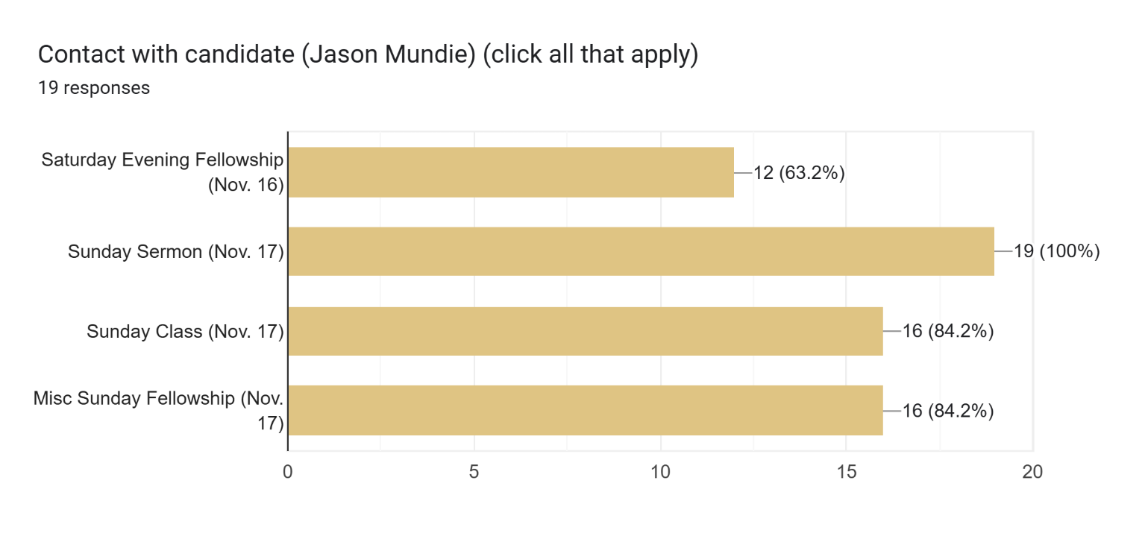

Section 1: Sermon and Teaching – How engaging and relevant was the sermon?

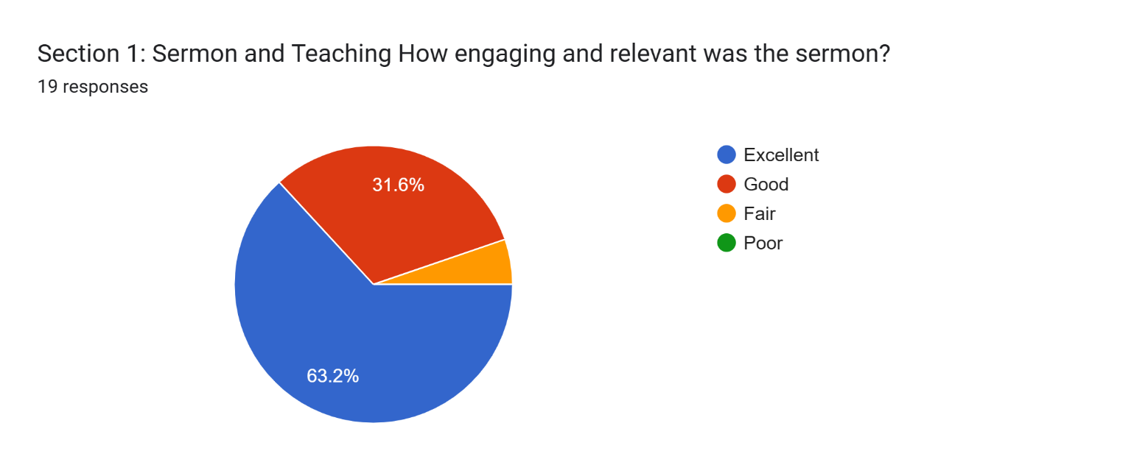

Section 1: Sermon and Teaching
How engaging and relevant was the sermon?
Add any comments here ...
15 responses
Jason seemed nervous, but understandably so as he is speaking in front of a new crowd and also with the pressure of being in an interview situation. However, Jason was very genuine and relatable. The sermon was personal and not theoretical.

Generally a good sermon. He was a bit repetitive and the flow seemed a little disconnected.

His personal sharing was very good.

I felt that he was able to reach the audience on both an intellectual and an emotional level.

well-delivered and relatable

Jason was able to get our attention for the topic with his own personal story. His strongest quality was he was very engaging with the audience. He also dealt with the topic well and gave some take aways for us to take home for transformation.

I thought the sermon was very good. Jason gave a personal example which allowed us to realize everyone goes through tough times that may result in depression. It made it OK to not be OK sometimes. I did feel he was a little nervous and had trouble making eye contact but that’s something I feel will improve as he gets more comfortable speaking to a large group he doesn’t know.

Good but the first guy that said no was much better [Ethan Laster]

He did a nice job. The only thing he needs to work on is eye contact to the broader audience. He focused on the first 2-3 rows.

He was authentic and humble and related scripture to our current suffering while offering hope. Very relevant

Sermon topic was certainly relevant. Although chosen by the leadership, I think Jason personalized it with his own stories, drew examples from the Bible, and spoke to the congregation in a very relaxed, conversational tone that made his message engaging and personal.

Definitely relevant but Jason’s delivery is not as engaging as Jeff Kryder’s. Jeff has had many years to hone his style and this is an area where training and experience could help Jason improve.

Pastor Jason spoke in a way that showed his ability to be open, sharing and honest about God's Word.

Jason was engaging and his sermon was relevant.

Jumped around too much in scripture those not familiar with the Bible could get confused

Section 1: Sermon and Teaching - Was the message clear and biblically sound?

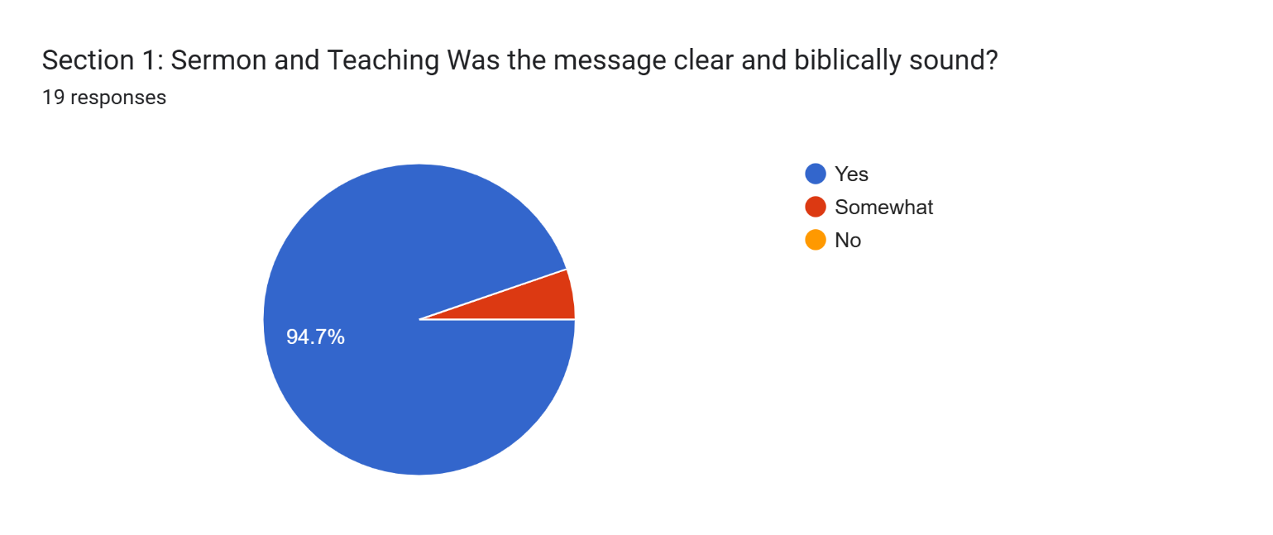

Section 1: Sermon and Teaching
Was the message clear and biblically sound?
Add any comments here ...
10 responses
Use scripture to support message.

Generally yes. He did veer of track and away from scripture a bit during Bible study

Using lots of scripture references was good.

Good translation of biblical good news into contemporary good news

Ok, didn’t totally grab me

Jason's sermon was excellent. He was well-prepared and engaging. He was hamstrung in his class assignment, though, as Grace and Mercy were covered the week before by Betty Vaughn, and next week's candidate will also be teaching on the same subject. Jason kept repeating himself throughout. You could see him struggling to find something new to say that hadn't been said the week before. I see this as no fault of his own. Had he been given a topic of his choice, I think he would have done much better.

Story of Naomi and Ruth. Applied the story of Naomi and Ruth, their struggles and despair, to our own experiences of suffering. God's faithfulness remains amidst bitterness and pain. Covenant with Abram, God's promise to us. Jason based his points on specific stories of the Bible as well as meaningful scripture. Appreciated his pauses to allow us to linger and absorb a particular point. Liked how he stepped aside from the podium. (Felt more casual and intimate.) Liked how he ended his sermon with practical application: spend time in God's presence through prayer, in His word, meditate on His promises, and also liked how he closed with a blessing for all in the congregation experiencing pain and struggle.

He drew from several parts of the Bible to illustrate his message.

Jason's message was made clear by sharing his life stories and how they line up with God's grace and mercy.

Yes, I felt like his teaching was biblically sound.

Section 2: Connection with the Congregation - How well did the candidate relate to different groups in our church?

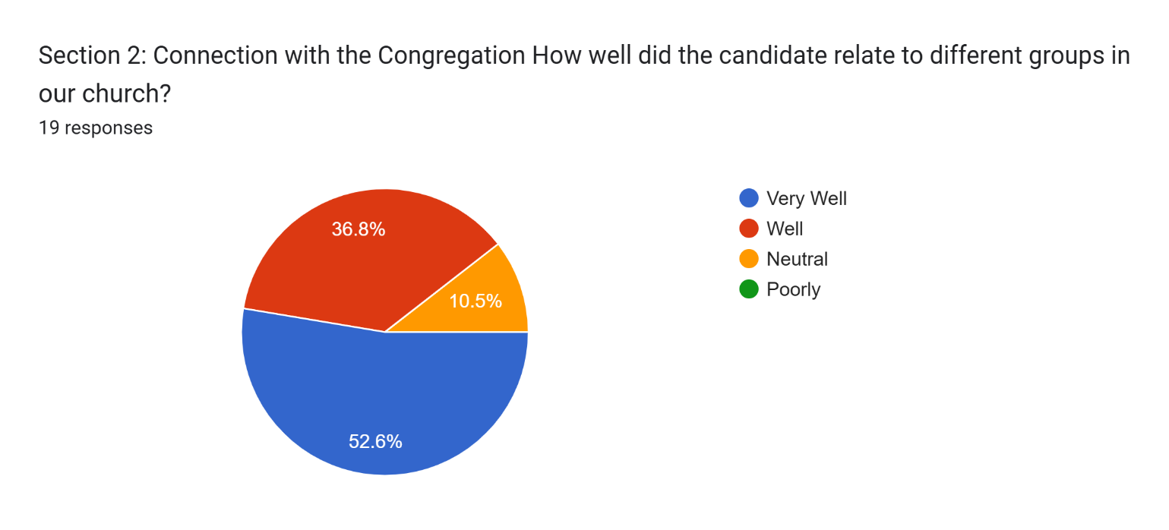

Section 2: Connection with the Congregation
How well did the candidate relate to different groups in our church?
Add any comments here ...
11 responses
Jason and wife Megan did well mingling with the congregation. He also spoke personally about struggles in his life with bitterness. Very relatable.

My observation from watching the Mundie’s interact with a variety of MX members seemed positive from a distance. I didn’t listen to their discussion with most members so I can’t make a definitive statement about the effectiveness of the interaction.

He is the right age to appeal to a wide audience- not too young to seem wet behind the ears to the middle-aged and older people and not too old to be out of touch or boring to the young ones.

I've heard positive comments from young(er) and old

I found him to be transparent, approachable, kind and genuine.

I checked Well up above, because I did not witness all of his chat with members. I don't know how he would relate to the 60+ generation, but I hope he would treat all constituencies equally.

They are accepting and warm and welcoming

Both Jason and Megan are very friendly and personable. They seemed honest and up front with their answers Saturday night with the ministry leaders. They seem very warm hearted. I love how they love children. The fact that they foster for the state says a lot about their character and compassion for the vulnerable. They seemed very comfortable and open at the meet & greet. I like that he comes from campus ministry. He would have insight on where young adults are at these days.

Jason’s experience with college students will allow him to relate to the ACTS ministry and may help bring young adults into our congregation – something we lack. Jason’s background from Churches of Christ in New York and Tennessee gives him a unique range of experience that can benefit our congregation. His experiences as an adopted child can help him relate to the ministries we support at CFS. His Korean ancestry will add to the diversity of our membership.

Jason was open to all groups in discussion.

Jason was very personable and he seemed comfortable with all age groups.

Section 2: Connection with the Congregation - Was the candidate approachable and personable?

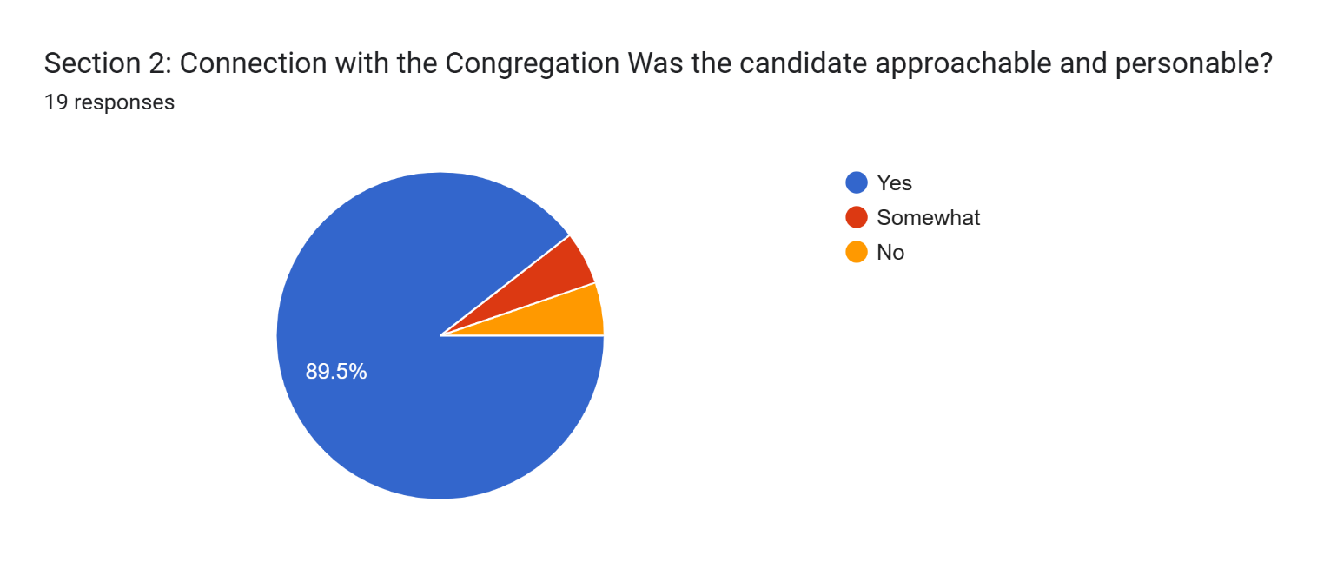

Section 2: Connection with the Congregation
Was the candidate approachable and personable?
Add any comments here ...
10 responses
Jason and Megan seem very easy to approach and get to know.

Watching from a distance the interaction with members seemed engaging.

It seemed that many were able to chat with him and Megan.

He is awkward, but does not let that slow him down from talking to people.

He and his wife were available to talk with. They were very present when they were talking with others.

He and his wife seemed interested in sharing with us as we talked with them. We are seeking not only a minister but also his wife. We are getting a team, and I found her to be very approachable. She is also seeking a Ph.D. or Ed. D. in English, and we shared some of our interests and experiences.

See comments above.

They were definitely personable and approachable. They displayed an easy give and take and complemented each other beautifully. They gave their full attention to whomever they were speaking to and were not running off to the next thing.

Yes He was very approachable and sincere.

Yes, I spoke with him. He was very personable.

Section 3: Overall Impression - Do you feel the candidate would be a good fit for our church?

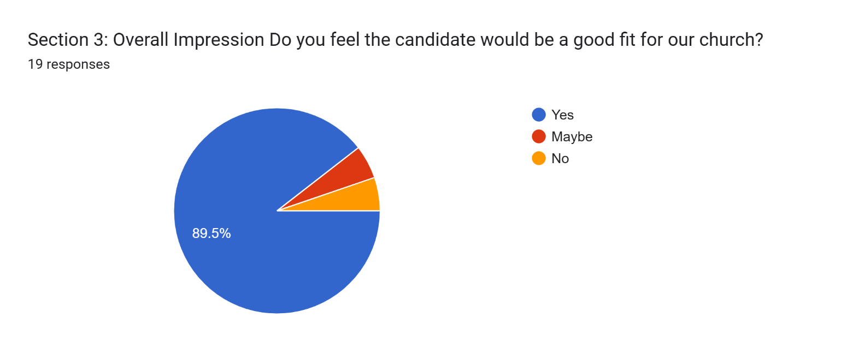

Section 3: Overall Impression
Do you feel the candidate would be a good fit for our church?
Add any comments here ...
13 responses
I like Jason and feel he would be a good candidate. I do worry about him not starting until May/June 2025. A long transition period. Perhaps Jason can commit to spending a week in St. Louis each month (preaching 2 Sundays).

It’s difficult to make a definitive called about fit from one visit. Using the one sermon as a barometer his preaching may resonate with seekers and new Christians. .

He and Megan will embrace our deep CFS roots.

In person he was much more approachable than I would've guessed from the zoom and online sermon.

His wife would be a great asset to our church as well.

Yes. They have several unique qualities that makes for a very good fit with MX and our unique qualities as a congregation. Diversity, young, heart for foster care are just a few.
Unsure at this time, just didn’t connect with me.

I think we need someone younger and eager to learn and grow.

He believes and practices the right things for our congregation. He promotes women's roles in worship and believes instruments are useful in worship. He believes in small groups and their potential for spiritual growth. In short, he checked all the right boxes!

He would be a good fit for our diversity and they understand the younger generations's skepticism and doubt.

Just as important as putting out a good sermon, is the lead minister's ability to interact with, relate to, and encourage members of the congregation. I feel Jason's personality, as friendly, caring, and outgoing as he appears to be, would be well-suited for this role. His background in Church of Christ, his understanding of the Bible, and his honest, open nature would facilitate a smooth transition. From what I gathered, he appears to be hard-working and well-grounded.

We think this couple would be an outstanding fit. I expect that as a couple they will bring a pastoral and personal approach to ministry at MX which I think was Jeff Kryder’s weakest area. I commend their desire to belong to a congregation where their daughter will see women involved in all aspects of worship which makes them a good choice for MX. Jason and Megan are very open to the use of instruments and participation of women in worship, which also makes them a good fit for our congregation.

yes

I feel that Jason would be a good fit for McKnight. I like his focus on diversity in the church and community. His strength would be reaching out to young adults. If we are looking for someone that can be actively involved in the community, especially young adults and college age, Jason seems to be a great fit. However, in my opinion, since this would be his first full-time leadership role, he may need some mentoring to get started. I guess the question would be, are we looking for a minister to step in and take charge in the minister role, or someone that can be active in reaching out to young adults, but may need some mentoring in the leadership role.

Additional Thoughts or Concerns
Please write any other feedback here:
14 responses
Concern is start date

His intangibles seems transferable to ministry. Relatability, vulnerability, youthfulness and passion for next gen.

The bit of nervousness he displayed is understandable and will improve with time.

The turnout for the meet and greet was somewhat embarrassing. Did it indicate a lack of commitment to the selection process, a lack of interest in the candidate, or do the members figure that the elders will make the right choice on their own?

I feel like we need someone to come in that is young, and even lacks the experience to help us as we try to reach out and be attractive to young families. They fit that ticket very well. Their experience anecdotally and academically with diversity could be very helpful to us as we continue to strive to be a diversified church.

I answered and submitted then realized I wanted to add something. I felt Jason was a lot more comfortable teaching the Bible class. It was a smaller group. He made it interactive and made eye contact with people.

Waiting to hear the the next candidate

Jason has to have the support of the elders and they must provide him with clear expectations, a coach/mentor and regular feedback.

Although I feel Jason & his wife would be a good fit for MX, I think the deal-breaker would be their foster child. Can they transfer fostering from Tennessee to Missouri? If they can't, they won't come, I am sure.

He would be a great fit for us as we navigate the next decade of reaching the next generation. I am all in. We went to lunch with them on Sunday and they are wonderful people. they are exactly who we think they are.

Thank you for inviting Wanda and me to the Saturday evening reception for Jason and Megan. Meeting
Jason and Megan in person in that setting allowed us to hear their story and see their personalities and relationship in a way that his preaching and teaching on Sunday alone does not.

GOD BLESS THE DECISION MAKERS AND GUIDE THEM IN THIER DISCERNMENT OF CHOOSING A GOOD FIT FOR OUR CHURCH.

I wonder if he might be a good fit for a position in a larger church that has a full-time minister that could mentor him as an "associate minister"?

Needs more seasoning

Excel Spreadsheet of Google Form Survey
Responses noted above are also available in an Excel spreadsheet here - https://www.shepherd.mx.mxcoc.xyz/positions/docs-24/MXMinisterCandidate-JasonMundie_Responses.xlsx.

