Elders Meeting
February 27, 2024
6pm – 8pm

Attendees: Steve Walker (chair), Don Fitgerald, Brad Stevens, Bret Blackford, Dave Weiler, Steve Awtry, Jeff Kryder, Jeff McGlawn (visit), Ross Brown (visit), Nathan Strickland, Jermiah Haywood

- Devotional
Mark 4:26-29 The Parable of the Growing Seed
²⁶ He also said, “This is what the kingdom of God is like. A man scatters seed on the ground. ²⁷ Night and day, whether he sleeps or gets up, the seed sprouts and grows, though he does not know how. ²⁸ All by itself the soil produces grain—first the stalk, then the head, then the full kernel in the head. ²⁹ As soon as the grain is ripe, he puts the sickle to it, because the harvest has come.”

- MX Family and Friends Updates/Prayer
{{ various }}

- Youth Group Update – Nathan Strickland
- Summary of 2023 events on-line here - 2023 Youth Ministry Breakdown (mxcoc.xyz) (Excel here)
- Policy for groups staying at MX building – any groups will need a sponsor who can make themselves available to help out or answer questions while group is on-site.
- 2024 Summer Intern – Nathan will extend an offer to Cindy Bowl of Knoxville. Cindy will stay at the Fergusons or with Marion Earnhart.

- Children’s Ministry Update – Jeremiah Haywood
- Debriefing/exit interview noted at Attachment A.
- 2024 Calendar here.

- Elders / Ministers
- Children’s Ministry Transition Period - TBD
- Search Team – Steve Walker will try and get the prior search team together that hired Jeremiah.

- Ministry Search Updates – Steve Awtrey
- Tasks, Interpretation, Communication and Timeline
  - No communication topics or date(s) set – to be discussed at future mtgs.
- Preacher search timeline
  - Senior preacher orientation
  - Bret submitted this draft information to assist potential candidates the Vision Elders – info here - http://tinyurl.com/5fjbrdxf
  - Bret will help coordinate the soft search with direction from Vision Elders.
- Candidate under review
  - Michael Santiago – resume, cover letter, sermon video
- Possible candidates to approach (see Attachment B):
  - Nate Reiser – Facebook, sermons,
  - Alden Bass – bio, OCU,
  - Josh Nix
  - Ethan Laster
  - Travis Akins

- Facilities - Bret
- Ladies first floor bathroom had a sewage backup on Sunday Feb. 25, 2024. Bret mopped up the sewage on Sunday and Tom Hunsaker snaked out the blockage Monday, Feb 26. Bret mopped the floors and wiped down all the toilets on Tuesday. The bathroom is now functional and ready for use. Bret and Tom will continue to monitor.
- Baptistry – the tank had some leaks and after 50+ years it was resurfaced. More information here - https://www.building.mx.mxcoc.xyz/baptismal/baptismal.html.
Tom Hunsaker and Bret Blackford were able to sweat and remove the pipe fitting going into the drain on 2.28.2024. With the fitting removed Tom and Bret were able to snake out the drain and unclog. Water drains much better now but will still need to be monitored.

- Misc
  - Marseilles update (https://www.chapelledefuveau.fr/) – McKnight has pledged $100,000 but no payments have yet been made. Craig Young has been contacted about the pledge and will inform MX when monies are needed.
  - Placing Membership – there are no formal guidelines. Periodically Steve Walker and Dave Weiler will hold a class for those new to McKnight and interested in joining our work. Discussion focuses on serving, tithing, etc., but baptism is not considered necessary for placing membership. Nor is a verbal pledge or declaration made (like at baptism when one is asked if they believe Jesus is the Christ, God’s son, who dies for us and has risen from the dead and is with God the Father.). Baptism is considered essential to becoming a Christian, but not for belonging and worshipping with the McKnight church family. However, a non-baptized member cannot take a lead in the Sunday worship (cannot lead a prayer, give a communion thought, etc.).

- Other – Siburt Institute’s “Equipping Leaders for Mission" Conference”. Area wide churches met at the McKnight building Saturday January 20.
  - Session video on YouTube – http://tinyurl.com/bdjt547r
  - Session video on website -- https://siburt.mxcoc.xyz/

MX Youth Group Newsletter (Feb. 24, 2024) – here - http://tinyurl.com/3f5dw7t2

Weekly Bulletin (Feb. 28, 2024) – here - http://tinyurl.com/5atr2jrn.

Attachment A

Jeremiah Debriefing

- Process and circumstances that led to you accepting the position at The Hills Church?
Per Jeremiah, much of this was feeling a loss of communion with other believers his age. Jeremiah came from a church with a large young professionals group and he misses this fellowship.

- Health and well-being of families.
  - Who are some spiritually healthy families – What are some of the characteristics that makes them healthy?
  - Who are the families that have some challenges? What are some of those challenges?

- How do you see the ministry evolving over the next person’s tenure?

- What are some of the opportunities for leadership to be present in the ministry?

- Calendar: Which events have been communicated to families and planning is underway?
  - Have there been resources procured or allocated for some of the planned events such as dollars spent?

- Timing on your departure.
Jeremiah will start his new position April 15, 2024. He plans to work thru April 12 and will probably take some vacation before he leaves.

- Is there a need for additional communication with parents about your departure?
  - Which parents were not in attendance for the announcement?
Discussed sending a summary of what was read on Sunday, Feb. 25 and share the link to the announcement on YouTube (https://youtu.be/XqjYoMvcvts?t=4532).

- Potential Candidates for children minister.
Jeremiah might have a couple of possible leads. (Kaya Coleman, Kate Schneider)

- What week to week activities and discipleship practices need to be immediately addressed to maintain the ministry?

Attachment B

Soft Search update 2/26/24 – prepared by Steve Awtrey

Michael Santiago - resume, cover letter, sermon video
- lives in Abilene, Texas
- Youth Minister at the University Church of Christ
- Married with one child
- Steve met with him at NCYM in January
- We have given everyone the link to a sermon he did on Christmas Eve - here
- Steve Awtrey has talked with him on the phone
- Steve Awtrey, Steve Walker and Jeff Kryder are planning a pre-zoom zoom this week or next

Josh Nix -
- Lives in Memphis
- Presently finishing up a preaching apprenticeship at Sycamore View Church of Christ with Josh Ross - Our Team — Sycamore View Church | Church in Memphis, TN
- Steve has had an initial contact with him and is planning a phone call toward the end of the week with him
- Two of their elders have given high recommendations of him
- Going to talk with Josh Ross towards the end of the week
- I have a link of a recent sermon that I have given to Jeff and Steve - here

Ethan Laster
- Name from Carson Reed
- Goes to Lafayette and is working on PhD at SLU - Graduate Student Profiles : SLU
- Carson said he was quite gifted and is undecided on whether to go into teaching or full time ministry
- He and his wife love St. Louis

Travis Akins
- Contact from Carson Reed
- Minister in Edmond, OK - Heritage Church of Christ - Edmond, OK - Minister (edmondheritage.church)
- Just got into a new building after renting for 6 years
- Carson said would be an excellent fit and bring some experience
- Carson said he was open to some conversations

Alden Bass – bio, OCU,
Nate Reiser – Facebook, sermons,
Philip Matheny - Philip & Sara Matheny - Sheltering Wings (sheltering-wings.org)
Travis Meyers - Graduate Student Profiles : SLU. MX Sermon - http://tinyurl.com/2n35y5be

Attachment C

Below are some possible questions for the initial phone interview with potential candidates for the Sr. Minister position.

Initial Phone Screening Questions

- In your career to this point, what are you most proud of?

- Tell me about your experience preaching and teaching.

- What are the most important elements in your philosophy of ministry?

- Why do you want to leave your current position?

- How would your former employer and coworkers describe you?

- What would best illustrate your leadership and people skills?

- What are your greatest strengths for this position?

- What are your biggest weaknesses?

- Given the job description, how would you describe your fit for this position?

- Given the job description, what about you might not fit so well?

Attachment C

Senior Minister Search Process – Post Resume (DRAFT)

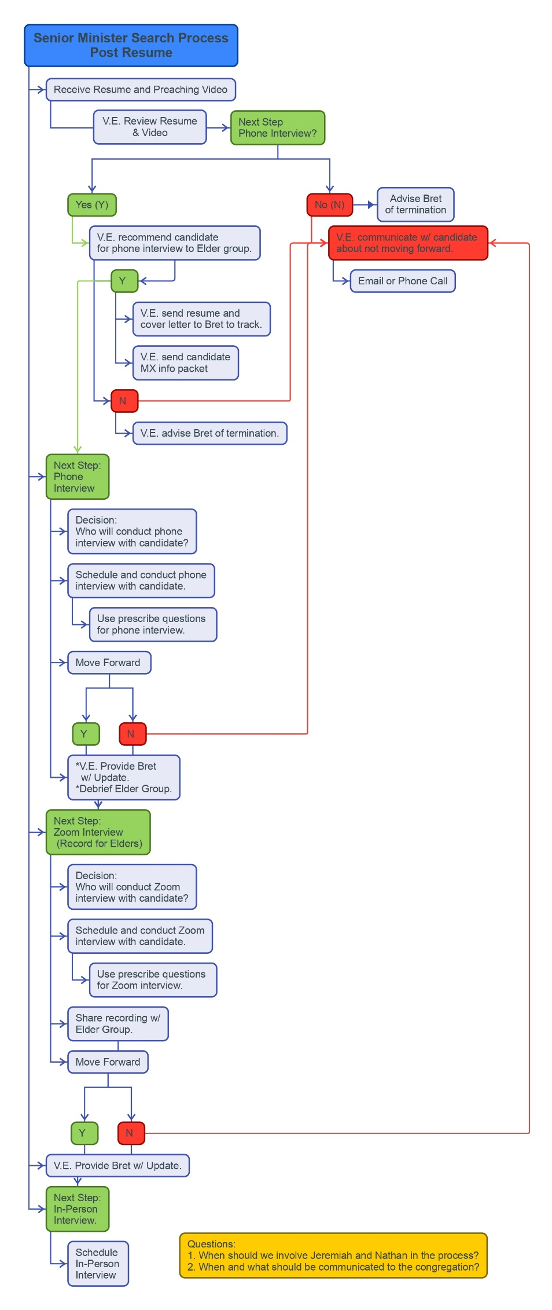
Also here … http://tinyurl.com/yc283cxn
Or here … http://tinyurl.com/54dd8u2m

Attachment D

Attachment D – draft Senior Minister Requirements

The elders will need to determine what we want in a minister. What are the must-have qualifications, and what are the nice-to-have items?

Examples below – just my draft list so do not take this as final on what we will use.

MUST HAVE | NICE to HAVE
Male | Children
Married | Divinity degree or some formal theological education/ training
Previous ministry experience | Church of Christ background  (what about other denominations?)
Heart for people and ministry over liturgy and law | Some training in counseling
Items noted in Senior Minister job description

Search Strategy:
The McKnight elders will take responsibility for the search, interview, and hiring of the new minister. When it has been determined that a candidate is suitable the elders will make a recommendation to the congregation and seek feedback. The elders, however, will still be responsible for the final decision.

It seems wise to seek the input and counsel of individuals with experience in congregational leadership, ministry, and staffing. As needed input from individuals like Carson Reed (https://acu.edu/faculty/carson-reed/) will be consulted.

- The full document on Jeff Kryder’s retirement and replacement considerations is available here … https://www.shepherd.mx.mxcoc.xyz/positions/docs-23/MX-SrMinister v2.docx.
- More information on the Church Health Assessment (CHA) can be found on the Siburt Institute website here … https://www.siburtinstitute.org/cha.
- Video Discussion with Carson Reed of the Siburt Institute available here … https://www.shepherd.mx.mxcoc.xyz/positions/docs-23/06.05.2023-CarsonReed.mp4.
- Siburt Salary Survey info here … https://www.siburtinstitute.org/salarysurvey. (also, salary based on teacher pay in local area is a good rule of thumb)

Attachment E

Minister Search Timeline
 |  | McKnight Crossings Church of Christ
 |  | New Minister Search Timeline
. | . | 2023 |  |  | 2024 |  |  |  |  |  |  |  |  |  |  |  | . | .
 |  | Oct | Nov | Dec | Jan | Feb | Mar | Apr | May | June | July | Aug | Sept | Oct | Nov | Dec
 | Soft Search |  |  |  |  |  |  | Hard Search (starts April 1, 2024)
 |  | (A) | (B) |  |  |  |  |  |  |  |  |  | (C) |  |  | (D)
 |  | (A) | Congregation notified in October 2023
 |  | (B) | Jeff turns 64 November 23, 2023
 |  | (C) | September 1, 2024 Jeff Kryder stops preaching
 |  | (D) | December 1, 2024 Jeff Kryder off payroll
 |  | Note 1: | Elders decided new minister can be brought on whenever suitable replacement found, even while Jeff Kryder still preaching.
 |  | Note 2: | Outside resources, such as Siburt Institute, will be utilized to help find candidates.

