Elders Meeting Agenda & Notes
December 2, 2024
6pm – 8pm

Attendees: Steve Walker, Don Fitgerald, Brad Stevens, Bret Blackford (chair), Dave Weiler, Steve Awtry, Jeff McGlawn (visit), Ross Brown (visit)

Next mtg.: Saturday December 7 @ 8:00am – select Senior Minister candidate.

- Time in Prayer: (all 15-30 minutes)

- Praise to and thankfulness for our Lord and Savior.

- Next MX Lead Minister.
Pray for clarity for both McKnight as well as the candidate and their family.
- John (Katie) Gunter
- Jason (Megan) Mundie

3. McKnight Crossings mission.
Our mission is to welcome others into a growing relationship with Christ.

4. Next Generation.

5. Unity.

6. The MX community becoming a spiritual influence in our neighborhoods.

Other prayer requests:

- Betty Vaughn wants the Elders to know she has a doctor’s appointment on Wednesday. There’s a suspicion spot on her breast.
- Arstine Dickerson is in Mercy hospital recovering from a second surgery.
- Jerry Mickey still has a lot of pain in his legs. He meets with the surgeon on Tuesday, Dec 3.
- Our Expectant Moms: Whitney Cannon and Anna Jones.
- New Parents: Alexandra & Daniel Striker
- Susan Blain – upcoming cardiac cath with possible stent – Dec. 6. Also blood pressure.
- Collins Corder – trip to Honduras.
- Lacricia Tucker – Please pray for my family and pray for me.
- Barbe Eickle – Food pantry clients:
  - Layla – young lady going through health and life challenges.
  - Sherri – daughter is addicted to heroin in California; won't contact Sherri. Daughter's son is with her and is living in a bad situation. Daughter's boyfriend is also addicted.
  - Nettie – asked for prayers for her teacher, Mr. Richard. He’s diabetic, had a bad infection and had a foot and part of his leg amputated this week.
  - Lalita – treatment for leukemia.
  - Louise – treatment for lung cancer.
  - JoAnn – strokes and poor health.
  - Bob –son is addicted and is in jail.
  - Julie – son with severe autism, is violent with Julie and others.

Prayers for Young Leaders:

- Mathew Bardowell | - Greg Walton
- Cas Grimshaw | - Leon Sewkarran
- Jason Vincent

- Thought About Candidates and Next Steps: (Awtrey/Walker 30-min)
- Jason Mundie Summary Info
- John Gunter Summary Info – in process
- Eric McPherson letter

Candidate Selection (12/7 @ 8:00am)
Meeting Saturday morning, December 7, 2024, at 8:00am at the MX Building. Goal is to select a candidate and discuss next steps.
- ASAP background checks on candidates:
  - Police Check
  - Credit Check
- Contact selected candidate to offer ministry.
- Give 1-week for candidate to respond.
- Wait 1-week to contact second pick in the event primary candidate declines.

What do we need to consider in the offer?
Reference Memorandum of Understanding (MoU) used with Ethan Laster here (.pdf / .docx).
Possible items to include: Expectation of office hours. Living within 30-min of building. Latest possible start-date. Interim monthly visits to MX prior to move. Other items outlined in the MoU.

- Children’s Minister (CM): (Walker 15-min)

- When to start looking – discussed hiring a new CM after new Senior/Lead Minister hired. New Lead Minister may not be in place prior to start of new CM.
- Hours (PT/FT) – discussed CM position seems to be running well with a part-time resource. The majority of the elders feel a full-time position which includes “Family Minister” responsibilities is appropriate and will be included as part of the 2025 budget.
- Misc Documents:
  - Children’s Minister Cover Sheet
  - MX Children’s and Family Minister Job Description
  - NextGen Milestones

Other Items: (as time allows)
- Draft 2025 budget – Dave Weiler (10-min)
Dave Weiler will preach Sunday December 8 on Giving and will give a brief budget overview. 2025 draft budget has a 5% increase over 2024 actual giving.

- Hospitality – Steve Awtrey (10-min)
Still important and a possible sermon topic in 2025 Q1. Elders briefly discussed making this an internal challenge for 2025 – hosting people at least quarterly in our homes or at restaurant.
See Attachment B

- 2025 Church Calendar – Steve Walker (5-min)
See Attachment C

Attachment A

2024 Advent Schedule
This flyer was given to our Trunk-or-Treat visitors.

Note: the topics listed next to the dates are not the sermon topics but the Advent theme.


Attachment B
DRAFT – HOSPITALITY - DRAFT

Elder Hospitality at McKnight Crossings:

The Elders recognize the importance of setting an example of hospitality for our congregation. By practicing hospitality, we not only connect more deeply with our church family but also create opportunities to reach out to our neighbors and the unchurched.

To make this meaningful, hospitality should become a regular practice, not an occasional event. We’re proposing a sustainable hospitality model focused initially on gathering with members in smaller groups, where genuine conversation and fellowship can flourish. While large events have their place, smaller gatherings provide the personal interaction that builds lasting connections.

We encourage each elder to host quarterly hospitality gatherings, either in their homes or other welcoming spaces. The goal is for hospitality to become a lasting and defining feature of McKnight Crossings—one that we as elders are committed to modeling.

Background - The Importance of Hospitality:

Hospitality is a deeply significant aspect of Christian life and community. Throughout the Bible, hospitality is emphasized as both a spiritual gift and an essential practice for believers, rooted in the idea that welcoming others reflects God’s love and grace.

- Biblical Foundations: In the Old and New Testaments, hospitality is both commanded and modeled. Abraham’s hospitality to strangers in Genesis 18 and Jesus’ interactions with a wide range of people are examples of how welcoming others embodies God’s care. In the New Testament, Jesus emphasizes this in passages like Matthew 25:35-40, where He equates welcoming strangers with welcoming Him. The Apostle Paul also instructs believers to “practice hospitality” (Romans 12:13) as a tangible way to show love.

- Early Church Practice: In the early church, hospitality was essential for supporting traveling Christians, including missionaries and teachers who depended on the generosity of local believers. Hosting others helped build community, encouraged discipleship, and facilitated the spread of the Gospel.

- Spiritual and Relational Value: Hospitality goes beyond social kindness; it serves as a bridge for deeper fellowship and discipleship. By inviting people into our lives, we create opportunities for meaningful relationships, service, and the sharing of faith. It is an invitation into God’s love, which can be especially meaningful for those who may feel isolated.

- Contemporary Importance: For the modern church, hospitality remains a powerful tool for outreach and community building. It helps break down barriers, fosters belonging, and provides comfort. By opening our homes and church doors, we live out a Gospel that is relational and compassionate, making others feel welcomed and valued.

Hospitality is especially important for church elders, as it is explicitly mentioned as a qualification for their role in the New Testament. In both 1 Timothy 3:2 and Titus 1:8, the Apostle Paul lists hospitality as a requirement for elders, highlighting its importance in leadership. This expectation reflects the idea that elders are called to lead by example, showing love and openness that invites people into the church community.

Here’s why hospitality is so critical for Elders:

- Modeling Christ-like Leadership: Elders are not only responsible for teaching and guiding the church but also for embodying Christ’s love in their actions. By being hospitable, they demonstrate the warmth and inclusivity that should characterize the church. Their openness sets a standard for the congregation, showing that everyone is valued and welcome.

- Fostering Community and Trust: Through hospitality, elders create spaces where church members feel safe and known. This helps deepen relationships and build trust within the church, which is crucial for spiritual growth, accountability, and discipleship.
- Strengthening Connections with Newcomers and Members: A hospitable elder actively reaches out to newcomers, making them feel welcomed and cared for. This goes a long way in making the church feel like a family, encouraging people to stay and engage in the community.

- Providing Spiritual Care: Hospitality allows elders to engage more personally with members of the congregation, enabling them to understand their struggles, joys, and spiritual needs. This personal connection is vital for shepherding, as it allows elders to provide more effective counsel, prayer, and encouragement.

- Reflecting God’s Heart: Elders are entrusted to reflect the heart of God to the people, and God’s nature is profoundly hospitable. By opening their lives and homes to others, elders embody God’s invitation for all to come to Him.

For Elders, hospitality is more than just a qualification; it’s a ministry that fosters unity, love, and spiritual depth within the church. Through this practice, they provide a living example of Christ’s love in action.

Attachment C.1
DRAFT 2025 Calendar Presented by Steve Walker v1
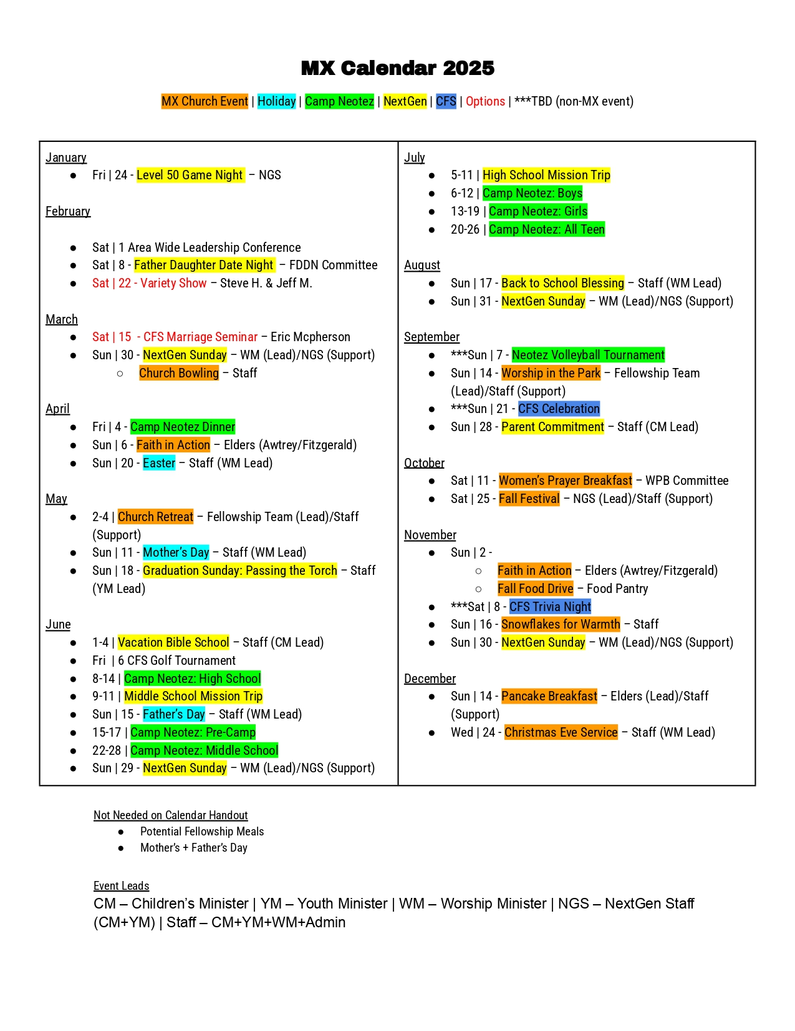

Attachment C.2
DRAFT 2025 Calendar Presented by Steve Walker v2

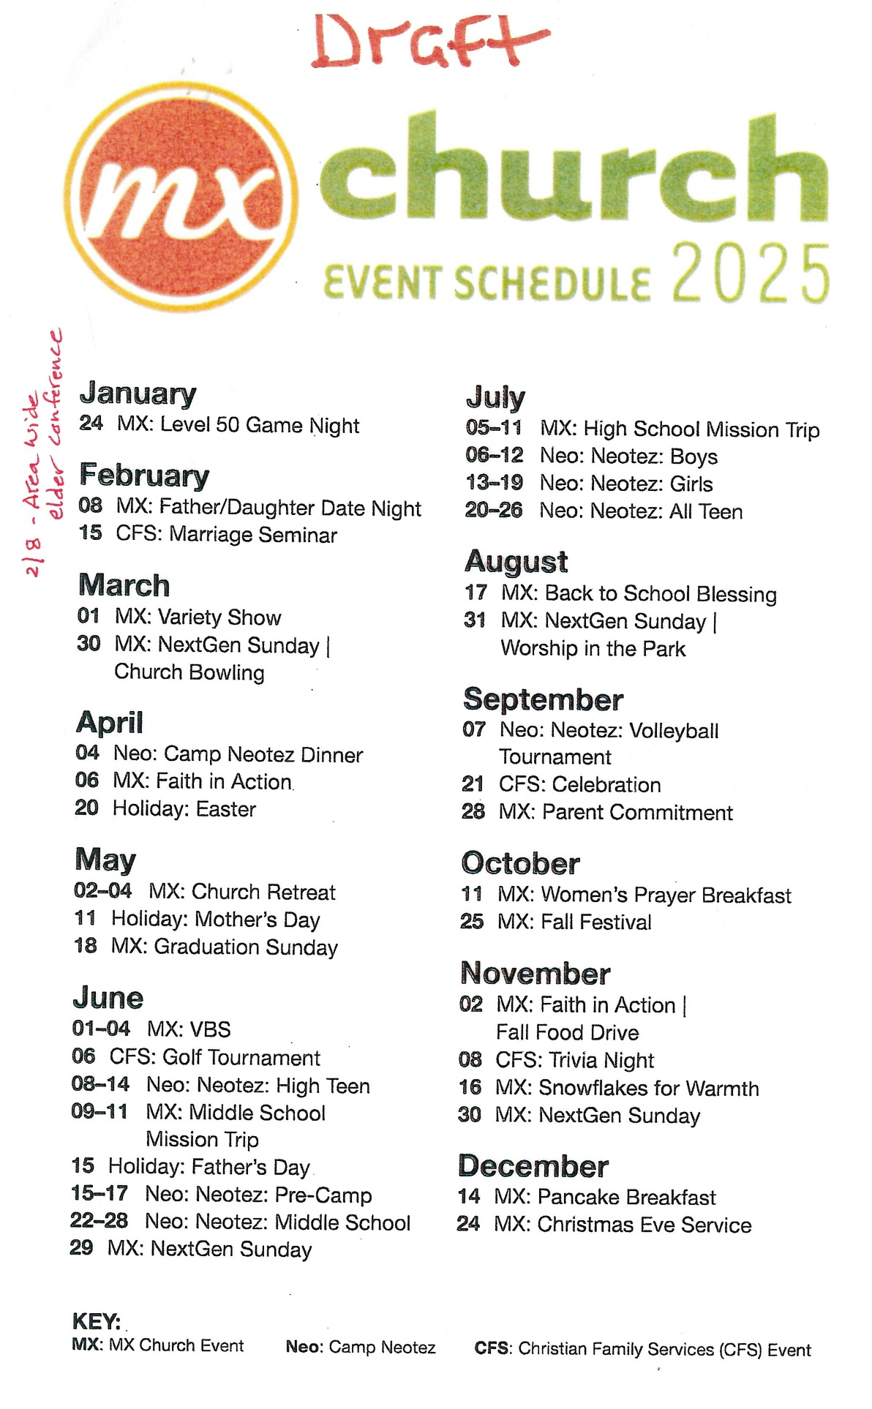

Attachment D

Betheline Outreach Center - Thank you!
Chapelle de Fuveau

https://youtu.be/YO2E2nLyRR4
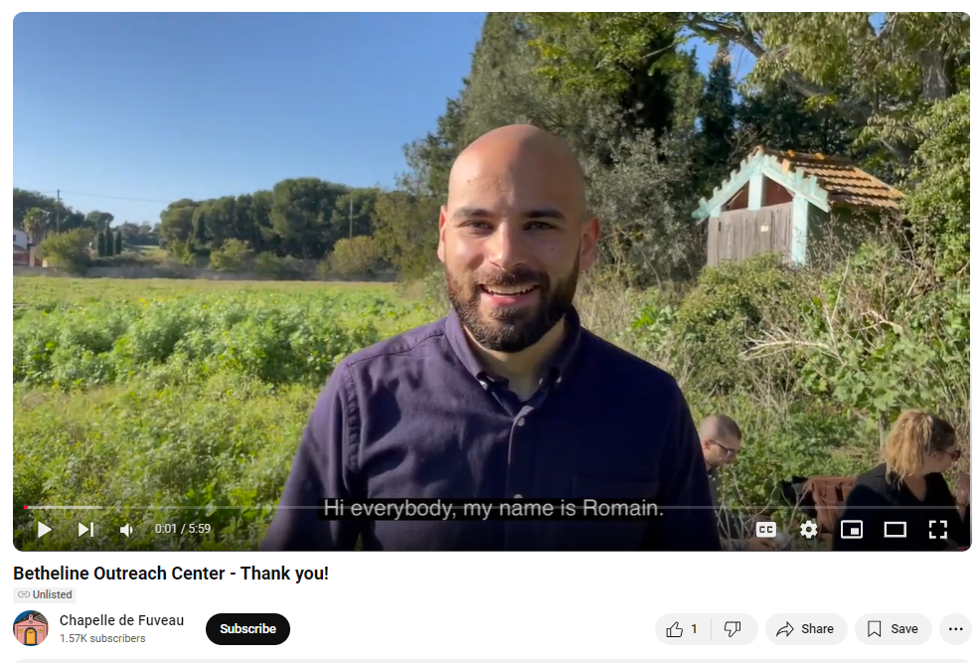

Bret Blackford felt part-time Children’s Minister was sufficient as the “Family Minister” responsibilities did not seem fleshed out yet. This reminds me of Agile Principle 10 – “Maximize the amount of work not done. Keep things simple.” Change only if there is a clearly documented and expected benefit.

