Elders Meeting
January 25, 2024
6pm – 8pm

Attendees: Steve Walker (chair), Don Fitgerald, Brad Stevens, Bret Blackford, Dave Weiler, Steve Awtry, Jeff Kryder, Jeff McGlawn (visit), Ross Brown (visit)

- Devotional
Abide: Remaining, Dwelling, Enduring
John 15:4-5 – apart from God we can do nothing.

- MX Family and Friends Updates/Prayer
{{ various }}
Louis West in hospice care
Becky Kryder – back surgery Feb 7, 2024

- Equipping Leaders for Missions - debriefing
- Leadership Conference held January 20, 2024
- Attachment A – debriefing questions and action items.

- Ministry Search Updates
- Tasks, Interpretation, Communication and Timeline
  - No communication topics or date(s) set – to be discussed at future mtgs.
- Preacher search timeline
  - Senior preacher orientation
  - Bret submitted this draft information to assist potential candidates the Vision Elders – info here - http://tinyurl.com/5fjbrdxf
  - Bret will help coordinate the soft search with direction from Vision Elders.
- Candidate under review
  - Michael Santiago – resume, cover letter, sermon video
- Possible candidates to approach:
  - Nate Reiser – Facebook, sermons,
  - Alden Bass – bio, OCU,

- Prayer with David Weiler
- Heart valve repair later in January

- Potential Leader/Elder Todd Mayberry
  - Decided to wait before approaching Todd about sitting in on Elder meetings

- Other – 2024 Budget
  - Dave Weiler presented the 2024 budget to McKnight on Sunday January 28, 2024. He also explained that McKnight intends to give $100,000 to the Marseilles church ($50,000 now and $50,000 later).
    - 2024 budget - http://tinyurl.com/5n9yxhtx

- Other – Siburt Institute’s “Equipping Leaders for Mission" Conference”. Area wide churches met at the McKnight building Saturday January 20.
  - Session video on YouTube – http://tinyurl.com/bdjt547r
  - Session video on website -- https://siburt.mxcoc.xyz/

MX Youth Group Newsletter (Jan. 24, 2024) – here - http://tinyurl.com/4nfbjha2

Weekly Bulletin (Jan. 10, 2024) – here - http://tinyurl.com/8xc3fzfe

Attachment A

Questions Used for Debriefing on Equipping Leaders for Missions seminar presented by Siburt Institute at the McKnight building on January 20, 2024.

Objective: Determine if there was a piece of information or a concept you heard on Saturday (1/20/2024) that could be valuable for us to take under consideration as a shepherding group or for you as a spiritual leader?

Based on what you heard on Saturday, what is something we are currently doing effectively?

Affirmed MX focus on NextGen emphasis, Pastoral Committee, focus on people, being spirit led (example is MX giving to Marseilles), elder group focus of overseer/pastor/shepherd.

Good for local leaders to know it is ok to wait. Not trying to fill every gap.

Again, based on information from Saturday (1/20/2024), what is something we are currently doing but can make improvement?

We need to encourage leadership within our congregation.
Exodus 18 – delegate

We should engage the wives in Sheppherd meeting occasionally.
How do we get more focused on the spiritual aspect of our shepherding responsibilities and what we feel God is calling us to do (individually and as a leadership)?
How do we communicate better with the congregation?

How do we make some of those improvements?

Time in prayer is important.
Being available to members is important.
Continue to push people into small groups and emphasis the benefits of small groups.

Was there any new information or reframing of a familiar concept that you would like to put on the table for exploration at a future date?

Action Steps:
- Mention small groups frequently on Sundays
- Communication Strategies. How can we better communicate with the congregation and provide avenues for feedback?
- People need to feel comfortable reaching out to the Elders and feel that the Elders are available.
- Invite wives to some of the meetings to encourage the “Shepherding Couples” model and get more diverse thoughts on questions and issues.

Attachment B

Below are some possible questions for the initial phone interview with potential candidates for the Sr. Minister position.

Initial Phone Screening Questions

- In your career to this point, what are you most proud of?

- Tell me about your experience preaching and teaching.

- What are the most important elements in your philosophy of ministry?

- Why do you want to leave your current position?

- How would your former employer and coworkers describe you?

- What would best illustrate your leadership and people skills?

- What are your greatest strengths for this position?

- What are your biggest weaknesses?

- Given the job description, how would you describe your fit for this position?

- Given the job description, what about you might not fit so well?

Attachment C

Senior Minister Search Process – Post Resume (DRAFT)

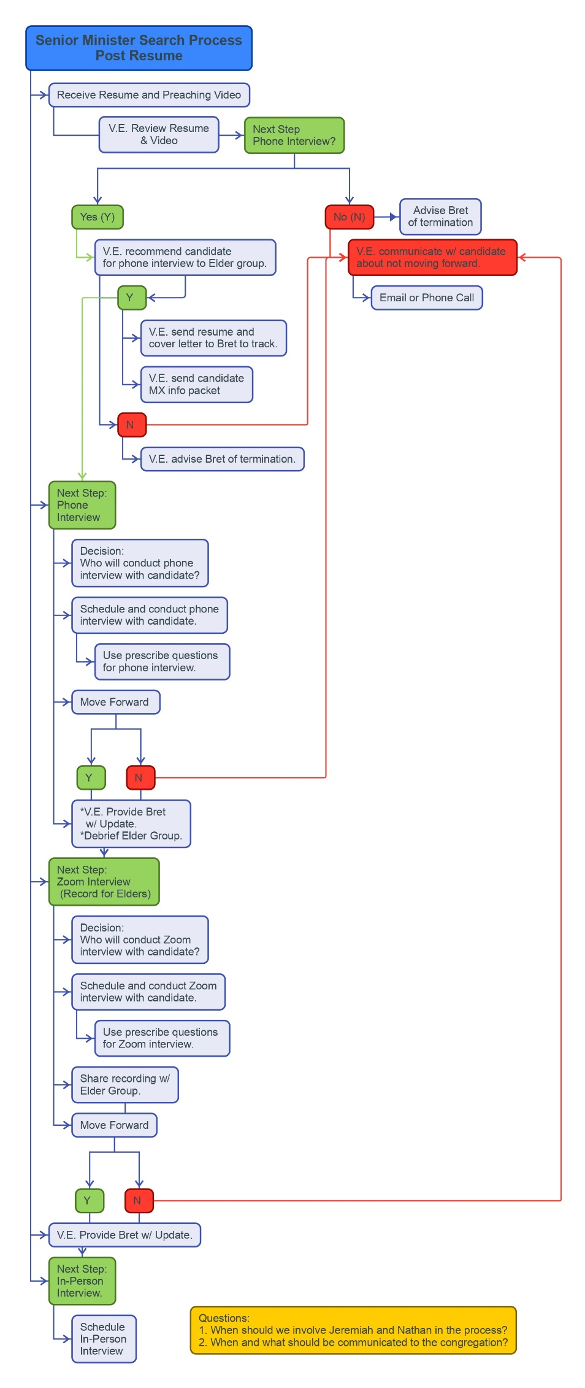
Also here … http://tinyurl.com/yc283cxn
Or here … http://tinyurl.com/54dd8u2m

How to Debrief - https://www.youtube.com/watch?v=e47EihKubZI
Problems with group discussions and decisions noted here … https://www.shepherd.mx.mxcoc.xyz/positions/docs/GroupDecisionMaking-12.09.2020.docx

