Elders Meeting
April 15, 2024
6pm – 8pm

Attendees: Steve Walker, Don Fitgerald (chair), Brad Stevens, Bret Blackford, Dave Weiler, Steve Awtry, Jeff Kryder, Jeff McGlawn (visit), Ross Brown (visit), Nathan Strickland

Next mtg.: May 6 – Dave Weiler chair

- People
{{ various }}

- Children’s Minister Update – Jeff McGlawn
- Jeff McGlawn is using Jeremiah’s computer.
- Mtg Sunday April 14 went well. Brief meeting, which was good!
- About ¼ of kids leave after worship (don’t stay for class)
- Adding instruments (guitar) to kids worship. Alec Hill (and his guitar) was a big hit last Sunday in Children’s worship. Thinking to continue something similar and possibly bringing in Mathew Bardewell and Greg.

- Youth Group Update – Nathan Strickland
Nathan unable to attend as out serving at Church on the Streets.

- Ethan Laster Debrief (after preaching Sunday April 14) – All
Almost universal approval of Ethan Laster (and wife Sarah) after his preaching Sunday April 14. (sermon here).
Elders were able to spend time with Ethan over this weekend:
- Saturday, April 13, dessert at Fitzgerald home: Awtrey, Brown, McGlawn
- Sunday, April 14, lunch at Blackford home: Stevens, Weiler, Walker, Nathan Strickland
- Nathan’s wife Sarah brings many great gifts.
- Nathan and Sarah are young which helps the McKnight demographic. Some concern that youth brings inexperience, but it also brings an open mind to help us “canoe the mountains”. Also remember, Our Lord was 30ish when he started ministry.
- Some worries that Ethan might want to go back into academia. This was discussed and not considered a concern/risk.
- Some MX members indicated the fundamentals are there and the rest can be trained (and Ethan seems coachable).
- Ethan and Sarah currently live in Ballwin but are open to moving closer to the church he ends up serving.
- No red flags noted.

- Sr. Ministry Search Updates – Steve Awtrey

- Summary Document on-line here - https://tinyurl.com/yc8p8tyn.

Consider 1 Samuel 16 and Judges 7 during this process.

- Interviews –
  - Steve Awtrey contacted Michael Santiago and Josh Nix and informed them that they both had excellent qualities but were not yet suitable for our minister position.
  - Patrick Barber – Jeff Kryder made two reference calls. Both spoke positively of Patrick but did not recommend him for our position. Elders decided to pass, and Steve Awtrey will contact Patrick.

- Visits – hoping to get Nathan Laster back for another Sunday early in June to preach and also teach a class. That weekend should also allow an opportunity for Ministry Leaders to mingle with Nathan and Sara, possibly with desserts at MX on the 4th floor Saturday before Ethan preaches. Steve Walker and Steve Awtrey may lead a brief series of questions to help the Ministry Leaders get to know Nathan and Sarah. Not intended to be a formal Q&A session where Nathan gets grilled with deep theological questions. However, Ministry Leaders can ask whatever as they mingle with dessert.

- Next Steps
  - Vison Elders to contact Ethan
    - Indicate McKnight is seriously interested.
    - Possibly draft a “Memorandum of Intent” (or something similar). Not a formal offer, as we need additional feedback from congregation, but an indication that McKnight intends to pursue Nathan as a candidate.
    - to invite Ethan to May elders meeting. Give Ethan an opportunity to talk in more detail about the opportunity and our interest. Make sure the decision is mutually beneficial and any reservations or scheduling issues discussed.
  - Vision Elders to check some of Ethan’s references. Contacting Carson Reed would be good as he has been part of the MX search process since the beginning and will have some good/useful insights into our decision to bring on Ethan to replace Jeff Kryder.
  - Vision Elders to contact Patrick Barber about our decision to pass.
  - Schedule Nathan to preach again sometime in early June.
    - Mingle with Ministry Leaders Saturday for dessert. See more detail in b above
    - Preach Sunday sermon
    - Teach Sunday class
    - Possible congregation potluck for light interaction with Nathan and Sarah. Again, not intended to put Nathan on the spot for Q&A session.
    - Ask Ministry Leaders to meet with elders to get their feedback on Ethan
    - Elders meet to decide if a formal offer should be extended to Ethan.
      - Will need to discuss salary range and recommendation with Admin Elders
      - Will need to clarify start date and any interim preaching prior to start date
      - Will need to discuss how MX will fill preaching after Jeff Kryder retires and Nathan (who will hopefully accept offer) starts.

- Faith in Action – April 21, 2024
Steve Awtrey will be on a beach somewhere so Don Fitzgerald and Bret Blackford will help get a list of projects and direct work crews. There will be a combination of projects around the building as well as a few at neighborhood homes.

The on-going list of building projects is available on-line here - https://tinyurl.com/2svvj695.

- Children’s Ministry Search
An important question was raised –
Q: After having a full-time children’s minister on staff for a couple years do we see the expected value? Would it be a better use of resources to look for a part-time children’s minister and also look for an additional minister to fill-in some gaps – family ministry, worship, evangelism, etc.?

Interim: Jeff McGlawn will take the lead in the children’s ministry starting April and can continue in this role for several months. Expected to work 12-15 hours a week. Additionally, Izzy Henegean will be an intern in this area for the summer, working around 30 hours a week @ $14.50/hr.

Interim Children’s Minister Coordinator job description – see Attachment D.1
Interim Children’s Minister Intern job description – see Attachment D.2

Josh Brown and Jason Vincent are heading up the search team looking for the next Children’s Minister (full or part-time). Children’s Minister Job description on-line here - https://tinyurl.com/3bjkyv75.

Recent survey results here - https://tinyurl.com/y5svyezv.

- Misc.
- Parking: our lot is getting full again. A good problem to have! Prior architectural review of possible lot usage improvement here - https://www.building.mx.mxcoc.xyz/pkng2.html.
- Directory: on-hold for review and discussion at future meetings.

MX Youth Group Newsletter (April 15, 2024) – here - https://tinyurl.com/2vwf2v5e.
MX Kids Newsletter (April 14, 2024) – here - https://tinyurl.com/yc6p28zb.

Attachment A

Ranking sheet also on-line here - https://tinyurl.com/ys3vbkzk

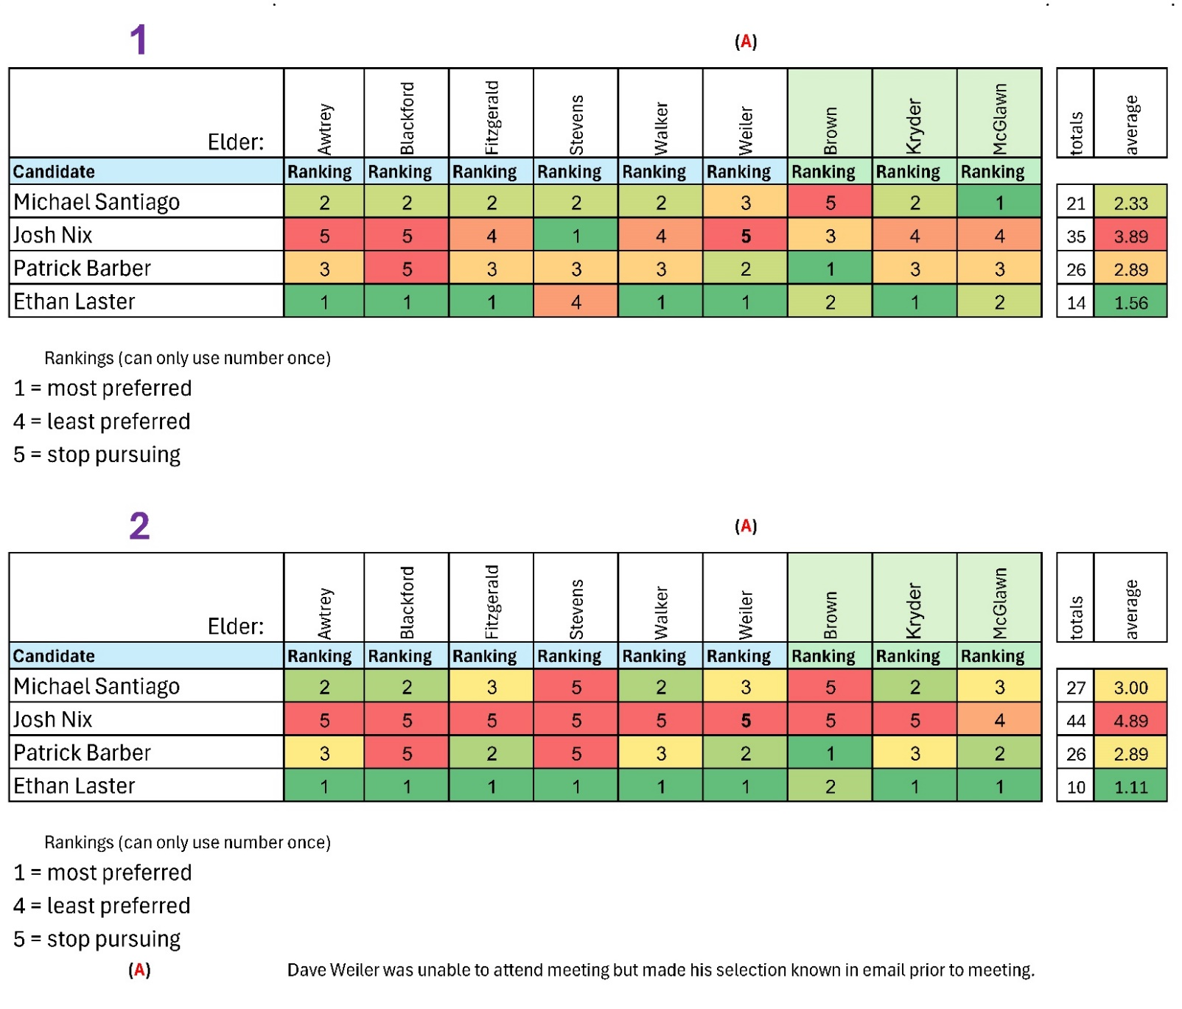

Per the above ranking Ethan Laster is clearly the strong favorite and Josh Nix would not be a good candidate.

All candidates had their strengths and seemed to have a genuine call and desire to serve in ministry and should be encouraged to do so, but Ethan is currently checking off more of the boxes we are looking for here at McKnight.

NOTE: Above ranking taken prior to Patrick Barber’s 2nd interview on March 28. He seems to have strengths but we need to check references prior to moving forward with Patrick.

Attachment B

Minister Search Timeline
 |  | McKnight Crossings Church of Christ
 |  | New Minister Search Timeline
. | . | 2023 |  |  | 2024 |  |  |  |  |  |  |  |  |  |  |  | . | .
 |  | Oct | Nov | Dec | Jan | Feb | Mar | Apr | May | June | July | Aug | Sept | Oct | Nov | Dec
 | Soft Search |  |  |  |  |  |  | Hard Search (starts April 1, 2024)
 |  | (A) | (B) |  |  |  |  |  |  |  |  |  | (C) |  |  | (D)
 |  | (A) | Congregation notified in October 2023
 |  | (B) | Jeff turns 64 November 23, 2023
 |  | (C) | September 1, 2024 Jeff Kryder stops preaching
 |  | (D) | December 1, 2024 Jeff Kryder off payroll
 |  | Note 1: | Elders decided new minister can be brought on whenever suitable replacement found, even while Jeff Kryder still preaching.
 |  | Note 2: | Outside resources, such as Siburt Institute, will be utilized to help find candidates.

Attachment C

Presented at the March 25, 2024 McKnight Elder meeting

5-Fold Leadership Model + Executive

The 5-Fold model is based upon Ephesians 4:11-13: ¹¹ So Christ himself gave the apostles, the prophets, the evangelists, the pastors and teachers, ¹² to equip his people for works of service, so that the body of Christ may be built up ¹³ until we all reach unity in the faith and in the knowledge of the Son of God and become mature, attaining to the whole measure of the fullness of Christ.

- Apostles – extend the gospel. As the “sent ones,” they ensure that the faith is transmitted from one context to another and from one generation to the next. They are always about the future, bridging barriers, establishing the church in new contexts, developing leaders, networking trans-locally.

- Prophets – know God’s will. They are particularly attuned to God and his truth for today. They bring correction and challenge the dominant assumptions we inherit from the culture. They insist the community obey what God has commanded.

- Evangelists – recruit. These infectious communicators of the gospel message recruit others to the cause. They call for a personal response to God’s redemption in Christ, also draw believers to engage the wider mission, growing the church.

- Shepherds - nurture and protect. Caregivers of the community, they focus on the protection and spiritual maturity of God’s flock, cultivating a loving and spiritually mature network of relationships, making and developing disciples.

- Teachers - understand and explain. Communicators of God’s truth and wisdom. They help others remain Biblically grounded to better discern God’s will, guiding others toward wisdom, helping the community remain faithful to Christ’s word.

Added:

- Executive – Administrate operational aspects. They play a key role in strategic planning, human resources, finance, recruitment, and all functional activities to ensure alignment with and accomplishment of the church's mission and vision.

Attachment D.1

Presented at the March 25, 2024 McKnight Elder meeting

Responsibilities for Interim Children’s Minister Coordinator (12-15 hours per week)
- Plan and serve in curriculum & events for ministry to Children ranging in life stage from newborn to 5th grade.
  - Children’s Worship
  - Bible Classes
  - Nursery
  - Milestones in Worship
  - Big Events (VBS, Back to School, Trunk or Treat, Father Daughter Date Night) - limited
  - Other Events in partnership with Youth Minister
- Available to families, Discipleship Leaders, and Volunteers on Sunday mornings.
- Communicate content summaries (weekly newsletter) & upcoming events with families and congregation through various print and social media venues.
- Recruit, train, & coach Discipleship Leaders and volunteers to serve various roles in the ministry.
- Participate in meetings with staff and elders (2x per month)
- Build relationships with families of Children and with our church family.
- Facilitate monthly Children’s Ministry Council meeting & leverage input.

Attachment D.2
Presented at the March 25, 2024 McKnight Elder meeting

Responsibilities for the Intern to the Children’s Minister Coordinator (CMC). The intern will work approximately 30 hours per week. (Three 8 hours on weekdays and 6 hours on Sundays)

Provide assistance to the Interim Children’s Minister Coordinator. Helping him with implementing curriculum & events for ministry to Children ranging in life stage from newborn to 5th grade. These include:
○ Children’s Worship
○ Bible Classes
○ Nursery
○ Milestones in Worship
○ Big Events (VBS, Back to School, Trunk or Treat, Father Daughter Date Night) -

- Under the guidance of the CMC the intern will provide assistance to fulfill the duties required to staff and prepare the nursery for Sunday mornings.
- Under the guidance of the CMC the intern will provide assistances to fulfill the duties required to prepare the Children’s bible study classrooms for Sunday mornings. Including making sure classroom materials are in rooms, volunteers have teaching materials and confirm adequate staffing as prescribed by CMC and preparing bulletin boards.
- Helping with NextGen milestones and big events.
- Attend NextGen meeting on Tuesday mornings and weekly staff meetings.
- Other duties as assigned by CMC and Senior Minister.

Bret thinks it a good idea to also explicitly invite former elders and elders-in-training to the dessert meeting. These men have served McKnight well and their input would be helpful. It will also give them the respect they deserve. I was thinking Steve Haupt, Steve Jones, Keaton Jones, Glenn Devania, and Jon Earnhart. Not sure of widows like Kay H., Suzie B., Joyce W.

