June 2023

**McKnight Crossings Church of Christ**

Plan for Transitioning to a new Senior Minister

Table of Contents

**Jeff Kryder Retirement:** 2

Retirement Date: 2

Retirement Gift: 2

Jeff’s Transition 2

**New Minister Search** 3

Job Requirement 3

Hire Date 3

Search Process 3

**Decisions and Action Items:** 4

**Summary** 5

**Exhibit A –** Retirement Proposal 6

**Exhibit B -** Requirements 7

**Exhibit C –** transition timeline 8

**Exhibit C.1 –** Bret hire timeline 9

**Exhibit C.2 –** Siburt hire timeline 10

## **Jeff Kryder Retirement:**

Jeff Kryder, Senior Minister, has given notice of his intent to retire at the end of 2024. After several decades of ministry Jeff indicated he is ready to step down as the full-time pulpit minister. On November 23, 2024, Jeff will be 65 and eligible for Social Security. This will provide Jeff the healthcare and financial benefits he will need to allow him to retire.

The selection and transition of the Senior Minister is a major event for a congregation and should be undertaken with care, planning, lots of discussion, and prayer. This document should be considered a tool in assisting to focus the various issues, action items, and decisions.

### Retirement Date:

The specific retirement date not yet determined. Jeff turns 65 on November 23, 2024 and will then be financial ready to retire. If Jeff is needed to step down from the pulpit prior to his 65th birthday he will still need an income until his November 23 birthday.

Several workable options have been considered:

* Jeff continues as full-time pulpit minister until retirement on November 23, 2024
* Jeff steps down as full-time pulpit minister sometime mid-2024 and continues as part-time pulpit minister. See **Exhibit A**
  + If Jeff were to function as part-time minister he would still need to be relieved of his other administrative and ministerial duties. His primary role in a part-time capacity would be pulpit minister.

### Retirement Gift:

The MX leadership needs to consider an appropriate way to express our appreciation and gratitude for all of Jeff Kryder’s work, love, and commitment over his years of service. As noted in **Exhibit A**, if initial proposal followed we would be gifting Jeff Kryder over $X,XXX.00. We should determine if this is appropriate or excessive and decide on an appropriate gift considering the current budget.

### Jeff’s Transition

Jeff Kryder is a gifted speaker and has helped shepherd the Mid-County and Mcknight churches for many years. This can be considered helpful or problematic with transitioning to a new Senior Minister.

Helpful:

* Jeff is a mature brother who could prop-up the new minister. The transition could be seen as less of a speed bump and more of a natural progression, with Jeff stepping down to retire and passing the baton to the new pulpit minister. Jeff’s presence could also calm the congregation and assure them there is no internal problems or issues causing the transition but a natural planned progression.
* The Shepherds have come to respect Jeff over the years and want to continue to have his gifts available to help strengthen the McKnight congregation. We also prefer to have Jeff continue to worship at McKnight during and after the transition.

Problematic:

* With a strong personality and connections with the congregation, Jeff could unintentionally undermine the authority of the new Senior Minister. Jeff’s presence may also inhibit the ability of the new Senior Minister to work with the Shepherds on strategy and planning. The new church leadership (Senior Minister and Shepherds) should be free and unencumbered in decision making.

Some organizations[1] with experience in working with minister transitions have advised have a gap between when the current minister steps down and the new minister begins. This gap is termed a “liminal space”, which is intended to give the congregation time to process the transition and plan for the next phase (McKnight 2.0). The hope is that the gap will allow the Shepherds and the congregation to re-focus and hit the ground running with the new minister.

## **New Minister Search**

Finding a suitable replacement pulpit minister should be a primary focus of the elders. The role, and the person, will be a key touchpoint for the congregation.

Due to the importance of the position and the limited pool of available candidates it is being considered if it would be helpful to engage a consulting group, such as …

* **Siburt Institute for Church Ministry** (<https://www.siburtinstitute.org/>)
* **Interim Ministry Partners** (<https://interimministrypartners.com/>)

**Siburt Institute**: On June 5, 2023, the elders met with Carson Reed and Shelby Coble to discuss search options. The recording of that session is available here … <https://tinyurl.com/2bxyjtkt>. This was a helpful early discussion with some insight into the challenges of finding a Senior Minister and focusing a church in the current environment.

### Job Requirement

See **Exhibit B** for initial draft.

### Hire Date

Several considerations on when McKnight might want to bring on a new minister.

Originally, most of the leadership considered starting a search process soon, well before Jeff Kryder were to step down from the pulpit, with the hope of hiring someone while Jeff Kryder was still a McKnight minister. This would provide continuity, a chance for the new minister to learn about McKnight while Jeff can mentor and provide a transition time for the congregation to wean off Jeff kryder and warm up to a new minister. This timeline might best close to that noted in **Exhibit C.1**.

Consulting group Siburt Institute suggested that Jeff step down from the pulpit before even starting the search process. Their research and anecdotal experience lead them to recommend a “Liminal Space” which allows for a healthy transition to a new minister and a renewed purpose and vision for McKnight. It is recommended that when bringing on a new minister it is a good time to re-evaluate the key vision and objectives of the McKnight church. This is a time to engage the congregation to build a vision and a path that a new minister would be hired to carry out. This timeline might best close to that noted in **Exhibit C.2**.

### Search Process

Options considered:

1. Managed internally by McKnight leadership
2. Use outside consultants
   1. **Siburt Institute for Church Ministry** (<https://www.siburtinstitute.org/>)
   2. **Interim Ministry Partners** (<https://interimministrypartners.com/>)

#### Elder Lead

The elders would like to lead the search process. No search committee.

After mixed results with search committees in other areas (Youth Minister, Children’s Minister), it was decided that the elders need to make the time and take responsibility for replacing Jeff Kryder. Even though the elders will take responsibility for the selection process it is recognized that the congregation will need to be consulted at various stages. When and how is still to be determined.

## **Decisions and Action Items:**

1. Determine Jeff Kryder last day
   1. As Full-time minister
   2. As Part-time minister
2. When to communicate Jeff’s retirement to congregation
3. Determine Jeff Kryder retirement gift / benefits
4. Decide if Jeff Kryder and new minister can overlap or if some separation time is needed
5. Decide when to start looking for new minister
6. Decide how to look for new minister
   1. Managed internally by McKnight
   2. Use consulting firms
7. Decide on job requirements (see draft at **Exhibit B**)
8. Decide on salary range
9. If interim preaching team will be used …
   1. Who will be in that rotation
   2. Who will help draft the preaching topics
   3. Will external ministers be needed/desired
   4. Would we be willing to use video sermons

## **Summary**

To manage Jeff's transition effectively, the following steps are recommended:

1. Communication: Open and transparent communication with the congregation is vital. Regular updates should be provided regarding Jeff's retirement plans and the process of finding a new Senior Minister.
2. Leadership Support: The Shepherds should publicly express their appreciation for Jeff's service and communicate their support for his transition to retirement. This will help alleviate concerns within the congregation and establish a positive atmosphere for the new Senior Minister.
3. Role Definition: Clearly define Jeff's role during the transition period. If he steps down as a full-time pulpit minister and continues as a part-time minister, outline his responsibilities and ensure he focuses primarily on preaching. It is essential to relieve him of administrative and ministerial duties to avoid any potential conflicts or confusion.
4. New Minister Search:
5. Job Requirements: Develop a comprehensive list of the desired qualifications, skills, and experience for the new Senior Minister. This should be based on the needs and vision of the congregation. Refer to **Exhibit B** for an example of job requirements.
6. Hire Date: Determine a target date for hiring the new Senior Minister. This will help create a timeline for the search process and ensure a smooth transition.
7. Search Process: Establish an elder-led search committee. This committee will be responsible for advertising the position, reviewing applications, conducting interviews, and ultimately recommending a candidate for consideration by the Shepherds and the congregation. It is important to involve the congregation in the selection process by seeking their input and feedback.
8. Decisions and Action Items:
   1. Decide on an appropriate retirement gift for Jeff Kryder, considering the budget and expressing gratitude for his years of service. Assess the proposed amount mentioned in **Exhibit A** to ensure it aligns with the current financial situation of the church.
   2. Develop a transition timeline (refer to **Exhibit C**) that outlines key milestones and responsibilities for both Jeff and the new Senior Minister. This timeline will help guide the congregation and ensure a structured transition process.
   3. Review and approve the hire timeline for the new Senior Minister (refer to **Exhibit C.1** for an example). This timeline should include important dates such as application deadlines, interview periods, and the announcement of the selected candidate.
   4. Consider the potential hiring of an interim minister to fill the gap between Jeff's retirement and the arrival of the new Senior Minister. This will ensure continuity of leadership and support during the transition period.
9. Implementation and Evaluation: Execute the transition plan, regularly assessing progress and making necessary adjustments. Provide updates to the congregation, keeping them informed about the search process and the expected timeline for welcoming the new Senior Minister.

By following these steps and utilizing the provided exhibits as references, the McKnight Crossings Church of Christ can navigate the transition to a new Senior Minister successfully. With careful planning, open communication, and support from the congregation, the transition can be a positive and transformative experience for all involved.

## **Exhibit A –** Retirement Proposal

This was originally presented at the April 17, 2023 MX Elder Mtg.

**Jeff's Retirement Discussion (**Apr 12, 2023**)**

**with Dave Weiler and Don Fitzgerald**

Proposal

1. Jeff to retire from full-time service at MX on May 31, 2024.
   1. This 1 year+ allows for Jeff's to focus his ministry for his last year.
   2. This 1 year+ allows for Jeff to prepare certain people and ministries for this transition.
      1. Worship.
      2. Spiritual Formation.
      3. Fellowship Ministry.
      4. Outreach Ministry.
      5. Staff Management (Job Descriptions, Reviews, Staff Development, File Management).
      6. Guest / New Member Ministry.
      7. Pastoral Team.
      8. Leadership Development.
      9. Next Gen milestone development.
      10. Young Adult / Young Couples Ministry.
      11. 2nd Elder Meeting of Month - creating process for praying, reporting, and feedback with Elders at 2nd meeting per month.
      12. Building Beautification Ministry.
   3. This 1 year+ allows for the church (leadership) to prepare for and secure a new Senior Minister. Start date in August or September of 2024.
   4. Regular (monthly) meetings with Elders (Don, Dave) will be helpful.
2. The church will "carry" Jeff's insurance and salary through Jeff's birthday in November of 2024 when Jeff will be 65.
   1. Jeff may serve in a partial service and / or leadership capacity during this time or in-line with Carson's recommendation can be gone completely.
   2. This will allow Jeff some "runway" for transitioning to new and different work for a few years. Examples:
      1. Start tutoring business.
      2. Non-profit Church / Ministry consulting and / or consulting.
      3. Fund Raising work for L'Arche, for instance.
3. Regular Meetings (monthly) with Don and Dave.
   1. Jeff to prepare and present ministry plans and updates at these meetings.
   2. Jeff to help with transition process in finding new Senior Minister.
   3. Jeff to have outlet for conversations in order to "finish well."

## **Exhibit B -** Requirements

Based on the responsibilities currently filled by Jeff Kryder, the qualifications and responsibilities of the new senior minister/pulpit minister at McKnight Crossings Church of Christ could include:

Qualifications:

* ~~A degree in ministry, theology, or a related field~~
* Experience in preaching, teaching, and leading a congregation
* A strong understanding of Scripture and the ability to effectively communicate its message
* A commitment to prayer and spiritual growth
* Strong interpersonal skills and the ability to counsel and guide others
* A willingness to work collaboratively with other ministers and the elders
* Married male, preferably with children

Responsibilities:

* Delivering the Sunday sermon and planning the liturgical calendar
* Assisting with the planning of the Sunday service and preparing those who will assist
* Planning and leading Bible studies and providing resources for small groups
* Serving as a spiritual guide and counselor for members and the community
* Presiding over weddings, funerals, and other major life events
* Assessing the health of the congregation and finding ways to maintain congregational health
* Leading community outreach events and connecting the congregation with the local community
* Addressing cultural issues and knowing how to address them with the congregation
* Training, directing, and mentoring other ministers
* Overseeing office staff
* Communicating and coordinating with the elders

It may also be recommended or nice to have for the new senior minister/pulpit minister to have experience in:

* Evangelism and outreach
* Leadership and organizational management
* Pastoral care and counseling
* Multi-generational ministry
* Technology and social media
* Working with volunteers

The input and counsel of individuals with experience in congregational leadership, ministry, and staffing, such as Carson Reed, could be valuable in determining the qualifications and responsibilities of the new minister and in the search process.

## 

## **Exhibit C –** transition timeline

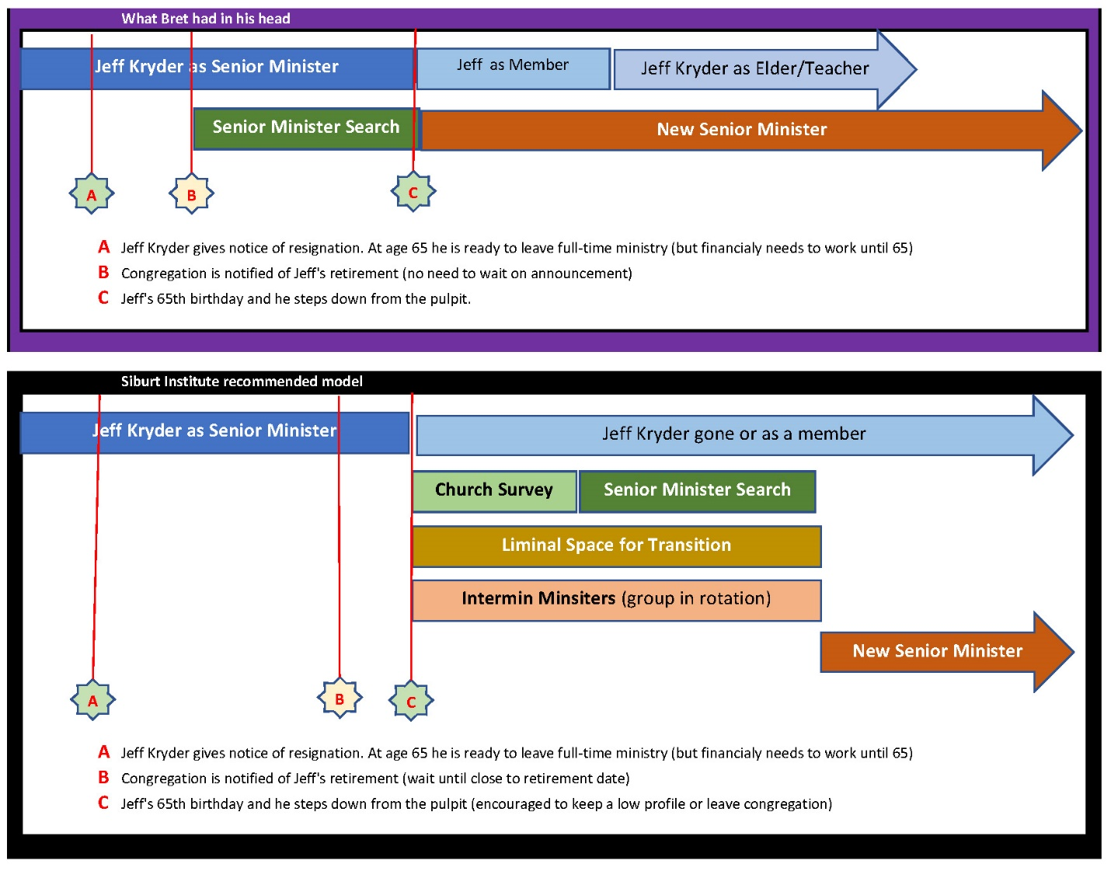

## **Exhibit C.1 –** Bret hire timeline

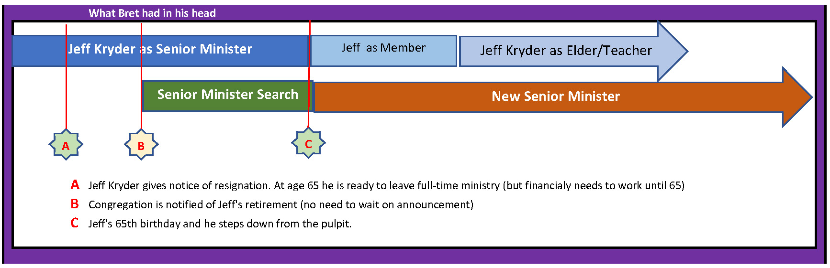

## **Exhibit C.2 –** Siburt hire timeline

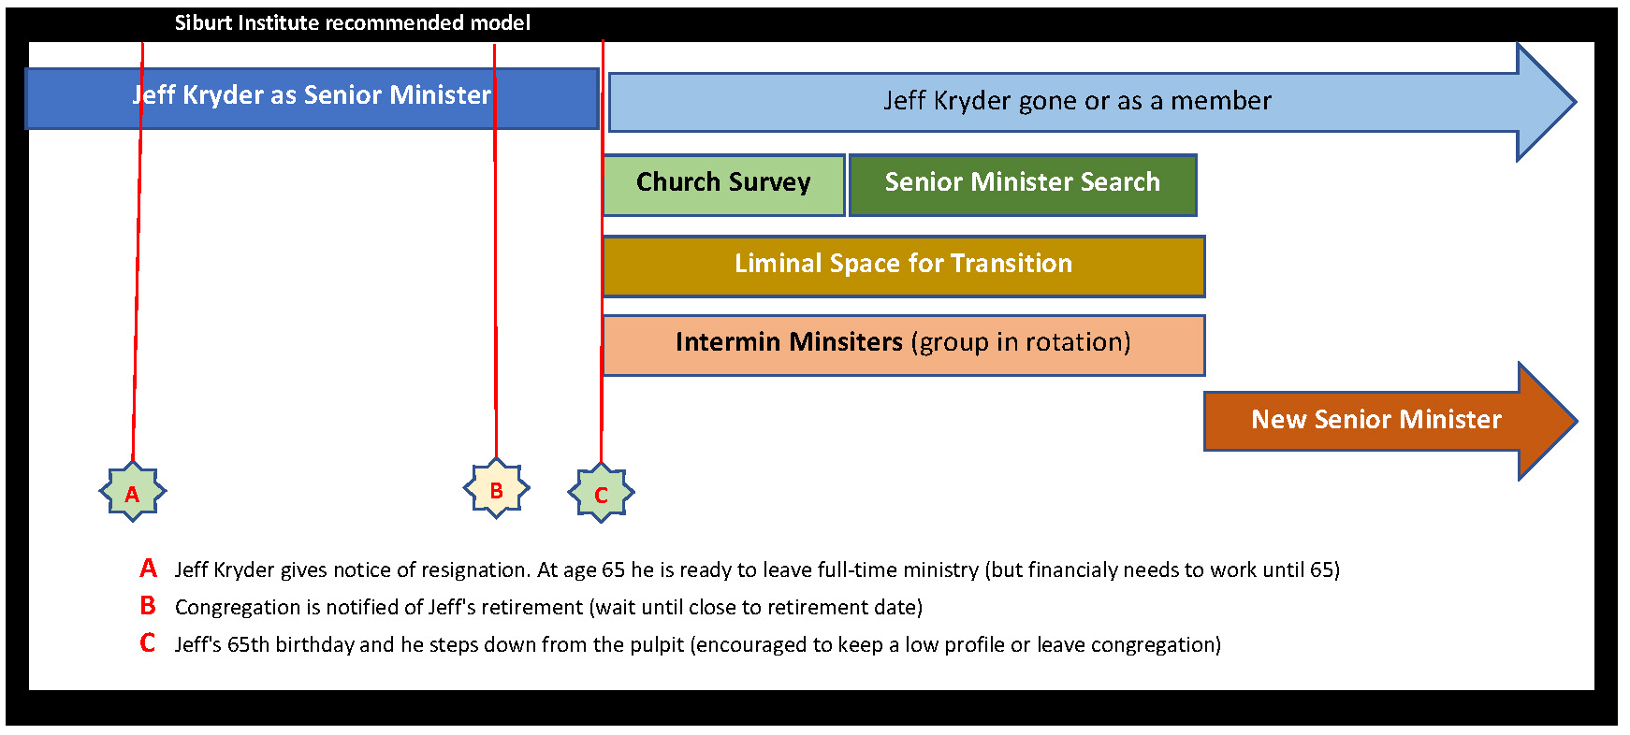

1. Sibert Institute for Church Ministry (<https://www.siburtinstitute.org/>) and Interim Ministry Partners (<https://interimministrypartners.com/>) are examples of Church of Christ based organizations that advise time between ministers.