Elders’ Meeting
December 4, 2023
Agenda & Notes

Attendees:
Dave Weiler, Steve Awtrey, Steve Walker, Bret Blackford (chair), Keaton Jones, Don Fitzgerald, Brad Stevens

Jeff Kryder, Jeremiah Haywood, Nathan Strickland

Next meeting January 2024 chaired by Steve Walker

Contents
1. Leadership 2
2. Update on Members and Concerns [15-min all] 2
3. Nathan Strickland updates [5-min] 2
4. Jeremiah Haywood updates [5-min] 2
5. Jeff Kryder updates [10-15 min] 3
6. Directory Updates [10-min Kryder/Stevens] 3
7. 2024 Budget Discussion [10-min Weiler] 3
8. Update on Area Wide Elders Conference at MX in January [7-min Awtrey] 4
9. LGBTQ+ [5-min] 4
10. Upcoming Dates 4
Attachment A.1 – MXYG Calendar 5
Attachment A.2 – MXYG Calendar 6
Attachment B – MX Kids Ministry 2024 Calendar 7
Attachment C – MX Kids Ministry Council 9
Attachment D – Requested Infant/Toddler Room Change 10
Attachment E – MX Kids Min Mission, Vision, Pledge 11
Attachment F.2 – draft Senior Minister Job Description 12
Attachment F.2 – draft Senior Minister Requirements 13
Attachment G – Minister Search Timeline 14
Attachment H.1 – 2023 Year in Review 15
Attachment H.2 – 2023 MX Ministries 16
Attachment H.3 – 2023 Connect Groups and Huddle Groups 17
Attachment I – Church Center App & QR Codes 18
Attachment J – 2023 Church Calendar 20
Attachment K – Elders and Ministers (photo) 21

- Leadership – thank you, Keaton! [7-min Bret]
- Keaton Jones stepping down 12/31/2023
- Louis West – should we ask if he is also needing to step down 12/31/2023?
Steve Walker to discuss with Joyce West prior to January 2024.
- Possible Elders-in-training:
  - Ross Brown, Jeff McGlawn, Matthew Bardowell.
  - Are current elders in agreement with these 3?
All elders are in agreement with the 3 candidates proposed. No reservations noted.
  - Has anyone contacted them?
All but Ross Brown have been contacted. Bret Blackford will discuss the opportunity with Ross.

- Update on Members and Concerns [15-min all]
{{ various }}

- Nathan Strickland updates [5-min]

Ministry Update
The only thing worth mentioning recently is that Zoe Parkinson reached out to me asking about being baptized. That's a big deal! As well as me having a baptism conversation with David Bardowell and have decided that he will be baptized on Wednesday, December 13.

Calendar
I'm attaching my winter calendar months (Dec-Feb). As for me personally, I am taking my vacation days every Thursday for the rest of the year, as well as Monday, December 18. – Exhibit A

MXYG Newsletter – Nov 27 https://tinyurl.com/3jetfpf7
MXYG Newsletter – Dec 04 https://tinyurl.com/246wussc

- Jeremiah Haywood updates [5-min]

Update 1: An update for our ministry is that I have created a Kidmin council consisting of 7 individuals who will serve as an advisory board for me. This group will meet with me via Zoom once a month to discuss ministry updates and concerns. They will speak about planned events and help me streamline our ministry more. I have attached the document covenant that was sent to this group – Exhibit C and online here - https://tinyurl.com/37shj7b6

Update 2: I have spoken with Bret regarding continuing forward with our expansion plan in our MX Beginners space. The proposed plan is to knock down the wall separating the two rooms and put in an accordion door. We recognize that this will solve one problem (space limitations) but won’t solve the problem of limited volunteers. I plan to work with the Kidmin Council to address this problem. Exhibit D

Keaton Jones and Don Fitzgerald to investigate work and start when ready.

Update 3: For the next couple of weeks, our children will practice during Bible class in the auditorium on December 3rd and 10th. I am currently working with Brian Hill regarding lighting, uploading slides, and tech. Give the crew who have worked hard on our MX Kids Christmas experience a nice thank you. Team: Valerie Creech, Peggy Hope, Gwen Walker, Matthew Bardowell, Rachel Bardowell, and Brian Hill

Update 4: I am finalizing our 2024 Kidmin calendar. I have sent it over to our Council members to comment on things that are missing, dates that can’t work due to school, and threats. I have taken the SWOT Analysis approach to planning the calendar. Note: the pool party is changing to TBD to coincide with the Grimshaw’s schedule. Please see the attached schedule for your records. Exhibit B and online here - https://tinyurl.com/4y24bv24

MX KIdMin newsletter – Dec 06 https://tinyurl.com/zakpnn39

- Jeff Kryder updates [10-15 min]
- Revised Job Description and Requirements Exhibit F

All elders agree with the draft job description. During soft search this is workable but additional detail will be needed for key items before hard search begins in April 2024.

Prayer and Fasting – As Brad Stevens pointed out, we need to seek and trust God in this decision. We need to be praying and fasting individually and as a leadership group. God may take us in a direction we haven’t planned, and we need to be open and listening.

- Directory Updates [10-min Kryder/Stevens]
- Jeff Kryder and Brad Stevens to make recommendations
some suggested changes (from an early email – subsequently updated):
- We wanted to produce a better name than “Shut ins” (perhaps “Medically Challenged”). In that category we had listed Alice Ferry, Norma Janes, Dru Knotts and Janet Patrick.
- We also thought that there could be a listing of “Former members” for those who left in good standing and wanted to stay in touch. Jerry and Lana Fox, Jim and Freddy Griffith, Jake and Jessica Munoz and Lane and Kim Hamm came to mind.
- We also wanted to denominate a group of “Friends” who are not members but show up consistently. For example, Craig and Heather Hamby, Drew and Erica Sevic, Stephen and Roxanne Worthy. There may be more folks in this category that we have overlooked.
- In terms of “deletions” we produced the following: Sara Henagean {but include Izzabelle Henagean}, Weston and Rachel Rathje, Quain and Melissa Tull, and John Watters. Per our last conversation perhaps move John to “Former Members”?
Latest directory here … https://tinyurl.com/dh4f2sfz.
Note: Brad Stevens and Jeff Kryder will make another review of the directory and present recommendations to the Elders in the January 2024 meeting.

- 2024 Budget Discussion [10-min Weiler]
Budget not yet ready. Expect review next Elder meeting early January 2024.

- Update on Area Wide Elders Conference at MX in January [7-min Awtrey]
Below information per Steve Awtry
- Date: January 20, 2024
- Time: 8:00-1:00ish (breakfast & lunch provided)
- Agenda: TBD, but Carson Reed and Siburt Institute will work with Steve Awtry and others to craft an agenda
- Attendees: so far 8 churches signed up. Invitation to elders and wives. Fee: $500.00 per attending church
- Sunday Sermon: January 21, 2023. Siburt has offered to preach.
  - We have Dr. Carson Reed and Shelby Coble to preach on Sunday, January 21st
  - Topics for that Sunday’s sermon below …

1. Ready, Set, Wait (Acts 1:1-11) The earliest church began---not with Peter's sermon on the day of Pentecost---but with Jesus' command and promise in Acts 1. What does it mean for a church to practice waiting?

2. Mission over Maintenance (Matt. 9:35-10:4) In Matthew's telling of the sending of the apostles, he offers four valuable elements of mission to his church---and to us today: healthy theology, practice prayer, God gives the gifts, and the power of community.

3. What is Good News? (Isaiah 40:1-11) The ancient prophet speaks words of peace and hope to weary people. This word called for preparation to receive extraordinary news that God is showing up in our world---then and today!

Sermon #2 was selected for the January 21st Sunday sermon.

- LGBTQ+ [5-min]
I have asked Dave Weiler to summarize some of his thoughts after reading on the subject and giving it deep thought during much of 2023. Dave indicated he would be ready to summarize some things Jan/Feb 2023.

Steve Awtrey also sent this link for consideration … I Love My Church | A Message from Andy Stanley on YouTube here - https://www.youtube.com/watch?v=kzxSi5KVkEE

Dave Weiler will present his thoughts on the topic in writing at the January 2024 Elder meeting.

- Upcoming Dates

12/17 - Pancake Breakfast / Children's Christmas Program During Worship / No Bible Class
12/24 - Christmas Service / No Bible Class
12/24 - Christmas Eve Worship
12/31 - No Bible Class

1/7 - Craig Young Preaches / Bible Class Next Gen Milestone Vision
1/14 - New Bible Class Begins - Recommitting to God's Great Cause
1/20 - Leadership Conference at MX
1/21 - Carson Reed and Shelby Coble Preach

2/15 - Easter Devo rollout (signup here -- https://tinyurl.com/2muerjt6)

Steve Walker is up to lead Elder Meetings in Jan and Feb.

Attachment A.1

Attachment A.1 – MXYG Calendar

MXYG Newsletter - https://tinyurl.com/3jetfpf7

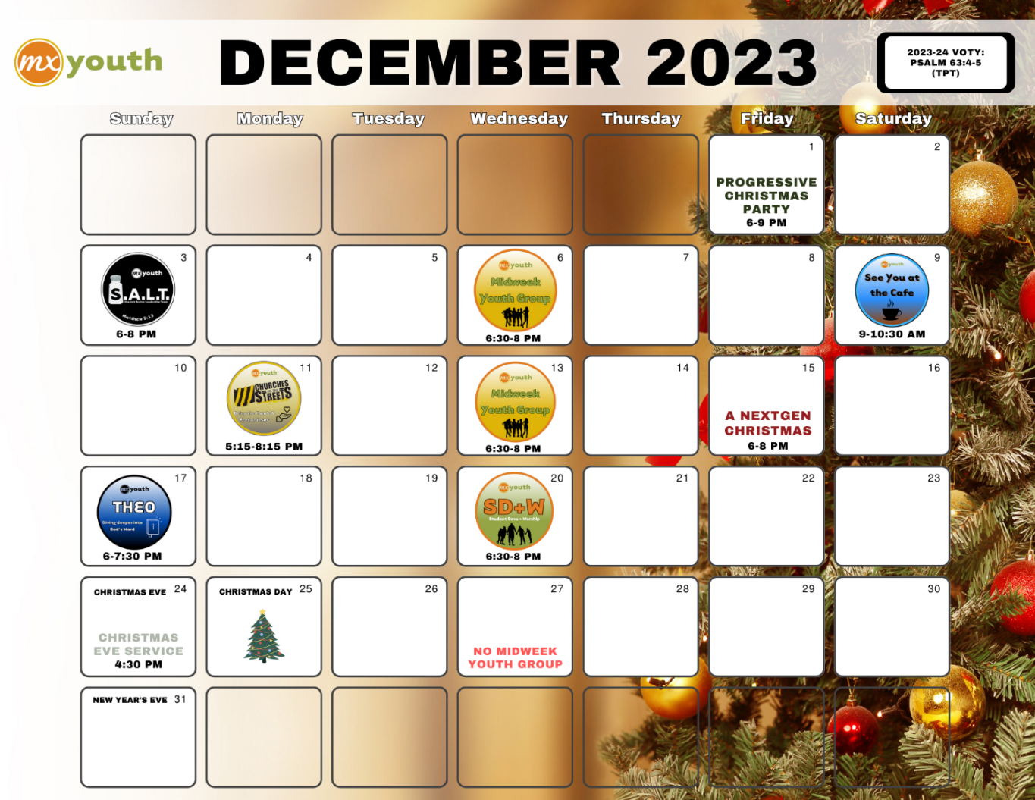

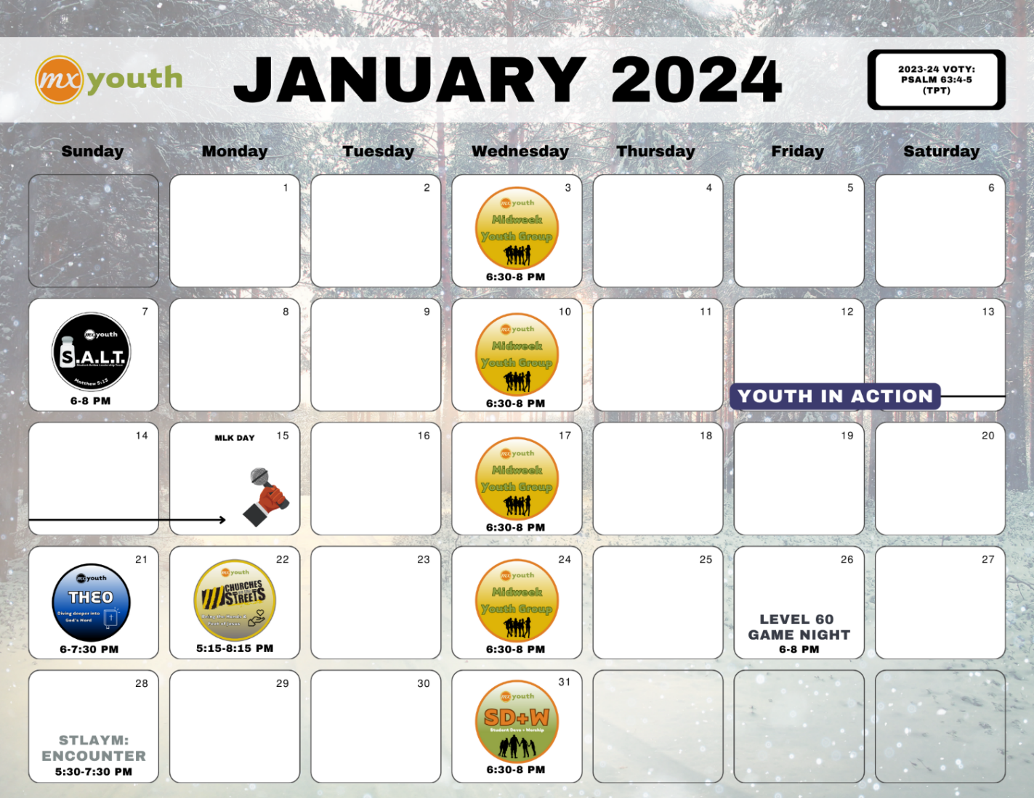

Attachment A.2

Attachment A.2 – MXYG Calendar

MXYG Newsletter - https://tinyurl.com/3jetfpf7



Attachment B.1

Attachment B – MX Kids Ministry 2024 Calendar

Also available on-line here … https://tinyurl.com/4y24bv24
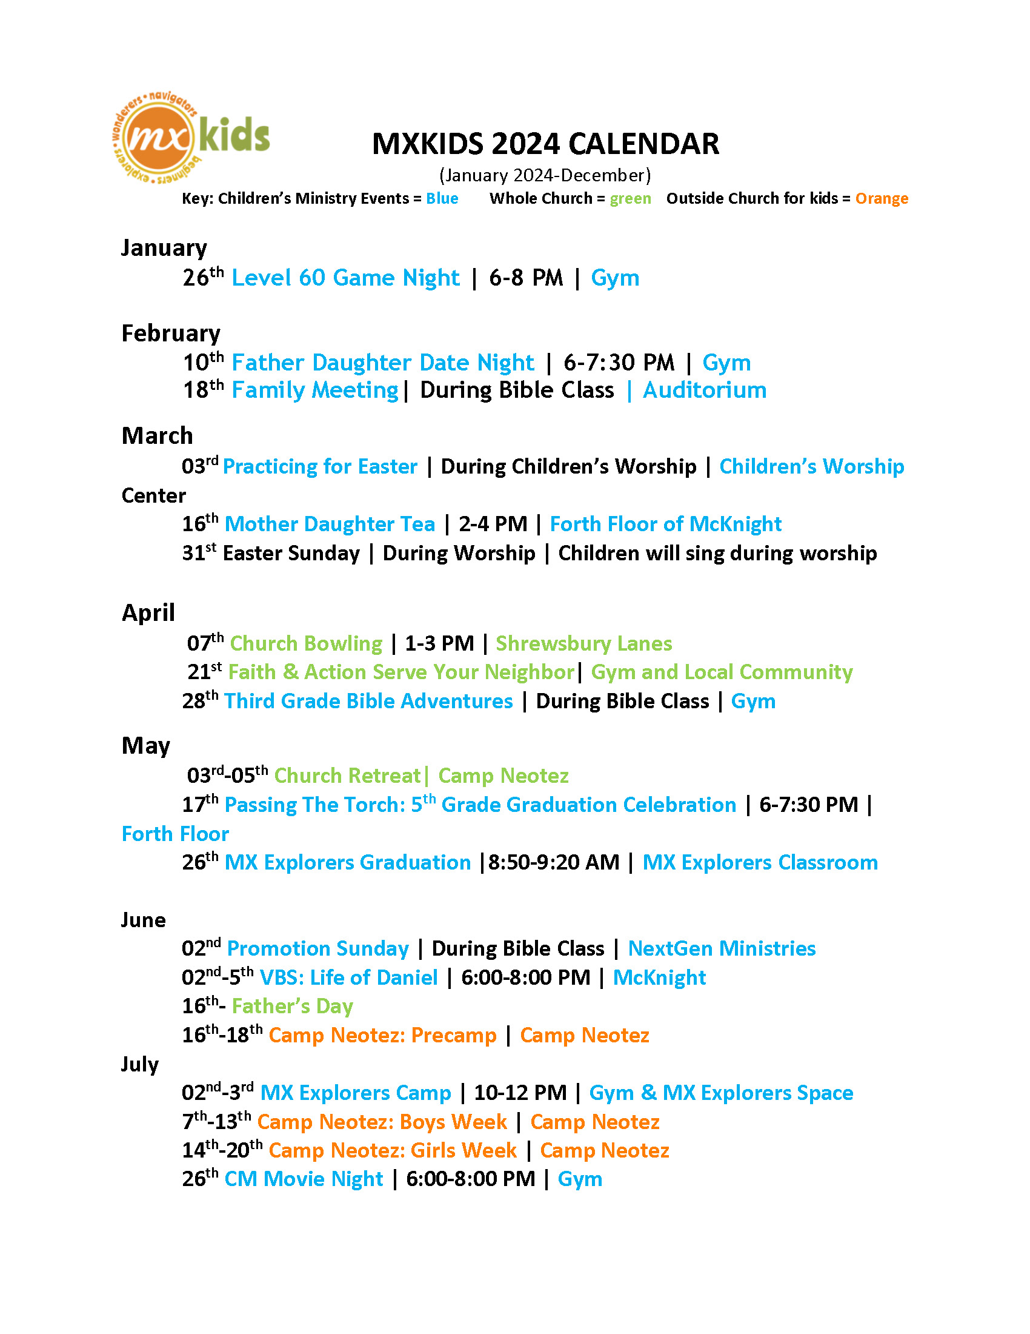

Attachment B.2

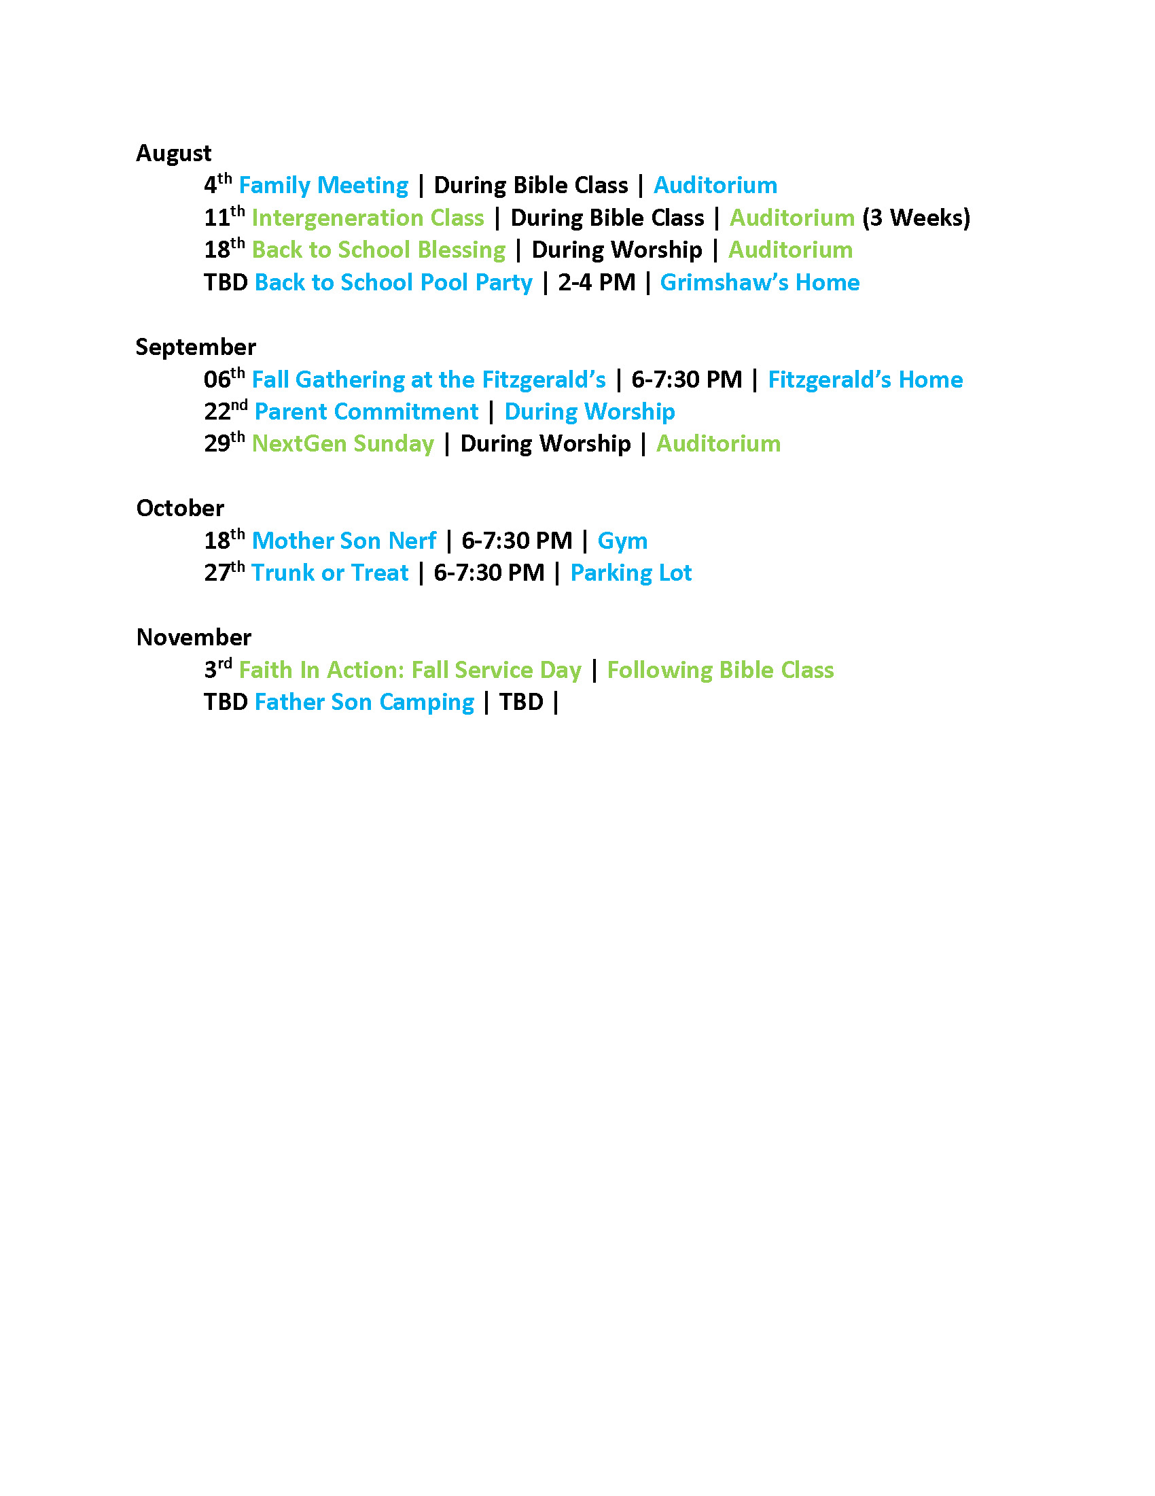

Attachment C

Attachment C – MX Kids Ministry Council
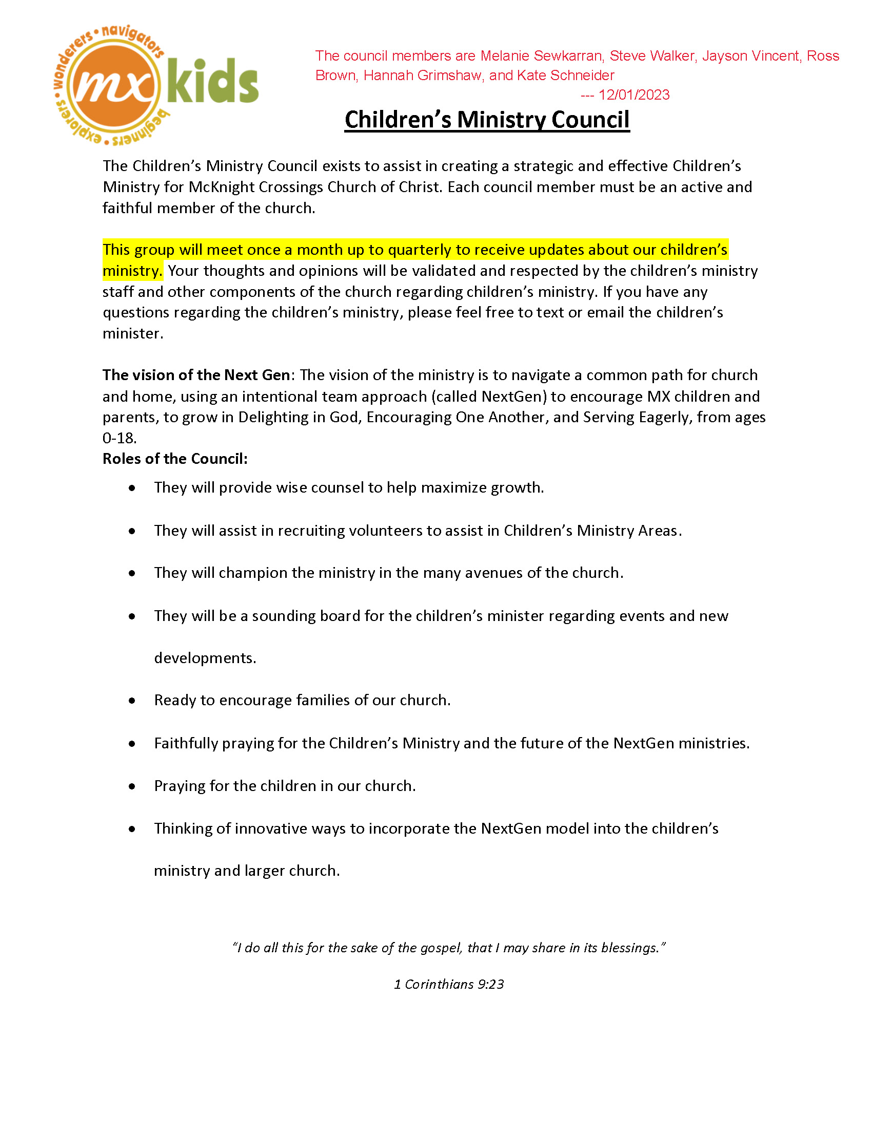

Attachment D

Attachment D – Requested Infant/Toddler Room Change

Below is where an accordion door has been requested.

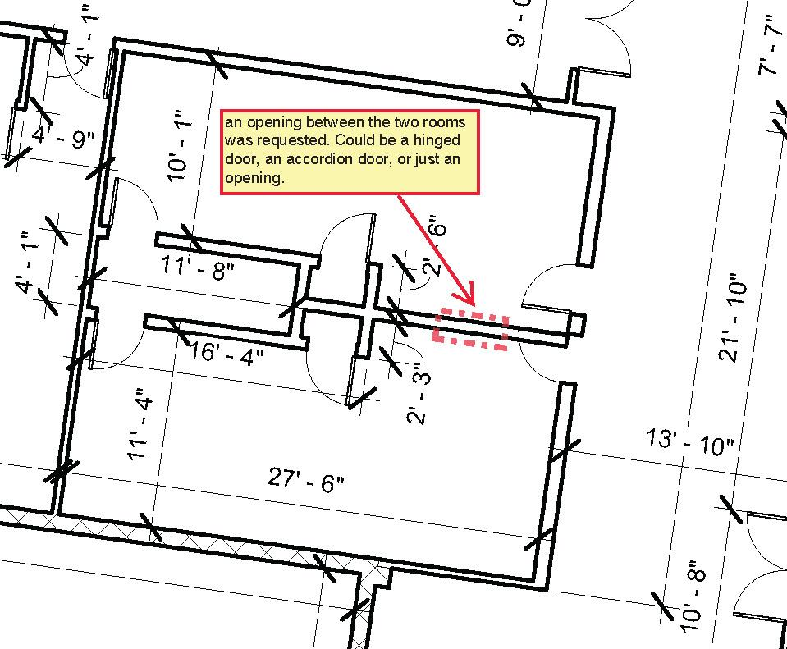

Attachment E

Attachment E – MX Kids Min Mission, Vision, Pledge

Our Mission - To welcome others into a growing relationship with Jesus Christ.

Our Vision – To journey together as a diverse Spirit-led family, generously reaching the next generation for Christ.

MX Next Gen Pledge

DELIGHT in God – We all want a secure footing for our life. We believe that having a relationship with God and Christ is the most important thing in the world to find that security. It addresses the deep and wide identity obsession of our culture – “Who am I?” A relationship with God answers the need to love and worship of something greater than ourself. *** I John 3:1 - See what great love the Father has lavished on us, that we should be called children of God! And that is what we are! Our MX desire is that every person in our network at every moment of every day will confidently say – “I am God’s child, loved by God.” Pledge - “You are God’s child, loved by God.”

ENCOURAGE One Another – We all want to belong and be valued somewhere. Why not here? *** 2 John 1:12 - I have much to write to you, but I do not want to use paper and ink. Instead, I hope to visit you and talk with you face to face, so that our joy may be complete. *** 3 Jn 1:14 - I hope to see you soon, and we will talk face to face. Most people, especially younger persons, will experience belonging before they believe. Our MX desire is that every person in our network will confidently say - “I feel seen and heard.” Pledge - “I see you and hear you!”

SERVE Eagerly – We all want our life to have significance, meaning, and purpose. God gives gifts, talents, and tasks to build His kingdom. *** Eph 2:10 - For we are God’s masterpiece. He has created us anew in Christ Jesus, so we can do the good things he planned for us long ago. Our MX desire is that every person in our network will confidently say – “I will eagerly do my part.” Pledge - “I will help you do your part as you help me do mine.”

Attachment F.1

Attachment F.2 – draft Senior Minister Job Description

The following is a DRAFT document for consideration
(December 1, 2023)

Senior Minister

General Information
- Job Title – Senior Minister
- Job Relationship – Supervised by Elders
- Position Summary – To lead and serve the church family in preaching, teaching, strategic planning, and in supporting and developing staff, ministries, and members.

- Proclaim the Word of God.
  - Maintain a discipline of personal growth in prayer and the Word of God.
  - Deliver quality Biblical messages that are inspiring and applicable to daily life.
  - Oversee and plan worship in coordination with the Worship Team.
  - Oversee Spiritual Formation Team, teaching classes as needed.

- Provide Leadership.
  - Consistently champion the church’s mission, vision, and values.
  - Cast vision for community outreach, events, and programs to strengthen the church.
  - Offer strategic planning and support to on-going and new Ministry Leaders and Ministry Teams.
  - Encourage and model discipleship relationships and a growing devotion to God.
  - Meet regularly with church elders.

- Supervise Ministry and Administrative Staff.
  - Coordinate and oversee Ministry Staff to carry out the church’s vision, ensuring team cohesion, alignment, and execution of roles and tasks.
  - Coordinate and facilitate staff meetings to nurture staff, respond to needs in church body, implement administrative tasks, and coordinate staff, ministry, and congregational calendars.
  - Oversee congregational communications (email, banners, social media, Live-Stream, and Sunday announcements, etc.)
  - Assist with technology initiatives that support the staff, ministries and congregational life.

- Provide Spiritual and Pastoral Care.
  - Offer and coordinate pastoral care and guidance to church members and others, including the sick and shut-ins.
  - Be on call for pastoral emergencies.
  - Coordinate pastoral care for funerals, weddings, and other special requests and events.

Attachment F.2

Attachment F.2 – draft Senior Minister Requirements

The elders will need to determine what we want in a minister. What are the must-have qualifications, and what are the nice-to-have items?

Examples below – just my draft list so do not take this as final on what we will use.

MUST HAVE | NICE to HAVE
Male | Children
Married | Divinity degree or some formal theological education/ training
Previous ministry experience | Church of Christ background  (what about other denominations?)
Heart for people and ministry over liturgy and law | Some training in counseling
Items noted in Senior Minister job description

Search Strategy:
The McKnight elders will take responsibility for the search, interview, and hiring of the new minister. When it has been determined that a candidate is suitable the elders will make a recommendation to the congregation and seek feedback. The elders, however, will still be responsible for the final decision.

It seems wise to seek the input and counsel of individuals with experience in congregational leadership, ministry, and staffing. As needed input from individuals like Carson Reed (https://acu.edu/faculty/carson-reed/) will be consulted.

Attachment G – Minister Search Timeline
 |  | McKnight Crossings Church of Christ
 |  | New Minister Search Timeline
. | . | 2023 |  |  | 2024 |  |  |  |  |  |  |  |  |  |  |  | . | .
 |  | Oct | Nov | Dec | Jan | Feb | Mar | Apr | May | June | July | Aug | Sept | Oct | Nov | Dec
 | Soft Search |  |  |  |  |  |  | Hard Search (starts April 1, 2024)
 |  | (A) | (B) |  |  |  |  |  |  |  |  |  | (C) |  |  | (D)
 |  | (A) | Congregation notified in October 2023
 |  | (B) | Jeff turns 64 November 23, 2023
 |  | (C) | September 1, 2024 Jeff Kryder stops preaching
 |  | (D) | December 1, 2024 Jeff Kryder off payroll
 |  | Note 1: | Elders decided new minister can be brought on whenever suitable replacement found, even while Jeff Kryder still preaching.
 |  | Note 2: | Outside resources, such as Siburt Institute, will be utilized to help find candidates.
- The full document on Jeff Kryder’s retirement and replacement considerations is available here … https://www.shepherd.mx.mxcoc.xyz/positions/docs-23/MX-SrMinister v2.docx.
- More information on the Church Health Assessment (CHA) can be found on the Siburt Institute website here … https://www.siburtinstitute.org/cha.
- Video Discussion with Carson Reed of the Siburt Institute available here … https://www.shepherd.mx.mxcoc.xyz/positions/docs-23/06.05.2023-CarsonReed.mp4.
- Siburt Salary Survey info here … https://www.siburtinstitute.org/salarysurvey. (also, salary based on teacher pay in local area is a good rule of thumb)

Attachment H.1

Attachment H.1 – 2023 Year in Review

. - 2023 Year in Review - .

Personnel Changes
Departures  - Jeremy Picker left 5/31/2023  - Jeannie Britzman left 12/31/2022  - Dolores Miller retired 3/30/2023 | Additions:  - Kaylynn Myers started 4/10/2023  - Nathan Strickland started 10/16/2022  - Jeremiah Haywood started 5/31/2022

Births, Deaths, Baptisms this year
Births 2023
- Lou Jones - born 04/30/2023 (Bradley and Anna Jones)
- Sedona Walton - born 03/13/2023 (Gregory and Olivia Walton)
- Ansel Frederick – born 11/21/2023 (Andy and Grace Clapper)

Deaths 2023
- Tiffany Henagean - passed away 6/24/2023

Baptisms 2023
- Isabell Patton, June 28, 2023
- Harmony Patton, June 28, 2023
- Max Brown, August 30, 2023
- Jayden Siebert, September 6, 2023

MX NextGen - numbers
Middle School kids: approximately 13
High School kids: approximately 15

*counting as active/has participated in recent weeks (comes to Sunday Bible class, Midweek Youth Group, fellowship events, etc.) *

Incoming Babies ~ 3
MX Beginners ~ 9
MX Explorer ~ 9
MX Wonderers ~ 11
MX Navigators ~ 10

More detail on children info in the Children’s Database (Excel) here - https://tinyurl.com/2u5yejmj

Most recent McKnight Directory here - https://tinyurl.com/dh4f2sfz

Large Capital Projects:
- Auditorium Stage and Lighting – more info here - https://www.building.mx.mxcoc.xyz/stage/stage.html
- Parking lot repaired and resurfaced – more info here - https://www.building.mx.mxcoc.xyz/pkng.html

Agreed a full-time Women’s Worship Leader would be appropriate – April 2023 mtg. notes

Special Consulting: In Q1 2022 the elders commissioned an outside review of the church. Dale Robinson met with several key leaders, ministry workers, and staff and provided some thoughts and recommendations.
Report is available here … https://tinyurl.com/y8xsueuc.

Special Consulting: In March 2023, the Elders had a video conference with Carson Reed to discuss current trends and issues in churches. Video available here … https://tinyurl.com/2zu2pnyc.

Attachment H.2

Attachment H.2 – 2023 MX Ministries
MX Ministries 2023

MINISTRIES (Inreach) | MINISTRIES (Outreach)
- Adult Christian Formation (Betty Vaughn, Jeff Kryder)  - Beautify the Building (Kara Karraker)  - Children’s Ministry (Jeremiah Haywood)  - Fellowship Ministry (Kari Ferguson)  - Finance / Budget (Brad Stevens / Dave Weiler)  - Hospitality (Funerals, Receptions Showers…)  - Men’s Ministry  - Office Administration (Elizabeth McPherson)  - Pastoral Team (Collins Corder)  - Print / Digital Communications (Nathan Strickland)  - Safety Team (Bret Blackford)  - Circle of Friends (Judy Miller, Linda Mueller)  - Tech Team  - Unity in Diversity (Todd and Beth Mayberry)  - Website and Social Media (Jeremiah Haywood)  - Women’s Ministry  - Worship / Praise Team (Kaylynn Myers, Carrie Strickland, Chris Fuller, Bryant Taylor)  - Youth Ministry (Nathan Strickland) | - ACTS Campus Ministry (Katie Holloway, Bret Blackford)  - Adopt a School (Jeremiah Haywood)  - Benevolence Outreach (Dave Weiler)  - Food Pantry / Fall Food Drive (Barb Eickele)  - Christian Family Services (Eric McPherson)  - College (Jayson Vincent, Adam Shelley)  - Connect Groups (Dale Simpson)  - Faith-in-Action (Steve Awtrey)  - Greeters’ Ministry (Joyce Holmes)  - Local Outreach (Jeff Kryder)  - Missions – Overseas (Jeff Mcglawn)  - New Member (Steve Walker)  - Pastoral Team (Collins Corder)  - Prayer Ministry (Dave Weiler)  - Young Adult Ministry (Carrie Strickland)  - Urban Outreach (Dave Weiler)  - Camp Ne-O-Tez (Steve Jones)

Attachment H.3

Attachment H.3 – 2023 Connect Groups and Huddle Groups

Connect Groups and Huddle Groups (August 2023)

Connect Groups | Huddle Groups
- Corder / Awtrey Group  - Weiler Group  - Keaton Jones Group  - Steve Jones Group  - Mcglawn Group  - Bardowell / Grimshaw Group  - Simpson / Hill Group  - Vincent Group  - McPherson / Chris Jones Group  - Walker Group  - Young Adult Group | - Todd Mayberry Group  - Alec Hill Group  - Kryder / Awtrey Group  - Keaton Jones Group  - Women’s Bible Study

Attachment I.1

Attachment I – Church Center App & QR Codes

Below is the information on the new church app that was shared with the church on May 7, 2023

This is the URL to use without the app: https://mxchurch.churchcenter.com/pages/home


Attachment I.2

This is the URL to use without the app: https://mxchurch.churchcenter.com/pages/home





Attachment J

Attachment J – 2023 Church Calendar

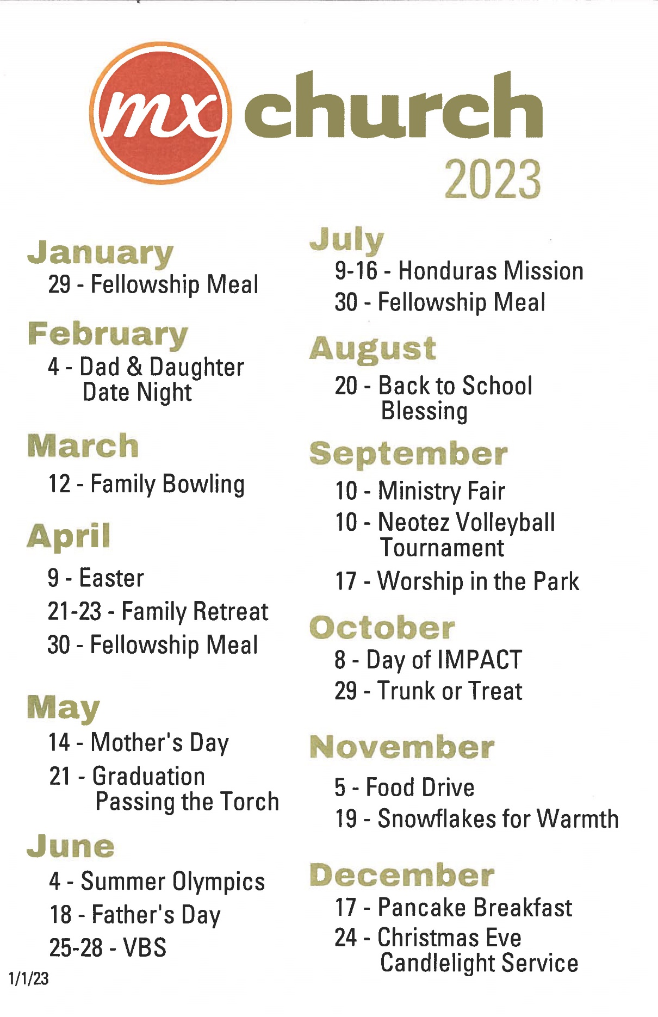

Attachment K

Attachment K – Elders and Ministers (photo)

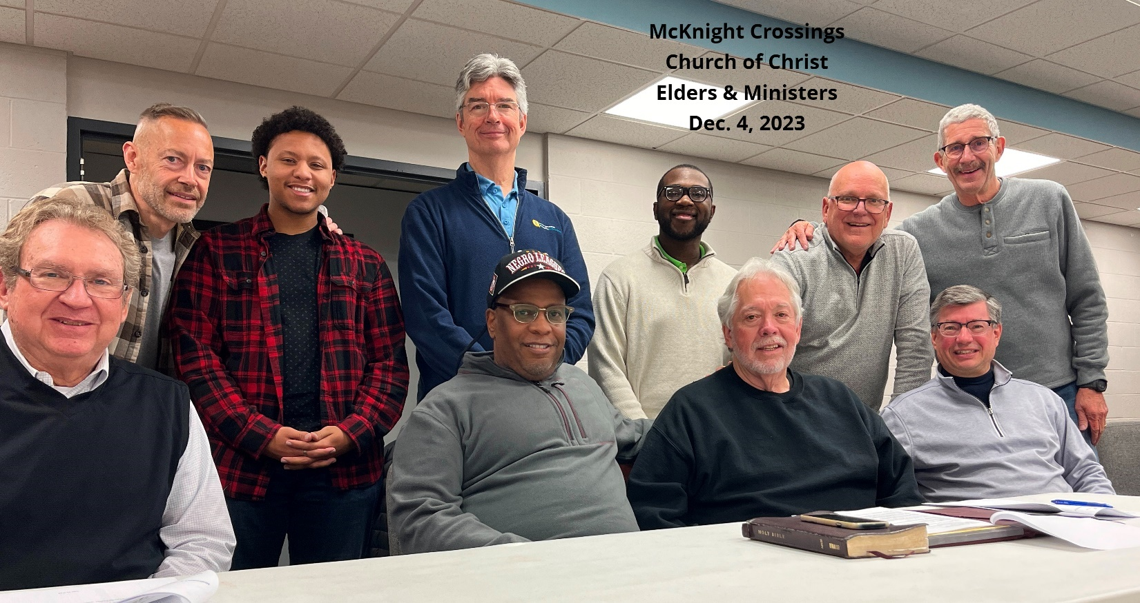

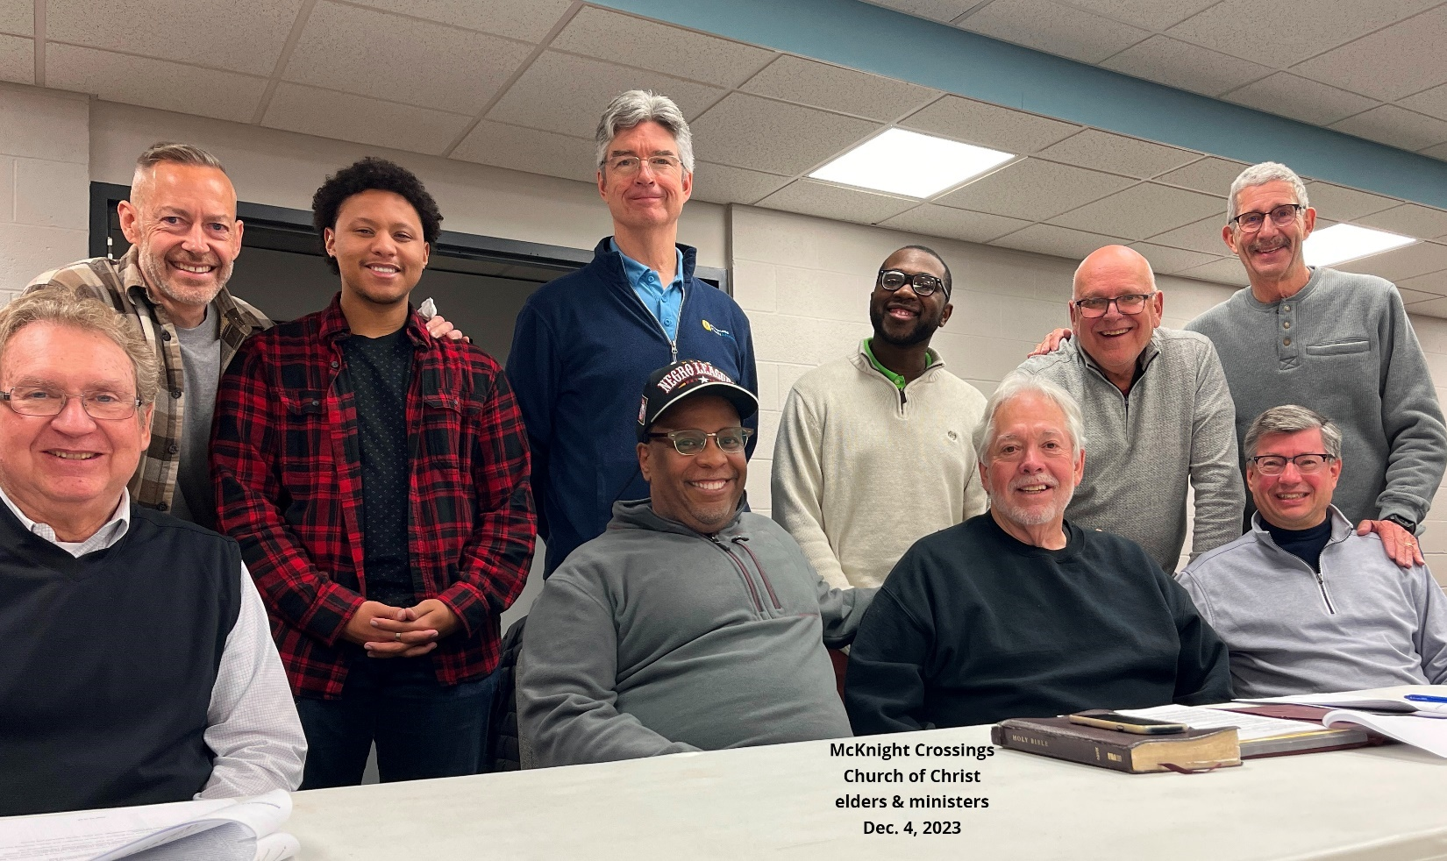

Rental Property: The church owns two rental homes adjacent to the church. Originally these were purchased with the intent of expanding the parking lot. However, we have been unable to get appropriate storm waiver and one of the houses is in a flood area. Also, location of the properties and sloping plots would make any potential parking additions prohibitively expensive. Based on the excessive cost and the zoning/flood issues these rental properties are no-longer considered to be used for expansion and are now investment assets.
Bret – if Jeff Kryder did not intend to preach, and we have no better offers I would consider someone from Siburt preaching. But we would need to know well in advance the topic or help craft that message. For McKnight, it might be helpful for the congregation to hear from an independent 3rd party the opportunity we have as we look for a new pulpit minister. It is an opportunity to clarify our mission and recommit to the work here at McKnight.

