Elders’ Meeting
November 6, 2023
Agenda

Attendees: Dave Weiler, Steve Awtrey, Bret Blackford (chair), Keaton Jones, Don Fitzgerald, Brad Stevens
Jeff Kryder, Jeremiah Haywood, Nathan Strickland

- Update on members and concerns [10-15 min]
{{ various }}

- Ministry updates
  - Nathan Strickland (Youth Ministry) [5-7 min]
See Exhibit A

  - Jeremiah Haywood (Children’s Ministry) [5-7 min]
See Exhibit B

  - Jeff Kryder

- Holiday Worship and Bible Class Schedule. [5 min]

- Finance Elders to do 5-minute Giving/ Budget exhortation after Kryder messages on November 12, 19, and possibly 26. [5 min]

  - Marseiles support. Can MX help raise funds for a new building?

“The monastery has been sold, is under new ownership, BUT, the new owner is dividing up the property and ready to sell the part that we want to buy!! We are preparing to put in an offer at this time. Please be praying for this!”
---- Craig Young

- Go through Directory to cull names and or follow-up plans on inactive list.
Jeff Kryder to briefly discuss review - Jeff Kryder and Brad Stevens to make initial pass and bring comments and recommendations to the Elders at future meeting. [5 min]

  - Brad Stevens to make first pass. When completed will hand off to Jeff Kryder for a second pass. Any changes will be brought before the full group of elders at a future meeting (when directory change recommendations are ready)

- Plans and requirements for Sr. Minister soft search. [15 min]
  - Review draft job description & requirements – Exhibit C
  - Admin elders will make first draft of job requirements. Goal is to get a high-level understanding of what we would be looking for should anyone be interested during our soft-search.
    - Draft will be brought before full group of elders for review and approval.
  - The full final version of job requirements and job description will be completed at a later time, but before hard-search.
  - Note: some info Jeff Kryder received from the Siburt Institute a few years ago. Pages 54-58 have Preaching / Senior Minister Descriptions. . In addition, there is a ton of info on interviewing, transition, etc., in the pdf – here. (https://www.shepherd.mx.mxcoc.xyz/positions/docs-23/Minister%20Transition%20Packet%202015.pdf)

- Use of 2nd Elders meeting in Jan for a meeting with all Ministry Leaders. Keep the momentum going! [7 min]

- Update on Area Wide Elders Conference at MX in January. [5 min]
  - Below information per Steve Awtry

Date: January 20, 2024 Time: 8:00-1:00ish (breakfast & lunch provided)
Agenda: TBD, but Carson Reed and Siburt Institute will work with Steve Awtry and others to craft an agenda
Attendees: so far 8 churches signed up. Invitation to elders and wives.
Fee: $500.00 per attending church
Sunday Sermon: January 21, 2023. Siburt has offered to preach.

- Feedback on Marriage Retreat - what, when, who [5 min]
- Decided not necessary at this time. Marriage is an important covenant that should be discussed in the pulpit. We can also have a special 4-week class, and inform individuals that resources are available at CFS.

- Plan to do a 40 Day to Easter Devotional Booklet developed by the congregation. To be ready by Feb 21. [7 min]
  - All agree this is a good idea
  - Betty Vaughn will take lead.
  - Should we use “Resurrection Sunday” or “Easter Sunday”? Brad Stevens favors “resurrection”

- Misc other?? [7 min]
  - Keaton Jones to step down as an elder January 1, 2024.
  - We should discuss this timeline with Louis West
  - Possible new leaders to develop. The following were suggested:
    - Ross Brown
    - Jeff McGlawn
    - Matthew Bardowell
  - Dave Weiler to provide some thoughts on the LGBTQ+ community and God’s church. This is just a starting point for further conversation. Possibly something by January 2024.

- Recent MX Bulletin - here
(https://www.shepherd.mx.mxcoc.xyz/positions/docs-23/11.08.2023%20-%20MX%20News%20and%20Prayer%20Concerns.pdf)

Note 1: The full document on Jeff Kryder’s retirement and replacement considerations is available here … https://www.shepherd.mx.mxcoc.xyz/positions/docs-23/MX-SrMinister v2.docx.

Exhibit A

Re: 11.06.2023 MX Elder mtg
Yahoo/Inbox

Nathan Strickland <nstrickland@mcknightcrossings.org>
To:M Bret Blackford
Mon, Nov 6 at 10:08 AM
Hi Bret. Here are my youth ministry updates for tonight's elder meeting:
  - Gearing up for Refuge this weekend. We have a total of 22 people going at the moment, 6 adults/16 students. To my knowledge, we are bringing the biggest group this year. This year's group includes students like Alayna Jones, Fred & Jackson Canady (who just signed up yesterday after some good persuasion). All first timers, as well as David Bardowell. I'm very excited about these students going!
  - ***speaking of David Bardowell, he expressed his desire to be baptized a few weeks ago, so that's also in the works***
  - The Church Family Initiative has been going very well. We've been to the homes of Carrie/Legrand, Keaton/Kathy, Eric/Elizabeth, Peggy Hope, & just last night, Joyce Holmes. We have more on the way and are looking forward to getting more elders looped in on this in the spring semester. Watching our church members connect with our students has been such a blessing (ask Keaton, he knows)!
  - Patty Lacoss-Arnold sent me an email a few weeks ago telling me that her daughter, Junia, who was getting very involved in the youth group, has no desire to attend youth group or church anymore. She expressed not really "clicking" with anyone, & felt church focused more on study than worship. This was disappointing to hear because she seemed to always be talking to people and was coming to events. Speaking with Patty yesterday at church gave me a bit more insight and said that this has been a common occurrence with friends/friend groups. I'm planning to meet with her sometime in the following weeks to understand the situation better.
  - We've been making progress with the Minton family. Jacob (9th) & Henry (7th) both came to Bible class on Sunday either a week or 2 ago. Jacob joined us for Midweek Youth Group this past Wednesday (big win!), and both boys sat with the youth group during church yesterday. Henry does gymnastics on Wednesday nights to my understanding, but having Jacob was a blessing & it seemed he had a good time. (David Bardowell goes to school with Henry, they are friends).
I believe that's all for now. I'll send more if I think of anything. Thanks!

Exhibit B

Re: Children's Ministry : 11.06.2023 MX Elder mtg
Yahoo/Inbox
Jeremiah Haywood <jhaywood@mcknightcrossings.org>
To:M Bret Blackford
Tue, Nov 7 at 2:43 PM
Children’s Ministry Update
  - We have begun practicing for our Children’s Ministry Play on December 17th. We have decided to go a different direction compared to last year, which looks like scripture and songs. My committee and I have decided that we will do a nativity play every other year compared to every year.

  - On November 12th, we will host the MX Kids Family Meeting following Bible Class. During this time, I will provide a form of holy listening for families and their children. Following that, I will allow myself to listen and hear what the family has to say about our Children’s Ministry. I believe it’s truly important to learn and partner well with the families.

  - On November 19th, the MX Kids will host our Friendsgiving following Bible Class. During this time, kids will have a chance to connect with each other, eat, and play games. This will follow what I consider a level 1 event. Level 1 m eaning that it provides connection and less spiritual.

  - On December 15th, the NextGen ministries will host our MX NextGen Christmas party. This will be for our MX Navigators (3rd-5th graders) through high schoolers. We will provide a simple appetizer, but families will bring the rest. We will watch a movie, have a white elephant gift exchange, and games.

  - Evie Bardowell has expressed interest in being baptized here at Mcknight. From my conversation with Evie, her parents must have a conversation with me regarding her spiritual maturity and if she’s ready to be baptized. I have been working on a baptism study for our MX Kids that I think will be helpful for parents to walk through with their child.

  - On January 26th, we are scheduled to host a Level 60 Game Night. This is a game night for our members who are 60 and up. I felt this calling on my heart due to noticing that we are always asking our older adults to serve in our NextGen ministries, but haven’t created many opportunities for our kids/teens to give back to them.

  - Finally, I brought up that I am currently in an exploratory phase with changing our MX Beginners Nursery space. We have a couple of options of changing this space to accommodate a larger space inside the room. Bret and I have talked about three different options to create a large space that still provide maximum safety. I plan to meet with a couple of my trusted MX Beginners discipleship leaders regarding their concerns and really poke holes in our strategic plan currently.
Thank you Bret for all that you do. I truly am blessed to have an amazing leadership group to work with.
Blessings,
Jeremiah

Exhibit C.1
Note: this document also available on-line here.

All of us need to have determined what we want in a minister. What are the must-have qualifications, and what are the nice-to-have items?
Examples (just my draft list so do not take this as what we will use/discuss with Carson):

MUST HAVE | NICE to HAVE
Male | Children
Married | Divinity degree or some formal theological education/training
Previous ministry experience | Church of Christ background  (what about other denominations?)
Heart for People and Ministry over liturgy and law
Items 1 – 11 listed below

McKnight Crossings Church of Christ (“MX”)
Senior Minister / Pulpit Minister
Qualifications and Responsibilities

We need to consider the responsibilities and qualifications of the individual who will take over the preaching and senior ministry responsibilities when Jeff Kryder retires next year. We need to consider what would be the requirements and what would be recommended or nice to have. We should also consider the various roles that Jeff Kryder currently fills and which will be transitioned to a new minister.

Jeff Kryder currently fills the following roles (my list which may be incomplete):

- Pulpit minister – responsible for the Sunday sermon. Plans the liturgical calendar and delivers the weekly sermon.
- Assist with the planning of the Sunday service and preparing those who will assist (singing, scripture reading, etc.)
- Bible study – responsible for the scriptural education of the congregation. Plans Sunday classes and help provide resources for the various small groups that occur throughout the week.
- Spiritual Guide and Counselor – main contact for members and those in the community with life and spiritual questions and needs. Ability to counsel personally or direct to others who may be better equipped to address the specific need(s).
- Religious Ceremonies – preside over weddings, funerals and other major life events
- Congregational Leader – assess health of congregation and looks for ways to maintain congregational health. Do we need fun times together to bond (picnics, family camp, etc.)
- Community Outreach – primary point person for connecting the congregation with the local community. VBS, picnics, door knocking, service projects, other outreach events.
- Addressing cultural issues – sensitive to current events and knowing when/how to address with the congregation.
- Train, Direct, Mentor other ministers
- Oversee office staff
- Communicate and coordinate all the above with the Elders
- Etc.

Search Strategy:
The McKnight elders will take responsibility for the search, interview, and hiring of the new minister. When it has been determined that a candidate is suitable the elders will make a recommendation to the congregation and seek feedback. The elders, however, will still be responsible for the final decision.

It seems wise to seek the input and counsel of individuals with experience in congregational leadership, ministry, and staffing. As needed input from individuals like Carson Reed (https://acu.edu/faculty/carson-reed/) will be consulted.

Exhibit C.2

Here is the same document re-worded by ChatGPT …

Based on the responsibilities currently filled by Jeff Kryder, the qualifications and responsibilities of the new senior minister/pulpit minister at McKnight Crossings Church of Christ could include:
Qualifications:
- A degree in ministry, theology, or a related field
- Experience in preaching, teaching, and leading a congregation
- A strong understanding of Scripture and the ability to effectively communicate its message
- A commitment to prayer and spiritual growth
- Strong interpersonal skills and the ability to counsel and guide others
- A willingness to work collaboratively with other ministers and the elders
Responsibilities:
- Delivering the Sunday sermon and planning the liturgical calendar
- Assisting with the planning of the Sunday service and preparing those who will assist
- Planning and leading Bible studies and providing resources for small groups
- Serving as a spiritual guide and counselor for members and the community
- Presiding over weddings, funerals, and other major life events
- Assessing the health of the congregation and finding ways to maintain congregational health
- Leading community outreach events and connecting the congregation with the local community
- Addressing cultural issues and knowing how to address them with the congregation
- Training, directing, and mentoring other ministers
- Overseeing office staff
- Communicating and coordinating with the elders
It may also be recommended or nice to have for the new senior minister/pulpit minister to have experience in:
- Evangelism and outreach
- Leadership and organizational management
- Pastoral care and counseling
- Multi-generational ministry
- Technology and social media
- Working with volunteers
The input and counsel of individuals with experience in congregational leadership, ministry, and staffing, such as Carson Reed, could be valuable in determining the qualifications and responsibilities of the new minister and in the search process.

Note 1: The full document on Jeff Kryder’s retirement and replacement considerations is available here … https://www.shepherd.mx.mxcoc.xyz/positions/docs-23/MX-SrMinister v2.docx.

Exhibit D

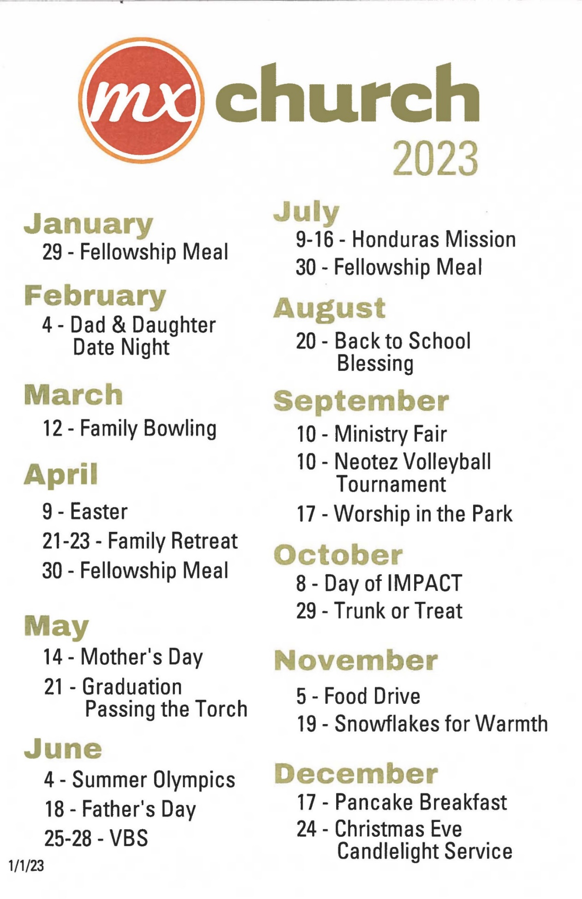

Bret – if Jeff Kryder did not intend to preach, and we have no better offers I would consider someone from Siburt preaching. But we would need to know well in advance the topic or help craft that message. For McKnight, it might be helpful for the congregation to hear from an independent 3rd party the opportunity we have as we look for a new pulpit minister. It is an opportunity to clarify our mission and recommit to the work here at McKnight.
Bret – I am fine with using “Easter.”

