Elders’ Meeting
August 7, 2023
Agenda

Attendees: Dave Weiler, Steve Awtrey (chair), Bret Blackford, Keaton Jones, Don Fitzgerald, Brad Stevens
Jeff Kryder, Jeremiah Haywood

- Update on members and concerns
{{ various }}

- Update from Jeremiah
  - Has some G.I. issues
  - Has a congenital heart issue
  - Visiting family Aug. 7-12

- Kylie Exit Interview
Meeting Aug. 8 from 6:00-6:30pm

- Youth Group (YG) Activity Scholarships
Elders plan to revisit policy at a later meeting when there is more time. Policy probably needs to be revised. The importance of maximizing the involvement in YG activities was recognized. It is important for spiritual and group/social growth and formation.

- Bed Bugs
On two separate Sundays a family has been identified bringing bed bugs into the building. The bugs were positively identified by multiple individuals. Plan is to treat the areas used by the family (foyer couches, nursery, section of pews) with insecticides. Family will also be contacted to discuss mitigation at their home. Dave Weiler to follow up with family (and will report back to Elders if some funding may be needed to help with fumigation, etc.).
Question: Do we need a policy to request individuals who are sick or who have other communicable issues (such as lice or bed bugs) to stay away until treated? This would be like policy and expectations at any public school.

- Elaina Grande Financial Needs
Elaina has been an active and long-time member of the Youth Group. She comes from a non-traditional family and has limited financial resources. Steve Awtrey has worked with Elaina to obtain significant scholarships at Harding University (Amen!). However, Elaina will probably still be struggling to pay for books and miscellaneous expenses while at school. The Elders have agreed to give Elaina $500.00 each semester to use as she needs. Steve Awtrey will work with the Finance Elders to transfer the funds to Elaina.

- Misc Notes
See Attachment A

- Discussion on Jeff’s Retirement
Elders have agreed on timeline

Date | Description
2022 | Jeff Kryder has notified the Elders late 2022 of his intent/desire to retire from ministry at age 65 (or earlier if finances allow)
23-Nov-23 | Jeff Kryder turns 64. Elders can announce to congregation Jeff steps down as minister before Nov 2024
1-Dec-23 | Start "soft search" for new minister
1-Apr-24 | start "hard search" for new minister
31-Aug-24 | Jeff Kryder no longer minister (still on payroll)
30-Nov-23 | Jeff Kryder no longer on payroll

Additional Notes:
- Don Fitzgerald will share timeline with Jeff Kryder asap.
- Elders agreed if we find a suitable candidate to not wait but hire. There can be overlap between Jeff Kryder and new minister hire.
- Elders will need to be aware of and manage any staff or congregational issues that arise during the transition to a new minister. Elders continue to do what is best for the church body and not focus on what is best for Jeff Kryder.

Liminal space refers to the place a person is in during a transitional period. It's a gap, and can be physical (like a doorway), emotional (like a divorce) or metaphorical (like a decision)

Files from Siburt:
Church Health Assessment Sample Report
Sample Preaching Schedule

Below is my representation of timeline noted above

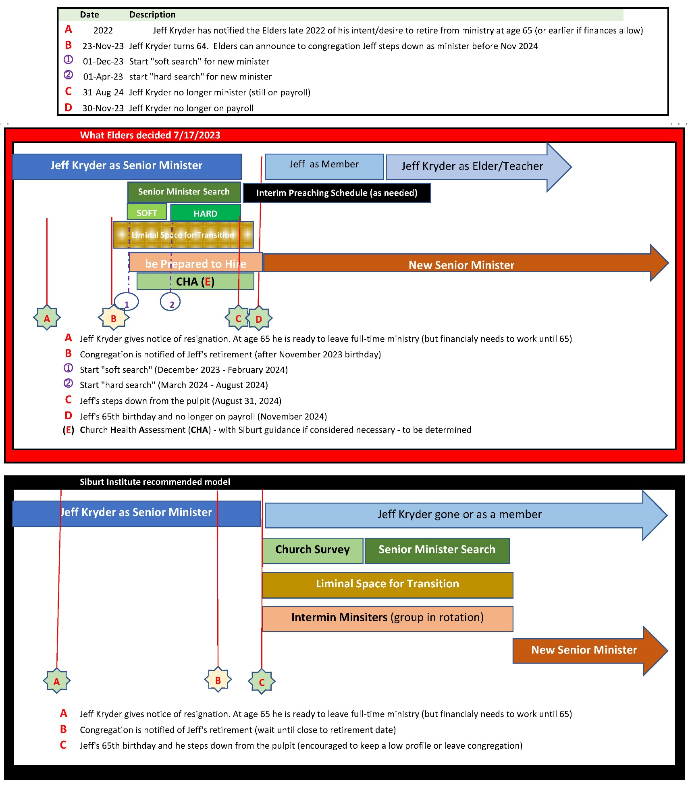

Note 1: The full document on Jeff Kryder’s retirement and replacement considerations is available here … https://www.shepherd.mx.mxcoc.xyz/positions/docs-23/MX-SrMinister.docx.

Note 2: More information on the Church Health Assessment (CHA) can be found on the Siburt Institute website here … https://www.siburtinstitute.org/cha.

Attachment A
Steve Awtrey distributed the following notes during the 8/8/2023 meeting

