Elders’ Meeting
July 17, 2023
Agenda

Attendees: Dave Weiler, Steve Awtrey (chair), Bret Blackford, Keaton Jones, Don Fitzgerald, Steve Walker
Jeff Kryder, Jeremiah Haywood, Freddy Grifith

Notes from July 10, 2023 meeting on-line here - https://tinyurl.com/myesx92n.

- Greeters Ministry – Freddy Griffith
Jim and Freddy Grifith will be moving to Texas and need to transition their role as leading the Greeting Ministry. Freddy provided some information:
- Exhibit A – Greeting 101
- Exhibit B – Greeting schedule 2023

- Update on members and concerns
{{ various }}

- Update from Jeremiah
  - Currently going through the “I AM” statements in the Bible. Such as, “I AM the Good Shepherd”, “I AM the Light of the World”
  - In Sept. starting the “Gospel Project” curriculum.
  - This Wed/Thr (July 19-20) from 10:00-12:00 there is a preschool camp. 4 kids have currently signed up.
  - July 28 – Family Movie Night from 6:00-8:00pm
  - July 30 - Pool Party at the Grimshaw home
  - Aug. 6 – Children’s Ministry and Parent info session during Sunday bible class.
  - ACU Summit – Jeremiah asked to help Oct 11-13. This should not be considered vacation but part of ministry.
  - Considering an “Empty Nesters Game Night” as a way to help encourage and give back to the congregation

- Jeremy Picker exit interview – see Exhibit C

- Discussion on Jeff’s Retirement
Various comments from 7/10 mtg noted at Exhibit D

Don and Steve were not able to share at lkast meeting so their thoughts on transition were given at the 7/17/2023 mtg.

Don Fitzgerald
Don likes Jeff Kryder’s proposal to retire on his 65th birthday, 11/2024, and Don sees Jeff working full-time trough September 2024 (with Q4 2024 as paid severance). Thinks announcing on Jeff’s birthday this year, 11/2023 is a good time to communicate to the congregation. Don also thinks there should be some “liminal space” but not sure how to currently structure that for MX. Don does want to start looking for a replacement minister well before Jeff Kryder stops preaching. If there is a gap between Kryder stepping down and a new minister hired, Don prefers having preaching done by local ministers or members of MX (rather than Siburt or other unknown). Don also ok with video sermons (like by Andy Stanley) and someone giving final thoughts on video from pulpit. Also, Don does not feel that Jeff Kryder needs to physically leave.

Steve Walker
Similar thoughts to Don’s above. Unsure how to fill preaching when Jeff Kryder gone. Steve does not see need for Jeff and Becky to leave. Steve thinks there is value in the Church Health Assessment (CHA). Steve is not opposed to an overlap between Jeff Kryder and a new minister should we find someone.

- Elders Draft Tentative Timeline

After months of getting input from Siburt (Carson Reed), and internal discussions, the Elders drafted the following timeline. This timeline is not yet “official” as all elders, including Brad Stevens who was absent, need to review and approve. And, as Dave Weiler strongly recommends, this need prayer and consideration.

Below are the whiteboard notes
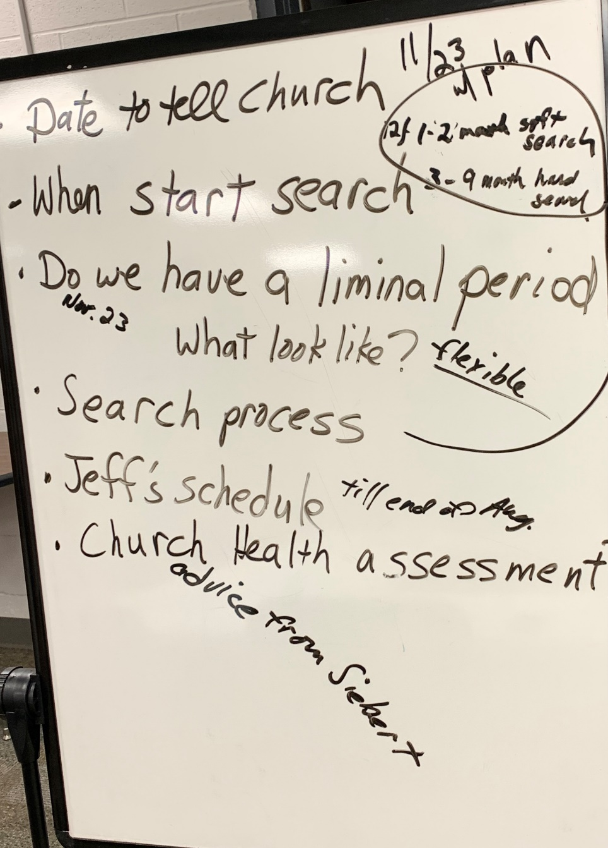

Liminal space refers to the place a person is in during a transitional period. It's a gap, and can be physical (like a doorway), emotional (like a divorce) or metaphorical (like a decision)

Below is my representation of timeline noted above

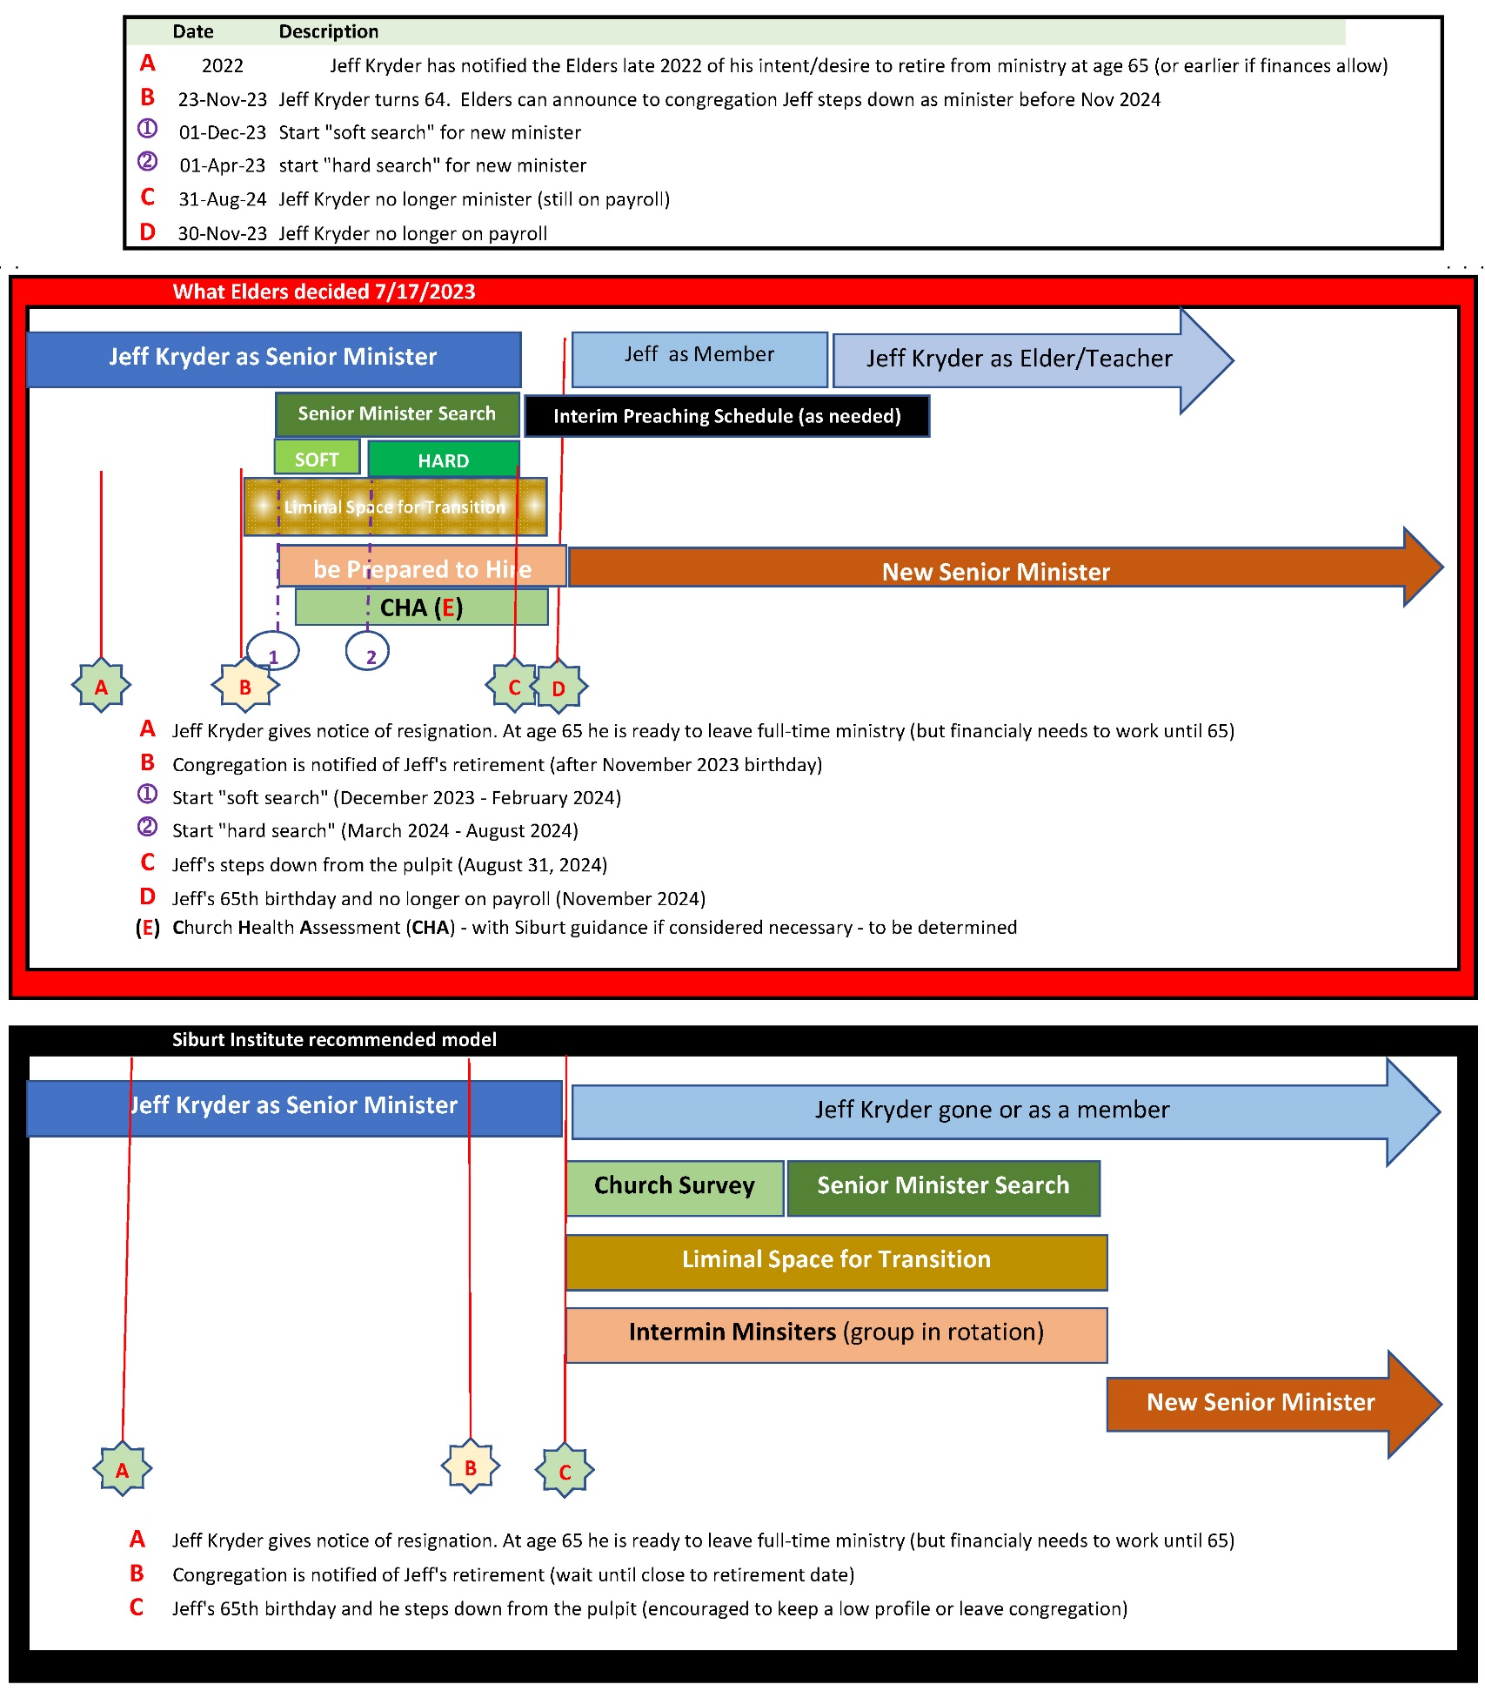

Note 1: The full document on Jeff Kryder’s retirement and replacement considerations is available here … https://www.shepherd.mx.mxcoc.xyz/positions/docs-23/MX-SrMinister.docx.

Note 2: More information on the Church Health Assessment (CHA) can be found on the Siburt Institute website here … https://www.siburtinstitute.org/cha.
Exhibit A.1

Greeters’ Ministry Overview
Updated June 12, 2020

Coordinator: Frederique Griffith
Fredyjim1@gmail.com
(314) 210-1114
Purpose

- Help people, especially guests, feel welcome.
- Assist visitors by escorting them to where they need to go:
  - Nursery
  - Children’s check in area
  - Classrooms
  - Restrooms
  - The auditorium
- Connect them with a member in their age group or life stage so they have someone to talk to and possibly sit with.

What to Expect

- You are scheduled to volunteer once a month.
- If there is a 5-Sunday month then teams rotate coverage which results in an additional opportunity each year to greet.
- If you are not available on the Sunday you are assigned it is expected you will find a substitute greeter. The best way to find an alternate is to switch with someone on a different team. Please communicate to the ministry leader so they know who will be covering for you.
- Be on time. You should be at the building no later than 8:55 am. You will greet until 9:40 am which allows for late arrivals.
- Coordinate with your teammate(s) to make sure a greeter is located by the front door as well as the North door (near the office) which is typically used for handicap access.
- A schedule is distributed at the beginning of the year and sent via email. Please note these important dates in your calendar.

Exhibit A.2

Greeting 101

We have generic welcome tags. Please take one upon arrival and return it before leaving.

Please don’t stand near the front doors since it is a high traffic area and easily becomes crowded. Please stand back from the doors, towards the middle of the lobby, where you can still see who is arriving. Our teens have been doing a great job holding the door(s) open and welcoming everyone as they arrive.

A handful of people arrive through the North door so if you’re feeling a little less chatty or tired, it’s a great spot to be! . Open the doors (they are locked on the outside) and let people know you are glad they are here.

When you see someone you do not recognize, please introduce yourself and find out their name. If they are newcomers, try to get them connected to others around you, point out the auditorium, children’s registration desk, youth group or children ministry leaders, nursery, according to their needs.

Assist parents with children to get registered at the desk or find the right classes for their kids. Same thing applies to the nursery.

Find someone to sit with them during service. “Walk with them”. Or, join them when your greeting duties are over.

There are visitors’ cards in the auditorium, so they will have a chance to complete provide contact information and prayer requests.

If someone wants more information about the church, they should be referred to an elder or other people who can talk to them after service.

Please take notice of where our visitors sit and let some people know who they are, why they are here, etc. so they can be approached after services. When worship is over it is nice to touch base with them to make sure there is nothing they need. You may want to leave services a tad early so you can be in the lobby to connect again with them before leaving.
Most Important: Help our visitors feel welcome so they experience the same sense of family that each of us has been blessed to have. These individuals will hopefully return again because of how we made them feel.

Disclaimer: The purpose of our time in the lobby area is not to visit with people we already know but to watch for newcomers so they can become our new friends.

Exhibit B
GREETER'S SCHEDULE 2023
Team coordinators are underlined.
TEAM #1: Kari Ferguson (314 443 8038); Beata McGlawn; Tim and Mary Ann Nicholson
Jan. 1 July 2
Feb 5 Aug. 6
March 5 Sept. 3
April 2 Oct. 1
May 7 Nov. 5
June 4 Dec. 3

Extra Week: April 30 - and December 31!! (there are 5 months with 5th week this year)

TEAM #2: Jim and Fredy Griffith (314 210 1114) , Larry Franke, Ann Haupt

(Joyce Holmes will greet for me the following dates: August 13; October 8 and 29; November 12). No subs for Jim

Jan. 8 | Aug. 13
March 12 | Sept. 10
April 9 | Oct. 8
May 14 | Nov. 12
June 11 | Dec. 10

Extra Week: October 29

TEAM #3: Sue Stevens (314 707 3983) Charles Eickele; Michelle Blackford, Ross Brown

Jan. 15 | July 16
Feb 19 | Aug 20
March 19 | Sept. 17
April 16 | Oct. 15
May 21 | Nov. 19
June 18 | Dec. 17

Extra Week: July 30

TEAM #4: Kay Heintz (314 814 2086) Marion Earnhart; Amy Weiler

Jan. 22 | July 23
Feb 26 | Aug 27
March 26 | Sept. 24
April 23 | Oct. 25
May 28 | Nov. 26
June 25 | Dec. 24

Extra Week: January 29

Exhibit C

Below are notes from the discussion Don Fitzgerald and Steve Awtrey had with Jeremy Picker

Jeremy Picker Exit Interview 5/18/23

- Why are you leaving?
“Complicated. I wasn’t sure what place I would have, what role to have.” Last summer he was trying to figure out his role and felt pushed out. By the end of the summer he was not comfortable where he was going to fit. People started calling and he started listening. He felt called to Youth Ministry. By November, Laura was pretty angry by how Lane and Eric spoke to Jeremy. Was not comfortable about the feedback Laura gave to the search committee about Nathan. That information got to the Stricklands. People were also talking to kids about their dad.

- Did you feel equipped and supported to do your job?
Yes. More when it was clear what his role was. In 2022 when role was worship and youth it was much better.

- Did you feel comfortable talking with the elders or Jeff when there was a problem?
Yes. Not too shy and maybe was too comfortable with Kryder and some of the shepherds.

- What went well for you as you served at MX?MC?
Relationships. Was given much grace, being trusted helped serve better because I knew the people better. Felt like was able to “read the room” well.

- What did not go so well? (What were contributing issues that may have prompted your resignation?)
See #1. “At the beginning it didn’t go so well because I was trying to figure out full time ministry.” Didn’t do well with the children’s ministry. “No one knew what to do. I did other things because I didn’t know what to do with the Children’s Ministry.”

- What things could we do better?
“Kaylynn is phenomenal.” With the Mid-County elders I felt part of the family, and part of the leadership that felt good. At MX, he doesn’t feel a part of the leadership team. Things were more transactional and not as much a part of the leadership. Jeff Earnhart said, “We will know if you are not doing your job.” There were times when he met with Jeff and had some hard discussions. There was a lot of trust then that is not there now. Michalie answered to Lane and Eric and not Jeff. Wondered who the staff is answering to. What is Jeff’s role? Should have more clarity. Shepherds will pull out their shepherd’s card and over rule the ministers. Felt not trusted to do their job. Develop a more trusting system.

- What would you change about your job?
Clarity of role. “I loved my job!”

- What advice do you have for us as we move forward?
Pouring into Nathan and Jeremiah is important. Teaching them the word (Jeff). Staff taking criticism and learning from it is important. Staff needs to be trusted. Remember that the church isn’t a business but needs to be spiritually led.

- Are there any issues you would like to address?
Concerned about where is Jeff at in his ministry. In hiring Nathan Jeff’s comment was hiring Nathan is the easier decision and is where we should go. (Wesley vs. Nathan.)

- In your opinion, what changes could be made in this team to bring increasing health and effectiveness?
Awareness of role and expectations clear. Have our roles and also “all hands on deck’. As a team to go ahead and get out of your lane. Working together more and cross training on other roles.

- Tell me a story about a time when you were especially excited to be part of this church, when you felt energized and vital. What was going on? What contributed to your excitement? Who was contributing to that time and what were they doing?
First and second Impact Weeks. Everything was clicking. Involvement from teens, members, elders, and it was an all church effort.

- Tell me a story about a time when you felt discouraged, and your energy was drained away. What was going on in the life of the church, and in your own life? What specifically happened and how did that affect you?
Outside of #1, When came back from COVID, heard more complaints than ever. He thought there would be a little respite but it didn’t happen. McGlawn and Karl quit. Was lonely for worship and when came back, didn’t get to enjoy worship as much. Realized how hard COVID worship was.

Exhibit D

Note: below are Bret’s attempt to capture what was discussed on 7/10/2023. Each individual below should correct their comments as needed to minimize miscommunication.

Brad Stevens
Appreciates Carson Reed’s approach and gives weight to his opinion as “he’s been down this road before.” Liminal Space also makes sense. Brad thinks new minister will need ability to do things twithought any input, coercion, or direction from Jeff Kryder.
Also, leadership needs to be transparent with church and announce something sooner than later. Brad thinks we should also start unwinding Jeff Kryder – Jeff should focus on preaching and we need to start weaning him off administrative and other responsibilities.

Keaton Jones
Feels that congregation expects Jeff Kryder will retire soon as he is almost 65. Keaton does not like Carson Reed’s transition plan. Keaton recommends that when we communicate to congregation about Jeff’s retirement we start looking to fill position. It may take quite some time to find a suitable replacement so starting soon is preferable.

Dave Weiler
Initially Dave wanted to have overlap with Jeff Kryder and new minister but now feels there is wisdom in Carson Reed and Siburt recommendation. Dave expects we will likely have an unknown minister coming in (as opposed to a known entity like a Phil Gold or a Travis Myers). With a new and unknown minister there will need to be a “reset” with the church and some congregational training will be needed/helpful/encouraged. Siburt can be brought in to teach on several Sundays during the minister transition on topics to prepare the congregation for a new minister and possibly new focus. Siburt will also help perform a health assessment for the “reset” (https://www.siburtinstitute.org/cha).

Steve Awtrey
Carson’s recommendations are good but do not fit McKnight church. Jeff Kryder is willing to back off things if asked. Steve like the idea of announcing Jeff’s retirement around November 2023. As this is when Jeff turns 64 it seems a natural transition to retirement in a year. However, when we announce Jeff’s retirement to the congregation we also need a rough idea of a plan (path forward) to go with that announcement. Steve thinks we should start looking for a new minister in Q2 2024 (April 2024) and once started we need to be ready to hire. Steve also likes the idea of a “liminal space” and we can adapt based on needs of new minister.
Interim Preaching – Steve likes the idea of having Siburt preach 1x month, having an MX member preaching 1x month, and 2x month having a known preacher, such as a Dale Robinson, EK Keller, Mike Root, etc.
Jeff Kryder can finish in August 2024 (and continues to be paid through November 2024). Steve is good with an overlap of Jeff Kryder and new minister, if needed and works with personalities (elders will need to assess based on circumstances).
Steve is also in favor of the Siburt Church Health Assessment.

Bret Blackford (thoughts on transition from earlier email - https://tinyurl.com/4358n8jw)
I’ve given thought to what Carson and Siburt recommend and understand much of the reasoning. However, I do not see this as a good fit, necessary, or helpful for McKnight. I am not worried that Jeff Kryder would intentionally or unintentionally work against the elders or the new Sr Minister. My thoughts on possible path forward …
- Inform the congregation shortly after Jeff’s 64th birthday (November 2023).
- Begin searching for new Sr Minister early 2024
  - Draft requirements
  - User Siburt and other avenues
- Plan to interview starting Q2 2024 (April)
- Hire as soon as acceptable candidate found
  - Can overlap with Jeff Kryder
  - Can learn from Jeff Kryder

We still need to hear from Don Fitzgerald and Steve Walker.

Exhibit D

June 29, 2023
Dear Elders,

Just a quick update as I will be on vacation on July 10, our next scheduled meeting.

1. Upcoming Preaching -
- Steve Awtrey on July 9
- Travis Myers on Aug 6
- Eric Mcpherson on Sep 10

2. Back to School Sunday - Aug 20
- Back to School Worship similar to other years with prayers for all involved in education.
- Combined Intergenerational Class in Gym. Jeff, Nathan, and Jeremiah will do the planning and teaching together.
- Invitation to members on that day to:
1. Pray for kids.
2. Get to know the names of kids.
3. Create places for belonging and identity at MX.

3. Church in The Park (Tilles) - Rescheduled for September 24.
- Due to conflict with CFS 50th event, we were able to move our picnic without a lot of fuss to the 24th.
- Eric preaching on Sep 10 will be about CFS and the event being held by CFS on Sep 17.

4. Ministry Fair - Sunday, October 1 and Sunday, October 8.
- Ministry Tables will be set up in the hallway for each of these Sundays.
- Jeff will preach on "Using Your Time, Talent, and Treasure to Strengthen the Body of Christ”

5. Faith-In-Action will begin soon. It will take the place of the scheduled IMPACT Day on October 8.
- We will look for an opportunity for the congregation to serve along with the FIA volunteers later in October or early November when the leaves fall.

6. New Members.
To be welcomed this week:
- Shannon Miller and River.
- Gloria Hanson.
- Cari Merrick.
- Andy and Grace Clapper (planned to be welcomed on July 16).
- Following up with Cornelius' family.

7. Pray for:
- VBS Follow-up. Great job, Jeremiah and volunteers!
- Newly baptized - Isabell Patton and Harmony Patton.
- Izzy and Sara - Memorial set for July 15 at 11:00.
- Honduras team.
- Campers.
- New Members.
- Fall Bible Classes - Ruth, taught by Gwen Walker; Jeff to teach Leadership Class.

--
Jeff Kryder
Senior Minister
McKnight Crossings Church of Christ

More information on the Church Health Assessment (CHA) can be found on the Siburt Institute website here … https://www.siburtinstitute.org/cha.
More information on the Church Health Assessment (CHA) can be found on the Siburt Institute website here … https://www.siburtinstitute.org/cha.

