**Elders’ Meeting**

**July 10, 2023**

**Agenda**

Attendees: Dave Weiler, Brad Stevens, Steve Awtrey (chair), Bret Blackford, Keaton Jones

* Devotional thoughts (See Steve’s attachment on Legalism)  **Exhibit A**
* Update on members and concerns

{{ various }}

* Discussion on Jeff’s Retirement

Various comments noted at **Exhibit D**

* Elders Follow up – Last Meeting

**LGBTQ+ discussion** – Dave Weiler mentioned study with Brian Hill and Bret Blackford on Sunday’s after worship. Brian Hill has a homosexual uncle and uncle asked McKnight’s position on the matter. Dave Weiler explained that McKnights position is that a marriage recognized by God is one man and one woman for life, but that homosexuals and those on the LGBTQ+ spectrum should be welcome to worship with the McKnight body. Books we are reading as part of this study:

1. [For the Bible Tells Me So (the biblical-theological necessity of LGBTQ+ inclusion in the church)](https://www.amazon.com/Bible-Tells-biblical-theological-necessity-inclusion-ebook/dp/B08LR143V4) by Katie Hays

* Dave, Bret, Brian Hill reading jointly

1. [Messy Grace : How a Pastor with Gay Parents Learned to Love Others Without Sacrificing Conviction](https://www.amazon.com/Messy-Grace-Parents-Sacrificing-Conviction-ebook/dp/B00TCI5312/ref=sr_1_1?crid=3JBQD0SHIQRUI&keywords=messy+grace+caleb+kaltenbach&qid=1689294894&s=digital-text&sprefix=messy+grace+caleb+%2Cdigital-text%2C83&sr=1-1) by Caleb Kaltenbach
2. [Messy Truth: How to Foster Community Without Sacrificing](https://www.amazon.com/Messy-Truth-Community-Sacrificing-Conviction-ebook/dp/B081M81TSF/ref=sr_1_1?crid=UCTW2ADSH596&keywords=messy+truth+caleb+kaltenbach&qid=1689294958&s=digital-text&sprefix=messy+truth+caleb+kaltenbach%2Cdigital-text%2C86&sr=1-1) Conviction by Caleb Kaltenbach

**Carson recommends …**

(see also **Exhibit B**)

1. Give short notice to congregation about Jeff’s retirement
2. Provide an interim period before bringing on a new Sr Minister.  A “liminal space”
3. Start looking for new SrMinister during interim period.
4. Perform a congregational health assessment during interim period
5. Jeff Kryder have no, or limited contact with congregation for a time
6. Interview, select, hire new Sr Minister
7. Sometime later Jeff Kryder allowed some contact with church

**Exhibit A**

**Below is the short devotional Steve Awtrey shared with the elders on July 10, 2023**

**Legalism**

Great thoughts I read from Rick Warren.

“*I no longer count on my own righteousness through obeying the law; rather, I become righteous through faith in Christ. For God’s way of making us right with himself depends on faith.*” (Philippians 3:9 NLT)

You can’t earn God’s approval. You can’t earn his love. You can’t earn his recognition. God is love, and he loves you unconditionally. If you want to be a happy person, you need to relax in God’s grace every day.

Philippians 3:3 says, “*We Christians glory in what Christ Jesus has done for us and realize that we are helpless to save ourselves*” (LB).

One of the things that will rob you of your happiness is legalism. Legalism is the attitude that you have to prove your love to God. Legalism is trusting in what you do for God instead of what Jesus did for you. It’s thinking that you have to follow rules and regulations and restrictions in order to prove yourself worthy.

How do you know when you’re a legalist? It’s when you’re judgmental of other people. How do you know when you’re living by grace? It’s when you’re gracious to others. People who live by grace often find it easier to forgive, because they recognize God continues to forgive them.

Legalism will suck your life dry of happiness. It sucks churches dry of happiness. Ever go to a legalistic church? That church is not happy. There’s no joy in a legalistic church. Everybody’s just there out of duty or guilt.

When you finally realize there’s nothing you can do to make God love you more, it is one of the most liberating feelings in the world. And, it is a key to happiness. Every day, remind yourself of the grace of God, and relax in it.

“*I no longer count on my own righteousness through obeying the law; rather, I become righteous through faith in Christ. For God’s way of making us right with himself depends on faith*” (Philippians 3:9 NLT).

**Exhibit B**

Below is the summary of timelines

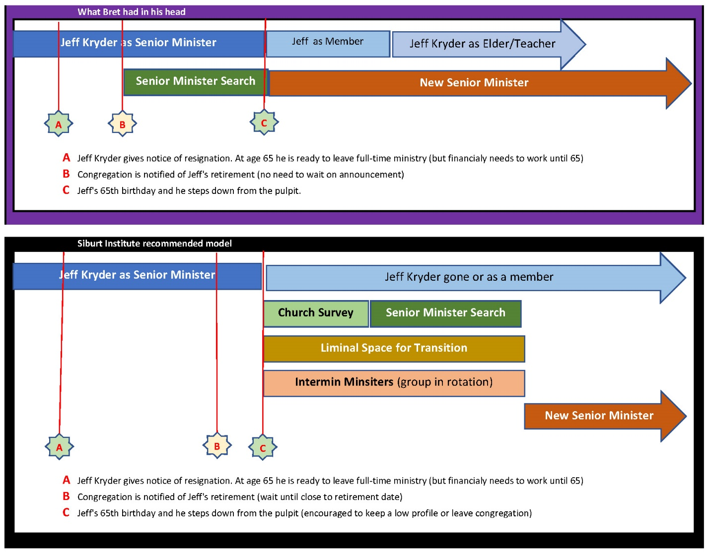

**Note**: The full document on Jeff Kryder’s retirement and replacement considerations is available here … <https://www.shepherd.mx.mxcoc.xyz/positions/docs-23/MX-SrMinister.docx>.

**Exhibit C**

June 29, 2023

Dear Elders,

Just a quick update as I will be on vacation on July 10, our next scheduled meeting.

**1. Upcoming Preaching -**

* Steve Awtrey on July 9
* Travis Myers on Aug 6
* Eric Mcpherson on Sep 10

**2. Back to School Sunday - Aug 20**

* Back to School Worship similar to other years with prayers for all involved in education.
* Combined Intergenerational Class in Gym.  Jeff, Nathan, and Jeremiah will do the planning and teaching together.
* Invitation to members on that day to:

1. Pray for kids.

2. Get to know the names of kids.

3. Create places for belonging and identity at MX.

**3. Church in The Park (Tilles) - Rescheduled for September 24.**

- Due to conflict with CFS 50th event, we were able to move our picnic without a lot of fuss to the 24th.

- Eric preaching on Sep 10 will be about CFS and the event being held by CFS on Sep 17.

**4. Ministry Fair - Sunday, October 1 and Sunday, October 8.**

- Ministry Tables will be set up in the hallway for each of these Sundays.

- Jeff will preach on "*Using Your Time, Talent, and Treasure to Strengthen the Body of Christ*”

**5. Faith-In-Action will begin soon.** It will take the place of the scheduled IMPACT Day on October 8.

* We will look for an opportunity for the congregation to serve along with the FIA volunteers later in October or early November when the leaves fall.

**6. New Members.**

To be welcomed this week:

- Shannon Miller and River.

- Gloria Hanson.

- Cari Merrick.

- Andy and Grace Clapper (planned to be welcomed on July 16).

- Following up with Cornelius' family.

**7. Pray for:**

- VBS Follow-up.  Great job, Jeremiah and volunteers!

- Newly baptized - Isabell Patton and Harmony Patton.

- Izzy and Sara - Memorial set for July 15 at 11:00.

- Honduras team.

- Campers.

- New Members.

- Fall Bible Classes - *Ruth*, taught by Gwen Walker; Jeff to teach *Leadership Class*.

--

**Jeff Kryder**

**Senior Minister**

**McKnight Crossings Church of Christ**

**Exhibit D**

Note: below are Bret’s attempt to capture what was discussed on 7/10/2023. Each individual below should correct their comments as needed to minimize miscommunication.

**Brad Stevens**

Appreciates Carson Reed’s approach and gives weight to his opinion as “he’s been down this road before.” Liminal Space also makes sense. Brad thinks new minister will need ability to do things twithought any input, coercion, or direction from Jeff Kryder.

Also, leadership needs to be transparent with church and announce something sooner than later. Brad thinks we should also start unwinding Jeff Kryder – Jeff should focus on preaching and we need to start weaning him off administrative and other responsibilities.

**Keaton Jones**

Feels that congregation expects Jeff Kryder will retire soon as he is almost 65. Keaton does not like Carson Reed’s transition plan. Keaton recommends that when we communicate to congregation about Jeff’s retirement we start looking to fill position. It may take quite some time to find a suitable replacement so starting soon is preferable.

**Dave Weiler**

Initially Dave wanted to have overlap with Jeff Kryder and new minister but now feels there is wisdom in Carson Reed and Siburt recommendation. Dave expects we will likely have an unknown minister coming in (as opposed to a known entity like a Phil Gold or a Travis Myers). With a new and unknown minister there will need to be a “reset” with the church and some congregational training will be needed/helpful/encouraged. Siburt can be brought in to teach on several Sundays during the minister transition on topics to prepare the congregation for a new minister and possibly new focus. Siburt will also help perform a health assessment for the “reset” ([1]<https://www.siburtinstitute.org/cha)>[[2]](https://www.siburtinstitute.org/cha)).

**Steve Awtrey**

Carson’s recommendations are good but do not fit McKnight church. Jeff Kryder is willing to back off things if asked. Steve like the idea of announcing Jeff’s retirement around November 2023. As this is when Jeff turns 64 it seems a natural transition to retirement in a year. However, when we announce Jeff’s retirement to the congregation we also need a rough idea of a plan (path forward) to go with that announcement. Steve thinks we should start looking for a new minister in Q2 2024 (April 2024) and once started we need to be ready to hire. Steve also likes the idea of a “liminal space” and we can adapt based on needs of new minister.

Interim Preaching – Steve likes the idea of having Siburt preach 1x month, having an MX member preaching 1x month, and 2x month having a known preacher, such as a Dale Robinson, EK Keller, Mike Root, etc.

Jeff Kryder can finish in August 2024 (and continues to be paid through November 2024). Steve is good with an overlap of Jeff Kryder and new minister, if needed and works with personalities (elders will need to assess based on circumstances).

Steve is also in favor of the Siburt Church Health Assessment.

**Bret Blackford** (thoughts on transition from earlier email - <https://tinyurl.com/4358n8jw>)

I’ve given thought to what Carson and Siburt recommend and understand much of the reasoning. However, I do not see this as a good fit, necessary, or helpful for McKnight.  I am not worried that Jeff Kryder would intentionally or unintentionally work against the elders or the new Sr Minister.  My thoughts on possible path forward …

1. Inform the congregation shortly after Jeff’s 64th birthday (November 2023).
2. Begin searching for new Sr Minister early 2024
   1. Draft requirements
   2. User Siburt and other avenues
3. Plan to interview starting Q2 2024 (April)
4. Hire as soon as acceptable candidate found
   1. Can overlap with Jeff Kryder
   2. Can learn from Jeff Kryder

We still need to hear from **Don Fitzgerald** and **Steve Walker**.

1. More information on the **Church Health Assessment (CHA)** can be found on the Siburt Institute website here … <https://www.siburtinstitute.org/cha>.
2.