Attendees:

Brad Stevens, Steve Walker, Dave Weiler, Jeff Kryder, Keaton Jones, Steve Awtrey, Don Fitzgerald, Bret Blackford (chair)

Next Meeting: **March 6 –** Dave Weiler chair

1. Welcome (Bret)
2. Opening Thoughts (Bret/Jeff Kryder 10+ min)

What is the goal of ministers/elders – pt. 2

* + [What Elders Do](https://www.shepherd.mx.mxcoc.xyz/docs/WhatEldersDo.pdf)
  + [MX Shepherding Model](https://www.shepherd.mx.mxcoc.xyz/positions/docs/McKnight%20Crossings%20Shepherding%20Model.pdf)
  + [Core Beliefs .pdf](https://www.shepherd.mx.mxcoc.xyz/docs/MX-CoreBeliefs-Schedule_A.pdf)
  + [Core Values .pdf](https://www.mxchurch.org/our-core-values)

Jeff Kryder followed up with part II of "*What are we elders and ministers supposed to do?*" by talking about the MX Shepherding Model (attached). The audio is also available here ... <https://www.shepherd.mx.mxcoc.xyz/positions/docs-23/02.06.2023-MX%20ShepherdingModel.mp4>.

Part I from Jan 11 mtg here … <https://www.shepherd.mx.mxcoc.xyz/positions/docs/MX-CoreBeliefs.mp4>

1. Connections and touch-points with members (Jeff Kryder 10-min)
   1. FELLOWSHIP

Kari Ferguson is heading up a Fellowship Team.  Steve Walker is going to join that team.  The team has lots of ideas.  It is yet to be seen how this will be translated into "boots on the ground".  However, at a minimum, I believe this group will be working on Fellowship Meals, Family Camp, and Fall Women's Prayer Time.

* 1. SENIORS

The Senior Ministry has various components.  One event is happening Jan. 27, 2022, hosted by Judy Miller and Linda Mueller, for widows at Marion's house.  They will be sorting out next steps to serve widows and others.  My hope is that the ministry will be expanded to Seniors, or at the very least - Special Sisters.

* 1. FAITH in ACTION

Steve Awtrey, has agreed to pick back up on Faith-in-Action later in the spring.

* 1. YOUNG ADULT

Carrie Strickland is coordinating / hosting the Young Adult Group on Thursday evenings.  Most of the leadership comes from Jeremiah and Nathan.

* 1. COLLEGE / YOUNG ADULT

Class to begin on Feb 5.  Jayson Vincent, Adam Shelley, and Ron Orick are the key champions.

* 1. Small Groups/Huddle Groups

This is an important ministry and I recommend the elders have group leaders invited to at least 1 elder meeting a year (if not more)

* Connect Groups – ref **Attachment B**
* Huddle Groups – ref **Attachment C**
  1. *Note*: some ministries and connections are critical to MX. Some may be temporary and can die when they have run their course.

1. Pastoral Elders (Bret 10-min)

Without Glenn Devania, Wole Okunade, and Louis West we have fewer connections with the congregation. It is important/necessary that the elders maintain real-time access to the congregation and can address the various spiritual, emotional, physical needs that occur.

* 1. Proposal

This seems to be a critical gap that exists in our leadership model. I recommend that we chose a couple individuals to act as deacons in this area.

Possible individuals: Ben Mehringer, Dolores Miller, Collins Corder, Marion Earnhart, Kay Heintz (others?)

I think this is important enough that we commission deacons to oversee, possibly for a 2-year term (make it more sustainable).

I suggest we identify 2 candidates for deacons in this area who would help oversee a larger group of individuals (let’s list some names) to make sure our elderly and sick are being visited and are available for calls as needed. We will need to put more consideration into how this should be developed. Note: ministers such as Jeff Kryder will still be point for serious life issues like end-of-life, terminal illness discussions, marriage issues, etc.

Proposal was considered worth pursuing. Jeff Kryder will work with a couple elders to begin implementing something similar.

1. Individuals with Budget Responsibility (Dave Weiler 10-min)

It is important that the elders know who is responsible for key areas of church. – ref **Attachment** **H**

1. Outsource payroll to ADP (Dave Weiler 1-min)

Have we transitioned to ADP and completed a payroll run?

* Elizabeth mentioned needing to decide on the following:
  + Payroll 2x month
  + Craig Young 1099 or W-2

Expected time-saving for Elizabeth McPherson monthly and at year-end?

Dave Weiler and Don Fitzgerald are taking the lead to get this past the goal-line.

1. Elder update (15-min) Time did not allow updates in these areas
   1. Vision (Steve A./Steve W.)
   2. Administrative (Dave/Brad/Don)
      1. Building (Bret/Don)
   3. Pastoral (Keaton)
2. Jeremy Picker Sabbatical (Steve Awtrey 10-min)
   1. January 16 -- February 28, 2023
   2. Info on how it is going
   3. New job description for when Jeremy returns – ref **Attachment D**

Steve Awtrey updated on Sabbatical.

1. Kari Ferguson (Jeff Kryder 10-min) – follow-up on conversation after budget Sunday
2. Miscellaneous
   1. Occasionally Jeremiah will make video lessons –
      1. How often are these made?
      2. Who is audience?
      3. is this proper use of his time?

Did not have time to discuss

* 1. Monthly Prayer (Dave Weiler 1-min) – any changes?

Did not have time to discuss. Dave Weiler can update as needed via email, or will add as agenda item to next mtg

* 1. Small Group Prayer in Worship
* Bret feels uncomfortable with these and will excuse himself to foyer
  1. Elder Meeting – now 1x-month unless compelling reason for more

It appears the consensus is meeting 2x month.

1. 1st Monday of month regular elder meeting 6:00-7:30 (or shorter)
2. Elder/Ministry meeting - TBD (Jeff Kryder will work on this with some input). Expect meeting to be on-site with a remote option. Meeting to last 60-minutes or shorter.

Dave Weiler is next in line to chair for March. Work with Jeff Kryder as you schedule meeting.

* 1. **Audrey Dolan** (Bret 5-min) – Audrey would like to add clothing to food pantry. She was going to start the first 5-minutes of meeting but had conflict so plans to attend March meeting.

Note: not all requests, even good ideas, need to be accepted. We should first decide if it fits with vision of church, if it doesn’t distract from an existing ministry, or if it deals with items that might best be handled with organizations/ministries beyond MX.

We did not have time to discuss at 2/6 meeting. Audrey may get 5 minutes at start of next elder mtg (3/6)

* 1. Carson Reed (Jeff Kryder 1-min) – March 14, 2023 available to meet with MX leadership
  2. Passing Communion – we’ve had church meals. Is it time to start passing communion and not just the collection?

Decided to announce this Sunday 2/12 that we will begin passing communion on Feb 19, 2023

* 1. Dolores retirement reception proposal - April 2.  (Jeff K.)

Will have a brunch after worship, instead of Bible class

* 1. 2023-24 Tilles Winter Wonderland

Decided to renegotiate agreement, looking for $1,300+ each season

**Attachment A**

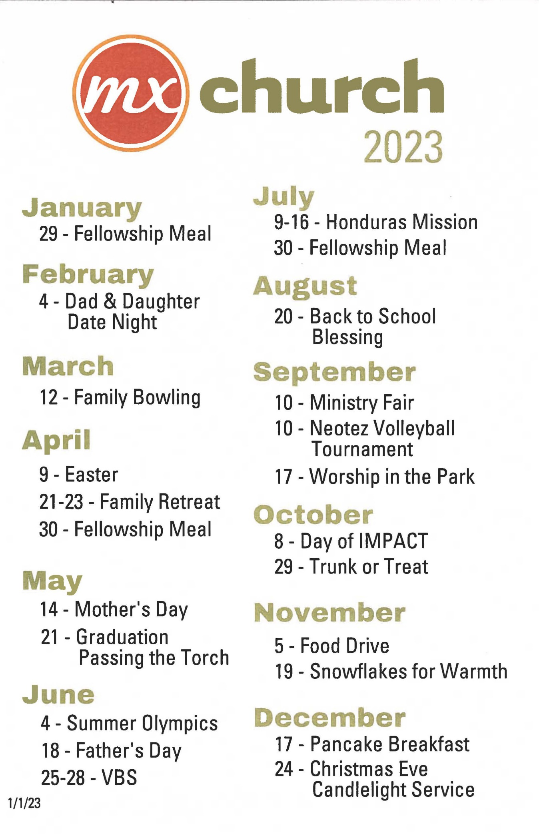

**Attachment B**

**CONNECT GROUPS – FALL 2022**

|  |  |
| --- | --- |
| **Steve & Susan Awtrey**  steveawtrey@gmail.com  314-374-3276  Collins & Trish Corder  jcorder20@aol.com  314-576-3703  Alternate Sundays, 6 pm  West County – Prefer no children  **Matthew & Rachel Bardowell**  mbardowell@gmail.com  314-440-1858  Sunday, 5 pm  Various homes  Children welcome  **~~Lane & Kim Hamm~~**  ~~lane_hamm@yahoo.com~~  ~~314-269-4049~~  ~~hammchicks@hotmail.com~~  ~~Sunday, 6 pm~~  ~~Kirkwood~~  **Alec & Wanda Hill**  alecwanda@sbcglobal.net  314-968-0434  Dale & Leslie Simpson  d1226ws@gmail.com  314-409-3321  Sunday, 6 pm  Various homes  **Keaton & Kathy Jones**  keaton.jones@sbcglobal.net  314-270-9632  Louis & Joyce West  joycedickersonwest@gmail.com  314-616-6219  Sunday, 5 pm  South County  Prefer no children  **Jeff & Beata McGlawn**  jeffbeatamcglawn@yahoo.com  636-692-3397  Brett & Michelle Blackford  bret_blackford@yahoo.com  314-402-7086  Wednesday, 6:30 pm  Rock Hill | **Jerry Mickey**  jmickey0327@att.net  573-380-5407  Monthly after church  At area restaurant  **Jeremy & Laura Picker**  jpicker@mcknightcrossings.org  636-825-6222  Alternate Sundays, 6 pm  Chesterfield  **Jayson & Wilka Vincent**  jayson.t.vincent@gmail.com  517-819-7805  Monthly on Thursday, 6:30 pm  Children welcome  **Steve & Gwen Walker**  srainey6@yahoo.com  Glenn & Janice Davania  rglenn88@hotmail.com  314-822-0321  Wednesday, 7 pm  **Dave & Amy Weiler**  dave-n-amy-weiler@juno.com  314-729-0327  Alternate Wednesdays, 7 pm  At the church building  **ACTS College Ministry**  Katie Holloway  mckuneke@gmail.com  573-578-5584  Friday, 6 pm  **Young Adults**  ~~Jeannie Britzmann~~  ~~jbritzmann@mcknightcrossings.org~~  316-633-0777  Thursday evening |

**Attachment C**

**HUDDLE GROUPS – FALL 2022**

**These are groups in addition to the Connect Groups. These groups meet during the week and are for men only or women only. Several meet for breakfast.**

**Todd Mayberry** (city4me@me.com)

* Men’s group
* Meets on Friday mornings, 7:00 AM
* At Starbucks in Richmond Heights

**Alec Hill** (alecwanda@sbcglobal.net)

* Men’s group
* Meets in Rock Hill
* Every other Wednesday morning from 7:00 AM

**Kryder/Awtrey** (jkryder@mcknightcrossings.org)

* Men’s group
* Meets on Wednesday mornings, 7:00 AM
* At Bread-Co in Webster

**Keaton Jones** (keaton.jones@sbcglobal.net)

* Men’s group
* Meets on Wednesdays at 6:00 AM
* Meets at Spencer’s Grill in Kirkwood

**Women’s Bible Study –** (dmiller@mcknightcrossings.org)

* Women’s group
* Location varies
* Friday mornings, 10:30 am
* Group is not closed, but since we use Bible study guides it is difficult to join mid-study.

**Attachment D**

**UPDATED JOB DESCRIPTION – JEREMY PICKER**

**WORSHIP AND CONNECTIONS MINISTER (Draft August 15, 2022)**

**Worship Planning and Coordination – *Delight in God***

* Meet regularly with Senior Minister to help guide and plan the direction of each Sunday worship assembly and other occasional times of worship.
* Will support the Worship Team and volunteers to ensure quality worship, drawing both the first time attendee and mature believer to the throne room of God and an encounter with Christ through corporate worship.
* Will ensure that praise team volunteers, worship leaders, musicians, and technology volunteers are recruited, trained, informed, and prepared to carry out their roles with excellence.
* Create, actively communicate, and effectively manage coordination, planning, and schedules of worship leaders, praise team singers, and instrumentalists for each worship time. Responsible for readiness of all details and personnel for practices and times of worship.

**Connections – *Encourage One Another***

* New Members - responsible for new members to move from 1st time guest to actively involved and invested in the congregation. This priority is to be done in conjunction with the Elders and Senior Minister.
* Ministry Development – will work with ministries and ministry leaders to sharpen direction, assist with recruiting, receive training, and have the resources to carry out their goals.
* Assist with church-wide events to encourage relationships and a strong sense of connection at MX. This includes events like Sunday Meals, Trunk-or-Treat, the Block Party, etc.
* Assist members and regular guests as appropriate to use their gifts and talents to build up the body and serve the community.

**Attachment E**

Attached is the latest weekly bulletin



Also here … <https://www.shepherd.mx.mxcoc.xyz/docs/02.01.2023%20-%20MX%20News%20and%20Prayer%20Concerns.pdf>

**Attachment F**

TinyUrl to Wayback ... <https://tinyurl.com/mtb6zmfc>

----- Forwarded Message -----

**From:** **Jeff Kryder** <jkryder@mcknightcrossings.org>

**To:** MX MXElders <mxelders@mcknightcrossings.org>

**Sent:** Wednesday, January 25, 2023 at 02:41:11 PM CST

**Subject:** **Why Your Church Has to Replace 32 % of Its Attendance to Stay Even**

In summary, based upon Thom Rainer's network of churches surveyed:

1. Death - 1%

2. Moving Out of Community - 9%.

3. Transfer to Another Church - 7%

4. Decline Attendance Frequency - 15%

Based on his stats, applied to MX at an attendance of 200, we need 64 new people to hold our own.  Yikes!  Thank God it's the Lord's church!  What else would the Lord have us do?

<https://churchanswers.com/blog/why-your-church-has-to-replace-32-percent-of-its-attendance-to-stay-even-each-year/?utm_source=convertkit&utm_medium=email&utm_campaign=Why+Your+Church+Has+to+Replace+32+Percent+of+Its+Attendance+to+Stay+Even+Each+Year%20-%209900706>

--

**Jeff Kryder**

**Senior Minister**

**McKnight Crossings Church of Christ**

**Attachment G**

**Live Generously** - **MX 2023**



1. Next Gen Focus:
   1. Encounter - Area-Wide Teen Worship
   2. College/ Young Adult Class and Outreach
   3. 5th Sunday Family Worship
   4. Congregational Meal / Honduras Fundraiser – Jan. 29
   5. Daddy Daughter Date Night
   6. Family Retreat
   7. Summer Olympics (instead of block party)
   8. Honduras Trip
2. Upcoming Classes:
   1. Parenting (Feb-March)
   2. The Gospel and Baptism (lntergenerational) (April-May)
      * + Mathew Bardewell, Jeff Kryder, Nathan Strickland
   3. 40 Days to Easter
3. Faith-in-Action / Senior Ministry / Widow Event

**Attachment H**

**2023 Budget**

The link to the 2023 budget noting who is responsible for key areas may be found here … <https://www.shepherd.mx.mxcoc.xyz/positions/docs-23/2023Budget-Final.xlsx>

The file is also attached below:

