Attendees: Brad Stevens, Steve Awtrey, Dave Weiler, Bret Blackford (chair), Don Fitzgerald, Steve Walker, Keaton Jones, Jeff Kryder

Next meeting: February 6, 2023

1. Welcome
2. Opening thoughts (Bret/Jeff Kryder)
   * What is goal of minsters/elders?
   1. [What Elders Do](https://www.shepherd.mx.mxcoc.xyz/docs/WhatEldersDo.pdf)
   2. [MX Shepherding Model](https://www.shepherd.mx.mxcoc.xyz/positions/docs/McKnight%20Crossings%20Shepherding%20Model.pdf)
   3. [Core Beliefs .pdf](https://www.shepherd.mx.mxcoc.xyz/docs/MX-CoreBeliefs-Schedule_A.pdf)
   4. [Core Values .pdf](https://www.mxchurch.org/our-core-values)

Jeff Kryder summarized *3. Core Beliefs* - <https://tinyurl.com/27vcd4e2>.

See also **Attachment J** below

1. Prayer
2. Ministry Updates
   * Jeremiah – Children
   * Nathan – youth – had to leave after 15 minutes so no update
   * Katie – ACTS – unable to attend
   * Jeremy – family
     + Worship plan while on Sabbatical
     + Church calendar – **Attachment F**
   * Jeff – general
3. 2023 Budget Review and Approval (Dave W.)
   * Elders approved budget noted at **Attachment I**

* Dolores Miller – retirement announcement to be made Sunday January 15, 2023. She will retire March 31, 2023 but will receive severance for remainder of year.
  + We should plan a reception to honor Dolores and the many years she has served Mid-County and McKnight.

1. Elder update: Time did not allow the various elders to update on these areas
   * Administrative
     + Building
   * Pastoral
   * Vision

* Bret mentioned that the Pastoral work needs assistance. We no longer have Glenn Devania or Louis West assisting with this. Only Keaton Jones trying to get with people as he is available. We should consider seeking out potential elders in congregation who already seem to be serving in this area.
* Keaton Jones has previously mentioned he seeks to step down as an elder in a couple years. We need to keep this in mind and plan accordingly.
* Steve Haupt – announcement to be made Sunday January 15, 2023 bout him stepping down as an elder.

1. Building: (Bret/Jeff)
   * Cleaning
     + Scheduling remains a problem. Michael and Whitney Cannon struggle to get consistent time to work at the building.
     + Possibility of getting Carol Briggs to assist now that she will be laid off.
   * Snow removal – costs about $600 per snowfall
2. Jan 17 sermon plan – Dave Weiler and Bret Blackford to present budget and discuss giving
3. People
   * Adelyne Barr, 19-year-old daughter of former members, Joel & Brenda Barr, died in an auto accident on New Year's Eve
   * Sydney – [house fire of relatives](https://www.kmov.com/2023/01/02/house-fire-displaces-family-wildwood/?fbclid=IwAR1WdkCuCewGzt2FfvXU28RuL5Q5oLgt7zgkATUL2SfuW5NYJy7610yh_4Y&mibextid=Zxz2cZ#lcf2s42yzi1kbby0hcq)

CONFIDENTIAL

* + Jae’la Hughes – Pray for me and my family, our safety, and finances.
  + Alec & Wanda – Prayers for Aunt Betty. Uncle Jerry died Friday, 12/16, and his memorial service was yesterday.
  + Peggy Hope – Struggling with nerves in back. Having MRI Wednesday. Thank you.

GENERAL

* + Larica Tucker – Please pray for my family. Love you all.
  + Bardowell child – Our cousin broke his leg and his mom has to do that and she has a baby in her stomach.
  + Kari & Brett Fertuson – My friend Nikol, is battling cancer.
  + Ernestine Gathing – Pray for my husband, Gregory.
  + Debbie & Gerald Davis and Abby– Abby starting alternate learning.

GUEST

Marcena Gunter

#1 Kilmar Woods

Belleville, IL 62223

708-378-1532

[marcenagunter@gmail.com](mailto:marcenagunter@gmail.com)

(Member of Centerville Church of Christ)

1. Transitions

* Jeff Kryder – he plans to get with Dave Weiler soon to discuss retirement, possibly in the next 2-3 years
* Keaton Jones – planning on stepping down as an elder sometime in the next couple of years
* Steve Haupt – need to announce to congregation he has stepped down as an elder
* Dolores Miller – retiring end Q1 2023.
  + Need to plan a reception in her honor
* Jeannie Britzman – moved to Florida and trying to mange her workload without overwhelming Elizabeth McPherson

Attachments

* **Attachment A** – weekly bulletin
* **Attachment B** – age-range demographics
* **Attachment C** – Future Church: 8 Church Trends to Watch in 2023
* **Attachment D** – The Road I’ve Traveled: videos now available at [www.mxchurch.org](http://www.mxchurch.org/)
* **Attachment E** – large Dec. 2022 contributions
* **Attachment F** – 2023 Church Calendar
* **Attachment G** – Live Generously - MX 2023
* **Attachment H** – Office Administrator job description
* **Attachment I** – 2023 Budget info
* **Attachment J** - McKnight Crossings Core Beliefs

**Attachment A.1**

Below is the most recent bulletin



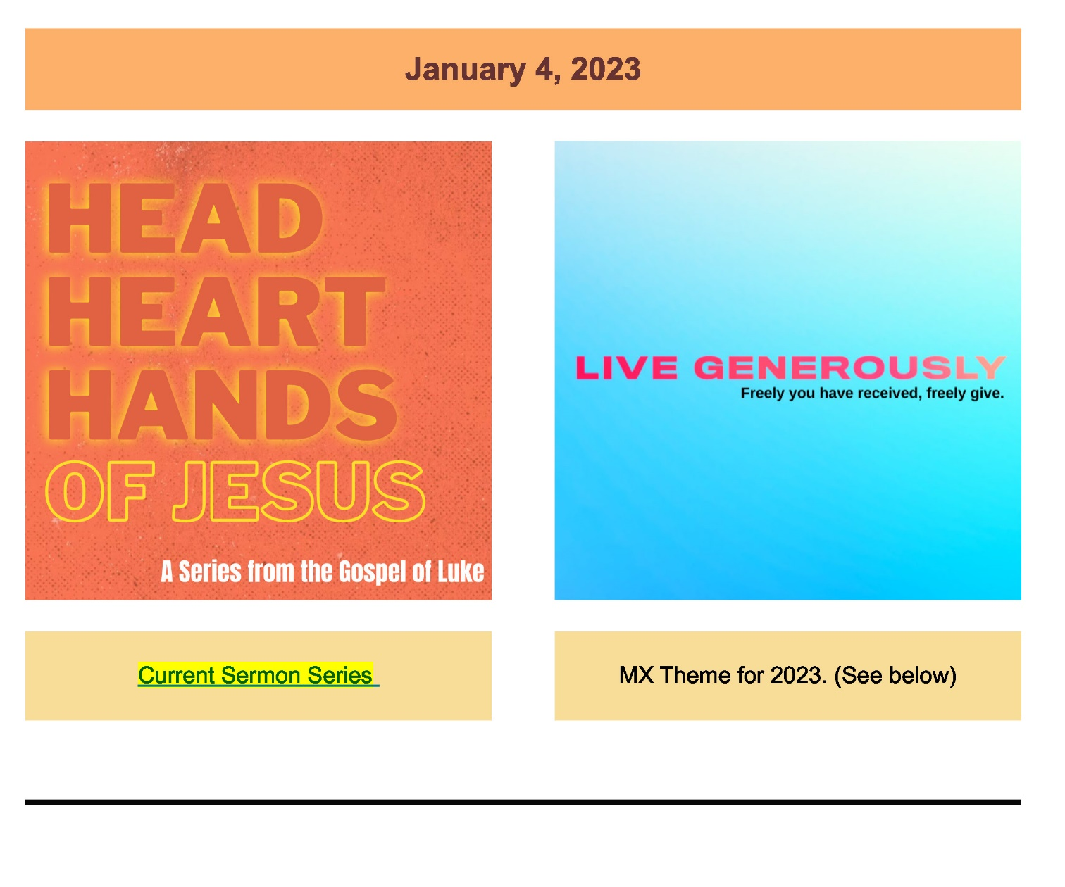

**Attachment A.2**

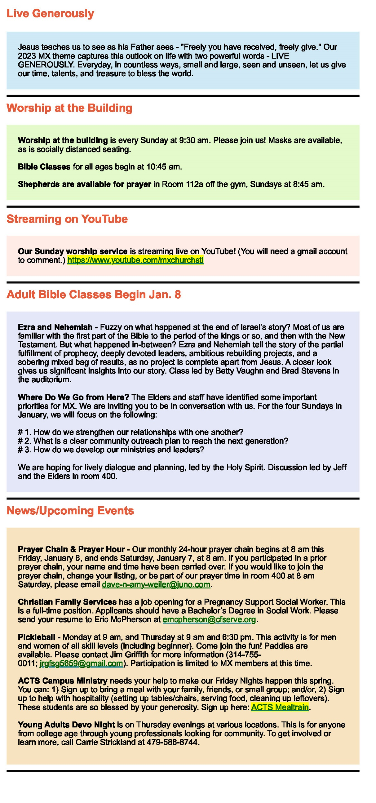

**Attachment A.3**

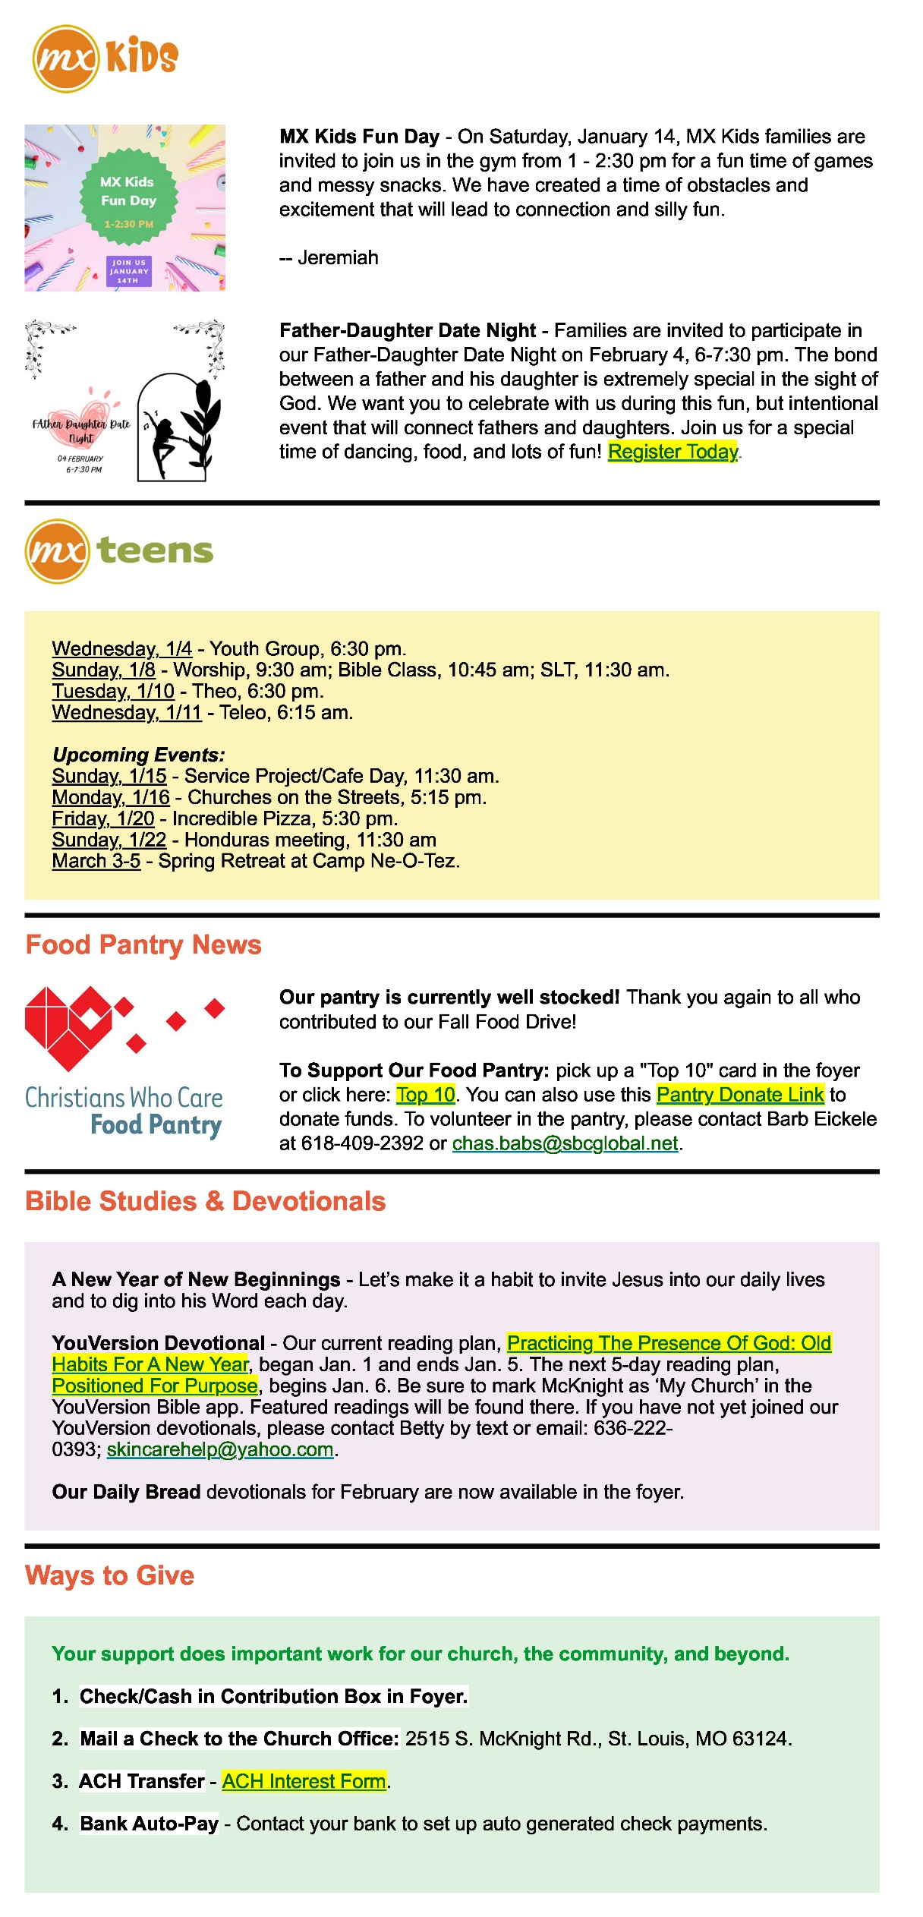

**Attachment A.4**

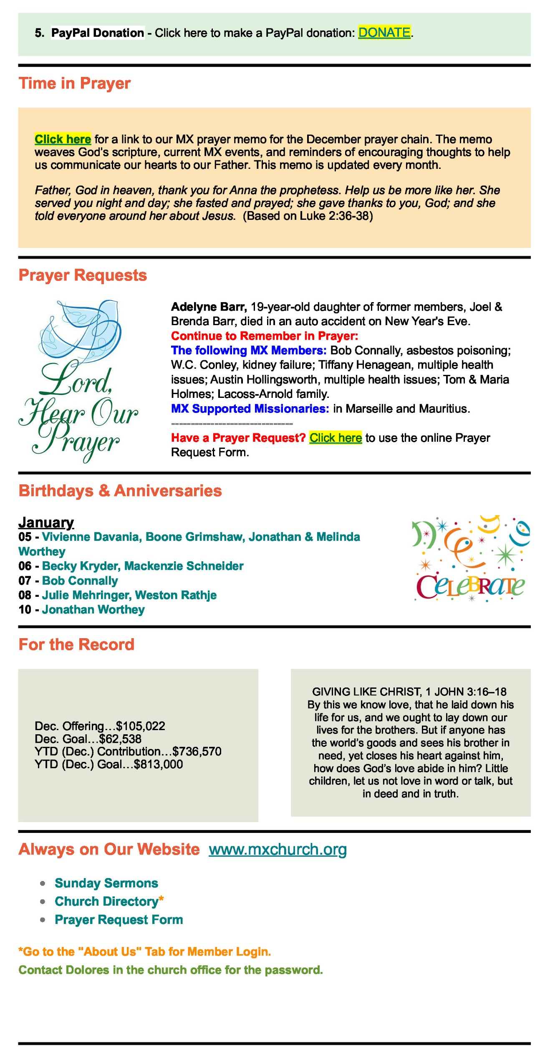

**Attachment B**

The following was shared by Steve Walker in January.

<https://marketingartfully.com/customer-demographics-age-ranges-numbers/>

# Age Ranges, Generational Names and Numbers

**By: Author**[**Tara Jacobsen**](https://marketingartfully.com/)

**Posted onLast updated: April 27, 2022**

**Data Collected from the 2020 Census.**

**Age range based on year 2022**

**The Silent Generation**

Born between 1927 and 1945

Age 77-95

*Data Set*

*75-79 is 9,113,714 people…. so 60% of that is 5,468,228*

*80-84 is 6,079,337 people*

*85+ is 6,621,816 people*

*Total number of people in the Silent Generation age range is 18,169,381 which is 5.46% of the population*

**The** [**Baby Boomers**](https://nam04.safelinks.protection.outlook.com/?url=https%3A%2F%2Fmarketingartfully.com%2Fboomer-genx-parents-millennial-genz-kids%2F&data=05%7C01%7Cmblackford%40archrsc.com%7Cbce4c43148474b35a9b208daf291e4ee%7C4d348abdd5144853aed8b4fb0643159f%7C0%7C0%7C638089005672054942%7CUnknown%7CTWFpbGZsb3d8eyJWIjoiMC4wLjAwMDAiLCJQIjoiV2luMzIiLCJBTiI6Ik1haWwiLCJXVCI6Mn0%3D%7C3000%7C%7C%7C&sdata=FqWr1RfBVQkUg%2BdjXDNiv8GRpbh%2FGHeorfvzTm0L2go%3D&reserved=0)

Born between 1946 and 1964

Age 58-76

Data Sets

55-59 is 28,785,721 people… so 40% of that is 11,514,288

60-64 is 20,315,718 people

65-69 17,301,772 people

70-74 is 13,246,178 people

75-78 is 9,113,714 and 50% of this one 4,556,857

Total number of people in the Baby Boomer age range is 66,934,753 which is 13.18% of the population

[**Gen X**](https://nam04.safelinks.protection.outlook.com/?url=https%3A%2F%2Fmarketingartfully.com%2Fgen-x-demographics-characteristics%2F&data=05%7C01%7Cmblackford%40archrsc.com%7Cbce4c43148474b35a9b208daf291e4ee%7C4d348abdd5144853aed8b4fb0643159f%7C0%7C0%7C638089005672054942%7CUnknown%7CTWFpbGZsb3d8eyJWIjoiMC4wLjAwMDAiLCJQIjoiV2luMzIiLCJBTiI6Ik1haWwiLCJXVCI6Mn0%3D%7C3000%7C%7C%7C&sdata=HMBcbCzmVElEwnFq42GBN5L44SF88CT6Myvd0wrWL7k%3D&reserved=0)

Born between 1965 and 1980

Age 42-57

Data Sets

40-44 is 6.1% 20,000,622 people… so 60% of that is 12,000,373

45-49 is 6.3% 20,569,969 people

50-54 is 6.4% 20,970,767 people

55-59 is 6.7% 28,785,721 people… so 60% of that is 17,217,433

Total number of people in the Gen X age range is 70,758,542 which is 21.27% of the population

**Gen Y or the Millennials**

Born between 1981 and 2000

Age 22-41

Data Sets

20-24 is 21,820,378 people… so 60% of that is 13,092,226

25-29 is 23,262,155 people

30-34 is 22,223,010 people

35-39 is 21,346,055 people

40-44 is 20,000,622 people so 40% of that is 8,000,248

Total number of people in the Millennials age range is 87,923,694 which is 26.43% of the population

**Gen Z, Post-millennials or iGen**

Born between 2001 and 2022

age 1-21

Data Sets

Under 5 is 19,650,192 people

5-9 is 19,979,039 people

10-14 is 21,107,910 people

15-19 is 21,174,955 people

20-24 is 21,820,378 people so 40% of that is 8,728,151

Total number of people in Gen Z age range is 90,640,247 which is 27.24% of the population

[https://marketingartfully.com/customer-demographics-age-ranges-numbers/](https://nam04.safelinks.protection.outlook.com/?url=https%3A%2F%2Fmarketingartfully.com%2Fcustomer-demographics-age-ranges-numbers%2F&data=05%7C01%7Cmblackford%40archrsc.com%7Cbce4c43148474b35a9b208daf291e4ee%7C4d348abdd5144853aed8b4fb0643159f%7C0%7C0%7C638089005672054942%7CUnknown%7CTWFpbGZsb3d8eyJWIjoiMC4wLjAwMDAiLCJQIjoiV2luMzIiLCJBTiI6Ik1haWwiLCJXVCI6Mn0%3D%7C3000%7C%7C%7C&sdata=uJX9kekoas8eGz0r7roTKZREx4OVo0WUWfsj1ckSX2g%3D&reserved=0)

**Attachment C**

The following was shared by Jeff Kryder in December 2022

# Future Church: 8 Church Trends to Watch in 2023

* [CAREY NIEUWHOF](https://careynieuwhof.com/author/carey/)

Hi Guys,

Here is a thought provoking article with quite a few "surprises".   I liked it, disliked it greatly, questioned its accuracy, and said, "I can see that."  Let me know the thoughts it prompts for you.

[https://careynieuwhof.com/future-church-trends/?he=Jkryder%40mcknightcrossings.org&el=email&utm_source=ActiveCampaign&utm_medium=email&utm_content=%5BNew+Post%5D+Here+are+the+8+church+trends+you+should+watch+in+2023&utm_campaign=1%2F2+-+Church+Trends+2023](https://nam04.safelinks.protection.outlook.com/?url=https%3A%2F%2Fcareynieuwhof.com%2Ffuture-church-trends%2F%3Fhe%3DJkryder%2540mcknightcrossings.org%26el%3Demail%26utm_source%3DActiveCampaign%26utm_medium%3Demail%26utm_content%3D%255BNew%2BPost%255D%2BHere%2Bare%2Bthe%2B8%2Bchurch%2Btrends%2Byou%2Bshould%2Bwatch%2Bin%2B2023%26utm_campaign%3D1%252F2%2B-%2BChurch%2BTrends%2B2023&data=05%7C01%7Cmblackford%40archrsc.com%7Cbce4c43148474b35a9b208daf291e4ee%7C4d348abdd5144853aed8b4fb0643159f%7C0%7C0%7C638089005672054942%7CUnknown%7CTWFpbGZsb3d8eyJWIjoiMC4wLjAwMDAiLCJQIjoiV2luMzIiLCJBTiI6Ik1haWwiLCJXVCI6Mn0%3D%7C3000%7C%7C%7C&sdata=u0B930HnLggylyySIPueu9B9ERtaadPkQTZnyKQ7OP8%3D&reserved=0)

- For instance, I didn't suspect that it would be so hard to get the boomers reengaged with church.   Thus far proving true for us.

- The identified problem that the Boomers have historically been our Volunteer base is spot on.  Now what?

- While I understand the idea that Volunteers have gifts and gift-oriented ministry[1] is very Biblical, I also do not believe that families can operate ONLY this way.  Meaning, in the family, I don't always get to use my gifts. Someone must do the dishes and take out the trash, and so I will do it because I am a servant first.

- I didn't think of Gen Z as being so open.  Still it begs the question, are they open to the Gospel and its accompanying lifestyle commitments that we announce?   Our emphasis on Next Gen is again on point.

- The online emphasis we have not adequately faced.  Is it essential to our future?  How so?

- Good observations on preaching, its role, its challenges, and the idea of curation of content.

I appreciate serving with you all!

- Jeff

--

**Jeff Kryder**

**Senior Minister**

**McKnight Crossings Church of Christ**

**Attachment D**

**"The Road I've Traveled" Videos Now Available for Viewing**

This past summer, members of our congregation shared important parts of their stories during our adult class "The Road I've Traveled." Attendees were blessed by each member's unfolding of key life experiences, observations, and personal growth that shaped who they are today. If you missed that class, or want to revisit a member's compelling story, these video interviews are now available on the church website. We invite you to watch them to encourage your faith and get to know these valued members of our body a little better.

Go to [www.mxchurch.org](http://www.mxchurch.org/). Under the "About Us" tab choose "Member Login." Enter the password "CROSSINGS" and you will see the collection of "The Road I've Traveled" videos readily available for viewing.

**Attachment E**

**Note large contribution in December 2022**

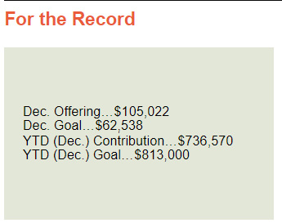

**Attachment F**

**2023 Church Calendar**

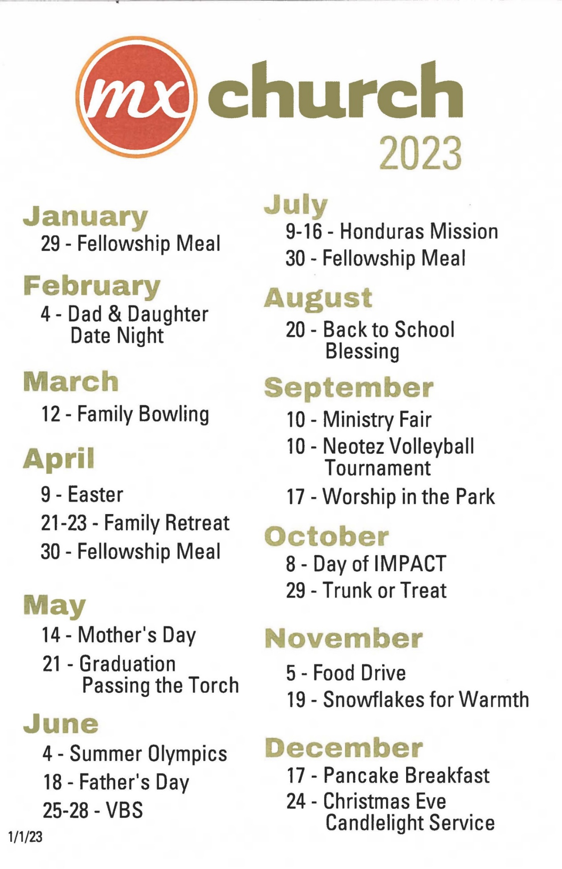

**Attachment G**

**Live Generously** - **MX 2023**



1. Next Gen Focus:
   1. Encounter - Area-Wide Teen Worship
   2. College/ Young Adult Class and Outreach
   3. 5th Sunday Family Worship
   4. Congregational Meal / Honduras Fundraiser – Jan. 29
   5. Daddy Daughter Date Night
   6. Family Retreat
   7. Summer Olympics (instead of block party)
   8. Honduras Trip
2. Upcoming Classes:
   1. Parenting (Feb-March)
   2. The Gospel and Baptism (lntergenerational) (April-May)
      * + Mathew Bardewell, Jeff Kryder, Nathan Strickland
   3. 40 Days to Easter
3. Faith-in-Action / Senior Ministry / Widow Event

**Attachment H**

**OFFICE ADMINISTRATOR 1/11/23**

**Daily/ Weekly**

QuickBooks (bookkeepi ng)

Pay Bills/Reimbursements/Support

Payroll Prep (2x/mo, timesheets, adjustments)

**Payroll Processing (2x/mo)**

Count Money from Sunday Contributions Weekly Contribution Reports

Servant Keeper Records of Contribution Weekly Bank Deposits

Banking Relationships (mortgage, investments, line of credit) PayPal & ACH Transfers, Management, Reporting

Administer Missionary Needs (finances/reimb/wire/communication/reporting) Employee Records (vacation, sick days, etc.)

Website Monitoring & Weekly Updates (accuracy & events) Set Thermostats

**Monthly / Quarterly / Annual**

MOE Procedures & Closing ofthe Books

Monthly Financial Reports (Finance Committee & Missionaries) Attend FC Meetings & Fulfill Objectives

Semi-Monthly & MonthlyTax Deposits (federal & state) Quarterly Tax Filings & VE Tax Filings

W-2's

Budget Information Prepared in the Fall

Budget Communication (with staff & ministry leaders)+ Respond to lnquiries Fall Communication w/lnsurance Broker & Healthcare Analysis Contribution Statements & Communication (fall YTD & VE)

EOY changes to Payroll, Benefits (HC, Retirement, LTD), EETax, Housing Automobile Tax/ Licensing Requirements

1099's + W-9 compliance Food Pantry Tax Credit

**Administration**

Oversee and Review Work of Secretary

Cover Front Desk when Receptionist is Out Answer Phones / Respond to Emails

New Hire Administrative Paperwork & Onboarding

Manage Healthcare Benefits, Retirement, LTD (enrollment, changes, terminations, inquiries)

Workman's Compensation

Meet Audit & Compliance Requirements (Hartford, HC group size surveys, etc)

Assist with Benevolence & Youth Scholarship Processing

Background Checks-Assist Ministers with Compliance

Point of Contact for Blood Drive, Polling, Funeral Deliveries/Setup, etc.

Go-between for Property Renters of 1346 and 1356 N. Rock Hill Rd.

Vendor Relations (Copier and other Office-related)

Website Enhancements

Standardization of Foyer

Coordinate Bulletin Board Refreshing

Order Building, Cleaning, Communion Supplies

Oversee Building Usage (requests, process, communication) & Keys

Oversee Van Usage & Driver Approval/Training

Annual Sexual Harassment/Molestation Prevention Training Upkeep of Kitchen and Refrigerator (incl Recycle)

Laundry (kitchen towels, custodial rags & dust mops)

**Congregational Communication and Events**

Review Weekly Emails

Job Satisfaction

Comp time for fellowship meals & church picnic

Reduced office hours & a plan for coverage on vacation days Lunch hour built into office hours (?)

Ability to work *outside* the office during non-office hours

Oversee SK Member Database& Digital Pictorial Directory

Redesign and Reorder Business Cards / Stationary

Redesign Paper Bulletin & Assist Configuration of Church Center App

Church Picnic (Worship in the Park)

Fellowship Meals

**Attachment I.1**

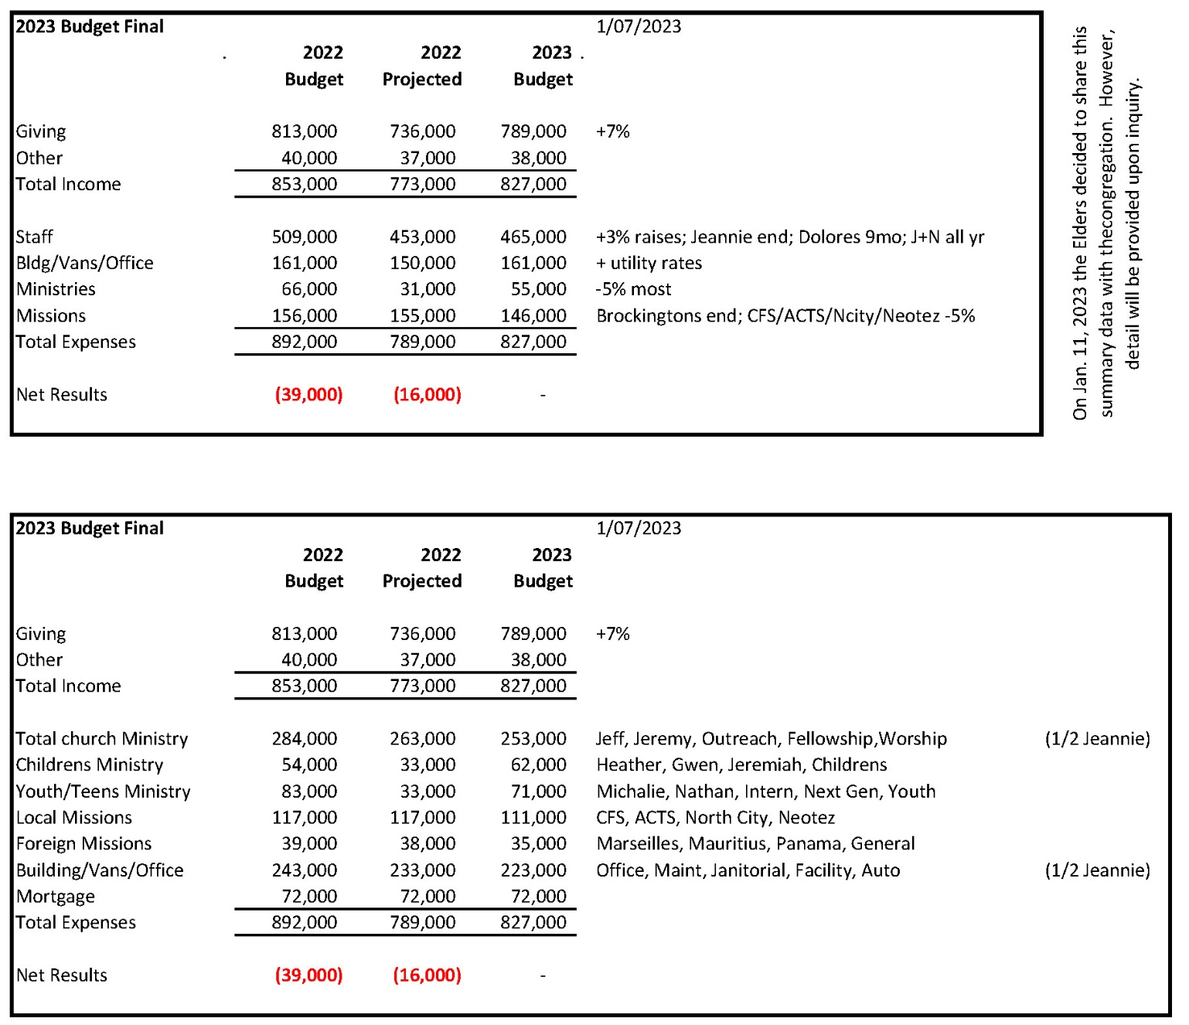

**Attachment I.2**

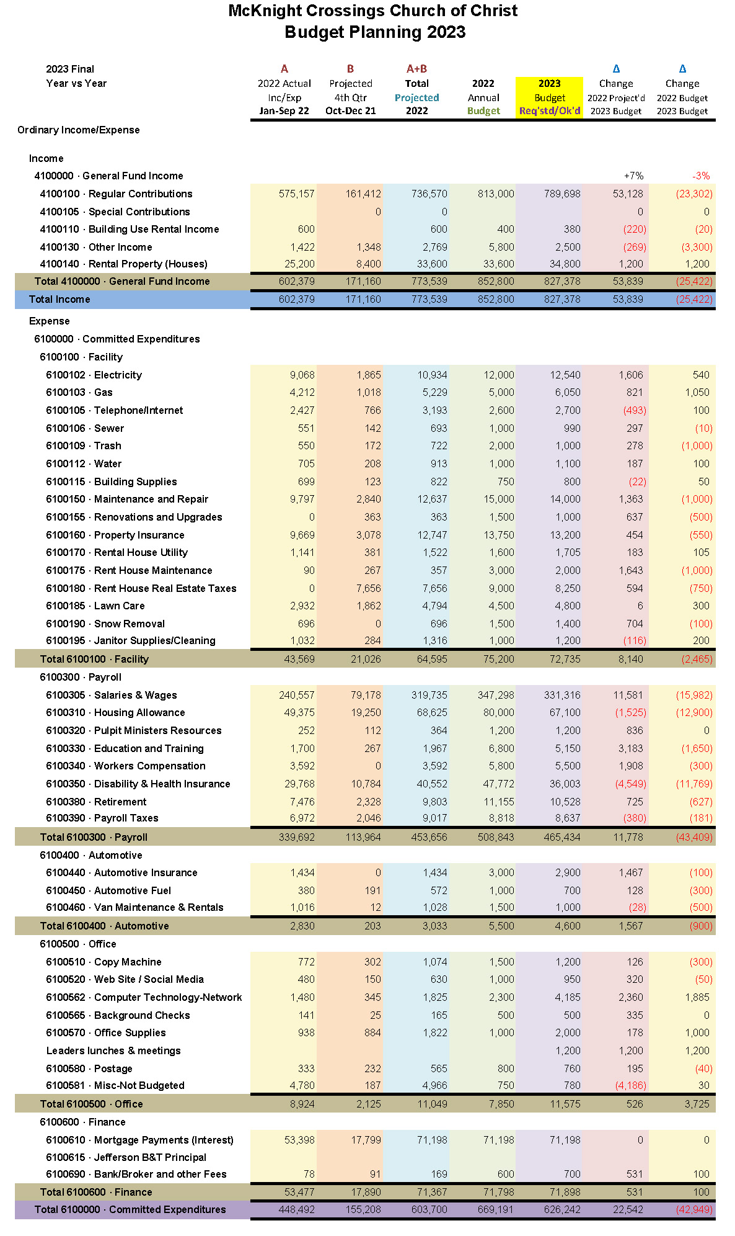

**Attachment I.3**

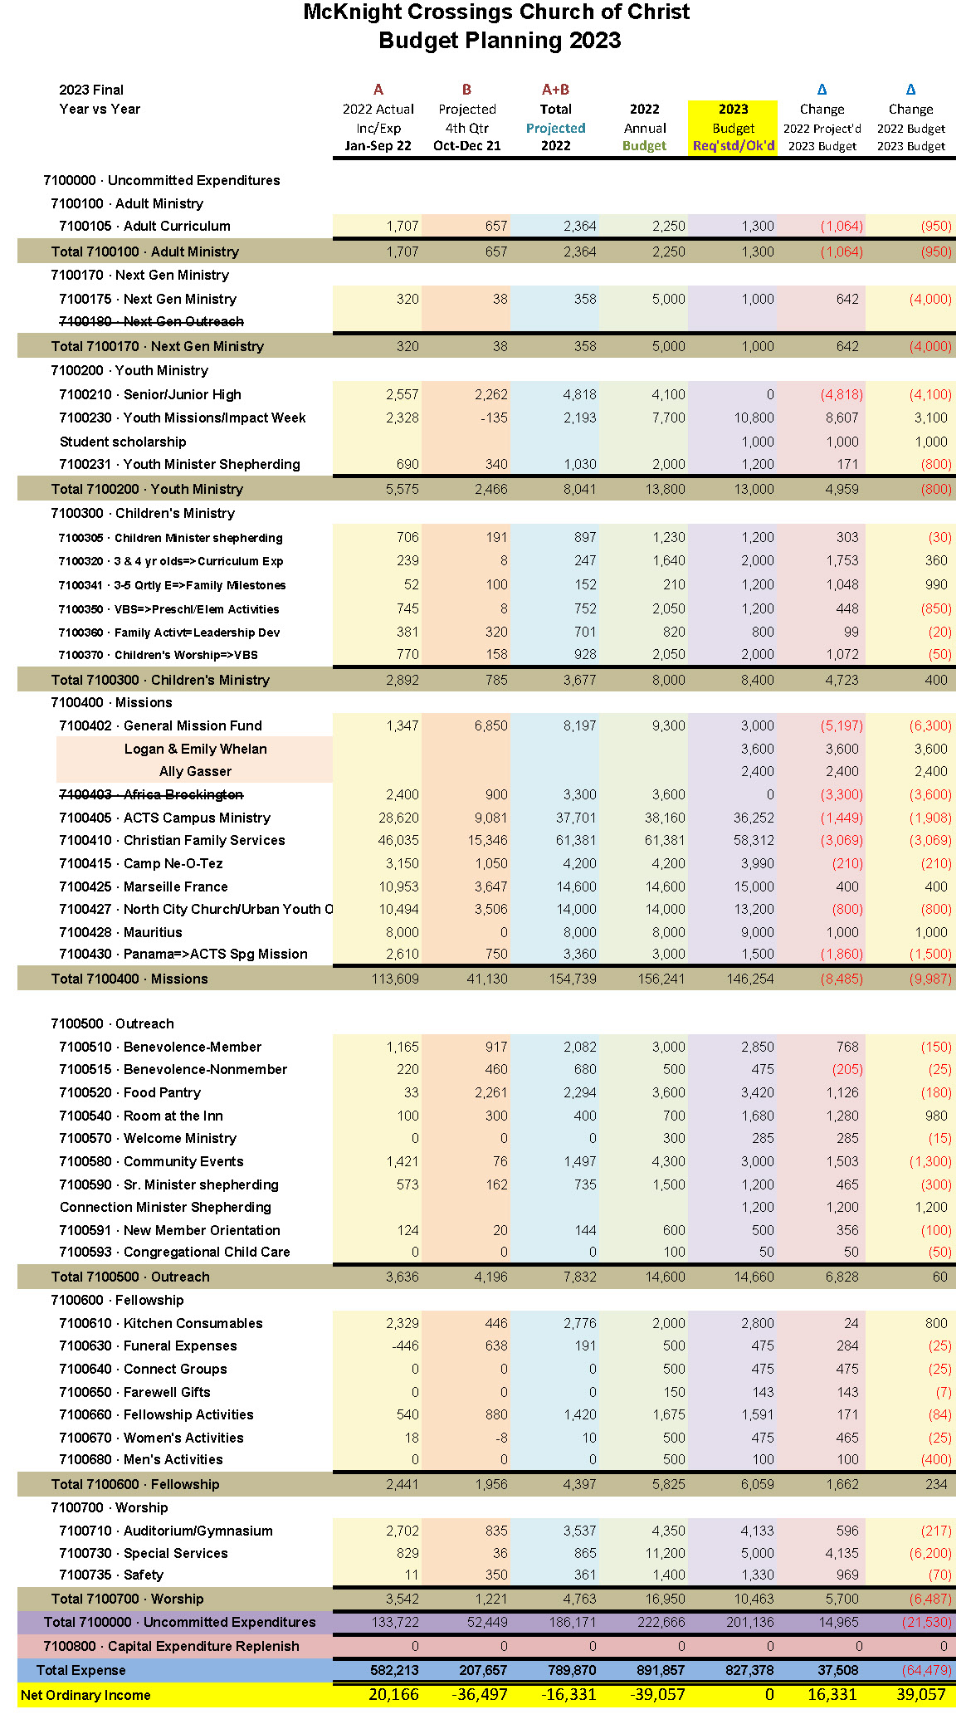

**Attachment J**

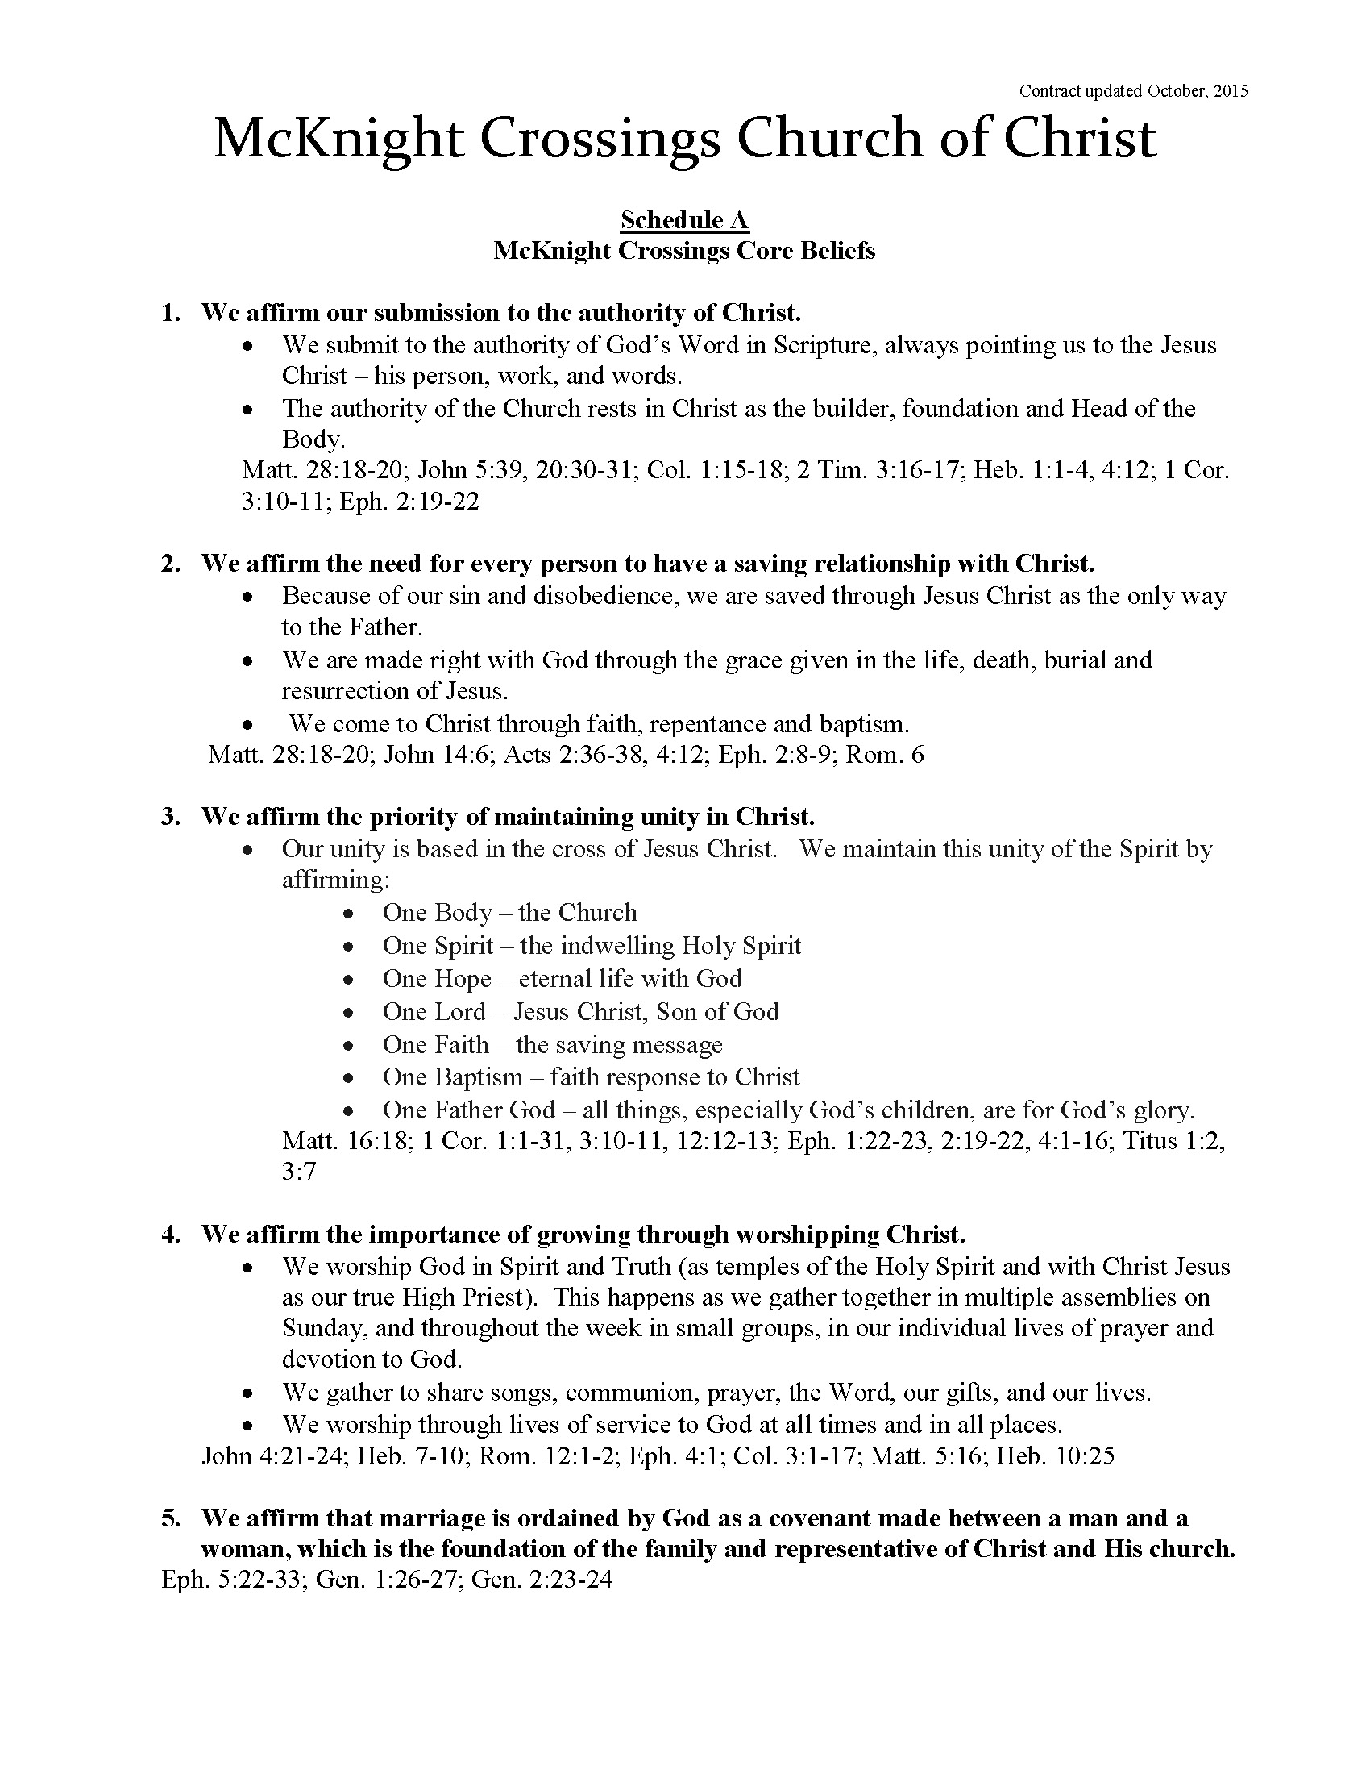

1. mBret – I have not found teaching on gifts to be helpful, and is often counter-productive. Often people consider their gifts those things they like to do and feel somewhat accomplished at. As Jeff mentions, this may not fit in with the mission/ vision of the church or the actual work that currently needs to get done. My $0.02