McKnight Crossings Church of Christ

Assessment of Worship Environment

Evaluation of
Physical and On-Line
Worship

November 2021

Prepared by:
Bret Blackford

To the elders of:
McKnight Crossings Church of Christ
2515 South McKnight Road, St. Louis, MO 63124

The following individuals contributed to the information contained herein:
Jeff Kryder, Senior Minister
Jeremy Picker, Family & Worship Minster
Jeannie Britzmann, Associate Minister
Jeff McGlawn, past involvement and technical advisor

Contents
Background 3
Recommendations 3
1. Lighting 3
2. Stage & Backdrop Repair/Replace 3
3. Audio 3
4. Video Streaming 3
Current Pain-Points 4
Goal/Requirements 5
Considerations of In-Person and On-Line Worship: 6
Some related questions for MX: 6
Exhibit A.1 – MX Auditorium Light Controls 7
Exhibit A.2 – MX Auditorium Light Diagram 8
Exhibit B – Scope document obtained from Jeannie Britzmann 9
Exhibit C – Project summary analysis obtained from Jeannie Britzmann 11
Exhibit D – Project summarization by Jeff Earnhart 12
Exhibit E – Bid from Advanced Audio & Lighting Systems 13
Exhibit F – Bid from Arch City Audio Visual Services 24
Exhibit G – Bid from Elite Enterprises 28
Exhibit H – Bid from HD Media 30
Exhibit I – Jeff Kryder discussion on Auditorium Project 31
Exhibit J – Jeremy Picker discussion on Auditorium Project 34
Exhibit K – Jeremy Picker discussion on Auditorium Project – follow-up 38
Jeff Kryder project comments summary: 39
Jeremy Picker project comments summary 39

Background: The Senior Minister, Jeff Kryder, and the Family & Worship Minister, Jeremy Picker, have shared ideas on how to improve the Sunday morning worship experience. Initial focus from the Senior Minister was the on-line worship experience but the Worship Minister also had ideas to improve the physical on-site worship experience.

Recommendations: The following are the recommendations of Bret Blackford based on current understanding of project goals. This list will probably need to be adjusted after further evaluation of the project and discussion with key stakeholders (Jeff Kryder and Jeremy Picker). The following is in order of operation, based on what should be done first, not necessarily in order of importance.

- Lighting: The first project should be the auditorium lighting, which has two (2) components:
  - Update the lighting controls: Replace the old 70s era push knobs with modern digital controls. This will make it easier for the untrained to run lights (e.g., funerals, wedding, etc.)
  - Add Stage lighting: Per discussions with Jeremy and Jeff the house lights are adequate (not great but they work). What is needed is additional stage specific lighting connected with the digital lighting controls mentioned above. Two types of stage lighting were recommended by contractors:
    - Track Lighting (preferred): This will be the easiest to install and require the least amount of additional rework of drywall and existing ceiling fixtures.
    - Add/replace some existing ceiling lights (not recommended): The existing can lights above the stage are not properly angled nor do they have the correct lumens.
  - Obtain new bids specific to this phase of the auditorium project.

- Stage & Backdrop Repair/Replace: The stage and backdrop are showing age and no longer work well with our worship aesthetic. However, no one has a clear vision of what the replacement stage and auditorium should look like.
  - Create a team to consider design options.
  - Design team makes recommendation to shepherds
  - Design selected
  - Contractor bid requested/accepted (or build using in-house labor)

- Audio: The current audio system is analog and is operated on Sunday be a skilled church member. A digital sound/mixing board would better ensure reproducible sound and allow more members of the congregation the ability to run sound on a Sunday. This will also make it easier to support special events like funerals and weddings.

- Video Streaming: This is important but should be talked later in the update process. The current streaming will be improved with lighting discussed at 1 above. Additional cameras and associated video equipment will aid the ease of production and video quality but can be addressed later, not an immediate pain point. This will also allow the leadership to discuss how we want o address on-line vs in-person worship (discussed later in this document).

Current Pain-Points (not in order of importance):

- Outdated Auditorium Lighting Controls
As noted in Exhibit A, the lighting controls for the auditorium are a set of old, mid-70s analog push-activated control knobs. These controls are hard to understand, hard to operate, and when they eventually fail will be difficult and time consuming to fix.

- Dim Auditorium Lighting
Many members have commented that the auditorium lights, even at maximum, are still dim.

- Dim/Inadequate Stage Lighting
Current overhead lighting is inadequate for on-line video. Video results (without any additional floor spot lamps) is poor and does not reflect the worship experience well.

- Extensive Worship Set-up
Prior to worship the audio and video system need to be brought on-line, checked, and calibrated/set.

- Several Single Points of Failure
Like many congregations, MX relies on specific key people to make the Sunday worship operate smoothly.
- The current soundboard needs a skilled technician and operating it is a learned skill (requires an apprenticeship).
- Video recording: usually performed by the same individual (not a deep bench if someone unavailable)
- Streaming set-up: usually performed by the same individual (not a deep bench if someone unavailable)

- Auditorium Stage and Back Wall Showing Age
The backwall needs maintenance and paint. May be a good time to revisit the current stage and backwall and rebuild so it compliments the in-person and on-line worship.

Goal/Requirements:
To be determined (TBD)

It is important for the successful analysis and execution of the project that clear goals and objectives are obtained and documented. These goals should document current pain points and things we would like to do but currently cannot. There should be objective goals that can be measured at the end of the project to determine if project was successful or not.

Along with these goals will be the identification of project owners and key stakeholders. Before vendors are selected or any physical work begins the elders need to understand and agree to the various goals of the project. Elders should consider …
- Do we want to be an on-line focused church?
- Are we happy/content with the on-line experience or do we need to expend some of our resources on improving?
- Are we happy with current worship aesthetic or do we want to change lighting, back wall, remove pews, etc.? All or in part?
- Do we want on spend resources on the Sunday audio system?

Bids Received to Date:
These are helpful in understanding ballpark dollars but need to be revisited based on specifics of desired work, and that the project will be performed in phases and not bid as a single job. Bids are difficult to read in this report and included to maintain completeness of documentation.
- Exhibit E - Advanced Audio & Lighting Systems, Inc
- Exhibit F - Arch City Audio Visual Services
- Exhibit G - Elite Enterprises
- Exhibit H - HD Media

Other Documents:
- Exhibit A.1 – Auditoium Lighting Control
- Exhibit A.2 - Auditorium Light Map
- Exhibit B – MX Auditorium Remodel memo, with goal. Author unknown
- Exhibit C - MX Auditorium Remodel- Bid Analysis. With goal. Author unknown
- Exhibit D – Auditorium Lighting and Electrical Upgrades. Email from Jeff Earnhart to Jeff McGlawn.

Considerations of In-Person and On-Line Worship:

As the shepherds consider the “auditorium Project” and worship we need to consider how we congregate. Historically we have always considered our Sunday worship as a joint in-person experience. With the advent of real-time on-line worship we need to consider what are short and long-term goals are for worship.

Some related questions for MX:

- If McKnight Crossings wants to provide an on-line worship experience is this something we will encourage (or do we prefer in-person)?

- If McKnight Crossings want to pursue an on-line real-time worship will that be emphasized over in-person worship? That is, do we build out the auditorium to accommodate the on-line worship possibly even to the detriment of in-person worship? An example would be lighting – would we want lighting, boom mics, screens, and cameras that look awkward in-person but improve the on-line experience? Do we spend our time and money focusing on on-line ministry over in-person?

- If McKnight Crossings pursues on-line worship how do we engage those members who worship remotely? How do we provide a sense of community?

- If McKnight Crossings wants to pursue an on-line worship experience how “professional” do we expect this to be? Are we looking at a functional alternative to in-person or do we want to spend resources (time and money) to provide something polished?

Below are just a few of the various articles written about the shift to on-line worship:

- N-PERSON ATTENDANCE V. ONLINE ATTENDANCE AND THE EMERGING TRAP OF DOING NOTHING WELL
HTTPS://CAREYNIEUWHOF.COM/IN-PERSON-SERVICES-V-ONLINE-SERVICES-AND-THE-EMERGING-TRAP-OF-DOING-NOTHING-WELL/

- IS “ONLINE CHURCH” REALLY CHURCH? THE CHURCH AS GOD’S TEMPLE
HTTPS://WWW.THEGOSPELCOALITION.ORG/THEMELIOS/ARTICLE/IS-ONLINE-CHURCH-REALLY-CHURCH-THE-CHURCH-AS-GODS-TEMPLE/

- NO PEW? NO PROBLEM. ONLINE CHURCH IS REVITALIZING CONGREGATIONS.
HTTPS://WWW.CSMONITOR.COM/USA/SOCIETY/2021/0209/NO-PEW-NO-PROBLEM.-ONLINE-CHURCH-IS-REVITALIZING-CONGREGATIONS

Exhibit A.1

Exhibit A.1 – MX Auditorium Light Controls

MX Auditorium Light Controls

Below are the analog rotary dials that are used to turn on/off the various lights in the auditorium. As you can see from the diagram the process is not readily intuitive and prone to mistakes. Also, this is an older mid-70s style switch that might be difficult to replace when it starts malfunctioning.

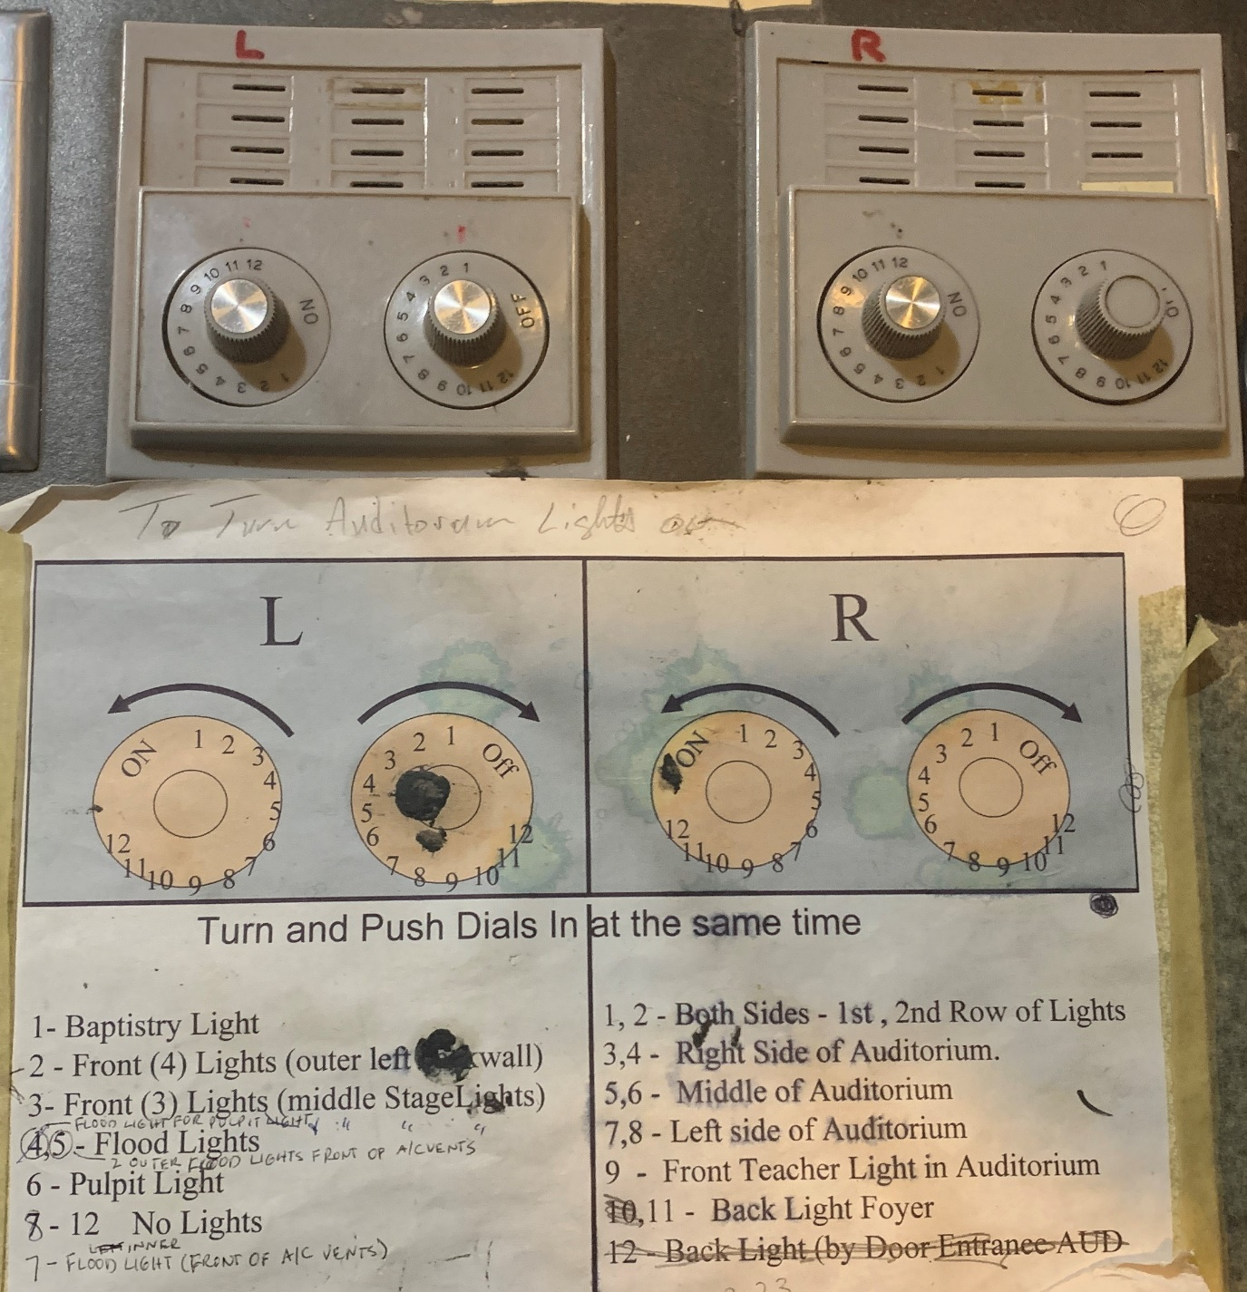

Exhibit A.2

Exhibit A.2 – MX Auditorium Light Diagram

MX Auditorium Light Diagram

Numbers below represent the switch setting that operates the light or series of lights. Example: R-1: indicates that these lights are switched using setting 1 on the R dial/knob.

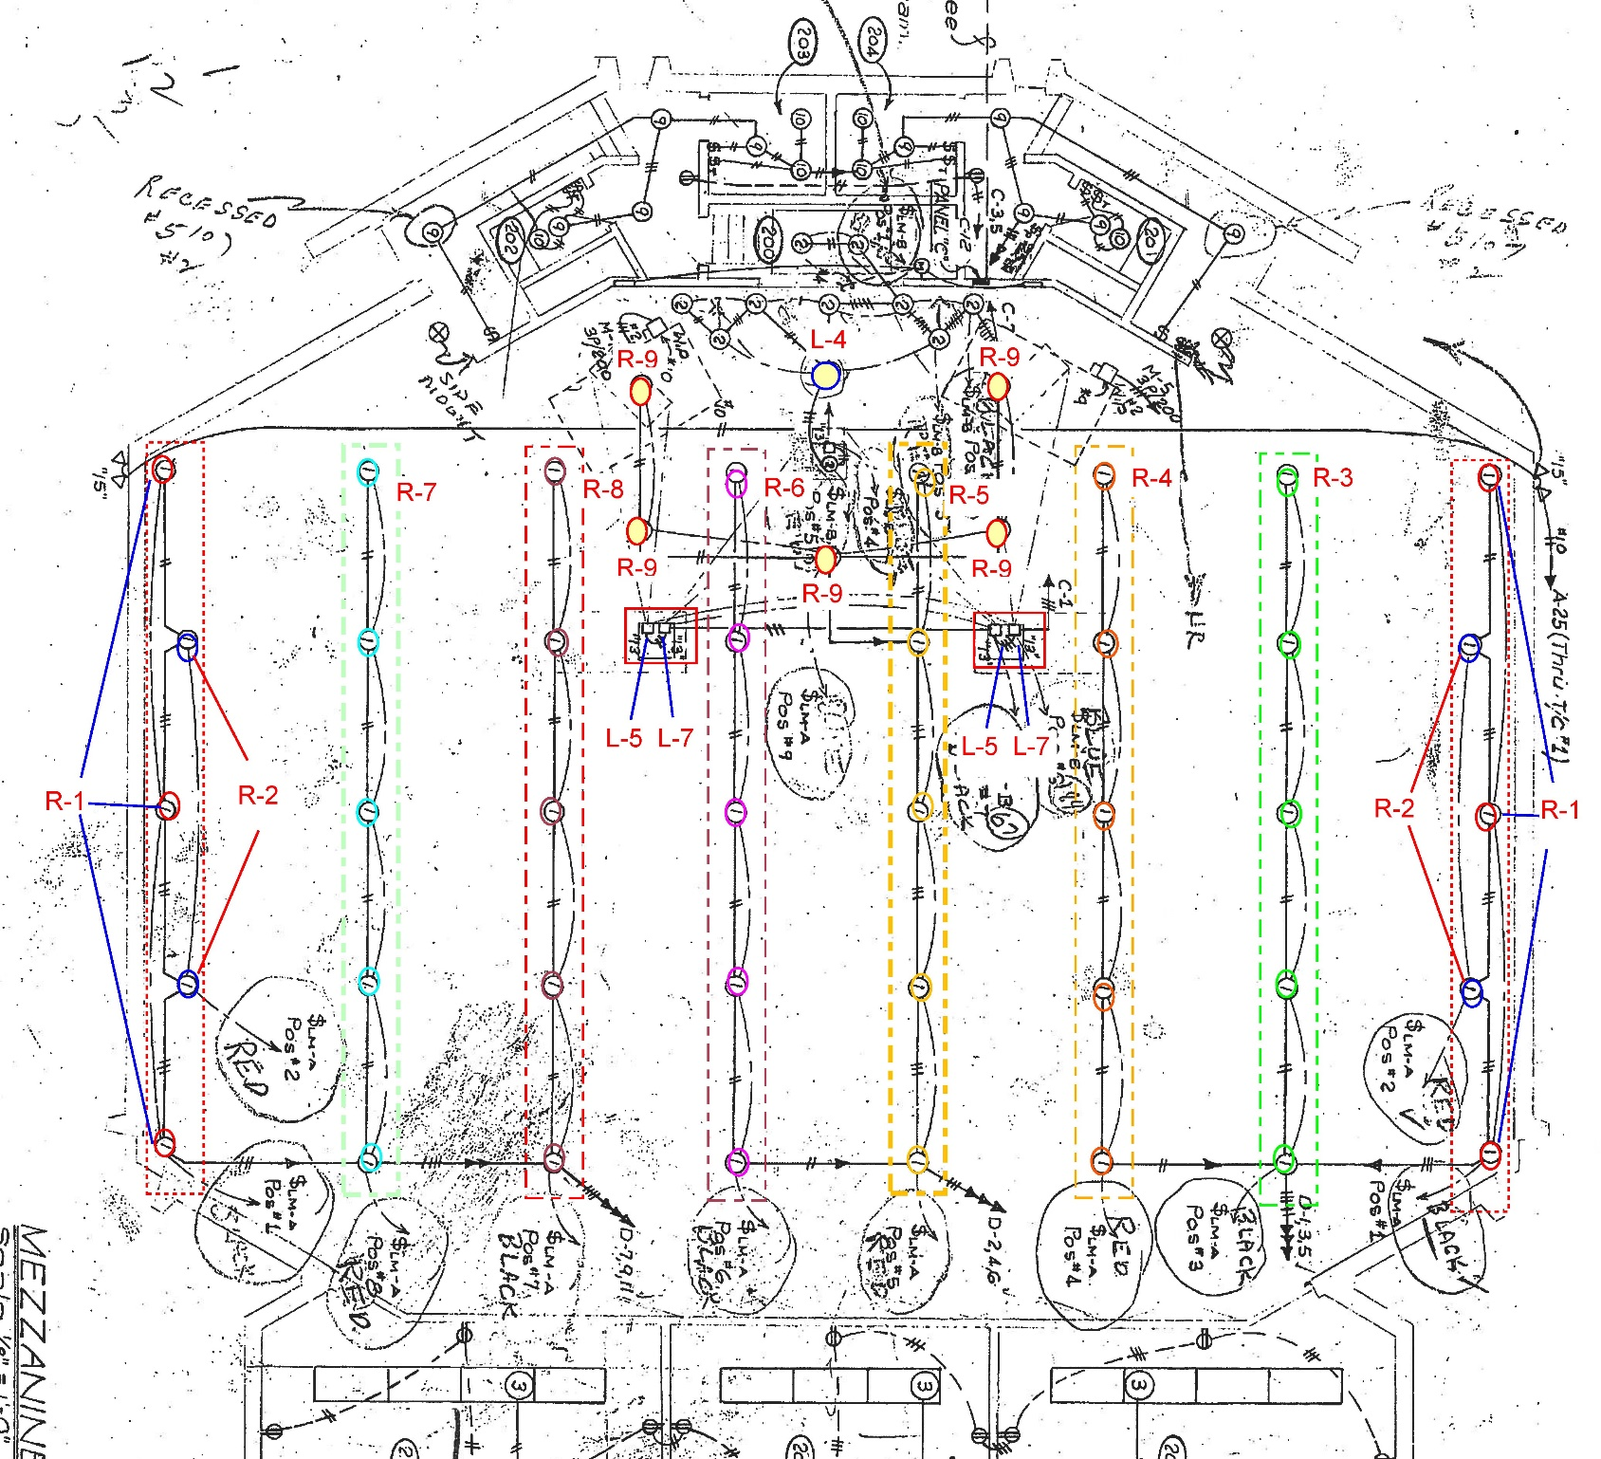

Exhibit B.1

Exhibit B – Scope document obtained from Jeannie Britzmann

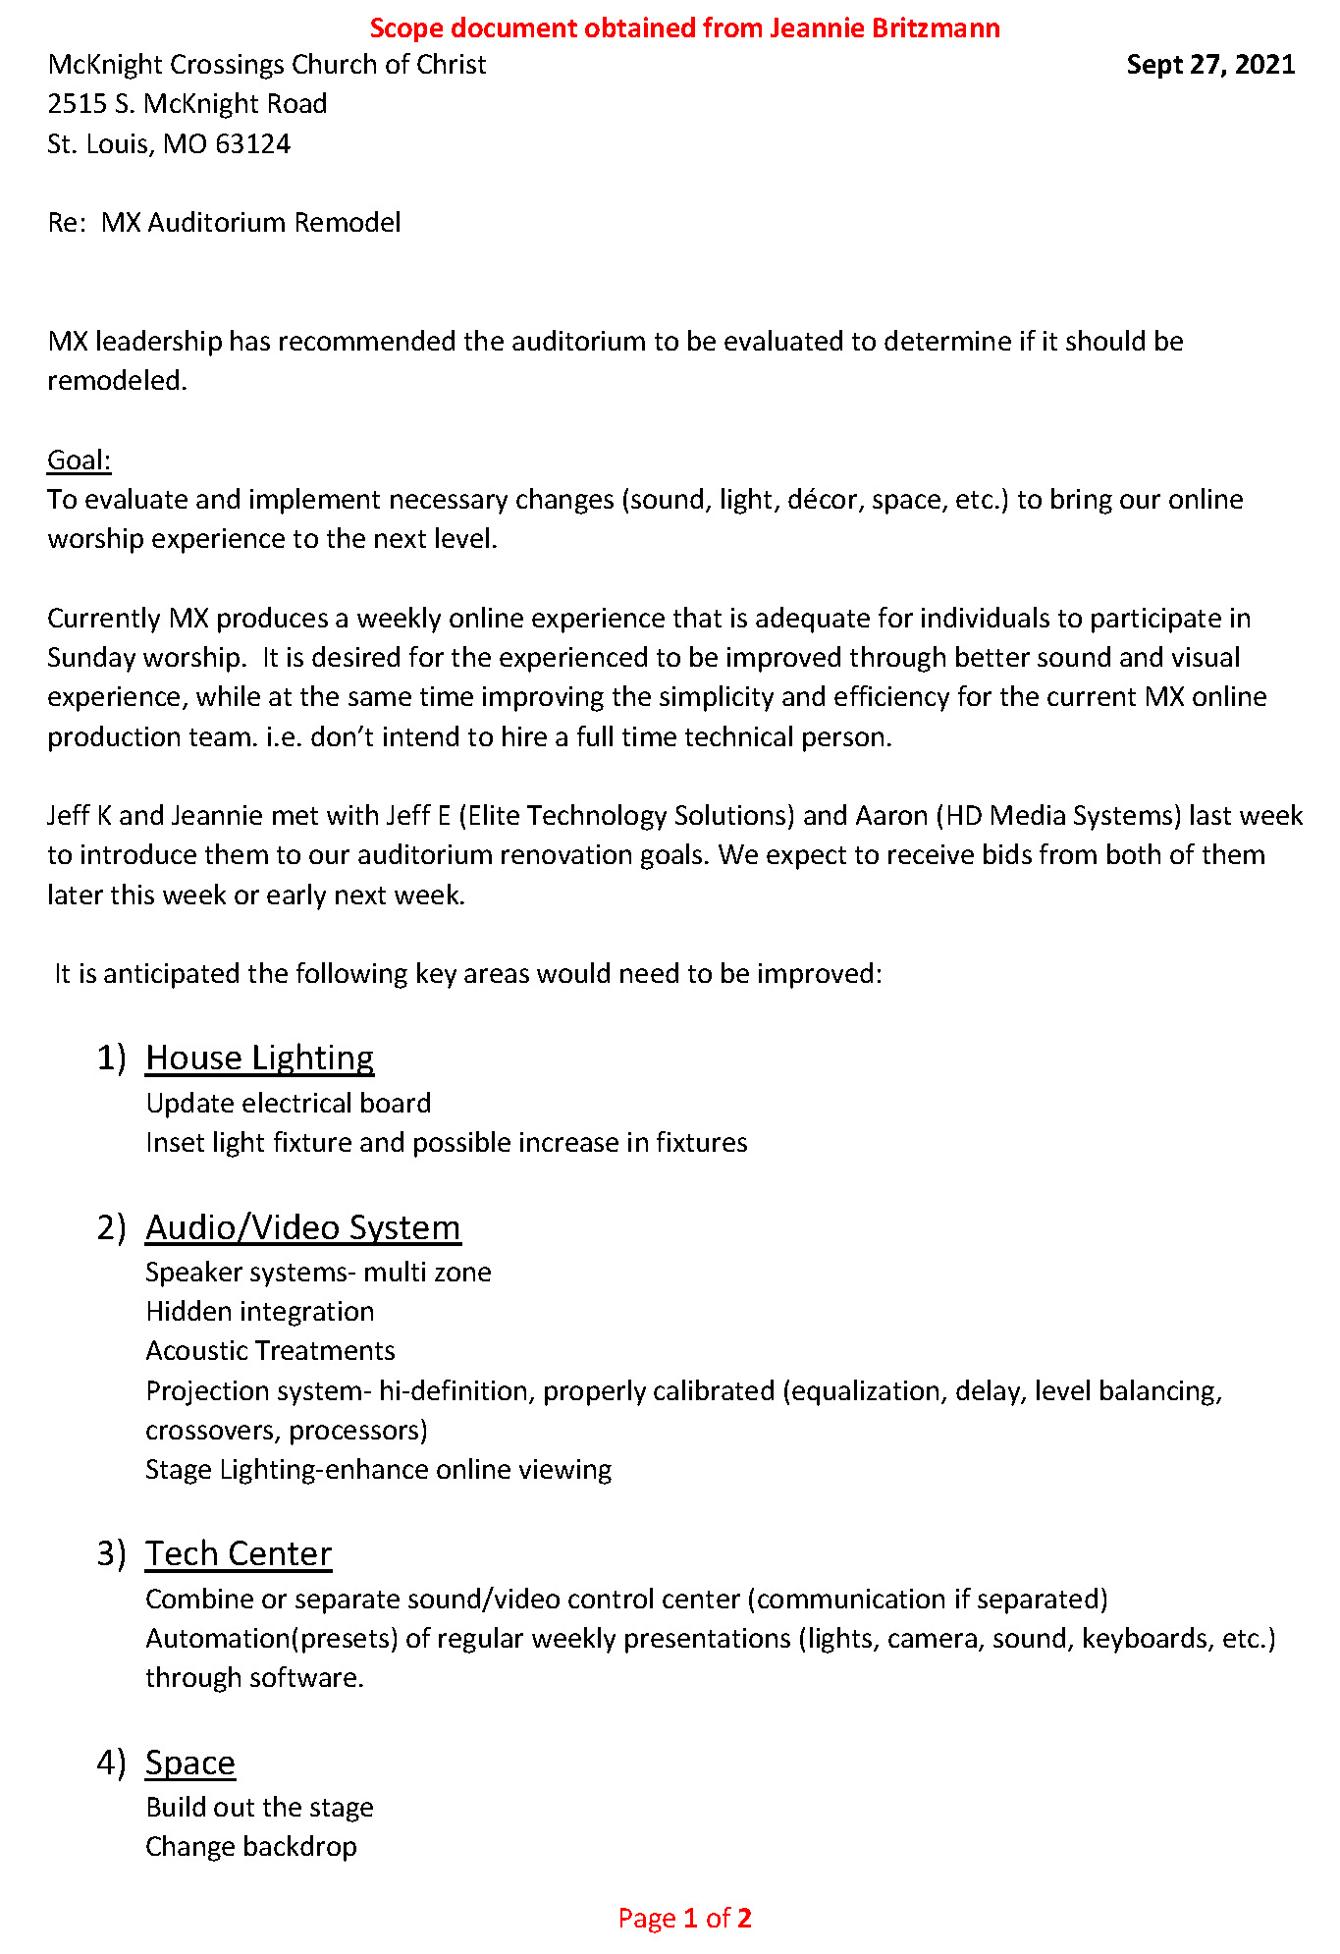

Exhibit B.2

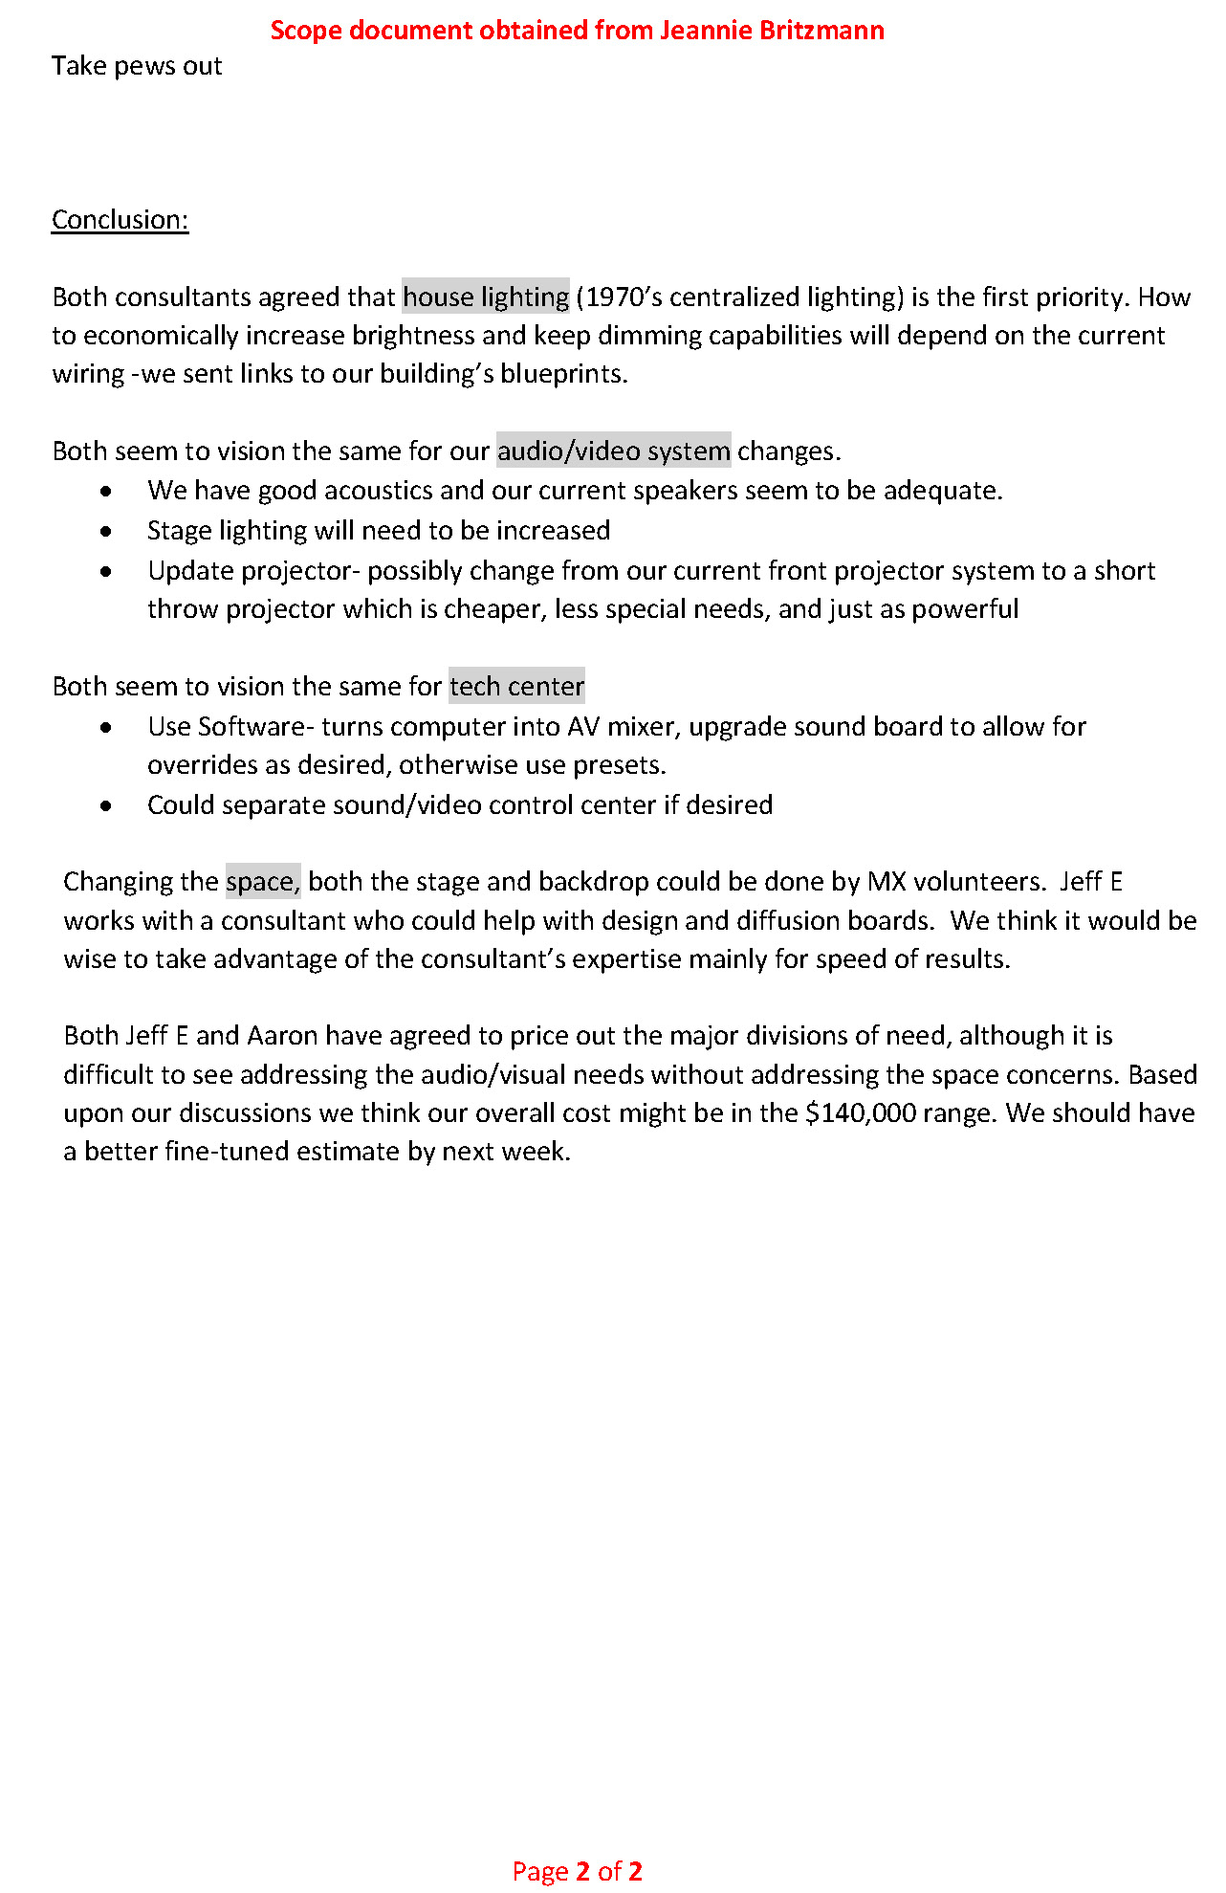

Summary (by Bret Blackford) of key items from above:

MX leadership has recommended the auditorium to be evaluated to determine if it should be remodeled.

Goal:
To evaluate and implement necessary changes (sound, light, décor, space, etc.) to bring our online worship experience to the next level.

Currently MX produces a weekly online experience that is adequate for individuals to participate in Sunday worship. It is desired for the [on-line] experienced to be improved through better sound and visual experience, while at the same time improving the simplicity and efficiency for the current MX online production team. i.e. don’t intend to hire a full time technical person.

Exhibit C

Exhibit C – Project summary analysis obtained from Jeannie Britzmann

Below is a summary analysis obtained from Jeannie Britzmann

McKnight Crossings Church of Christ November 1, 2021
2515 S. McKnight Road
St. Louis, MO 63124

Re: MX Auditorium Remodel- Bid Analysis

MX has received bids from Jeff E (Elite Technology Solutions) and Aaron (HD Media Systems) for technical system upgrades (lighting, audio/video, tech center, physical stage/backdrop).

Goal: To evaluate both bids, choose which company to engage, implement necessary changes to bring our online/in person worship experience to the next level.

Conclusion: Jeff K and Jeannie B would engage Elite to upgrade our outdated systems.

The major difference between the two bids is the new house lighting system. Elite will use high-quality LED recessed fixtures that run on low-voltage and high-quality DMX controlled power supplies. Elite is experienced in DMX lighting and states they can integrate the new system with our audio/visual controls for an easy-to-use reliable system for our volunteers without needing to add any additional lights in our ceiling. This reduces cost and ultimate construction risks.

Elite Projected Costs:

1) Sound system Upgrades-$16,000
Highlights-Install digital signal processor for mixing control, and loudspeaker management. Install programmable control processors (iPad).

2) House lighting-$60,000
Highlights-Low voltage LED replacement fixtures, DMX controlled power supplies

3) Streaming Camera System-$15,000
Highlights-3 HD broadcast quality PTZ cameras, 4-Ch HDMI A/V streaming mixer

4) Projector and Screen-$39,000
Highlights- 1 High-quality laser based projector, HD resolution with 8000 lumens, I throw lens, 1 High-quality motorized projection screen, tab-tensioned ALR screen material 138”by 75”tall

5) Stage lighting-$10,000

6) Stage Backdrop- $10,000

Exhibit D

Exhibit D – Project summarization by Jeff Earnhart

Below project summary per Jeff Earnhart – 12/16/2018
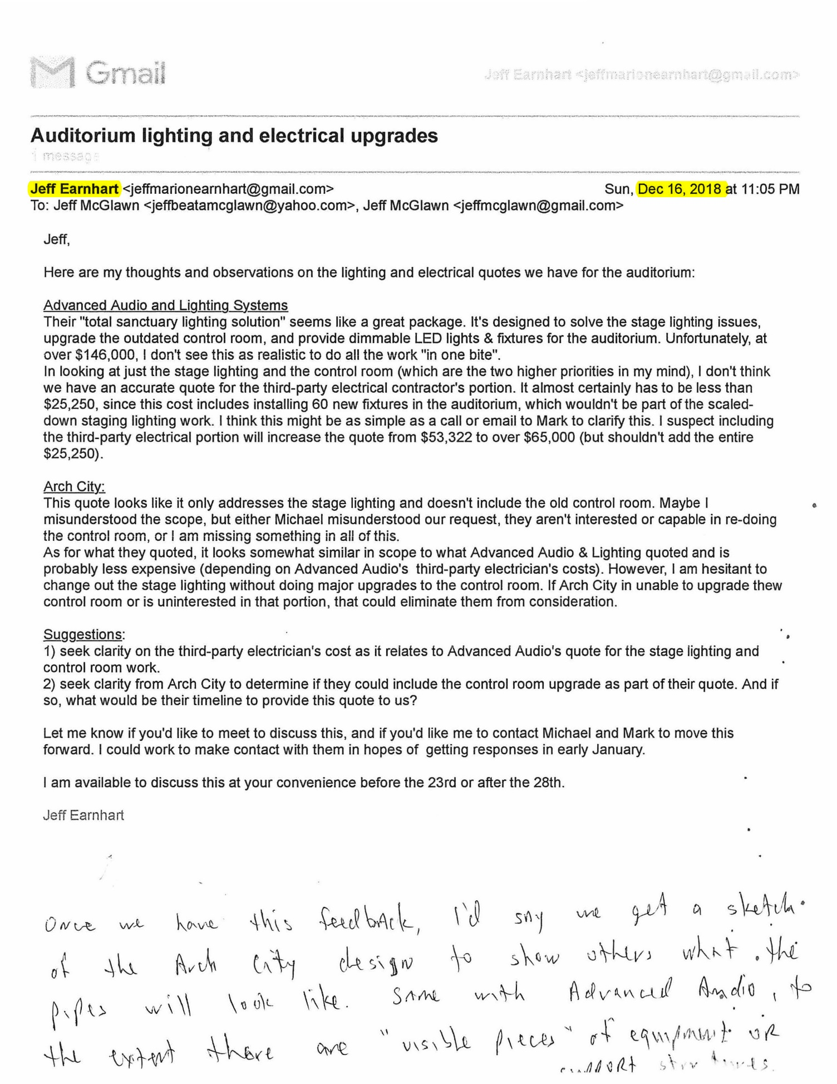

Exhibit E.1

Exhibit E – Bid from Advanced Audio & Lighting Systems

Bid from Advanced Audio & Lighting Systems, Inc

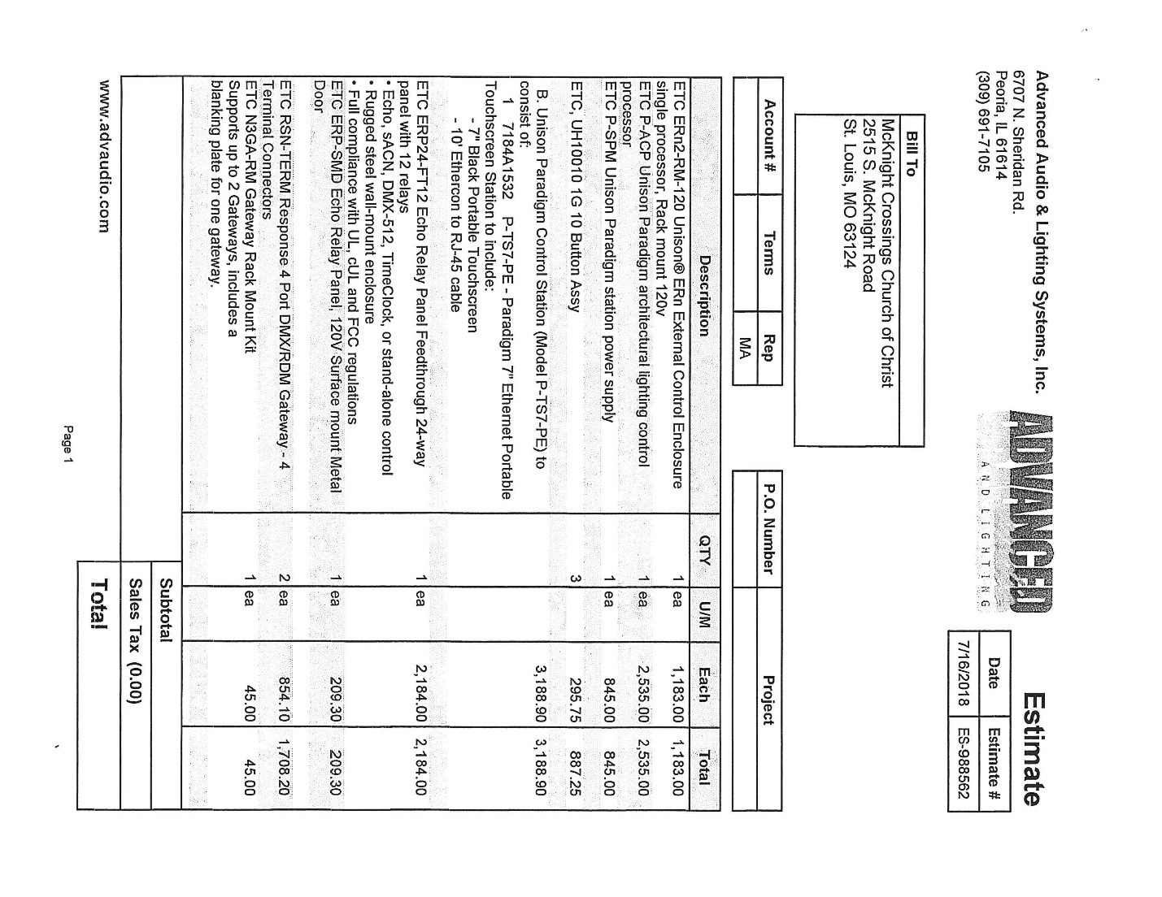

Exhibit E.2

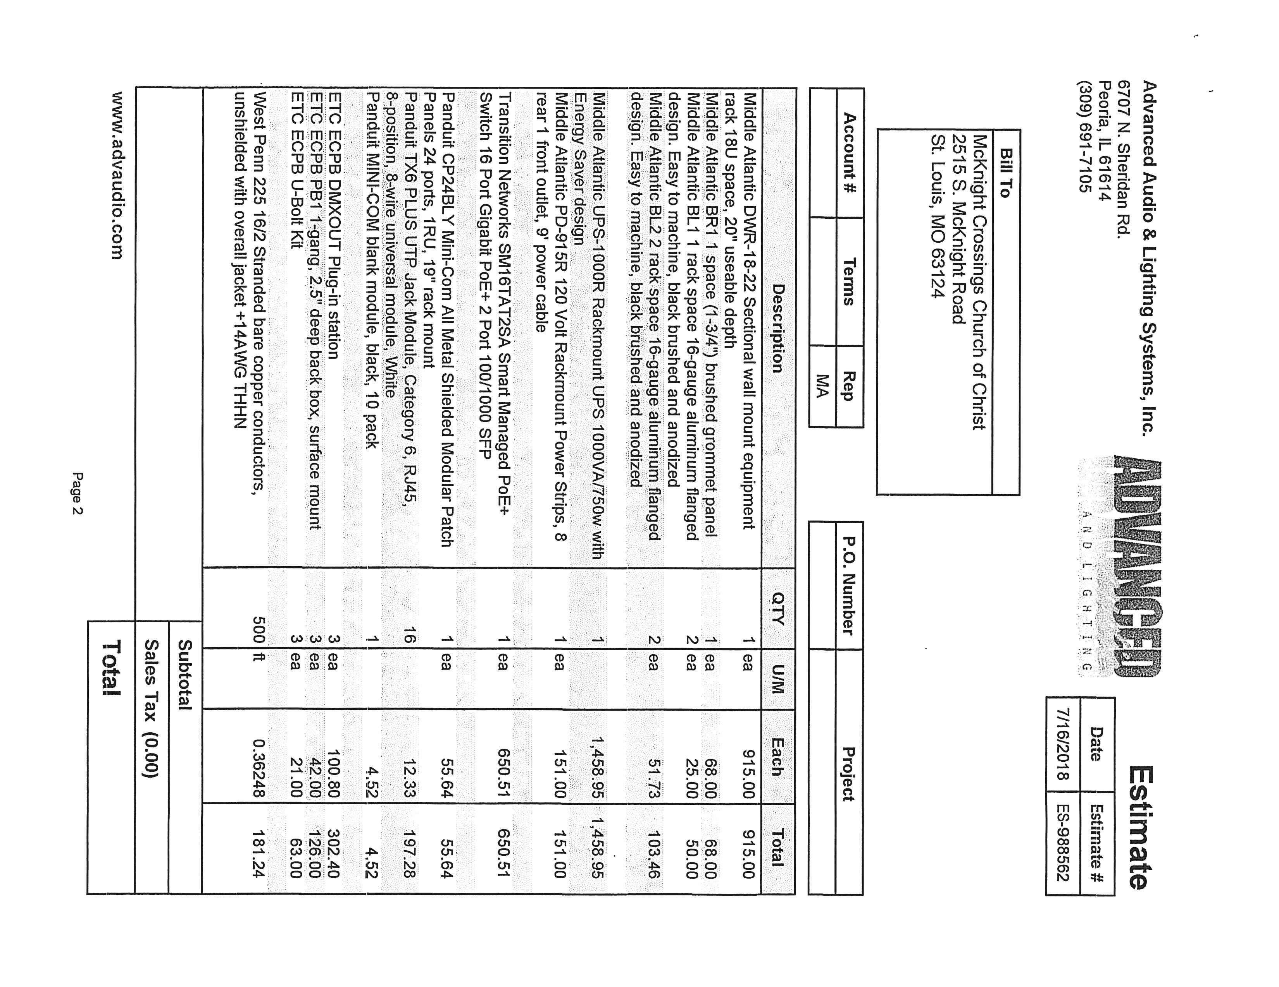

Exhibit E.3

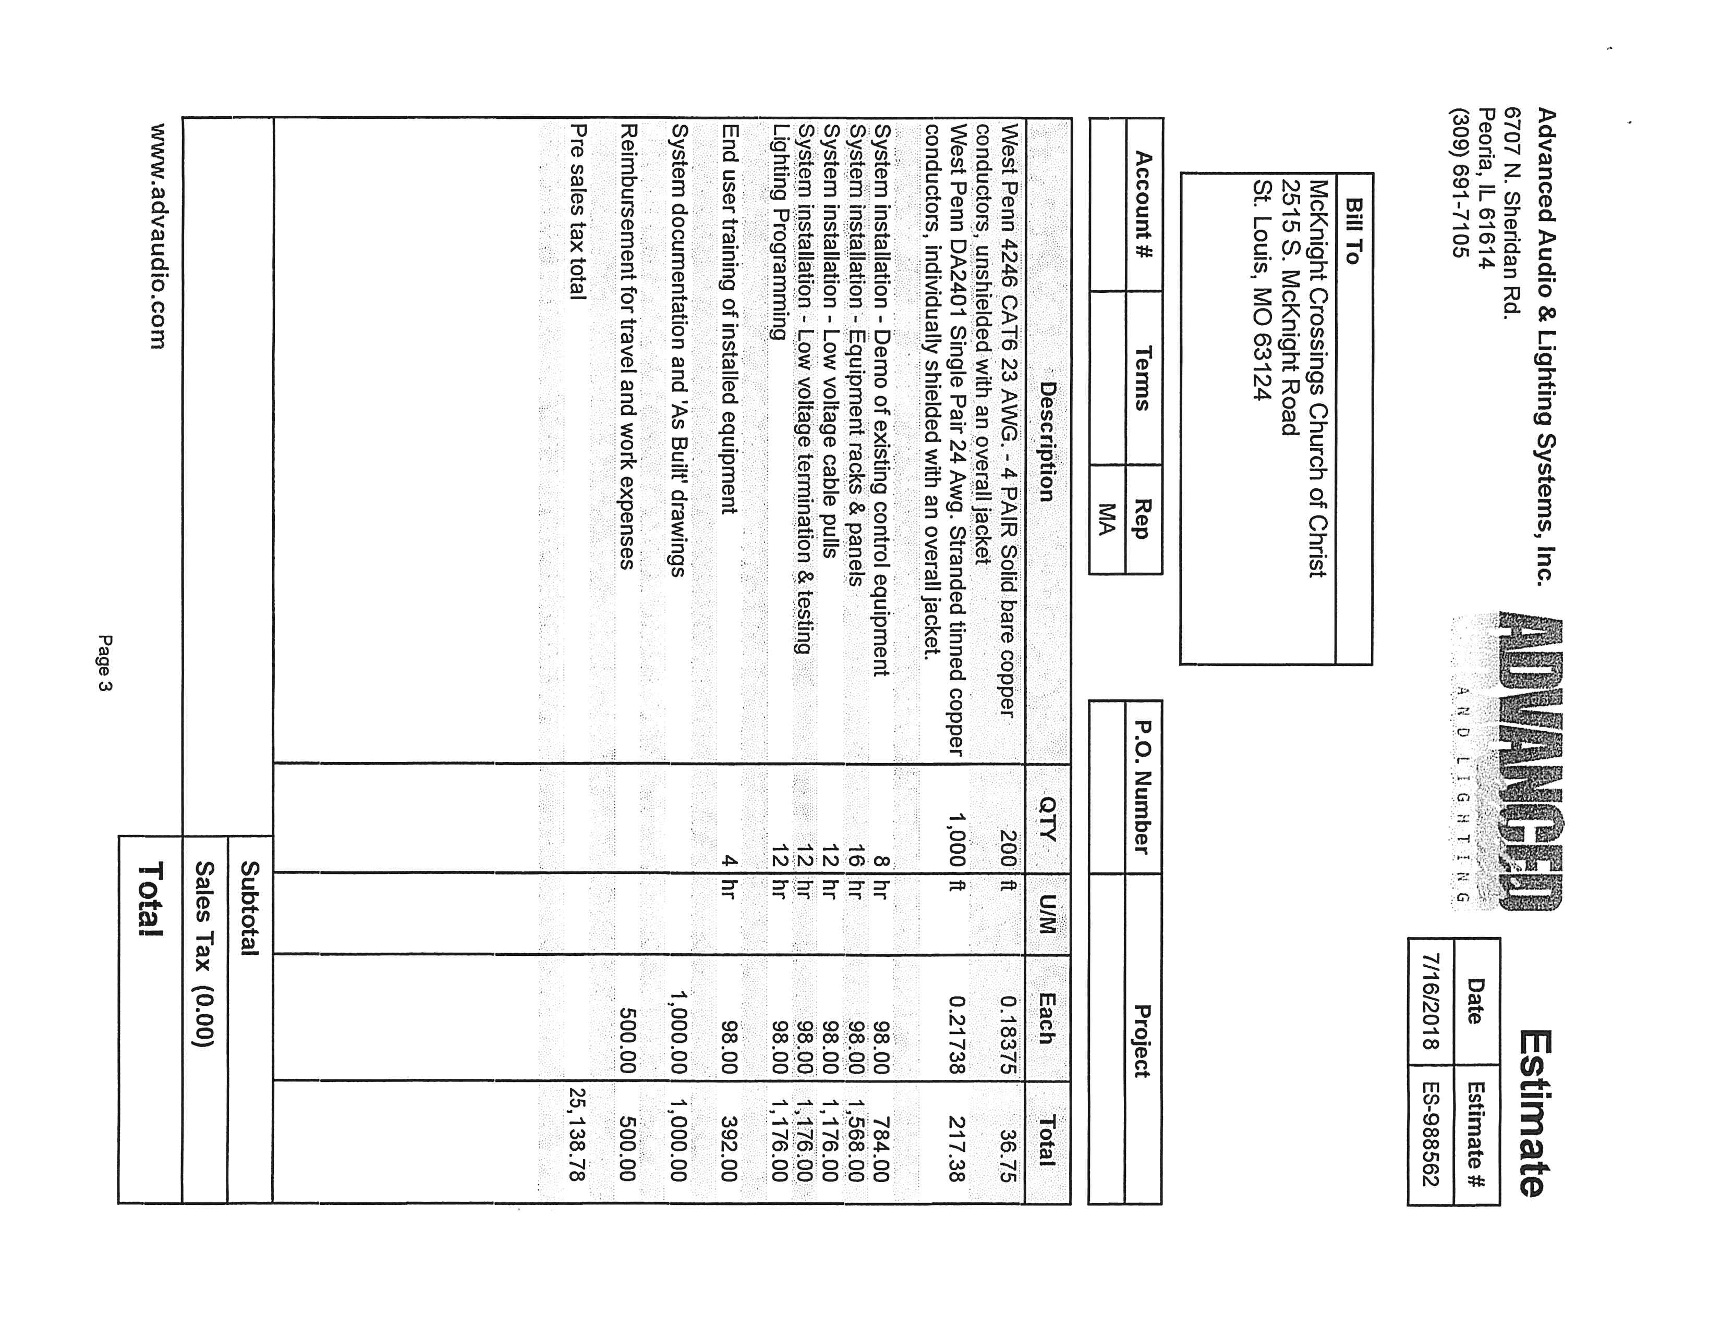

Exhibit E.4

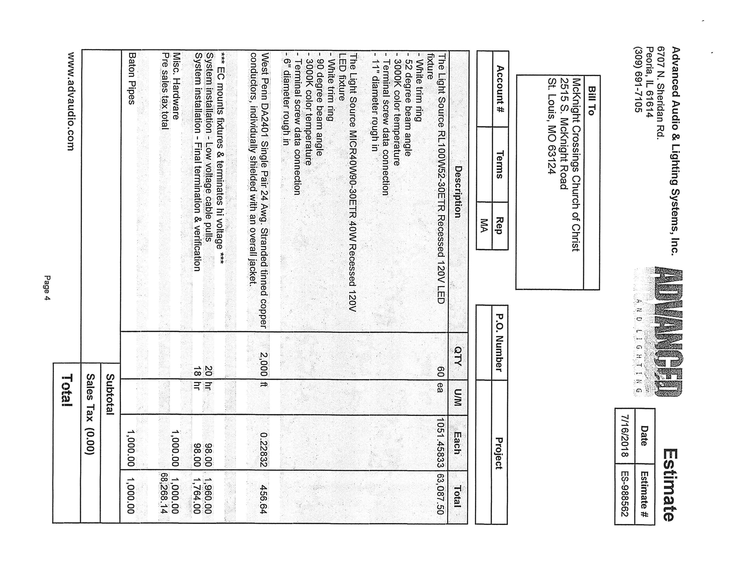

Exhibit E.5

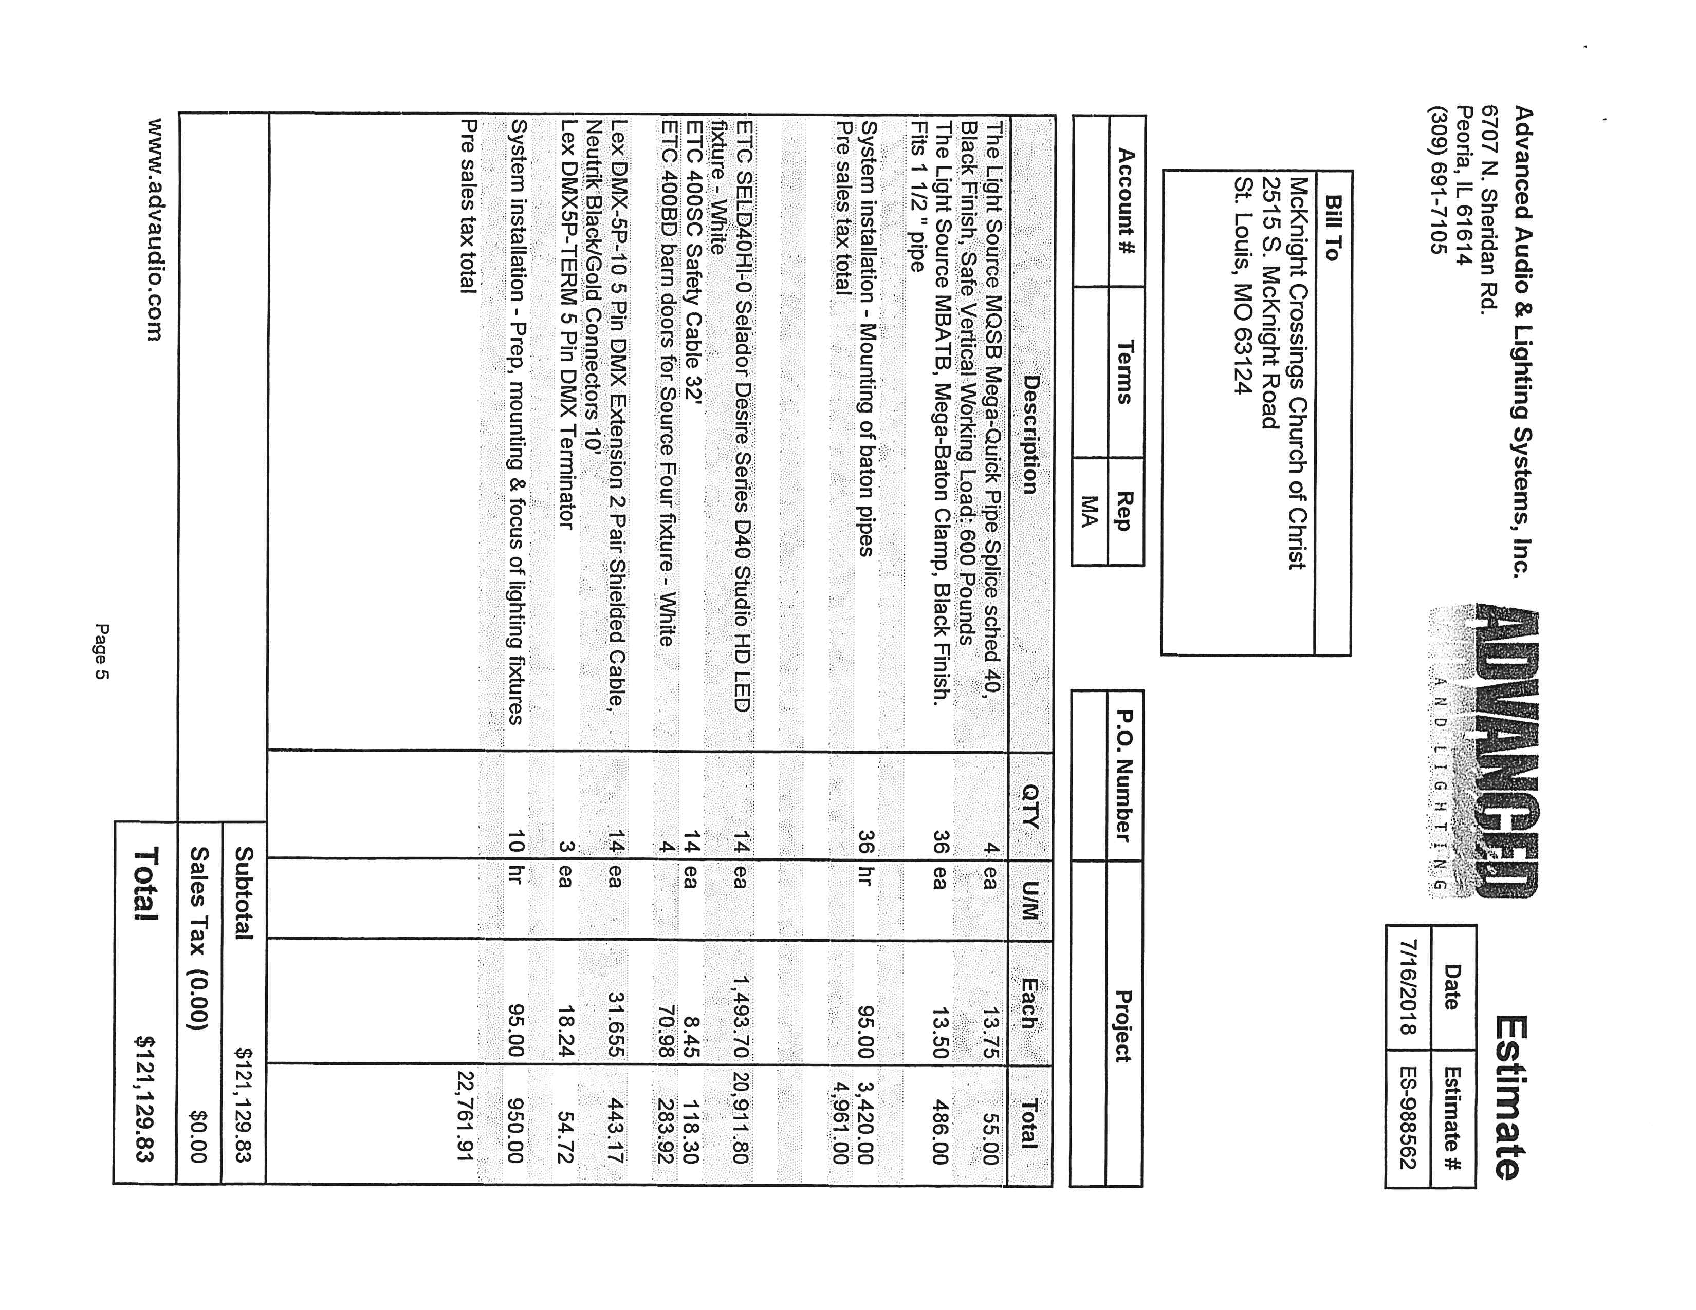

Exhibit E.6

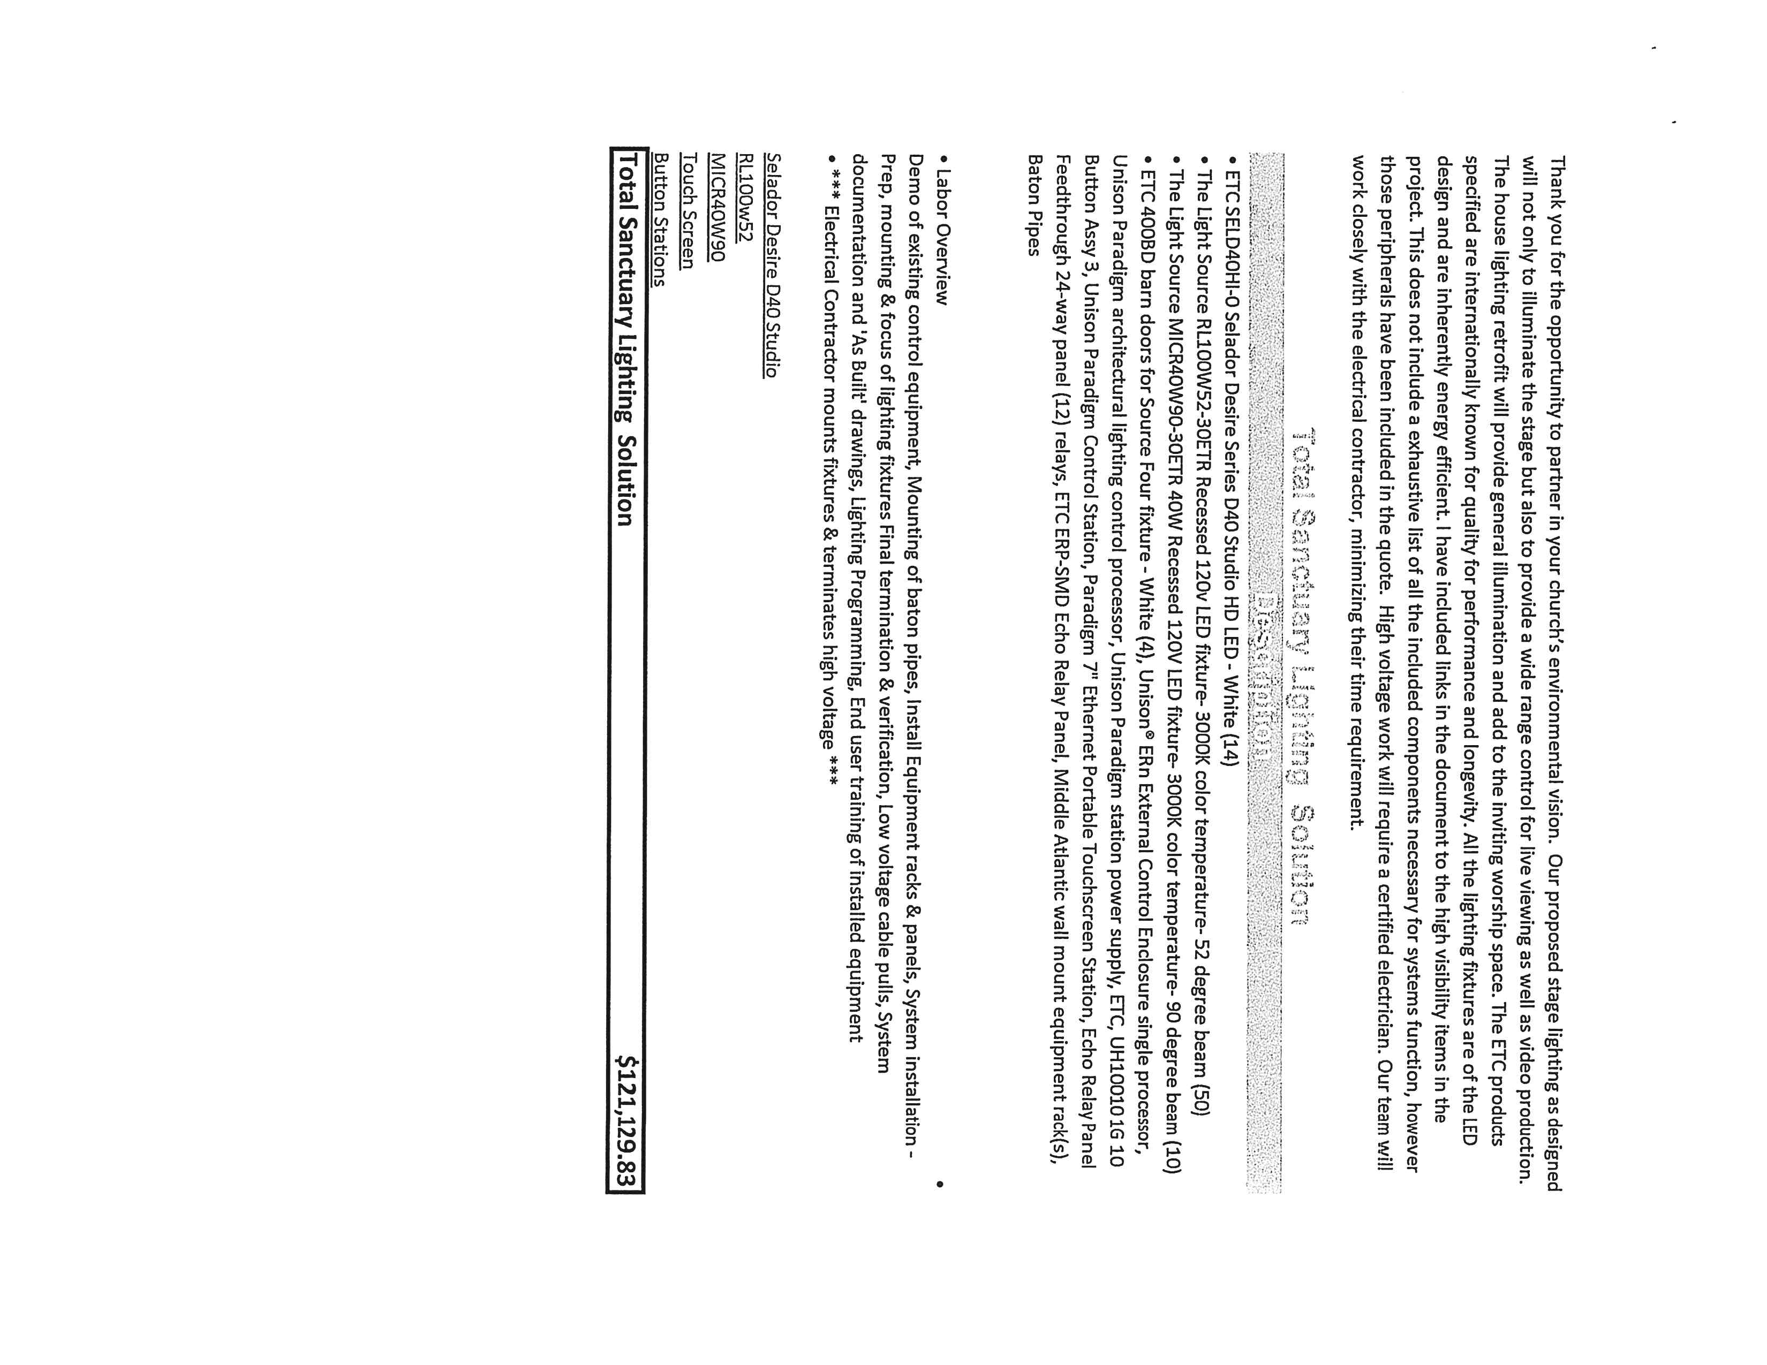

Exhibit E.7

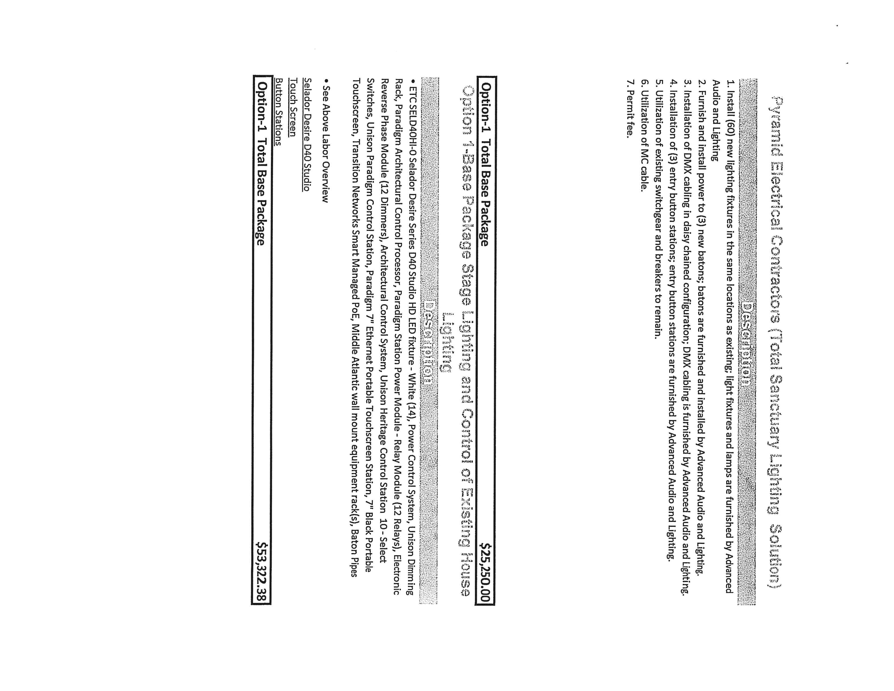

Exhibit E.8

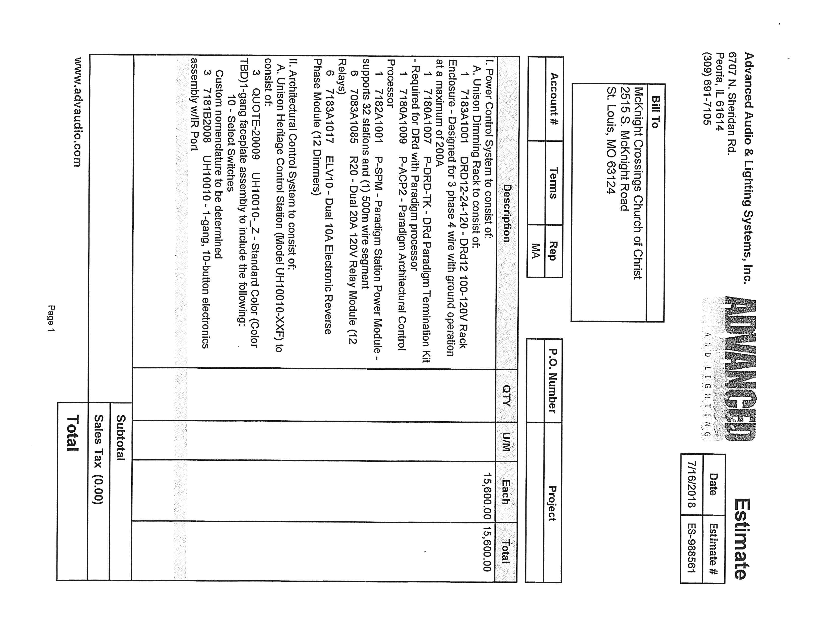

Exhibit E.9

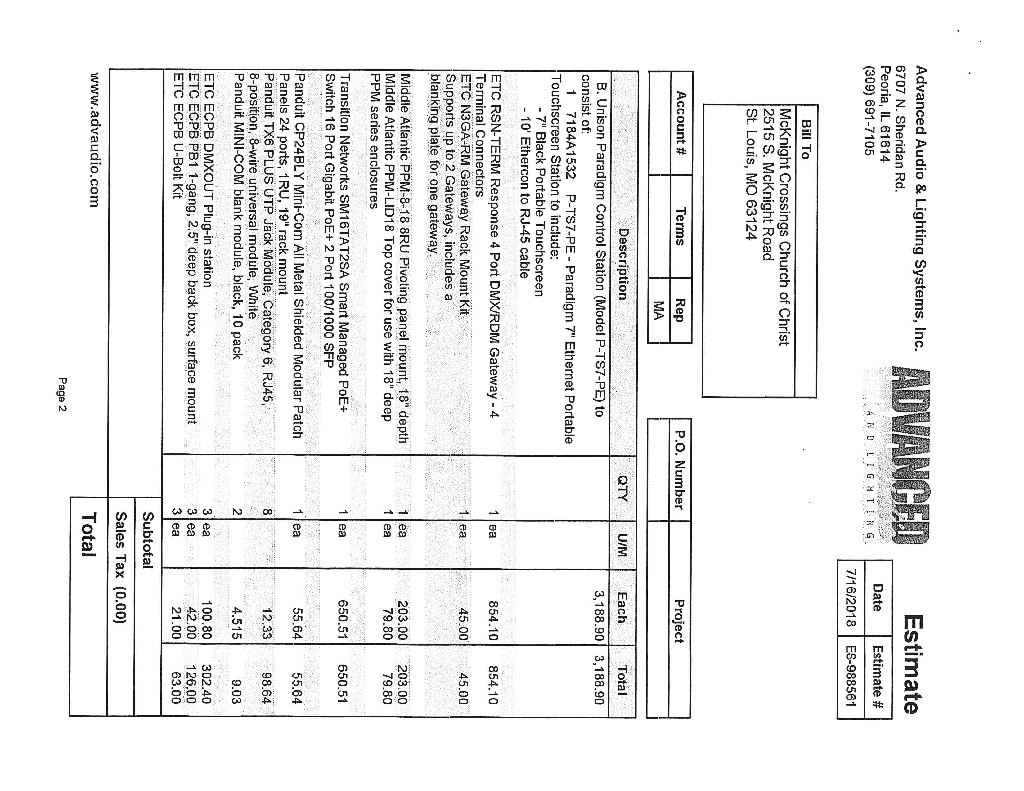

Exhibit E.10

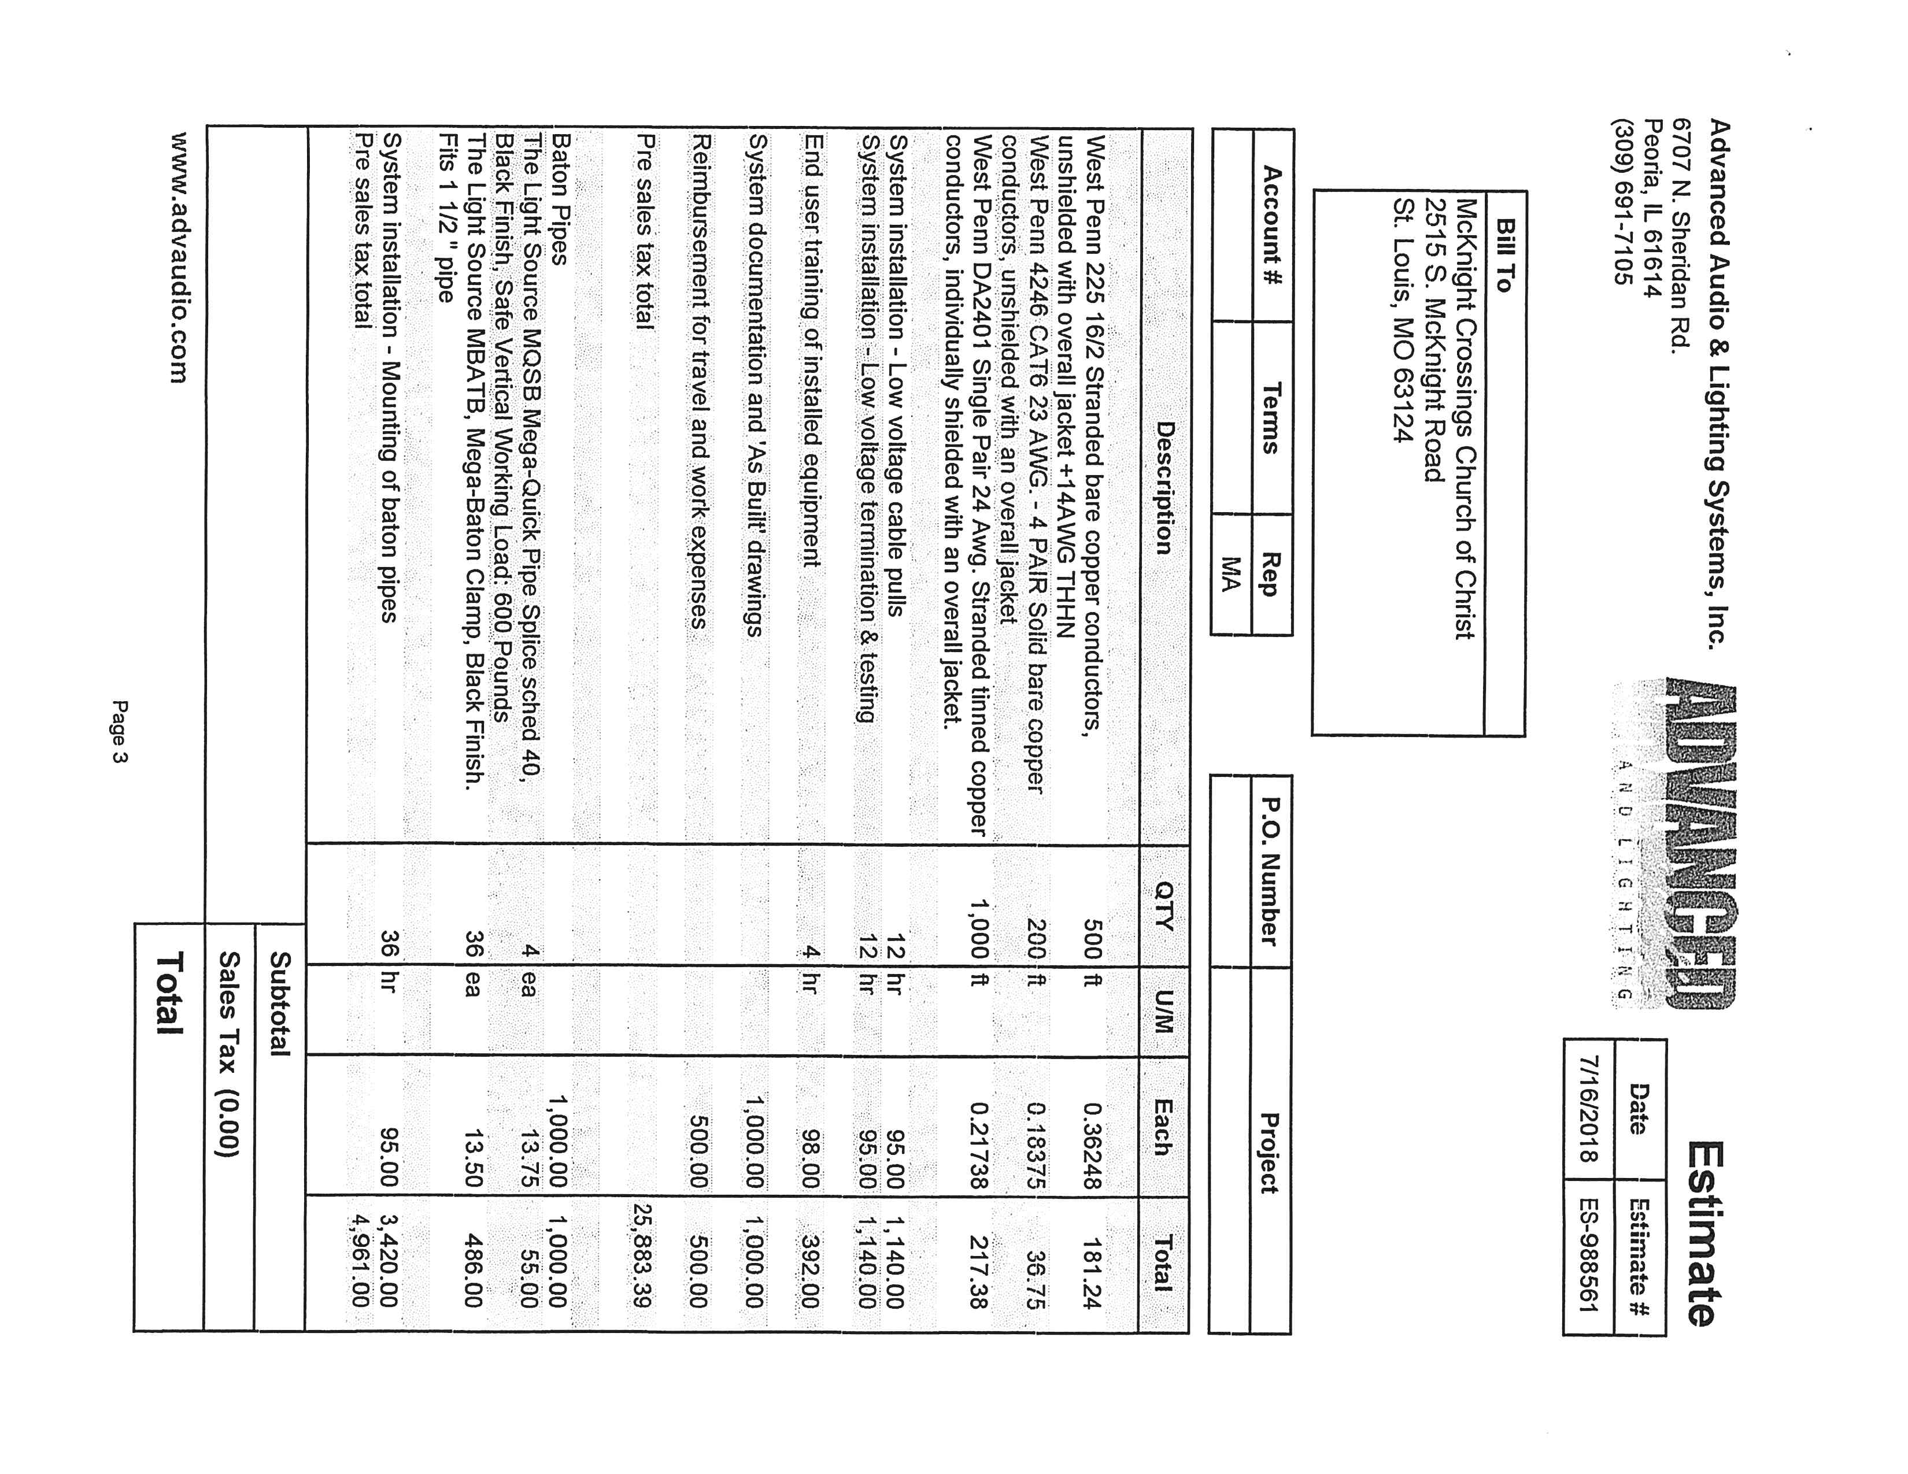

Exhibit E.11

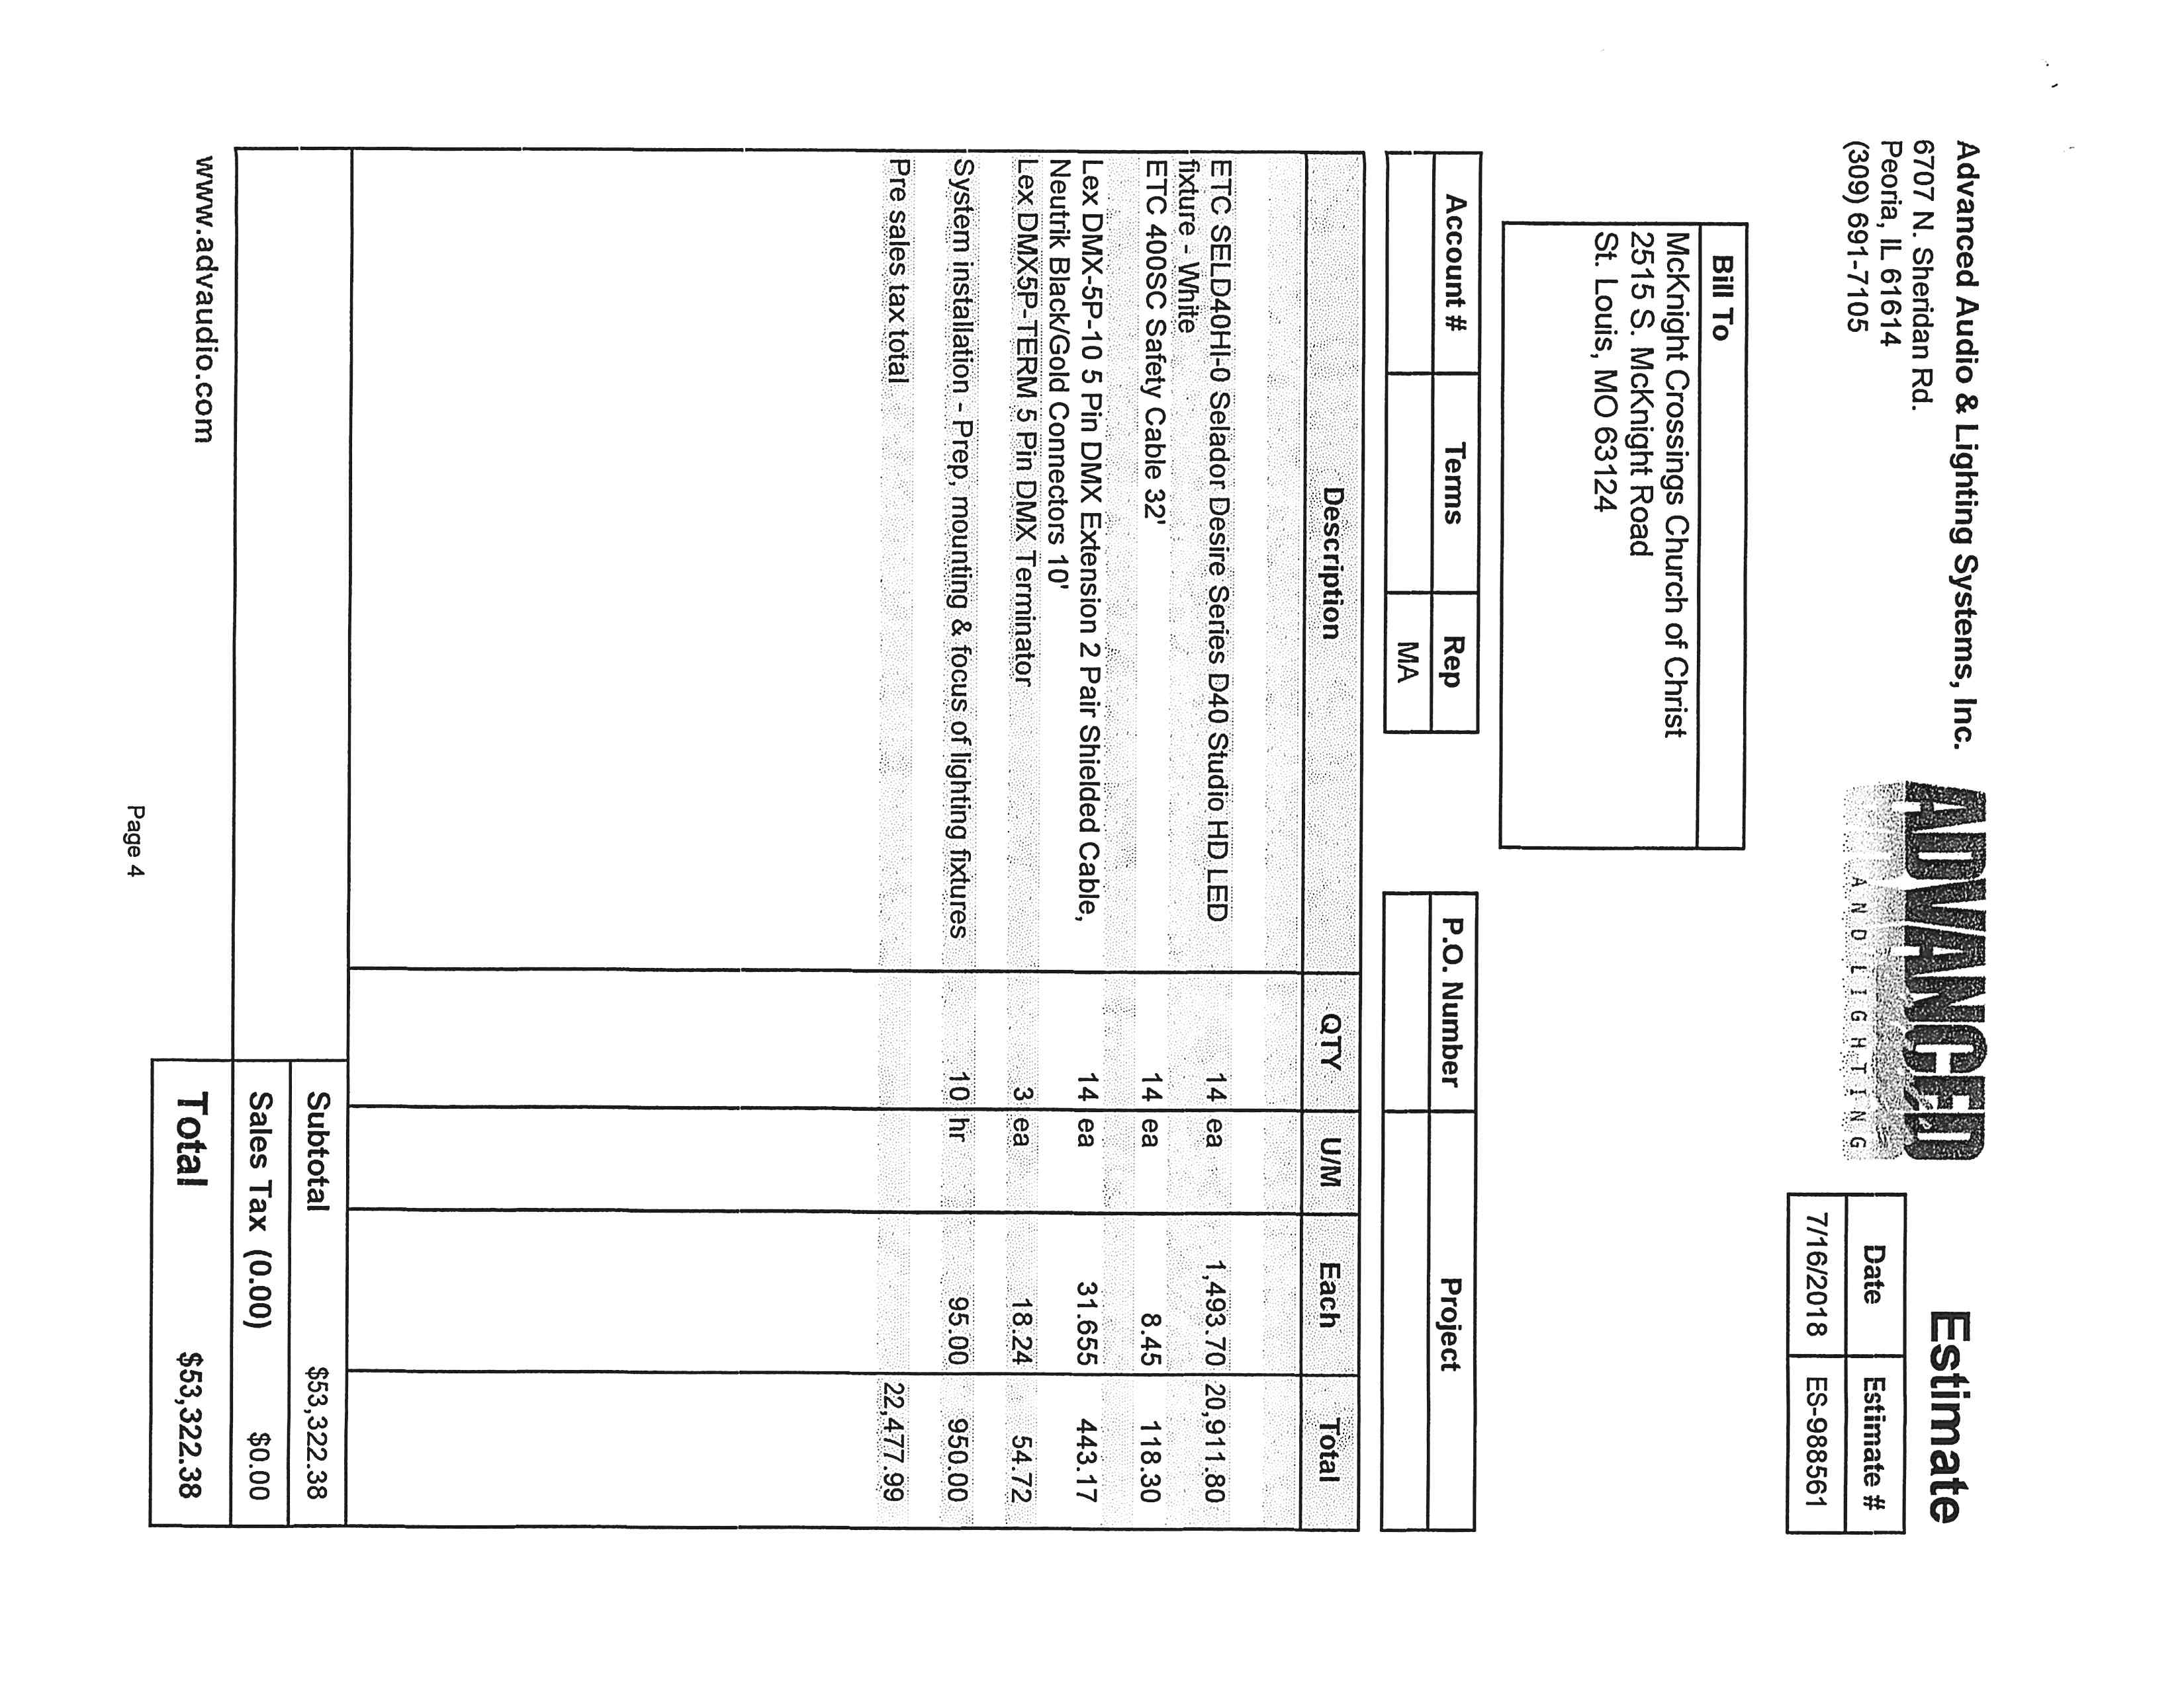

Exhibit F.1

Exhibit F – Bid from Arch City Audio Visual Services

Bid from Arch City Audio Visual Services

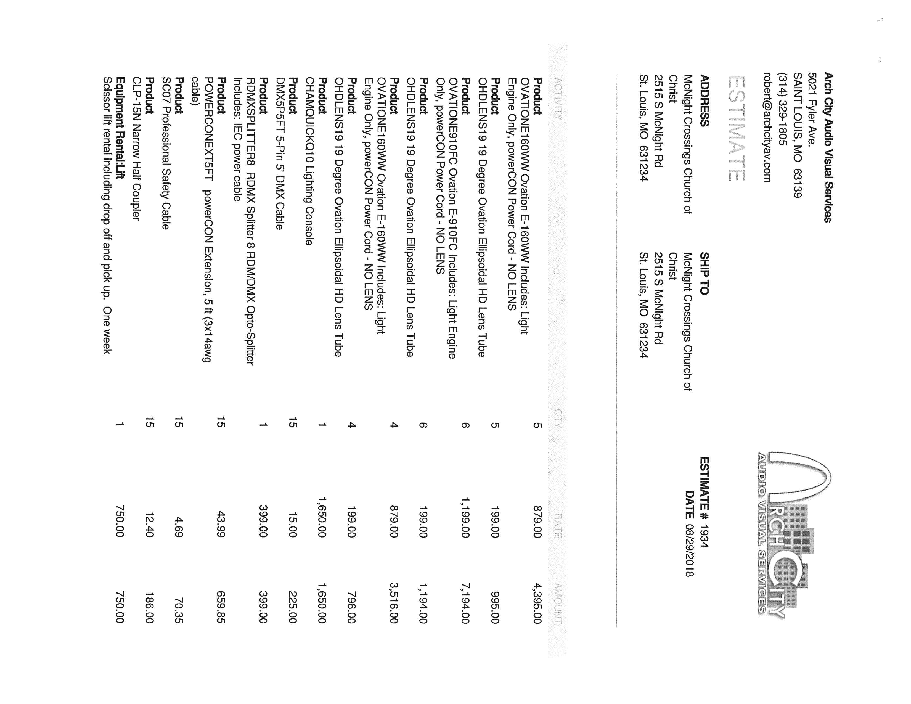

Exhibit F.2



Exhibit F.3

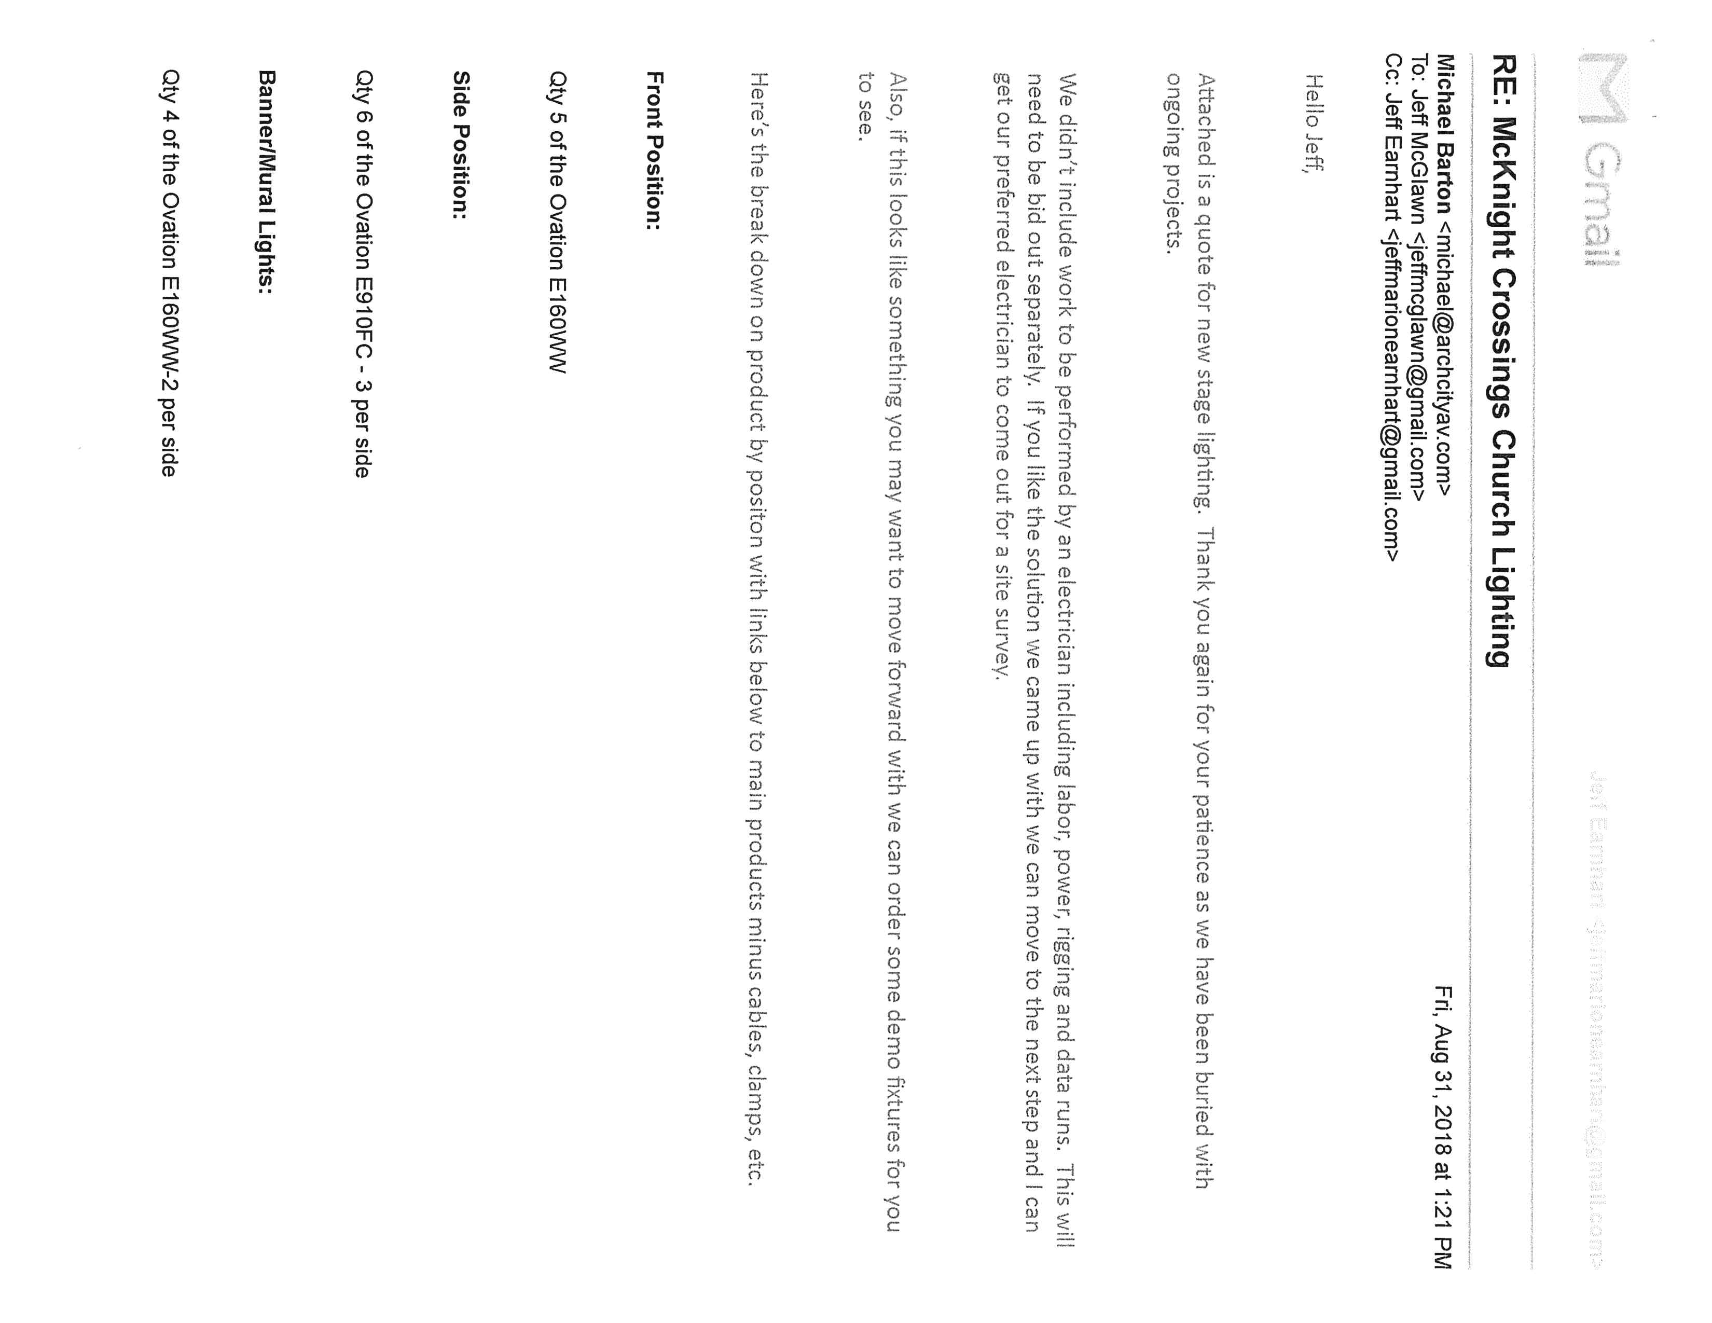

Exhibit F.4

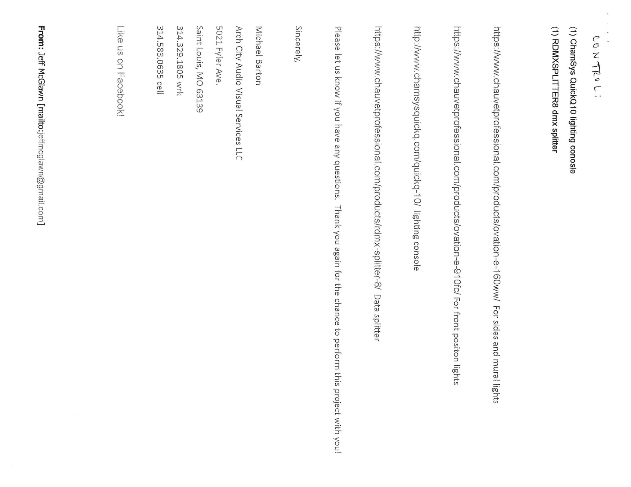

Exhibit G.1

Exhibit G – Bid from Elite Enterprises

Bid from Elite Enterprises

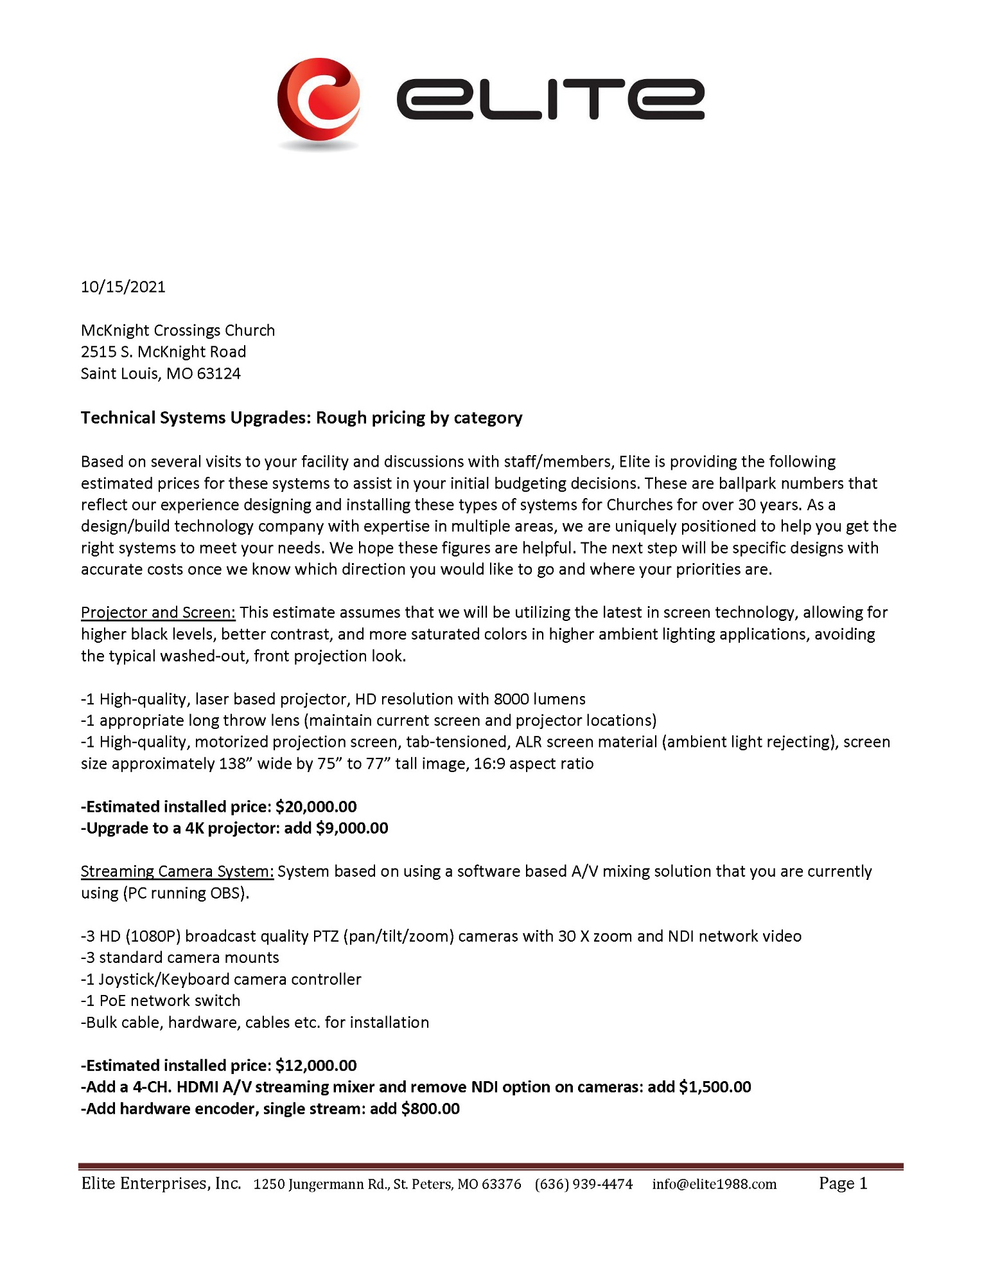

Exhibit G.2

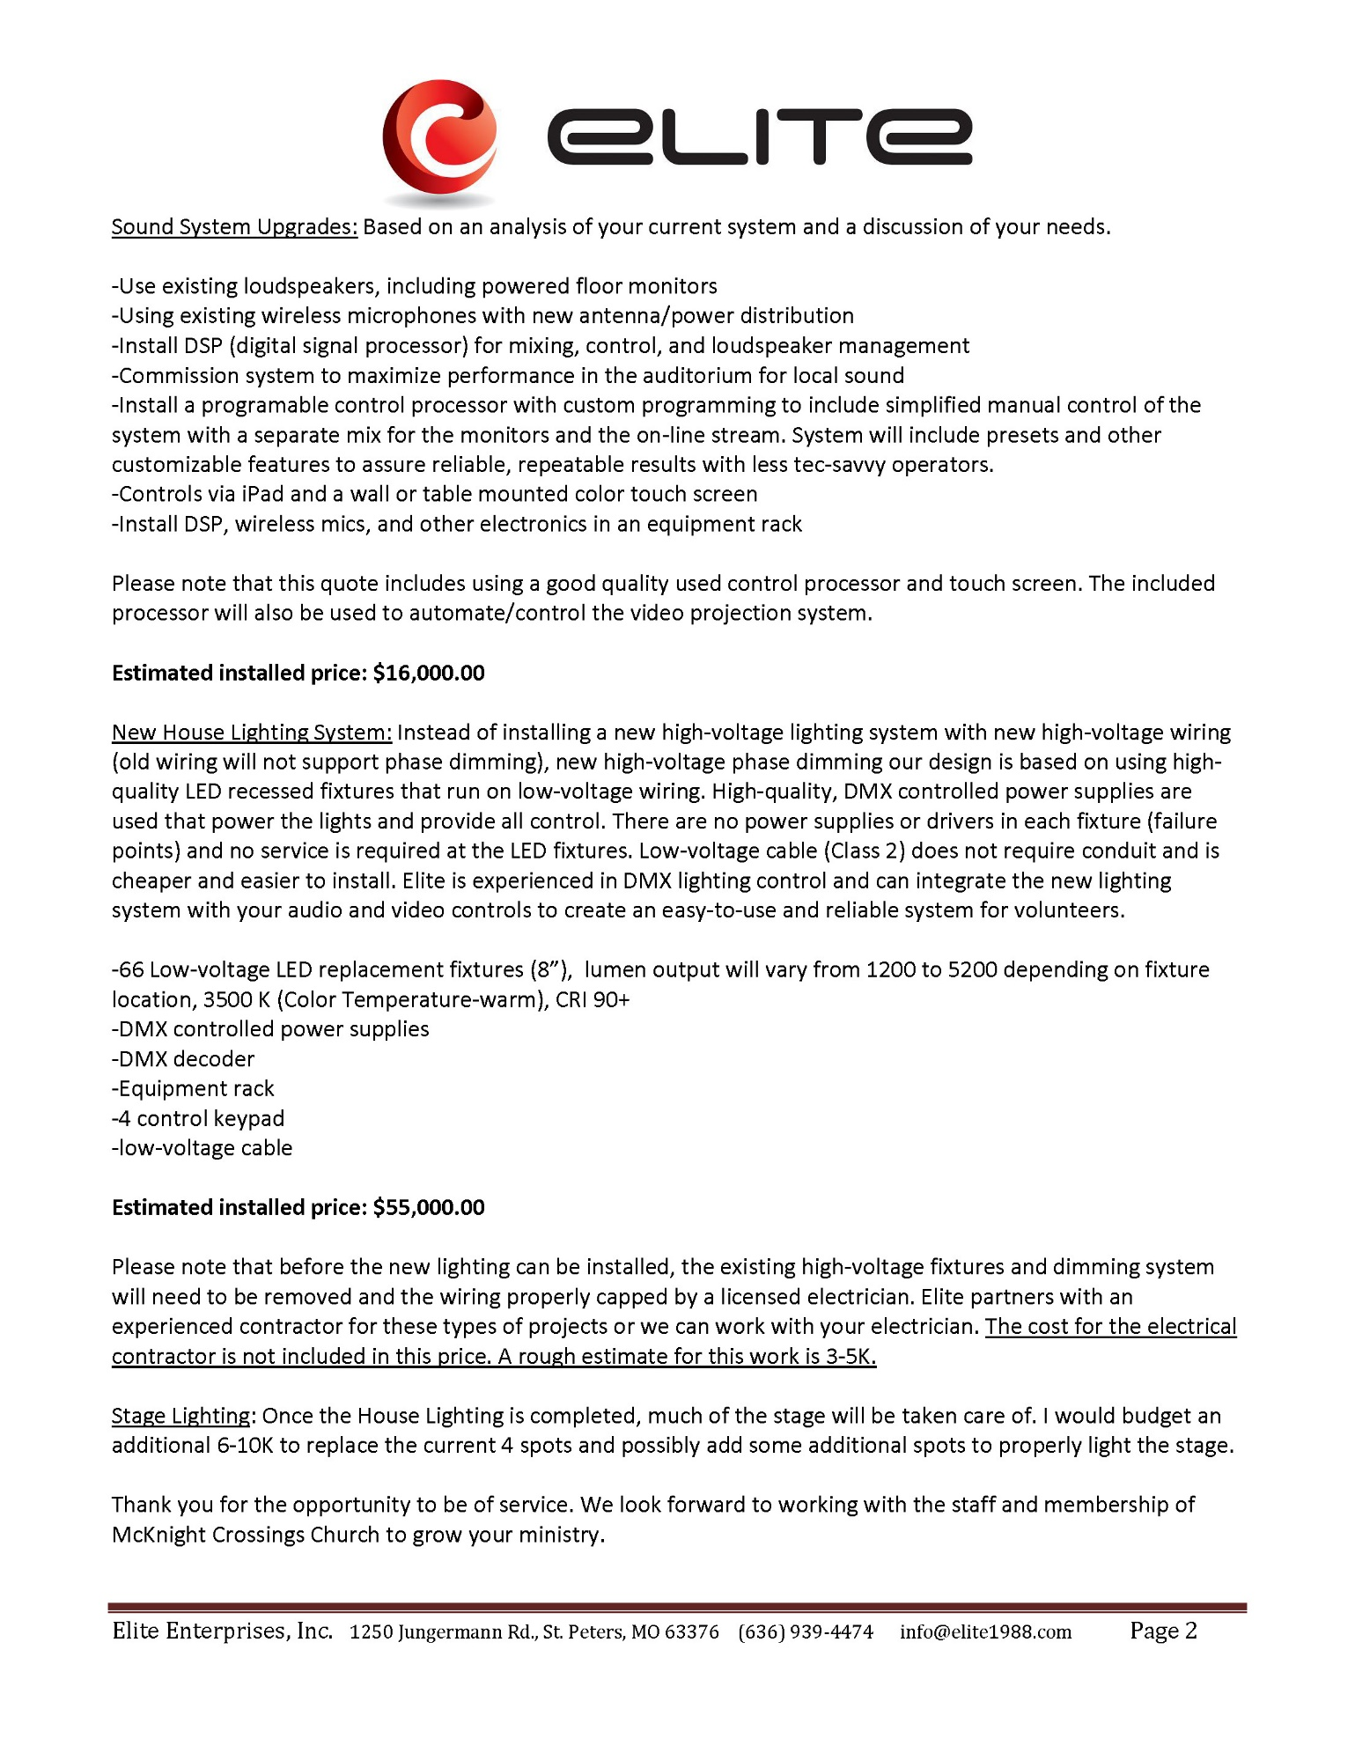

Exhibit H.1

Exhibit H – Bid from HD Media

Bid from HD Media

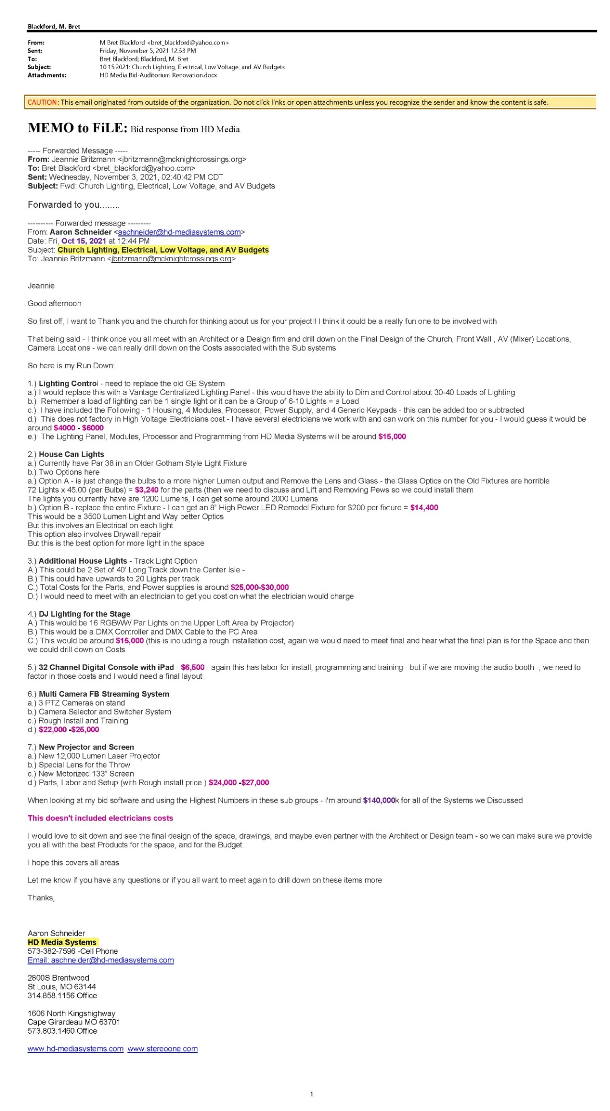

Exhibit I.1

Exhibit I – Jeff Kryder discussion on Auditorium Project

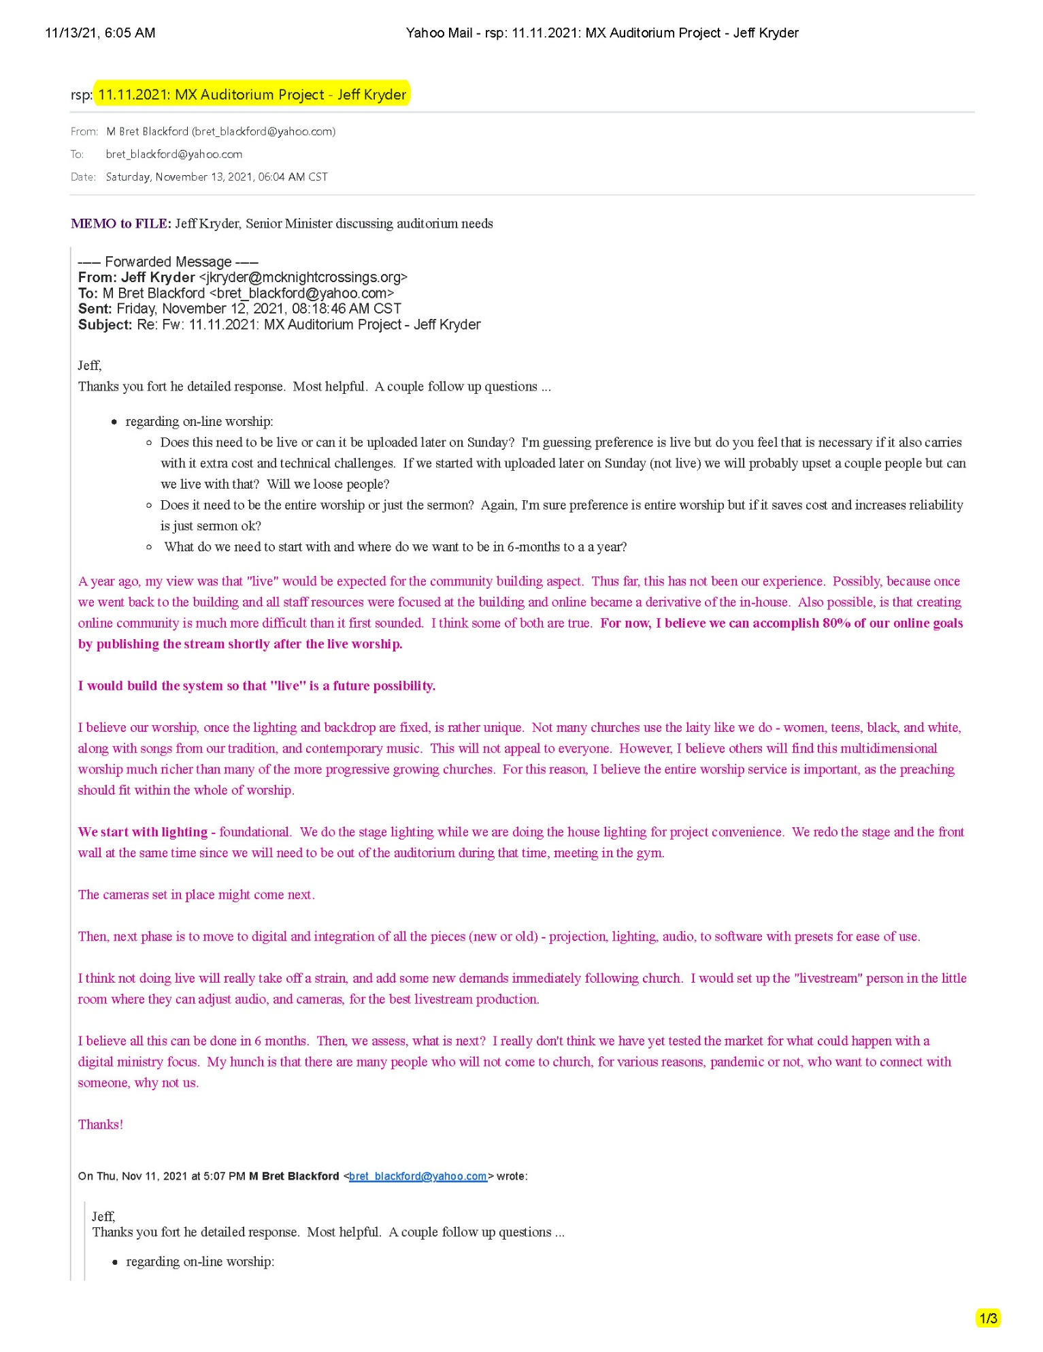

Exhibit I.2

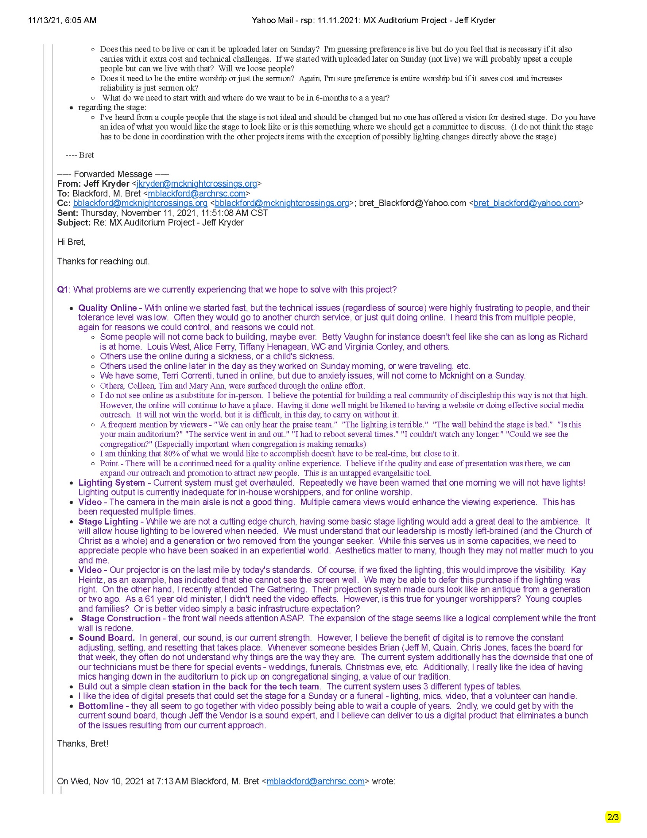

Exhibit I.3

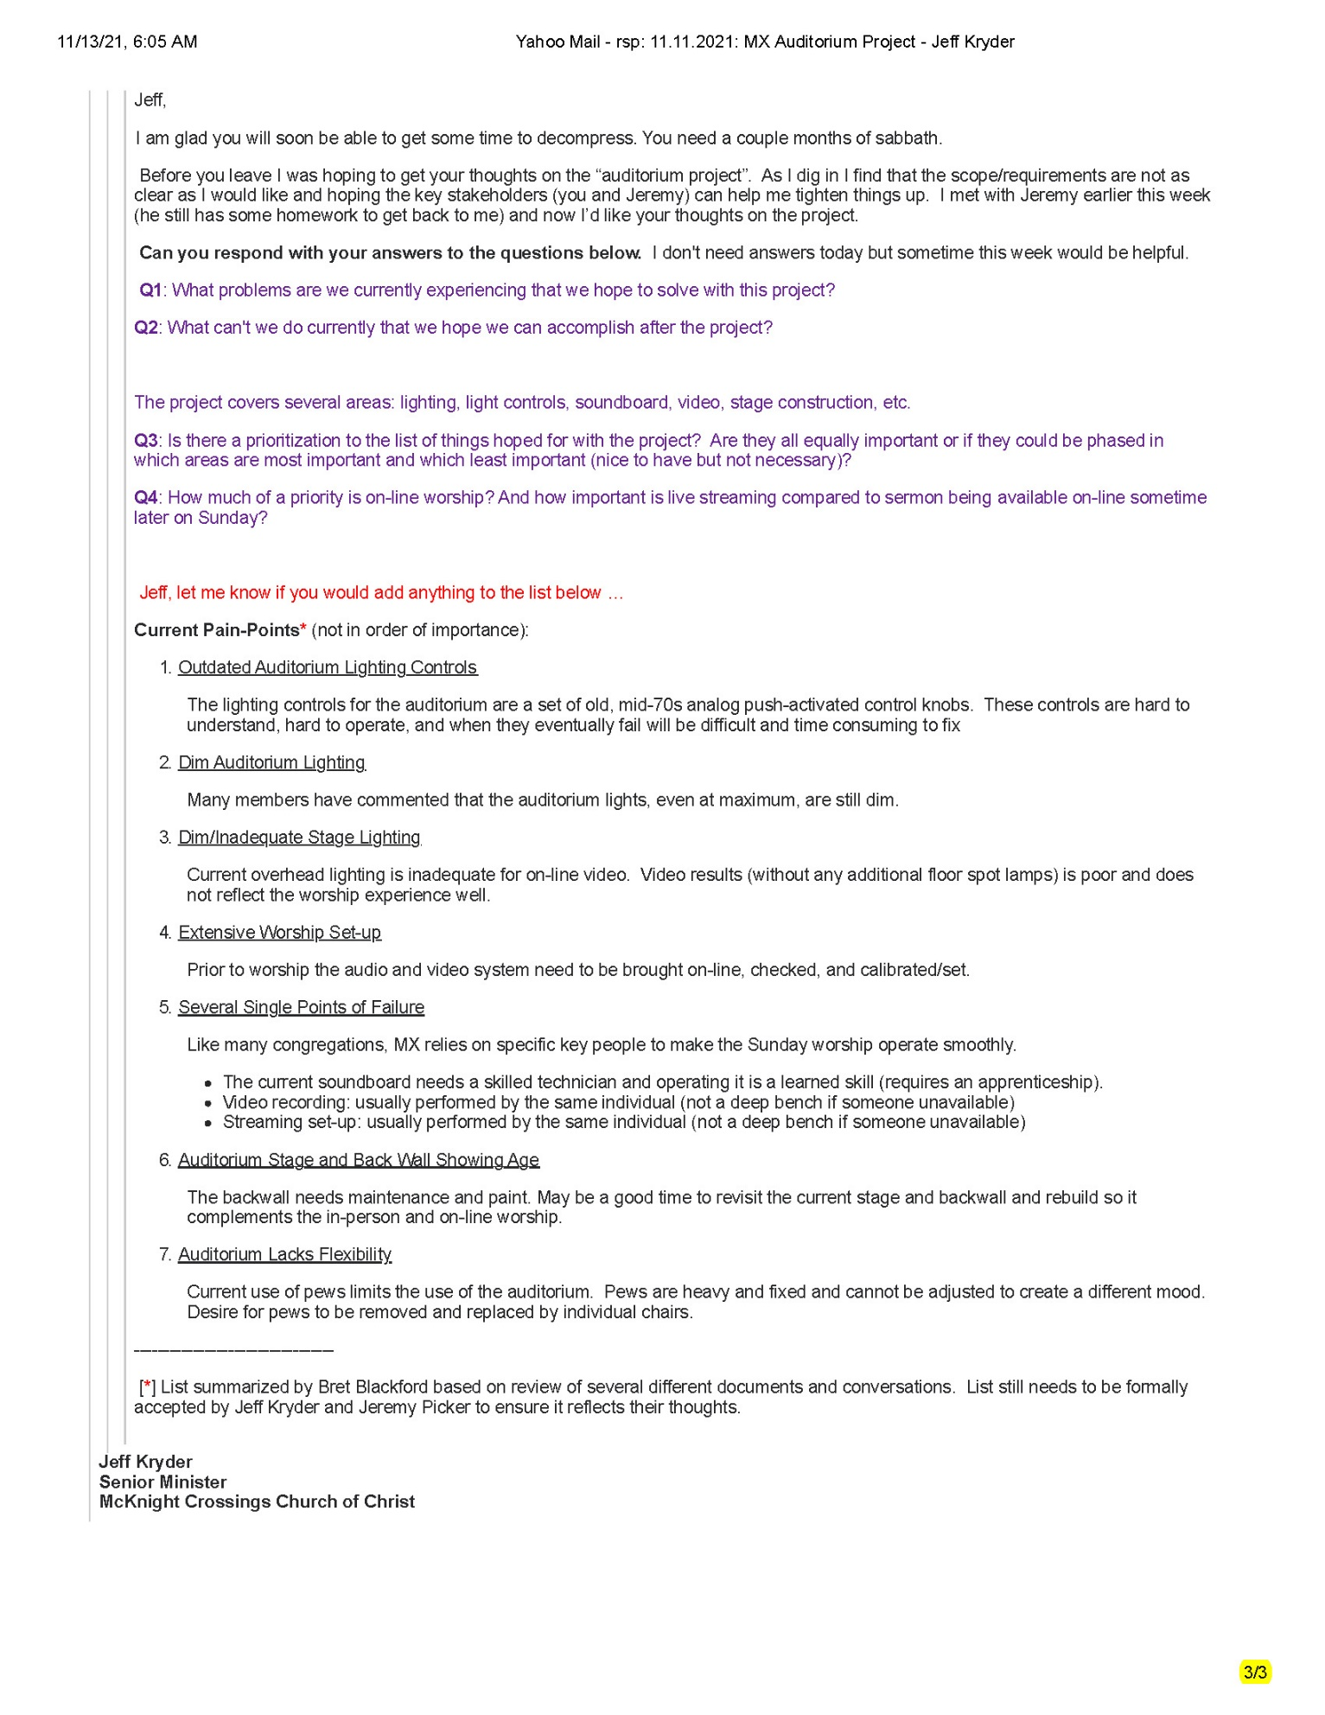

Exhibit J.1

Exhibit J – Jeremy Picker discussion on Auditorium Project

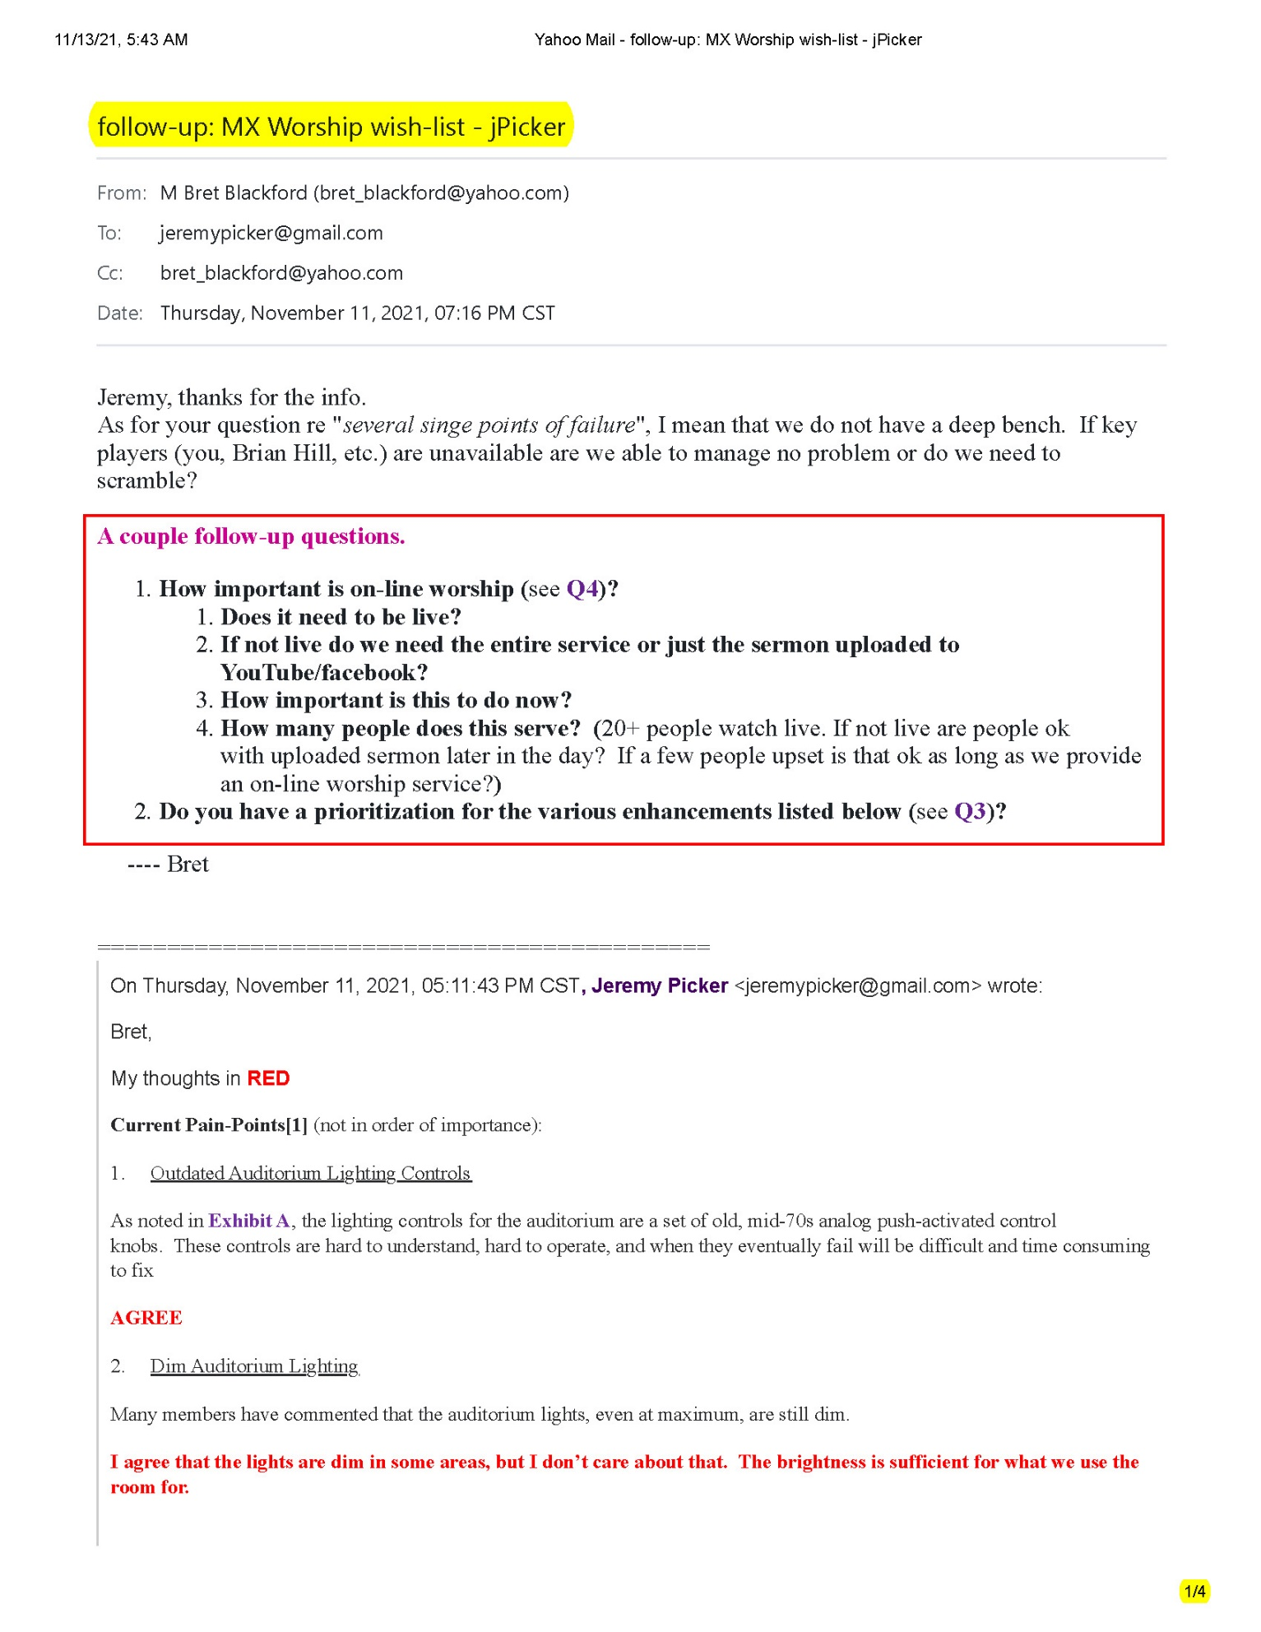

Exhibit J.2

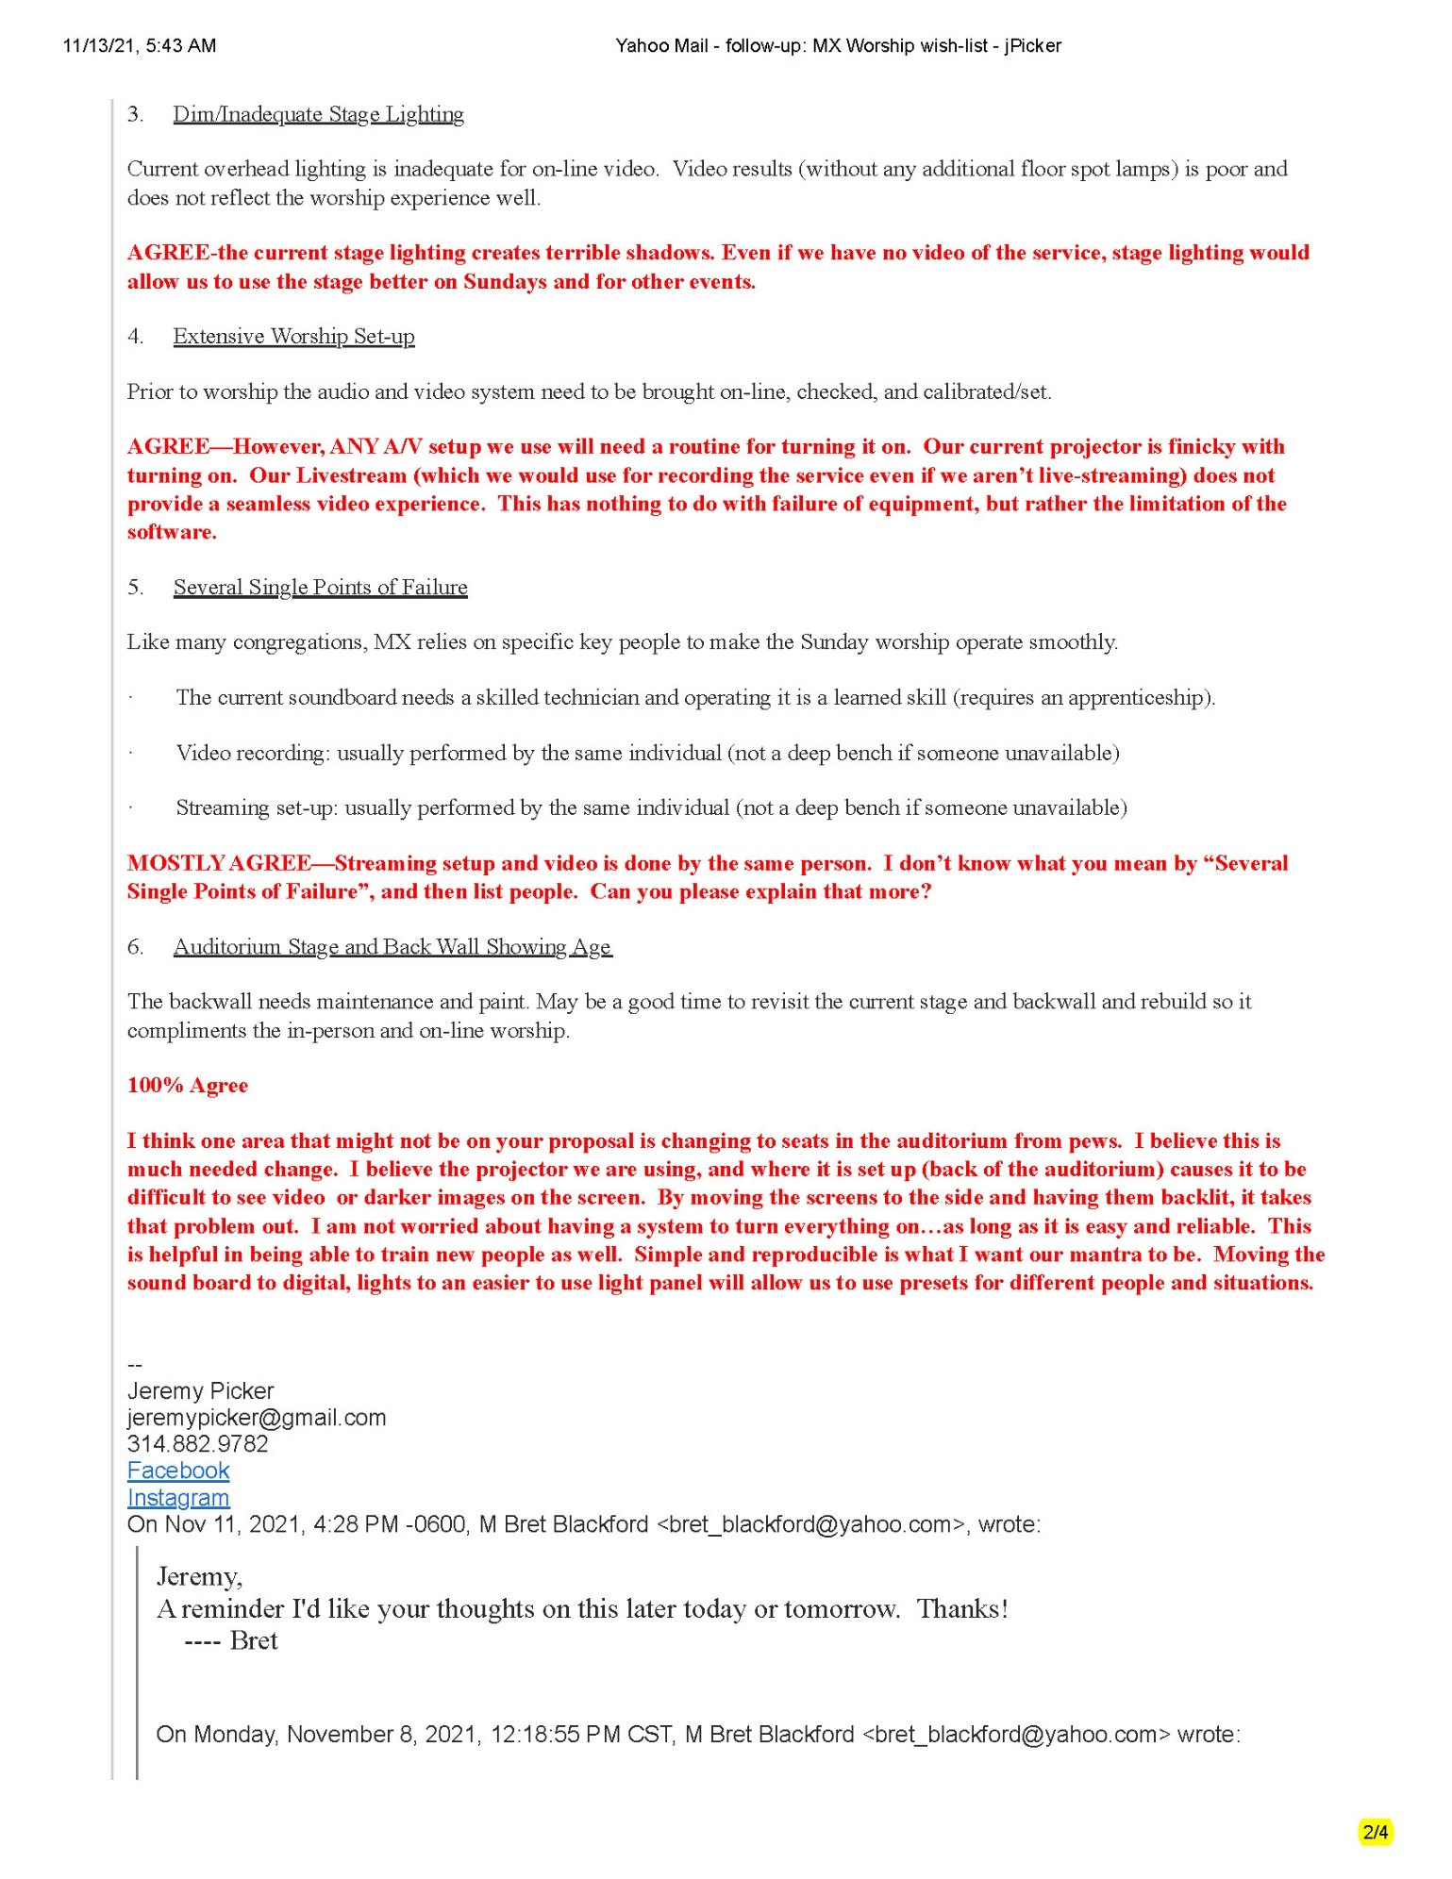

Exhibit J.3

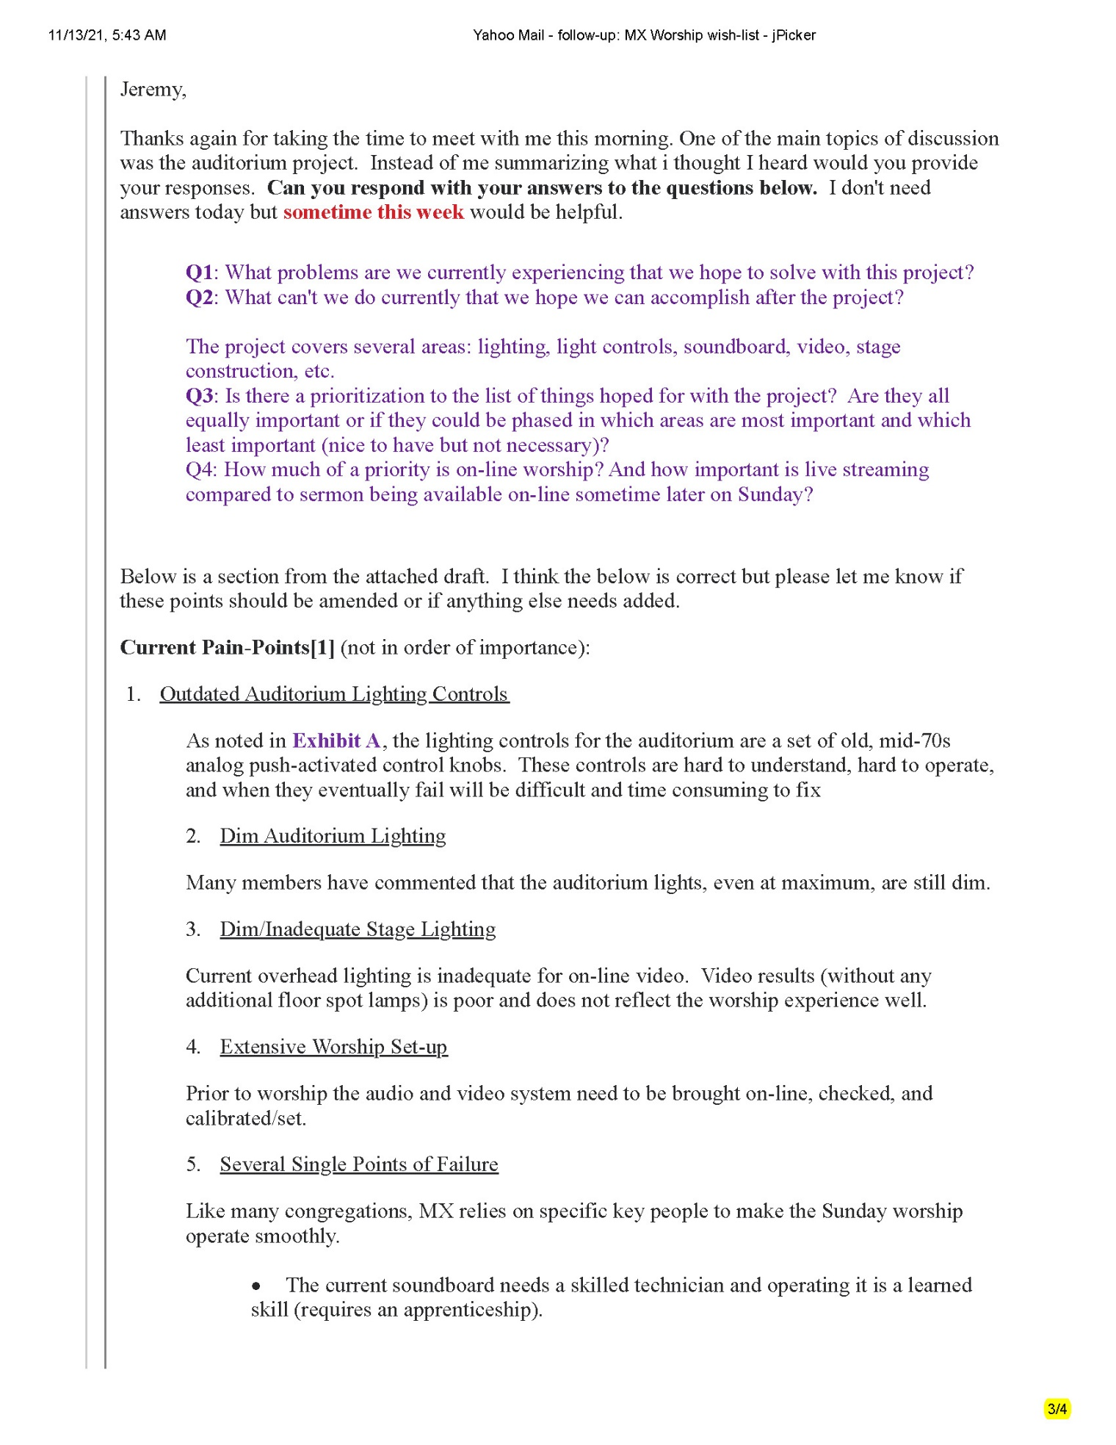

Exhibit J.4

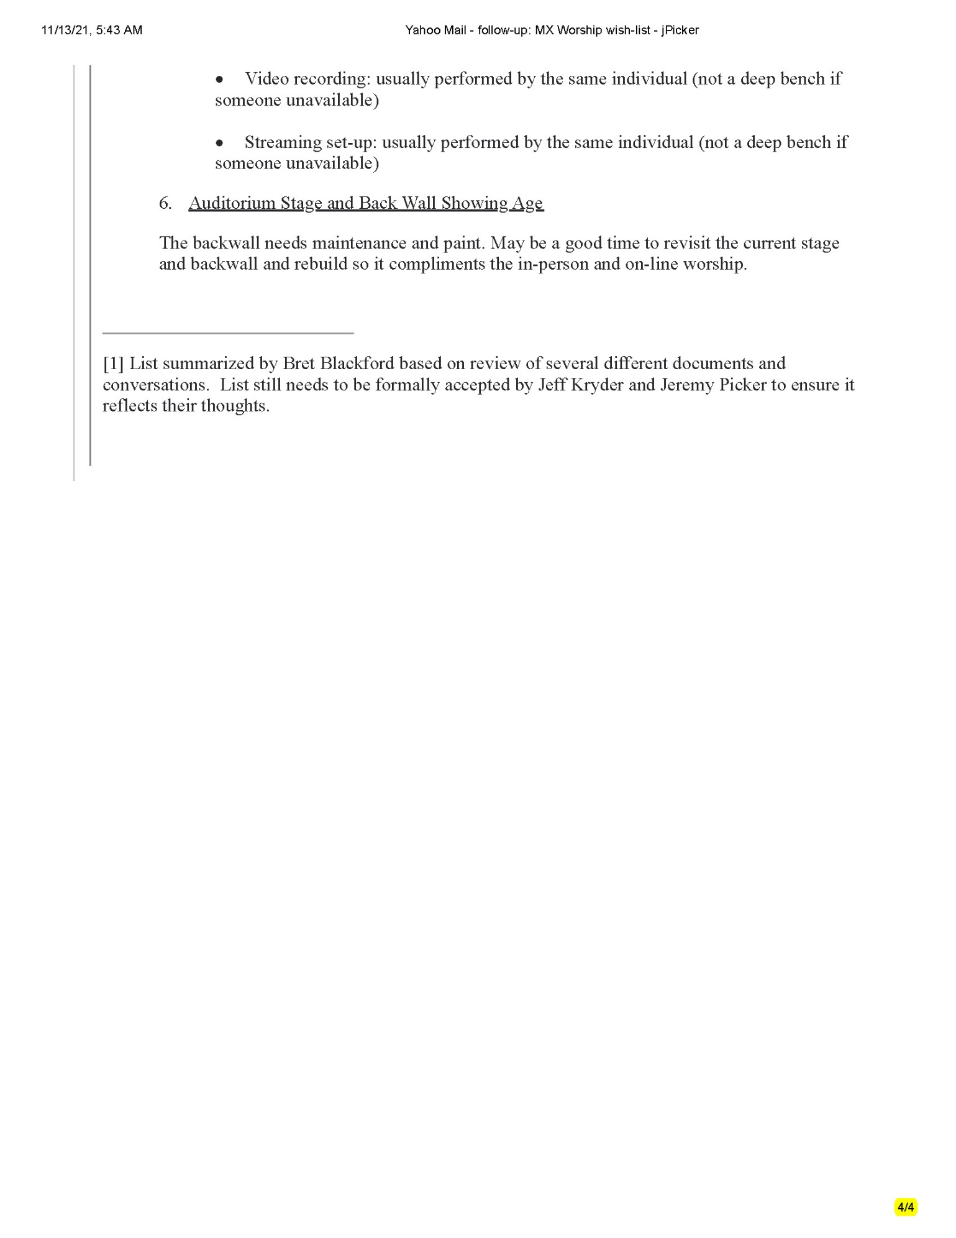

Exhibit K.1

Exhibit K – Jeremy Picker discussion on Auditorium Project – follow-up

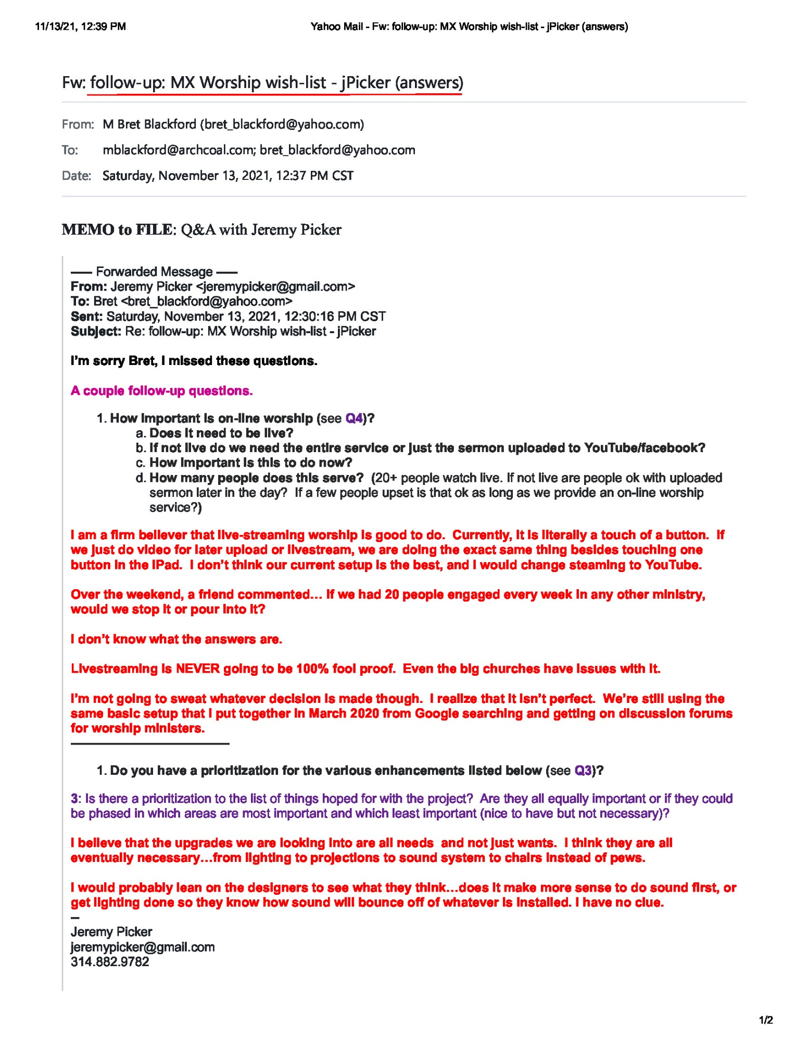

Exhibit L
Exhibit K – summarized comments from Jeremy Picker and Jeff Kryder
Below attempts to summarize the comments of Jeff Kryder and Jeremy Picker from the various in-person and email discussions (see Exhibit J & Exhibit K)

Jeff Kryder project comments summary:

- House lights Jeff did not specifically address existing house lights. Jeff did agree that Stage lighting, is terrible and needs attention. Lighting output is currently inadequate for in-house worshippers, and for online worship.. Also, repeatedly warned that existing lighting controls will one day not work and will be difficult to repair. Lighting controls need to be updated to make operating the house lights and the desired new stage lighting easier.
- Livestream is increasingly important. With online we started fast, but the technical issues (regardless of source) were highly frustrating to people, and their tolerance level was low. Often they would go to another church service, or just quit doing online. I heard this from multiple people, again for reasons we could control, and reasons we could not.
  - Some people will not come back to building, maybe ever.
  - Others use the online during a sickness, or a child's sickness.
  - Others used the online later in the day as they worked on Sunday morning, or were traveling, etc.
  - We have some, Terri Correnti, tuned in online, but due to anxiety issues, will not come to Mcknight on a Sunday.
  - Others, Colleen, Tim and Mary Ann, were surfaced through the online effort.
  - I do not see online as a substitute for in-person. I believe the potential for building a real community of discipleship this way is not that high. However, the online will continue to have a place. Having it done well might be likened to having a website or doing effective social media outreach. It will not win the world, but it is difficult, in this day, to carry on without it.
  - I am thinking that 80% of what we would like to accomplish doesn't have to be real-time, but close to it.
- Point - There will be a continued need for a quality online experience. I believe if the quality and ease of presentation was there, we can expand our outreach and promotion to attract new people. This is an untapped evangelistic tool.
- Improve in-person worship video screen used to display songs, scripture verses, etc. Currently it is hard for several to read.
- Jeff feels current audio is good but wants to make sure it is easy to operate. The current system additionally has the downside that one of our technicians must be there for special events - weddings, funerals, Christmas eve, etc.
- Wants digital presents wherever available – audio, lighting, video streaming, etc.

Jeremy Picker project comments summary:

- House lights are a little dim but not bad. No compelling reason to update. Stage lighting, however, is terrible and needs attention. More light and less shadows is needed. Also, lighting controls need to be updated to make operating the house lights and the desired new stage lighting easier.
- Prefers livestream over later upload. Does not consider livestream significantly more challenging than record and upload later. Note: It is a given that livestream will occasionally have glitches. This is unavoidable, regardless of equipment, personnel, and money spent.
- Jeremy would like to replace the pews with individual chairs. Thinks this allows more functionality to the auditorium.
- Reproducibility is a key mantra for Jeremy. Lights, audio, streaming should be constant each Sunday and easy enough to allow several trained members to operate.
- Stage and backdrop are bad. A clean/modern stage and backdrop that also works well on video is very much needed.
- All items of the “Auditorium Project” are needs and not wants.

Jeff Earnhart and Dave Arnold replaced the auditorium lights with 150W LEDs back in 2018. At this time they dropped the lights slightly inside the can cylinders which provided slightly better house lighting.
List summarized by Bret Blackford based on review of several different documents and conversations. List still needs to be formally accepted by Jeff Kryder and Jeremy Picker to ensure it reflects their thoughts.
Above text in purple a placeholder. Comments are by Bret Blackford and will be replaced when more project information obtained from Jeff Kryder, Jeremy Picker, and the elders.
This is also a valid concern for in-person worship. What do the shepherds expect of the congregation regarding fellowship, attendance of classes and mid-week small groups, etc.? In-person worship is no different that on-line worship if members leave immediately after service.

