**Elder’s Meeting**

April 18, 2022

Attendees: Wole Ukunade, Louis West, Bret Blackford (notes), Brad Stevens, Steve Awtrey, Dave Weiler (chair), Don Fitzgerald (remote)

Next Elder meeting: May 2, 2022 Chair: Bret

**Opening prayer** – Dave Weiler

**People updates**

* Jon Earnhart – stepping away from the Elder internship at this time
* Rick Salley – doing security
* Mayberrys at church
* New couple Daryl and Merci (live in Clayton by Brentwood mall) moved from Ohio. Here last two Sundays.
* Steve Gordon, dad, and brother here Sunday

**Okunade news** – Wole

* Retiring at end of June 2022
* May put house on market to look for a home in Dallas, TX next to daughter.
* When should we announce Wole? Can we announce with Glen Devania and have same potluck?

**Devania event update**

* Date for picnic
  + 5/15 possible date for shelter. Steve Walker checking with family
* Date for announcement? Steve Walker to decide

**Bennett event update for April 24** - Bret

* April 24 2:00-3:30 at M1 bank see **Appendix H**
* Get in announcement for this Sunday
* Bret to get last date of Sunday for AJ – we can pray for them
  + Sunday May 15, 2022

**Children's minister candidate visiting 4/22-24** - Steve W.

* Jeremiah Haywood, candidate
* See interview weekend agenda at **Appendix A**
* Praise & Popsicles Lunch & Play **Appendix B**
* Children’s Minister Job Description **Appendix C**
* Children’s Minister Search Process **Appendix D**
* Jeremiah Haywood Resume **Appendix E**

**Teen minister candidate visiting 4/29 - 5/1** – Lane

* Jamey Grimsley
* See interview weekend agenda at **Appendix F**
* Jamey Grimsley Resume **Appendix G**

**Elders/staff retreat update** – Lane (possibly **June 4**?)

Per Lane Hamm email agenda would look something like this:

* Icebreaker to get us into creative thinking mode
* Brainstorming on redefining what Delight/Encourage/Serve mean in 2022
* Land 3-4 priorities to support
* Discuss Staff roles/ Ministries to explore to support priorities
* Outline next steps
* Dinner together with wives.  Thoughts on where to get a reservation?
* Location:
  + MX building
  + Steve Walker club house
* Do we need more elders? Do we need different (younger) elders?

**Dale Robinson report** (link [here](https://www.shepherd.mx.mxcoc.xyz/docs-2022/MX%20Interview%20Report-Elders.pdf))

Recommendations:

1. **Attend to God’s Mission** – discuss at Elder/Staff Retreat
2. **Gatherings of the MX Community** – Pastoral Elder group
3. **Governance and Roles** – Vision Elder group
4. **Congregational Ministries** – discuss at Elder/Staff Retreat
5. **Administrative and Ministerial Staff**

Admin. Elders:

* 1. Consolidate Jeannie & Elizabeth role
  2. Part-time Communications role

Vision Elders:

* 1. Jeff Kryder Responsibilities
  2. Jeremy Picker Role

**Closing prayer** - Wole

**Appendix A**

**Jeremiah Haywood Interview Schedule**

The following is from Steve Walker’s 4/18/2022 email

Weekend

The committee is excited about Jeremiah’s visit.

**Key Events**

Friday 4/22

1. Tour MX facilities.
2. Visit and dinner with ACTS.
3. The Vincent’s will also host and house him for the evening. He will have breakfast with the Vincent family on Saturday morning.

Saturday 4/23

1) Committee Interview.

* The discussion will be led by Ross Brown, Kate Schneider and Matthew Bardowell. Others will be there to help with the evaluation.

2) **2:00 Elders, wives and staff will spend time with Jeremiah on the 4th floor.**

**Informal time together. Be prepared to ask questions.**

3) Dinner with the Grimshaw’s and Kryder’s.

* Jeremiah will spend the night with the Grimshaw’s.

Sunday 4/24

1) Jeremiah will attend worship service.

2) During Bible study, Gwen Walker will work with Jeremiah has he observes the various classes and meet teachers in the “Kids Community”.

3) 12:00-1:00 Lunch and Play in the gym.

* Jeremiah will lead a devotional, teach a couple songs and play games with the children.
* Melanie Sewkarran and Alicia Brown are working with Jeremiah planning the activities.
* Laura Picker and Nana Taylor are organizing food, pre-registration and set-up for the event.

Jeremiah interview weekend will conclude with the *Lunch and Learn*. (see **Appendix B**)

Challenges:

All that we have learned about Jeremiah from personal interactions and trusted others, we like him. However, there are no other candidates in the pipeline. We want to continue to be prayerful and let the spirit guide us in our evaluation.

|  |
| --- |
| Committee formed: |
| Jim & Dana Patterson, Leon Sewkarran, Jeff & Beata McGlawn, Jayson & Wilka Vincent, Laura Picker, Gwen Walker, Nana Taylor, Philip Matheny, Hanna Grimshaw, Jake & Jessie Munoz, Kate Schneider, Ross & Alicia Brown, Hanna Grimshaw, Heather Goff, Matthew Bardowell, Adam Shelly |

**Appendix B**

**Jeremiah Haywood Lunch and Play: April 24 @ 12:00-1:00**

**Praise & Popsicles Lunch & Play**

The goal of this event is to help kids connect with God, themselves, and their friends. We want kids to walk out remembering that they are loved, chosen, and redeemed by God. We will achieve this through allowing time for fun together, connecting with their parents, and creating an atmosphere for kids to understand Jesus.

Logistics:

* Kids will walk into the gym and will be greeted by an adult. We will have a table with sharpies, nametags, and high fives. Parents will also be greeted at this table.
* Families will proceed through the buffet line, then find a place to sit.
* We will have a couple of ice breakers questions for parents and kids. We should be able to get two families per table.
* Families can ask each other the ice breaker questions and eat.
* We will gauge the families to see how long it takes them to eat. We will start our first high energy game after.

Schedule:

Very flexible with families.

|  |  |
| --- | --- |
| **Time:** | **Activity:** |
| 12:00 | Family enters, find table, and grab lunch |
| 12:30 | Start with two games |
| 12:38 | Transition to bingo game. |
| 12:40 | Begin praise songs |
| 12:45 | Allow time for question and answer. |
| 1:00 | 3–5-minute devotional |

**Appendix C.1**

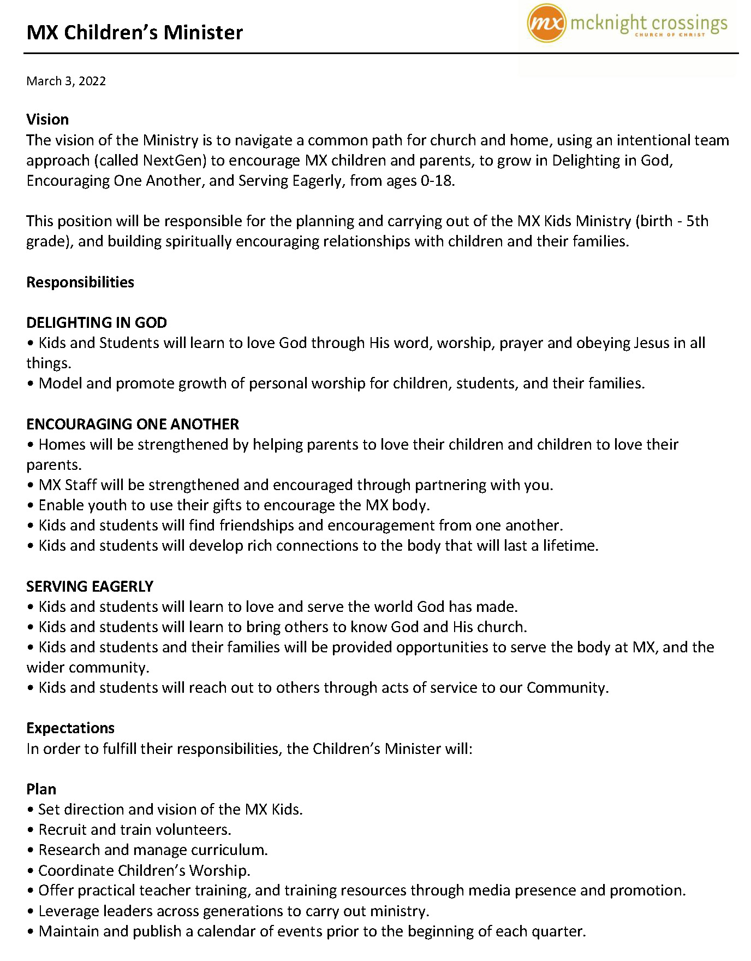

**Appendix C.2**

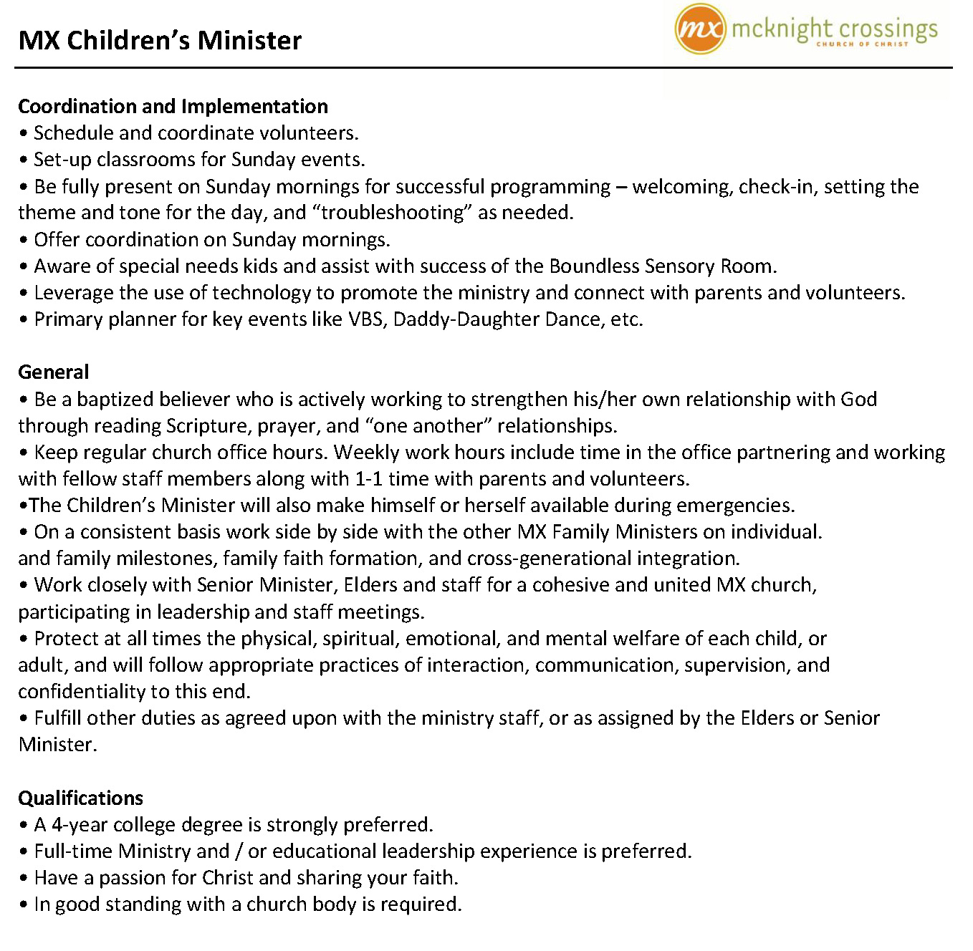

**Appendix D**

**Below is the Children’s Minister timeline as described by the Search Committee**

|  |
| --- |
| Search Process   1. Search team to develop a timeline and meeting schedule. 2. Solicit input from the parents whose children are age appropriate to the ministry. 3. Refine the job description. 4. Begin the candidate search process. 5. Identify qualified applicants. 6. Screen selected applicants. 7. Invite qualified candidates to interview for the position. 8. If Elders, parents and search team determine there’s a fit, make an offer. |
| Post-Employment   1. Tools for success post-employment. 2. Onboarding and parent mentoring. |

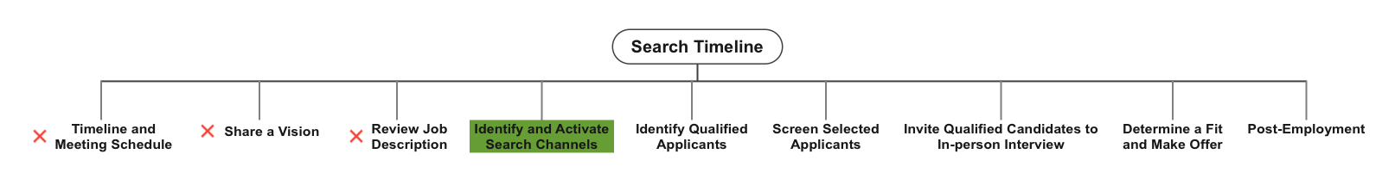

|  |
| --- |
| Committee formed: |
| Jim & Dana Patterson, Leon Sewkarran, Jeff & Beata McGlawn, Jayson & Wilka Vincent, Laura Picker, Gwen Walker, Nana Taylor, Philip Matheny, Hanna Grimshaw, Jake & Jessie Munoz, Kate Schneider, Ross & Alicia Brown, Hanna Grimshaw, Heather Goff, Matthew Bardowell, Adam Shelly |

**Appendix E.1**

**Jeremiah Haywood Resume**

**Children’s Minister**

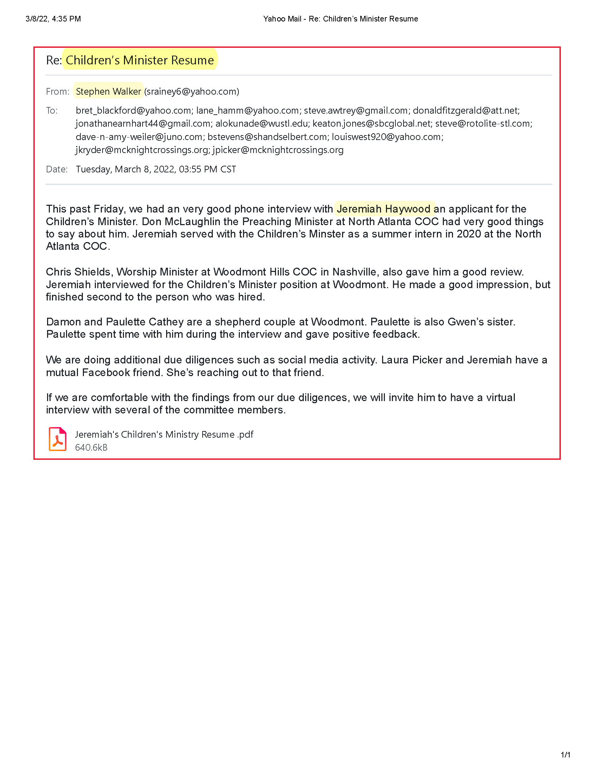

**Appendix E.2**

**Jeremiah Haywood Resume**

**Children’s Minister**

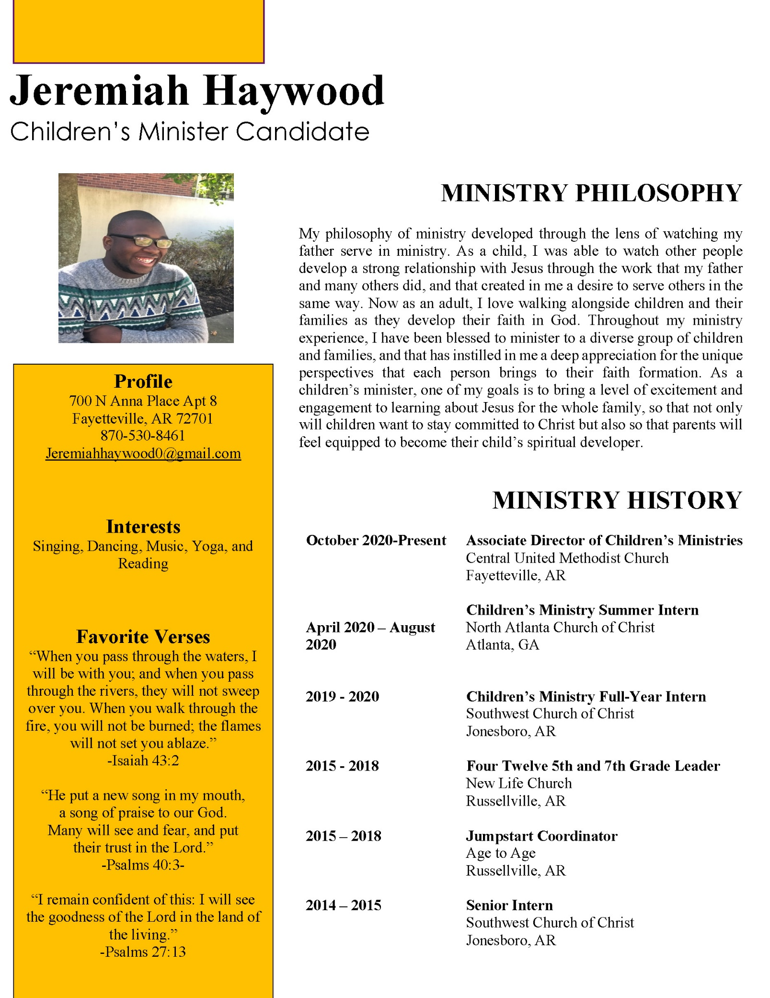

**Appendix E.3**

**Jeremiah Haywood Resume**

**Children’s Minister**

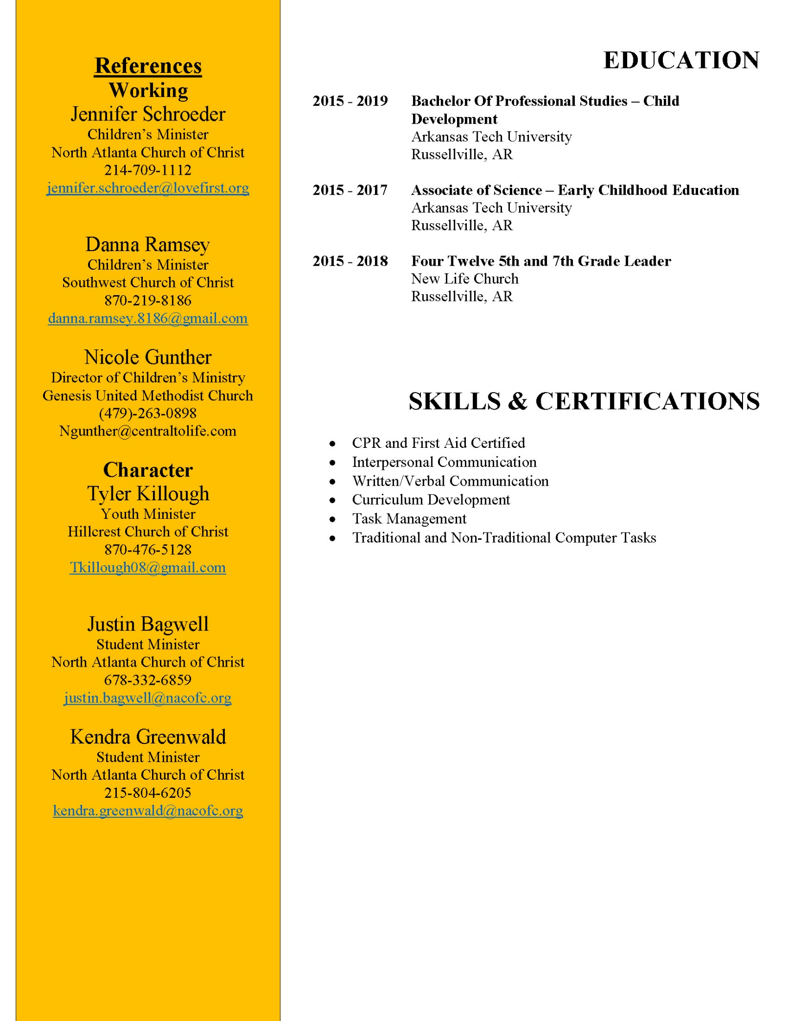

**Appendix F**

**Jamey Grimsley Interview Schedule**

**Youth Minister**

**Jamey & Jacie Grimsley**

**04/29/22 – 05/01/22**

**Friday, April 29th**

6:00 – 7:30pm : Pizza Hangout + Activity + Devo

7:45-8:30pm : Parent Q&A

8:30 – 9:00pm: Meet with SLT members

**Saturday, April 30th**

9:00 – 10:30am – (Jamey only) Interview with Committee (including youth group members)

11am – 12:00pm – Jamey & Jacie meet with Elders & Wives

12:00pm – Jamey & Jacie have lunch with Jeremy, Laura, Jeff and Becky

Free Time

6:30pm – Dinner with Committee Members

**Sunday – May 1**

9:30am – Grimsley’s attend services

10:45am – Jamey leads combined class

Meet with parents from 11:30am to 12:00pm to get their feedback.

Search Membership:

Jon Earnhart , Eric McPherson, Rachel Bardowell, Sara Matheny, Jeff McGlawn, Beata McGlawn, Steve Beauchamp, Coen Reigers, Sydney Bax, Grady Goff, Ansley Picker, Kennedy Picker

**Appendix G.1**

**Jamey Grimsley Resume**

**Youth Minister**

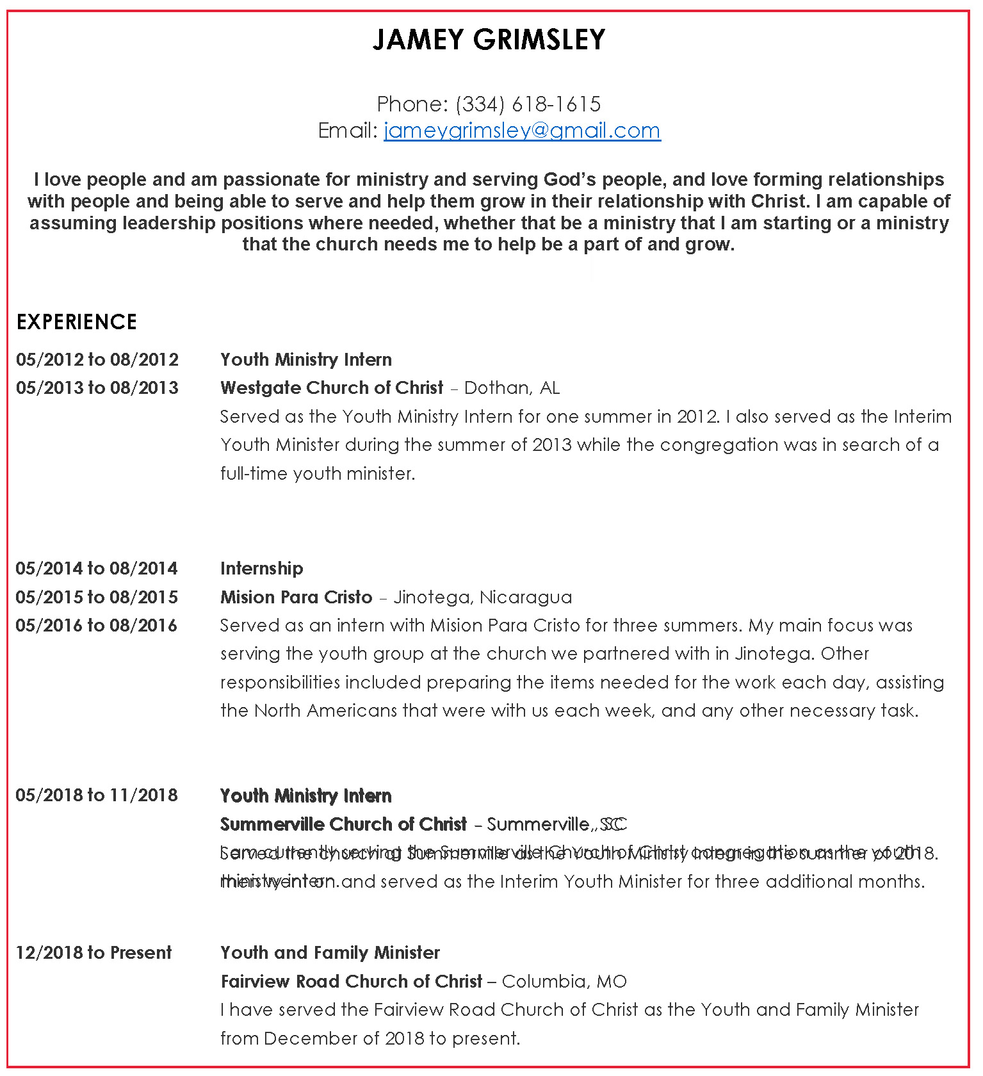

**Appendix G.2**

**Jamey Grimsley Resume**

**Youth Minister**

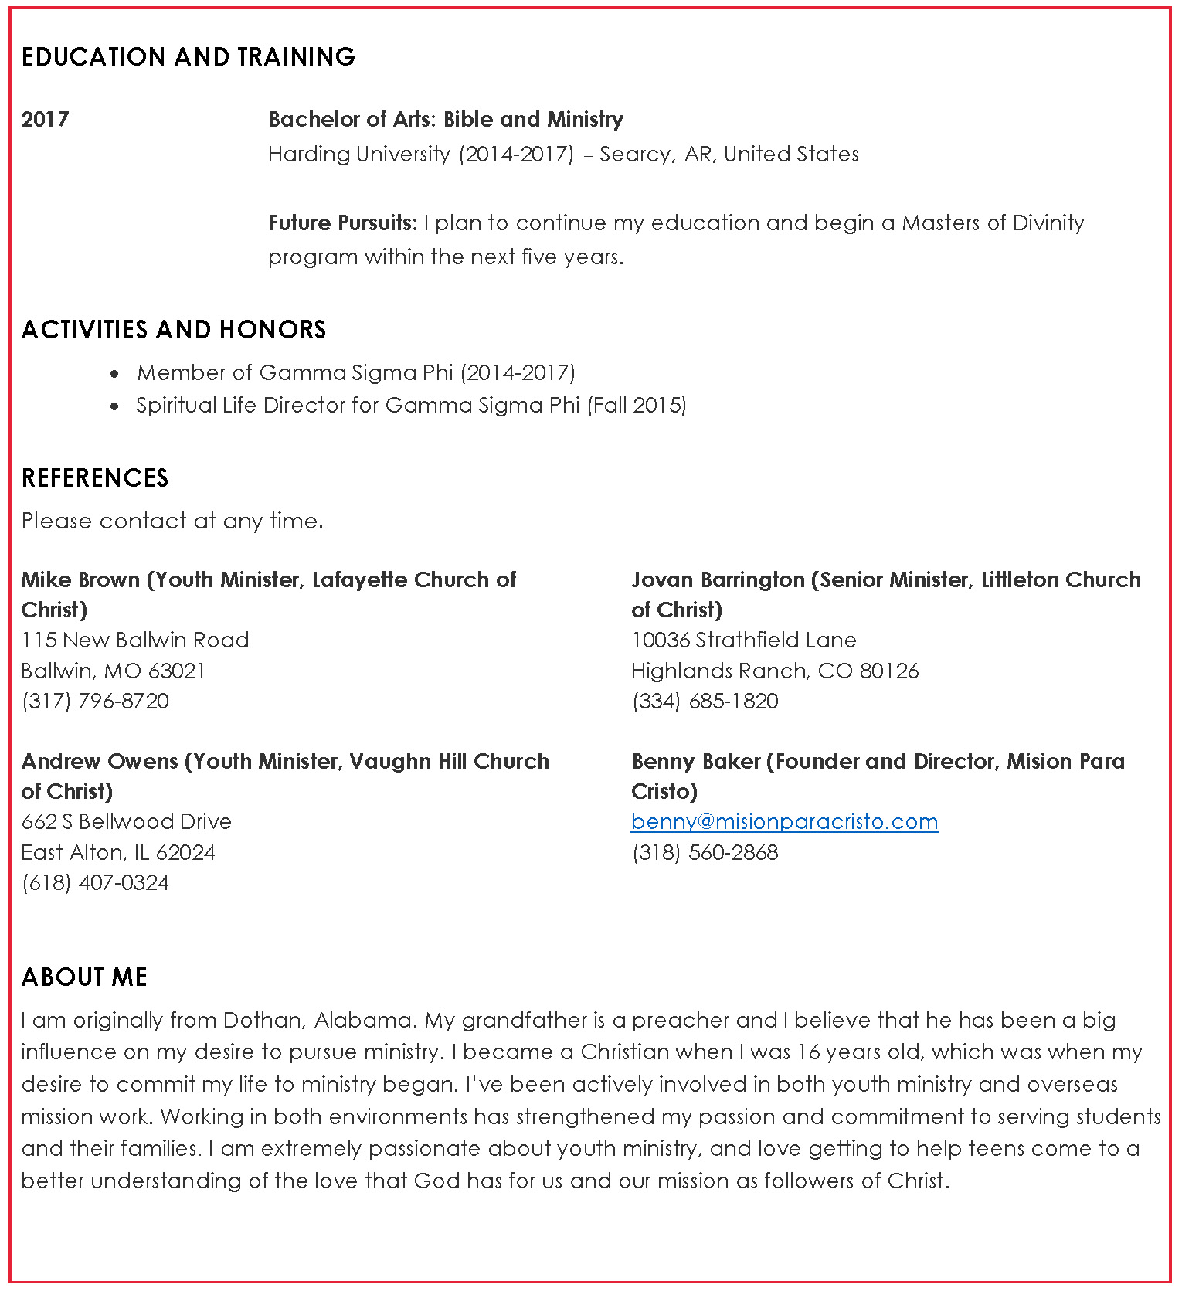

**Appendix H**



**Farewell and Thank You Party**

For

**AJ and Susan Bennett**

|  |  |
| --- | --- |
| Date: | April 24, 2022 |
| Time: | 2:00 – 3:30 pm |
| Where: | [M1 facility](https://goo.gl/maps/71mKVzSc9E924ZRR8)  7 N. Bemiston Ave.  Clayton, MO 63105 |

After 25 years of service AJ and Susan Bennett will be moving to Texas and transitioning the ACTS Campus Ministry to Katie Holloway. AJ and Susan have touched thousands of lives over these 25 years and blessed so many of us. I hope we can gather to send this couple off with our blessings and love.