Attendees: Steve Walker (chair), Louis West, Keaton Jones, Steve Awtrey, Bret Blackford, Brad Stevens, Don Fitzgerald, Jeff Kryder

Philippians 4:6 – “*Do not be anxious …* “

We have big decisions and need to trust in God.

1. **People** 
   1. Lacoss-Arnold family – Patty broke ankle and still [waiting on courts](https://web.archive.org/web/20220927223527/https:/www.stltoday.com/news/local/crime-and-courts/st-louis-county-woman-faked-daughters-illnesses-for-more-than-a-decade-charges-say/article_47c049c2-622e-5caa-882a-4a8da958f1db.html) with the girls
   2. Norma Janes – she was happy to hear from Jeff Kryder. She does not go out except for groceries and does not want anyone to the house. Jeff not sure if Norma is following services on-line or in any medium. She talks with Barb Dolan and Nel.
   3. Jan Patrick – Cathy Jones talked with her. Vicki Roberts and Barb will try and have lunch with her this week. Steve Haupt played piano for her.
   4. Alice Ferry – wanted to join a small group via Zoom. Keaton unable to help with this. Not sure how we should deal with these types of situations.
   5. Audrey Dolan – Marty’s ex-wife – had a hard young life. Her 12-year-old granddaughter has been coming on Wednesdays and Sundays. She is part of a grandparents raising grandchildren group – would like MX to get involved with this.
   6. Judy Miller & Linda – Linda put sister in nursing home. An answered prayer and a bog list for Linda. They are looking into taking over the senior ministry (Special Sisters II).
   7. Care Ministry? – can we have members taking communion to others?
      1. Are we taking care of widows?
   8. John Waters – Steve Awtrey talked with him. Called to talk. He plans to come back but has been in Amarillo TX.
2. **Youth Minister** – Nathan
   1. Steve Awtrey thought class went well
      1. Nathan’s Youth Ministry Vision – not so much vision as activities.
      2. What we are looking for is a personality and the rest we can train
   2. Keaton – Nathan is a positive kid and he want to do this. Keaton thought he did well with the class. Feels Nathan is able to plan things out.
      1. Jeremiah will bring out the best in either candidate.
   3. Steve Walker – Nathan knows the kids and was able to engage the kids in the class. Nathan was ready for interview and had some things he wanted to talk about.
      1. Wesley may be good at first but Nathan may be a better long-term candidate.
      2. **Q:** **Which candidate will better help MX reach our goals?**
   4. Don Fitzgerald – Nathan desires to do this.
   5. Jeff Kryder – really likes Nathan and has seen a great deal of growth.
   6. All elders present agreed that both candidates would be good candidates.

* Should Steve Awtrey get with Youth Group to discuss if they would/could back each candidate? We should call the parents and students together to get their commitment to back the decision.

**Saturday October 3**

* 8:00-9:00 Prayer
* 9:00–10:00 get with Search Committee individually
* **Make a decision** – **pick a candidate** (see **Attachment B**)
  + - Contact chosen candidate
    - If offer accepted – plan announcement

1. **Clarity on 4 Ps**
   1. How do we better engage the community?
   2. How do Strengthen our Relationships with one another and Connect Groups as a focal point
   3. How do we continue our focus on NextGen?
   4. How do we develop Ministries and Leaders?
2. **Class**: October 2 – “Where do we go from here?” see **Attachment A**
3. **Staffing Updates** – Steve Walker and Steve Awtrey
   1. Jeff Kryder outlined duties of all staff roles
   2. Steve A and Steve W are attempting to re-align duties for future vision of staff
   3. Elizabeth McPherson currently has too many duties
   4. Don Fitzgerald and Bret Blackford – Admin Elders with building focus.

**Attachment A.1**

Summary from Jeff Kryder of new class starting October 2, 2022

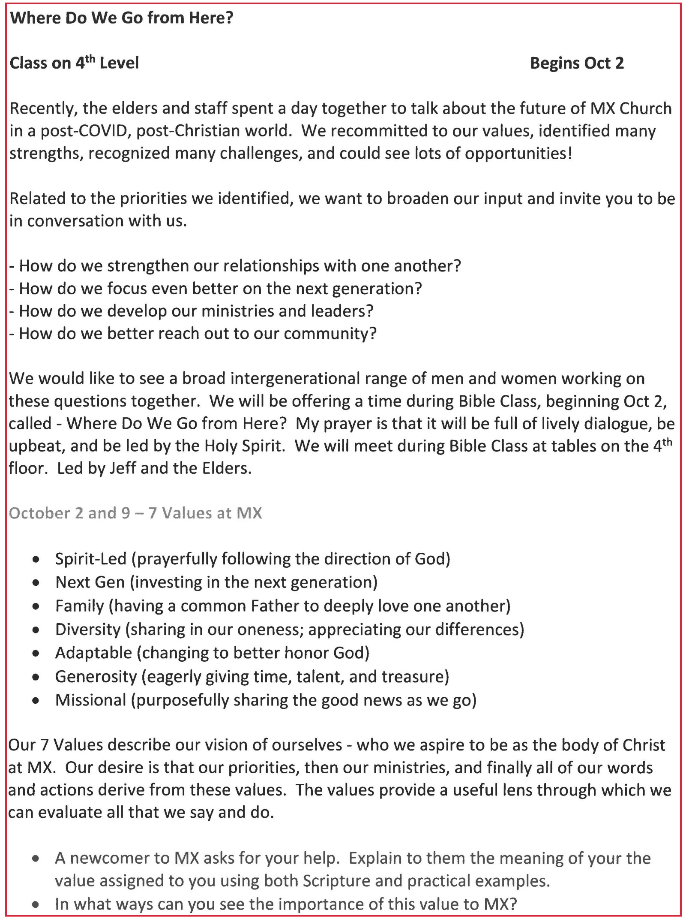

**Attachment A.1**

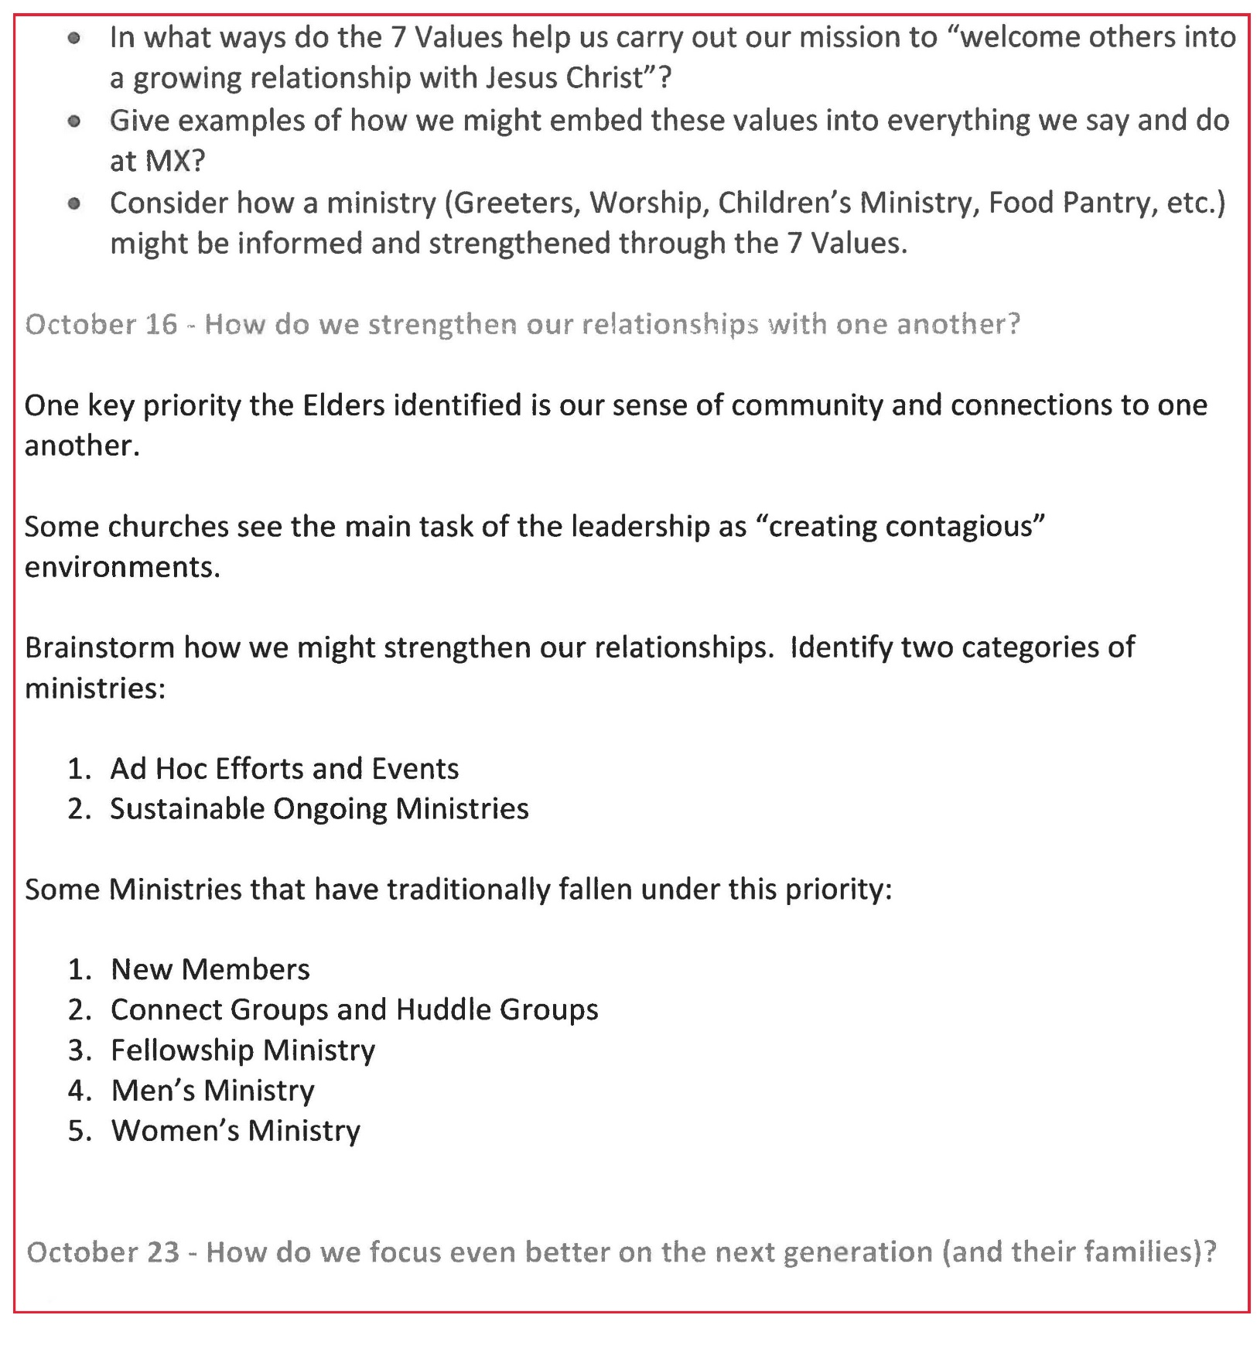

**Attachment B**

Below is a sanitized generalization of responses from parents and teens (from Steve Awtrey confidential handout). It is a crude heatmap but gives an indication of how individuals responded to the Youth Minister candidates.

