July 18, 2022 @ 6:00pm

**MX Elder Meeting**

Attendees: Brad Stevens, Bret Blackford, Keaton Jones, Jeff Kryder, Steve Awtrey, Don Fitzgerald, Dave Weiler, Steve Walker

1. **People Update** –

* Michael & Whitney Cannon – had car repossession notice. Dave Weiler able to assist and Dave will work with them on budget and planning.
* Bryant and Nene Taylor – Dave still working to get with them on discussing finances and budgets. They are looking for a 3-bedroom to accommodate a new foster child.
* Keaton met with Jim Roberts who fell and hurt his arm. Slipped on floor and hurt arm. Vicki said he fell again off a ladder. Jim has lots to do on the house and Keaton will try and help.
* Jaime Wehrung – still a crazy schedule with the kids.
* John Waters – not sure of status – he has been in Texas for a while
* Marie and Jerome Allen – Dolores said they sent a big makeup check, but we have not seen them since last year. This may be a good opportunity to connect with them.
* WC Connelly – Dave & Amy Weiler saw him and wife at Culvers. He is still doing dialysis and on kidney transplant list.
* Cindy and Sergio Munoz – have been visiting MX.
* Ron & Stacey Cruz back after a while. Stacey fell and wearing a boot. Ryley doing well after surgery but self-conscious about being on a crowd.
* Steve Awtrey’s brother Ron in rehab in Bethesda. He is losing weight but doing better.
* Tod and Beth Mayberry at building with Tora.

1. **Youth Ministry Search** –

* Steve Awtrey – Concerned this is going to spin out of control. There is a split on ***Jeremy Picker*** and [***Nathan Strickland***](https://www.shepherd.mx.mxcoc.xyz/docs-2022/NathanStrickland-Resume.pdf)***.*** The elders need input from the YM Search committee. We should get feedback from the Youth Group who went on Colorado trip? Also, input on Nathan?
  + Will MX loose families if we chose one over the other?
  + If not Jeremy Picker then what will his role be going forward?
  + Elders will trust the Committee to do its work

Attachments:

* + July 17 Jenny Reijgers email **Attachment A.1**
  + July 18 Dave Weiler resp to J Reijgers **Attachment A.2**
  + July 18 Lane Hamm resp to J Reijgers **Attachment A.3**
  + July 18 Tara Beachamp email **Attachment A.4**
  + July 19 Lane Hamm update on YM search **Attachment A.5**
  + [***Link***](https://www.shepherd.mx.mxcoc.xyz/docs-2022/MX%20YM%20v2.pdf) – prior discussion from Steve Haupt and Bret Blackford on Youth Minister position

1. **Adding Elders (**MX Church Leadership Structure**)**

After discussion noted below consensus was reached that the Elders should approach four (4) men to see if they are willing to attend the Elder meetings and shadow the elders for 6-12 months. Then, if mutually agreeable, they will be presented to the congregation for possible commissioning as an elder. The men were selected from the initial list submitted by the Elders earlier in the week (see **Attachment B**). The four men are: Jon Earnhart, Steve Jones, Collins Corder, and Charles Eickele.

We also agreed that there should be leadership development, two tracks: 1) one for those men who we see as possible future candidates for joining the elders, and 2) another group of those in the body who are currently leading or have the qualities of leadership (included women like Kari Ferguson).

Below were discussion items to help define the goal/outcome of eldership number and composition. Additional questions/thoughts from Bret noted in **Attachment C**.

* How many elders do we need?
  + Dave Weiler – more members on a non-profit board is better. Feels similar to eldership IF we use sub-committees: Finance, Pastoral, Vision
  + Do we have a roadmap [Steve Walker]
* What qualities are we looking for to balance us as an eldership?
  + We have a need for Pastoral elders to work with Keaton (many of the possible new elders have good qualities for this)
  + Keaton likes younger elders for a different perspective
    - Are young professionals and families comfortable with the direction of the church? Do we get eldership representation for/from them?
  + Don Fitzgerald – wishes we had more specifics about what elders did in the first century. What are we looking for in a new elder? What skillset to complement the current elders? We have uncertainty to what we are calling someone to when they are commissioned as an elder here at MX.
  + Admin Committee [Dave Weiler] – involves many people, more than just the elders. What if the Vision Committee were 2-3 elders plus a couple individuals from the congregation? Same with other Committees.
  + Jeff Kryder – Leadership development is important. How do we grow the pool and encourage those to seek the position of eldership. How do we encourage ministry leaders? Are we giving members a calling?
  + Steve Walker – Can we still give members a task, challenge them to step in. Perhaps NOT as an elder but to take the lead or work with a task – to help further the kingdom.
    - After Covid there seems to be a feeling of instability. Is the MX Leadership just trying to keep the plates spinning?
    - What do we need for the next 2-3 years? Who do we have now to help is in the next 2-3 years? How do we call them to step up?
    - Whatever we do we need to communicate it to the congregation.
    - Jeff Kryder – buy-in will increase when congregation gets involved. There are a lot of skillsets in our congregation. How do we bring these to bear, to leverage these to help the congregation?
      1. What is the Leadership mission?
      2. Do we need a weeknight to bring talented and spiritual members together to discuss and pray about the mission of MX? Target people, challenge them, and give them something worth their while.
      3. Erich McPherson influences people but not through the normal channels. Meaning, are Elders leading the sheep or are the sheep taking lead from someone else?
      4. Don Fitz – do we need to look at an elder/deacon type model? Elder mission leader connections. As we discuss leadership training it sounds like deacons.
      5. Dave Weiler – would we be helped from the Serving And Leading Together (SALT) team concept? Link [***here***](https://www.shepherd.mx.mxcoc.xyz/positions/docs/SALT%20Team%202020%20-%20Serving%20and%20Leading%20Together.msg)
  + List of Possible Elders:
    - Are there initial qualifications for being on the list? Children? Divorced? Position on marriage, etc.?
    - We probably want three lists:
      1. Ready to come along the elders – come along for 6-12 months to see if they feel called. Mutual between the elders and the candidate.
         * Jon Earnhart – Steve Awtrey and Jeff Kryder
         * Steve Jones – Steve Awtrey will connect
         * Collins Corder – Brad Steven will connect
         * Charles Eickele – Keaton will connect
      2. Need additional training and encouragement (Minor Leagues)
         * Ross Brown
         * Jeff McGlawn
         * Karl Reijgers
         * Steve Beachamp (perhaps ready for group 1)
         * Jon Earnhart (perhaps ready for group 1)
         * Matthew Bardewell
      3. Younger elders
      4. Leadership Development
         * Can include women
      5. Unknown due to qualification questions [divorce]:
         * Eric McPherson
         * Jayson Vincent
         * Brett Ferguson
  + We may lose several elders such as Don Fitzgerald and Keaton Jones (retiring), Lane Hamm (moving), Lewis’ health may be an issue.
  + Should we share the attached with the Elder candidates or does this document need to be updated first?
    - ***MX Shepherding Model*** [.[docx](https://www.shepherd.mx.mxcoc.xyz/positions/docs/McKnight%20Crossings%20Shepherding%20Model.docx)] or [.[pdf](https://www.shepherd.mx.mxcoc.xyz/positions/docs/McKnight%20Crossings%20Shepherding%20Model.pdf)]

1. **Other Items** –
   1. **Vision Retreat/Next Steps –**
   2. **Dale Robinson Recommendations –** [*link here*](https://www.shepherd.mx.mxcoc.xyz/docs-2022/MX%20Interview%20Report-Elders.pdf)
2. Jeff Kryder **Hallway/Foyer Class** – this has traditionally been its own animal and serves a good purpose.
   1. Are we able to connect with the 50 and under crowd?
   2. Elizabeth mentioned Eric in a troubled place with McKnight since letter, which went unanswered.
      1. Dave Weiler talked with Eric about the letter. Dave understood that Eric just wanted to voice his opinion and didn’t expect a response from the elders. Letter [***here***](https://www.shepherd.mx.mxcoc.xyz/positions/docs/ErichMcPherson-09.23.2021.pdf).
      2. Shall we invite Eric to an elder meeting? How can we connect with Eric and Elizabeth? Can someone go to dinner with the McPherson’s ?? Possibly Brad Stevens take them to diner.

**Attachment A.1**

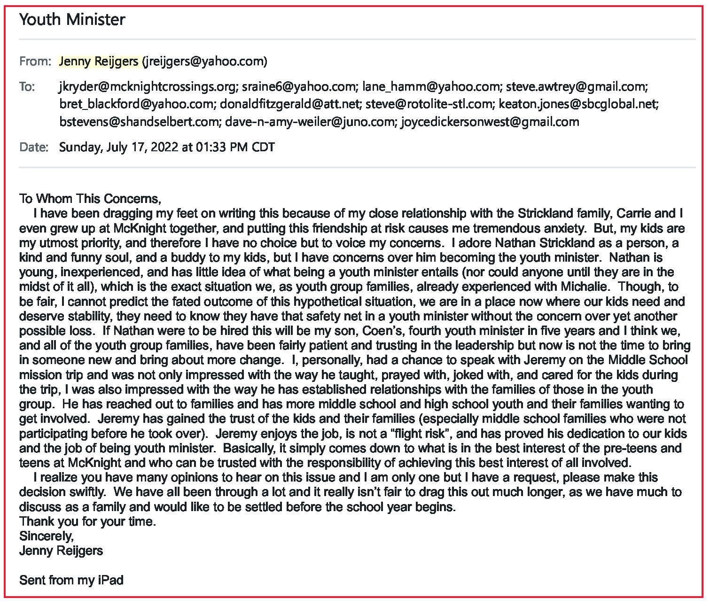

**Attachment A.2**

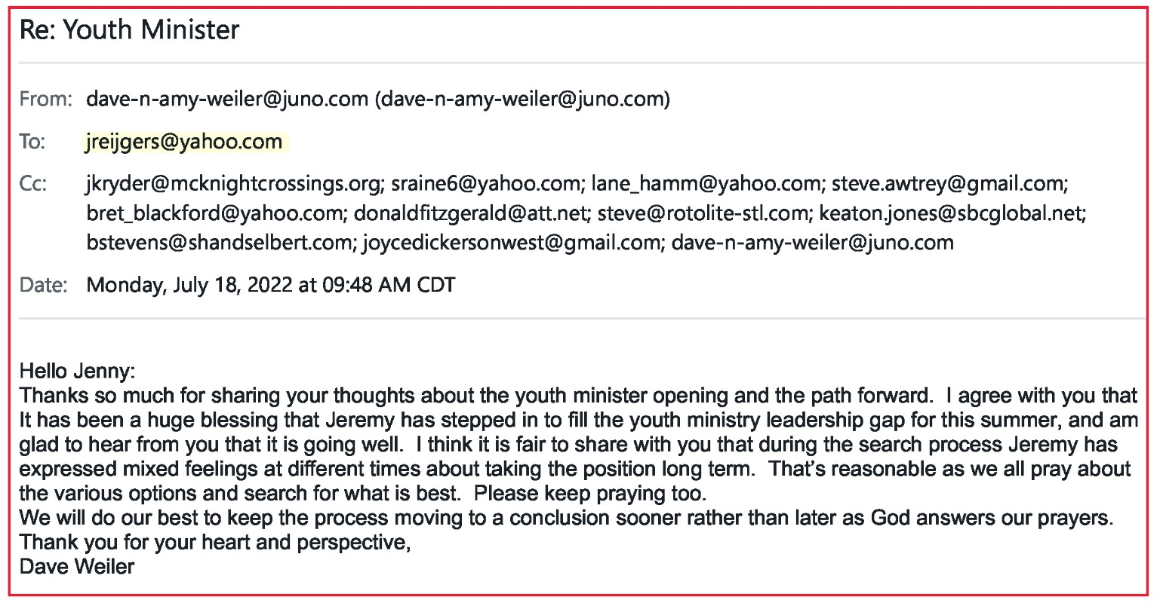

**Attachment A.3**

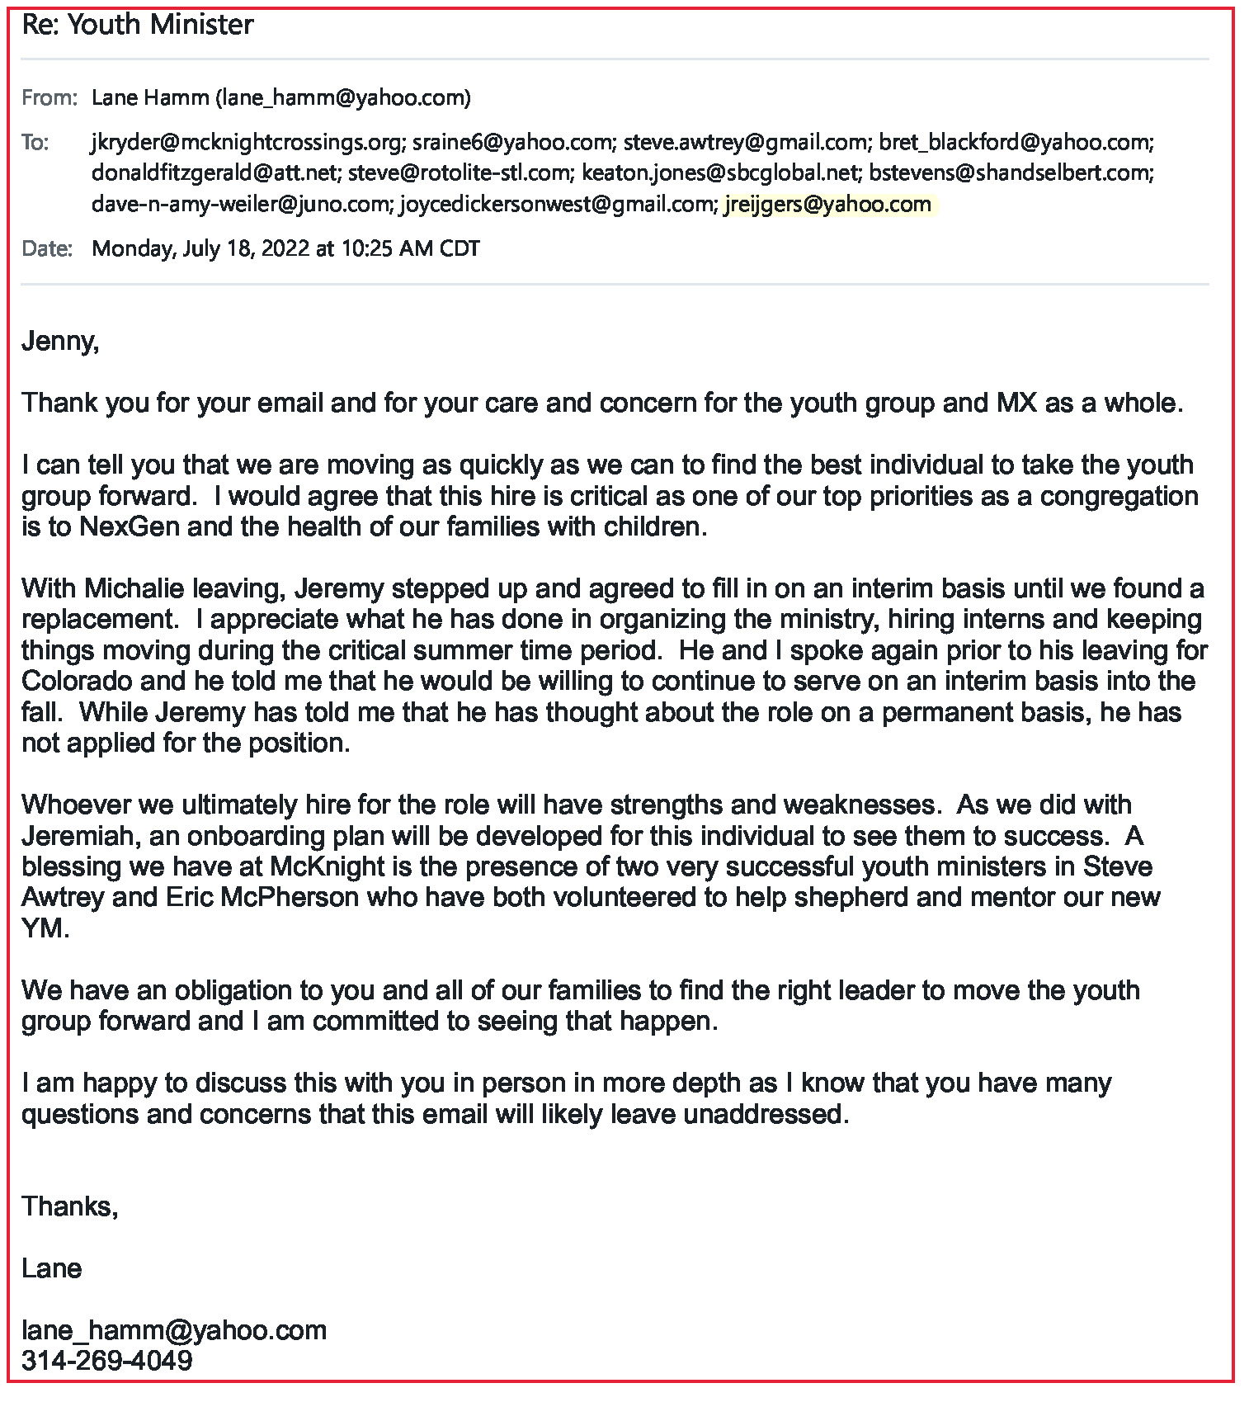

**Attachment A.4**

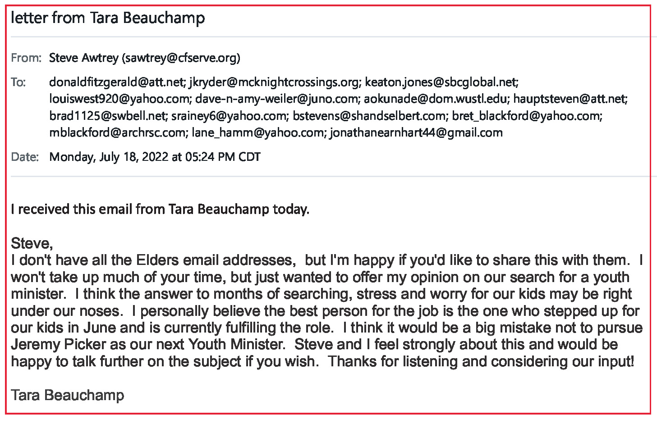

**========== ========== ==========**

**Attachment A.5**

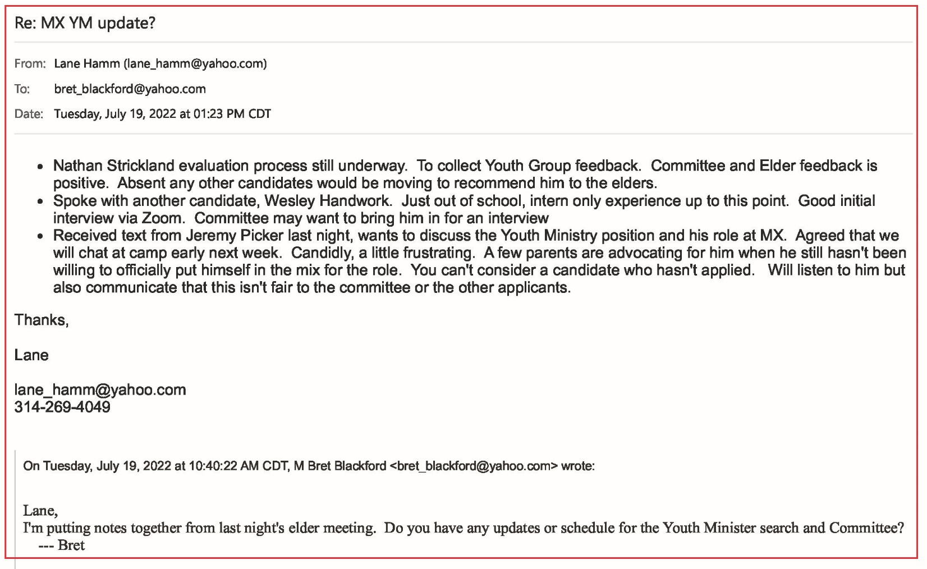

**Attachment B**

Below provided 7/18/2022 to Elders by Steve Awtrey

**Names brought up to consider as Shepherds**

1. Steve Beauchamp
2. Jeff McGlawn
3. Steve Borth
4. **Jon Earnhart**
5. **Charles Eickele**
6. Brett Ferguson
7. Jeff Goff
8. Jim Griffith
9. Kirk Kasicki
10. Rob Kruse
11. Karl Reijgers
12. Ross Brown
13. Alec Hill
14. Ben Mehringer
15. **Collins Corder**
16. Dale Simpson
17. Matthew Bardowell
18. Jayson Vincent
19. Eric McPherson
20. **Steve Jones**

*“I know we will have push back on Eric & Jayson because they both dealt with divorce.  I feel God’s forgiveness covers that and does not necessarily disqualify them from serving as elders.”*

*“I know we would need to confront the "can't be divorced" deal). Eric cares way too much to be on the sidelines”.*

*“I think we should consider allowing the congregation to tell us who is a good fit.”*

**========== ========== ==========**

Here is a summary from the May 3, 2021 meeting notes (link [***here***](https://www.shepherd.mx.mxcoc.xyz/positions/docs/05.03.2021%20MX%20Elder%20Mtg%20Minutes.pdf) and a companion website [***here***](https://www.shepherd.mx.mxcoc.xyz/OneWife/)) :

*Conclusion: The de facto standard has been that divorce excludes a man from Elder selection. The articles reviewed and associated discussion did not present a clear and compelling reason to change direction on this position and consensus agreement remains that an Elder should not have been divorced.*

*Although there was consensus on the conclusion we realize there is nuance in the passages that keeps them from being clearly black and white. Both sides of the position were discussed. However, one theme that we returned to in our discussion was that of the many listed qualifications of an elder that the marriage covenant is a sacred thing, and not to be taken lightly.*

**Attachment C**

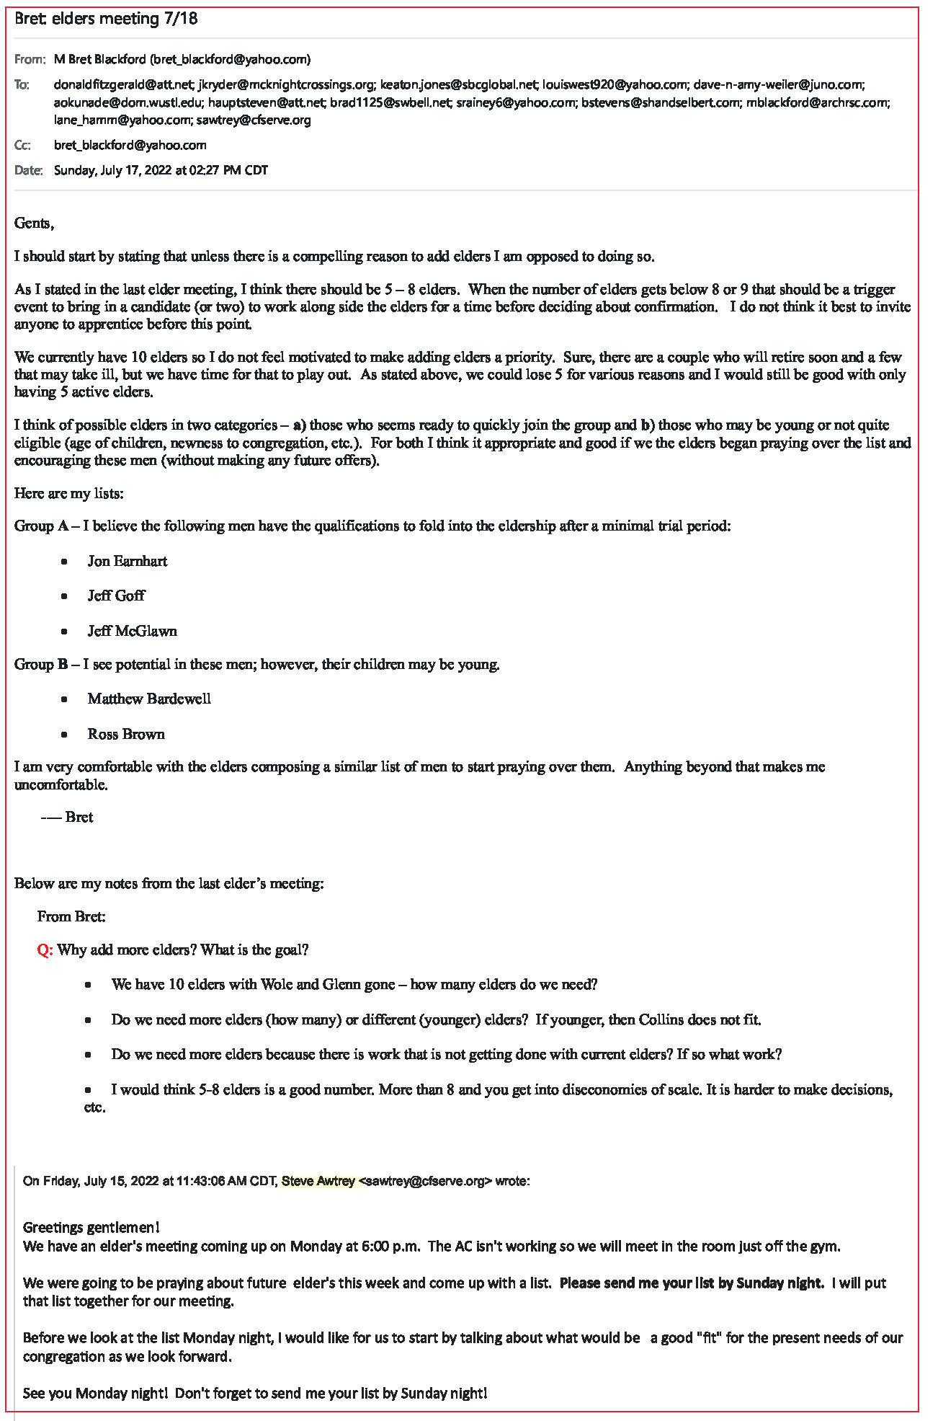

**Attachment D**

