Attendees: Brad Stevens (chair), Don Fitzgerald, Steve Awtrey, Dave Weiler, Bret Blackford, Keaton Jones, Jeff Kryder

People
- Glen and Janice Devania – both fell and are in hospital
- Jamie Wehrung – Pat and Jamie have all 4 grandkids and Jamie still working. Michelle Blackford plans to babysit the grandkids soon so Jamie can get to church.
- Cathy Jones – having some difficult times emotionally with depression, etc. She has been going to Dr and Keaton hopes they narrow down the issue(s). She is having muscle issues and it makes her worry.
- Mark & Emma Fitzgerald – one of the adopted kids’ biological father has died. Mark looking to get custody of the other siblings.
- Jeannie Britzmann – leaving in December. Sunday Dec. 4 planning a reception

Vision Elders
- Plan for Dolores –
With Jeannie leaving January 1, 2023 we hope to have Dolores work through Q1 2023 (with 6-months severance ~ $12,000). We hope Dolores will also do volunteer work.
- Jeremy’s Job Description –
Vision Elders working on a rough draft – “Worship and Connection Minister” (Exhibit A). Jeremy does not always need to lead worship but should bring up new leaders in this area.
Jeremy needs to work on his volunteers and make this a priority.
- Shifting of Job Responsibilities – assigning some of Jeannie’s tasks to other staff – see Exhibit B.
- Jeremy’s sabbatical – Steve Awtrey proposed a 6-week sabbatical for Jeremy to start as early as the second week in January 2023. Steve feels this sabbatical will help Jeremy refocus and reenergize. All elders present agreed to the sabbatical. Bret Blackford and Brad Stevens had reservations about a sabbatical being an appropriate remedy but did agree.

Budget
- Projecting a large shortfall for 2022. We had a special contribution but down about $100,000 shortfall for 2022.
- 1/3 cash reserve of budget
- Asking ministry leaders to reduce 5% from budget.
  - CFS, ACTS, North City all reduced, but foreign ministries keep full budget.
- 2023 budget may have a $60,000 deficit
- Jeff Kryder – do we need to discuss budget January 1 & 8, or should we make statements at 2022 year-end?
- Steve Awtrey – should we communicate need and ask if people want to give bonus or stock? Also would like to give more of a raise to staff.
- Don Fitzgerald – agrees with Jeff Kryder that we need to get budget/tithe in front of congregation early. Also, for tax planning there may be benefits to giving in 2022. Let’s challenge the congregation!
- Keaton Jones – older members having trouble with the economy and inflation on a fixed income. Makes finances precarious.
- Many members have not made an intentional decision to give. Perhaps COVID made it easy to stop giving or to leave Sunday worship.
- The less engagement you have the less giving you have. Just because people are at Sunday service does not mean they are engaged with the church.
- Initial 2023 salary proposal by Dave Weiler:
2% raise for 2023 for staff (Jeff K and Jeremy P) -
  - will not apply to Nathan Strickland
  - Jeremiah will get a 1% and $1,000 bonus at end of year 12/31/2022
  - Elizabeth will get 2% plus 10% (12%), which gets her salary above Jeremiah
- 3% raise was requested by Steve Awtrey. Perhaps we should give Jeremiah 3% instead of 1% and a $1,000 bonus. Agreed to by elders.
  - New 2023 budget will have a 3% raise and a female summer intern.
- Messaging – Jeff Kryder mentioned in many ways we are having a good year and should be charged up about this.
  - New hires – Nathan and Jeremiah
  - New families
  - Food Pantry
  - Other areas have momentum
- Keaton – no doubt MX has been blessed this year (2022). When we ask for greater giving, we should tell the body what has been done and share the excitement.
- Summer Youth Intern – do we need a guy intern? We had a good female intern last year who is interested in coming back. Should we hire a female intern?
  - New 2023 budget will have a 3% raise and a female summer intern.
- $2,500 budget for Honduras ($2,000 for Nathan and $500 misc.)
  - Estimated at $1,800-$2,000 / person
- $1,200 year for 4 ministry staff for allowance for eating with people. Total of $4,800.
- Keaton would like to give more to Pantry.
- Elizabeth is a gatekeeper and NOT a ministry preventer. She is not there to be a wet blanket but to find a balance between stepping out in faith and being responsible with time and money.

Avgränsa den sista torsdagen i november som en dag som ska iakttas av alla mina medborgare, var de än må vara, som en dag av tacksägelse och lovprisning till den allsmäktige Gud, universums välgörande Skapare och Härskare.

Exhibit A

Below is the new job description the Vison Elders have proposed for Jeremy Picker. This was initial provided to the elders at the 8/15/2022 elder meeting. Notes available here.

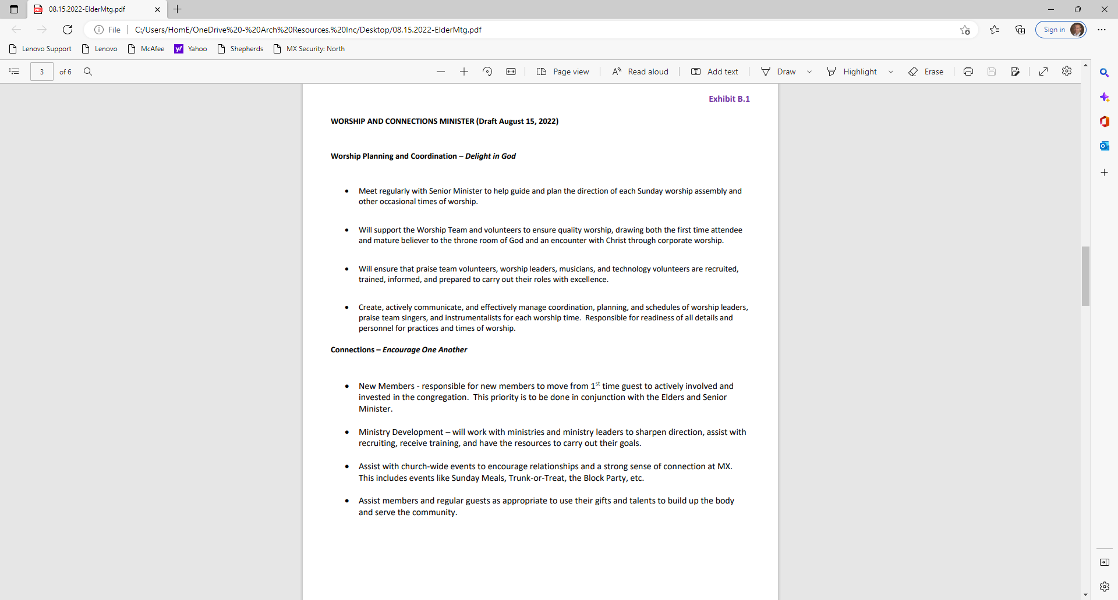

Exhibit B

This was initial provided to the elders at the 8/15/2022 elder meeting. Notes available here.

Jeannie Britzmann Current List of Job Requirements

Ministry
- New Members – Jeremy Picker
- Community Events - Block Party (Nathan & Jeremy), Ladies Prayer Breakfast (Katie Benyo & Hannah G.)
- 24-Hour Prayer Time – Dave Weiler
- RightNow Media – Jeff Kryder
- Ministry to Members

Finance and Back Office
- Financial Analyst and liaison to Admin Elders / Finance team
- Final Prep and Revision of Budget Documents
- Health Insurance and Property Insurance Eval and Review
- Commercial Insurance Contact
- Sexual Harassment Documentation, Procedures and Yearly Review w/Staff and Elders - Dave Weiler and Steve Awtrey
- As Hoc Projects (Payroll Tax, Legal Issues, Accounting Issues, etc.) – looking to outsource payroll

Building
- Manage Building Maintenance Projects and Maintenance Staff - BC
- Hire and Manage Regular and Non-Regular Cleaning Staff – Jeff Kryder
- Oversee 3rd Party Vendors (HVAC, Parking Lot, Elevator, Lawn, etc.) – Elizabeth
- Capital Projects Management (New Lighting, Repair Awnings, Mud jack Front Wal, Alarms, Locks, New A/C) - BC
- Manage Volunteers to Work on Building- BC
- Set Thermostats – Tom H.
- Order and Manage Banners - Jeremiah
- Building Use/Rental; Procedures and Management (Pickleball, CFS, Weddings, Funerals, etc) - Elizabeth
- Oversee Building Supplies, Furnishings, Repairs and Reordering – Tom H
- Rental Home Management - BC

BC = Building Committee (Don Fitzgerald and Bret Blackford)

Rental Property: The church owns two rental homes adjacent to the church. Originally these were purchased with the intent of expanding the parking lot. However, we have been unable to get appropriate storm waiver and one of the houses is in a flood area. Also, location of the properties and sloping plots would make any potential parking additions prohibitively expensive. Based on the excessive cost and the zoning/flood issues these rental properties are no-longer considered to be used for expansion and are now investment assets.

