Elder Meeting
August 15, 2022

Attendees: Don Fitzgerald (chair), Louis West, Steve Awtrey, Dave Weiler, Jeff Kryder, Keaton Jones, Bret Blackford, Steve Walker, Brad Stevens

People:

- Becky Kryder with covid.
- Chris and Sharifa White (and Gavin) back on Sunday
- Jeremiah Haywood car problems – looks like he may have an extended warranty to help cover the engine repair
- Isabella going to Bishop De Burgh school. Dave Weiler taking her to school in mornings and Debbie Fitz taking her home.
- Bob and Mary Joe – Keaton visited, and Bob moving slow and needs oxygen. Bob is not receiving treatment as not much they can do for his asbestos exposure.
- Collins Corder – will pass on offer to serve as an elder. Brad spoke with Collins who feels he is not qualified.
- Charles Eickele – Keaton talked with him about interest in eldership. Charles still does not feel he is ready or called.
- St Louis Flood – Don Fitzgerald mentioned FEMA offering some assistance.

- FEMA Link here … https://www.fema.gov/press-release/20220815/people-flood-damage-missouri-can-apply-fema-help

- Channel 5 info here … https://www.ksdk.com/article/weather/flooding/fema-searches-for-flood-victims-needing-assistance-st-louis-missouri/63-f73503d9-478d-461b-88ff-83e4cb9e978f

Vison Elder Report:
- Financial Impact of possible new hires – see Dave Weiler’s handout (Exhibit A)
- Can we do Scenario #1 with current giving? Dave Weiler indicated with decrease in giving it will be a stretch.
- Have we asked the church families to step up? We have a new Children’s Minister and are looking at a Youth Minister. NextGen is key to MX and is going well, but have we challenged the members to help?
- Job Descriptions – copies available for Dolores, Jeannie, Elizabeth. Jeff Kryder and Dave Weiler are reviewing these to see what is needed going forward and how/who will take over. (Exhibit B)
- Jeremy Picker – what should his role be.
- Don Fitz – what are the basics for what we need here at MX? What is our picture of key goals – and then how do we fill these roles.
- Steve Walker - taking things in and rethinking.
- Don Fitz – we need a picture f what is necessary, then we can challenge each other on what we have and what we need. Can we objectively look at our church. Don is a visual guy and would like a diagram of what we think we need.
- Culture has changed and harder to get volunteers – when we call people to volunteers it should be on important and “meaty” things.
But should we also call people to the mundane? --- Jeff Kryder

Other Business:

- New YouTube sermon site seems stable but not intuitive how to get live feed and comment on sermons. There is an opportunity here for some additional ministry work. Can we get some How To documents together on this?
- Directory – We need to update with new and lost members.
- McPhersons – invite them to share with the elders their concerns

Next Elder meeting:

- Monday August 29 – Don Fitz will chair this meeting
  - Invite McPhersons (Eric and/or Elizabeth) – Brad Stevens to invite McPhersons
  - No staff at this meeting – perhaps Jeff Kryder not present when discussing with McPherson?

- Monday September 12 or 19 – Steve Awtrey chair Sept meetings
  - Next steps on outline of future MX structure (Exhibit C).
  - Jeff Kryder to get list of responsibilities and Bret will get a screen to help visually walk through this.
  - Serving and Leading Together (SALT) – see handout (Exhibit D).

Exhibit A

 | MX Staff Changes - Impact Scenarios
 | (Wages+Benefits) |  |  |  | as of: | August 15, 2022
 | Position | Hrs/wk | Currently | Current  Budget | Scenario #1  (JP same) | Scenario #2  (JP YM) |  | .
 | Preaching/Teaching | FT | Jeff K | $131,000 | $131,000 | $131,000
 | Worship/Connections | FT | Jeremy P | $85,000 | $85,000
 | Youth Minister | FT | open | $54,000 | $52,000 | $85,000 | (A)
 | Children's Min/Social Media | FT | Jeremiah H | $52,000 | $52,000 | $52,000
 | Office Administrator | FT | Elizabeth | $58,000 | $61,000 | $61,000 | (B)
 | Associate Minister | 32 | Jeannie B | $55,000
 | Office Support | 20 | Dolores M | $25,000
 | Maintenance | 20 | Tom | $25,000 | $25,000 | $25,000
 | Custodial | 22 | Dylan B + | $15,000 | $15,000 | $15,000
 | Communications | 10 | none |  | $13,000 | $13,000 | (C)
 | TOTAL |  |  | $500,000 | $434,000 | $382,000
 |  |  |  |  | ($66,000) | ($118,000)
(A) | If Jeremy Picker is Youth & Worship minister. He has yet applied or indicated he wanted the position
(B) | a $3,000 raise to recognize additional work if other front office staff removed
(C) | possible expense to get social media/email/communication assistance

Youth Minister Candidates (click name below for resume):

    - Nathan Strickland
    - Wesley Handwork
    - Jeremy Picker – still has not applied or otherwise communicated a desire for the position
    - Jamey Grimsley
    - Wait/other candidate

Exhibit B.1

WORSHIP AND CONNECTIONS MINISTER (Draft August 15, 2022)

Worship Planning and Coordination – Delight in God

- Meet regularly with Senior Minister to help guide and plan the direction of each Sunday worship assembly and other occasional times of worship.

- Will support the Worship Team and volunteers to ensure quality worship, drawing both the first time attendee and mature believer to the throne room of God and an encounter with Christ through corporate worship.

- Will ensure that praise team volunteers, worship leaders, musicians, and technology volunteers are recruited, trained, informed, and prepared to carry out their roles with excellence.

- Create, actively communicate, and effectively manage coordination, planning, and schedules of worship leaders, praise team singers, and instrumentalists for each worship time. Responsible for readiness of all details and personnel for practices and times of worship.

Connections – Encourage One Another

- New Members - responsible for new members to move from 1st time guest to actively involved and invested in the congregation. This priority is to be done in conjunction with the Elders and Senior Minister.

- Ministry Development – will work with ministries and ministry leaders to sharpen direction, assist with recruiting, receive training, and have the resources to carry out their goals.

- Assist with church-wide events to encourage relationships and a strong sense of connection at MX. This includes events like Sunday Meals, Trunk-or-Treat, the Block Party, etc.

- Assist members and regular guests as appropriate to use their gifts and talents to build up the body and serve the community.

Exhibit B.2

Jeannie’s Current List of Job Requirements

- Ministry
  - New Members
  - Community Events (Pray & Go, Block Party, Ladies Prayer Breakfast, etc.)
  - 24 Hour Prayer Time
  - Manages Right Now Media
  - Ministry to members

- Finance and Back-Office
  - Financial Analyst and Liaison to Admin Elders / Finance Team
  - Final prep and revision of budgeting docs
  - Health Insurance and Property Insurance eval and review
  - Insurance contact
  - Sexual harassment documentation, procedures and yearly review with staff and elders
  - Ad hoc projects (payroll tax, legal issues, accounting issues, etc.)

- Building
  - Manage building maintenance projects and maintenance staff
  - Hire and manage regular and non-regular cleaning staff
  - Oversee 3rd Party vendors (HVAC, Parking Lot, Elevator, Lawn, etc.)
  - Capital Projects Management (New Lighting, Repaint Awnings, Mudjack Front Wall, Alarms, Locks, New A/C.
  - Manage volunteers to work on building
  - Set thermostats
  - Order and Manage Banners
  - Building use and rental management and procedures (Pickleball, CFS, Weddings, Funerals, etc.)
  - Oversee supplies, furnishings, and repair and reordering
  - Rental home management

Exhibit C

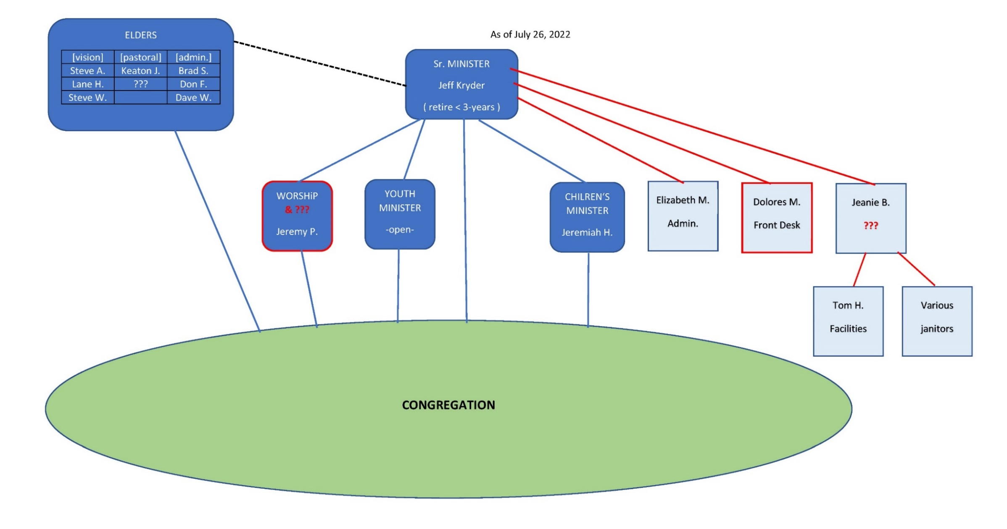

Exhibit D

SALT Team 2022 (August 2022)
Serving and Leading Together
There is much joy in serving God together! What a great time to serve God at MX!

Purpose
- To assist with works of service, projects, and discipleship alongside the MX Staff and Elders.
- To serve with other SALT members.
- To continue to develop as the next generation of leadership at MX.
Expectations
- Committed to Jesus and God’s church at MX.
- Meet on the 3rd Monday night per month to focus service to MX, receiving encouragement, and aligning with the leadership vision. Part of this time will be a joint meeting with the Elders’ Meeting.
- Develop, lead or co-lead one or more projects.
- Recruit others in the congregation to assist as needed.
Partial List of Projects:
- Recruit for various ministries.
  - Hospitality.
  - Technology.
  - Fellowship.
- Offer creative fellowship times (like Pancake Breakfast, Breakfast Burritos, and Mystery Meals), including times for fellowship during Bible Class time.
- Assist with better giving communication, tactics, and budgeting commitments for 2023.
- Projects like technology emphasis, like QR Code, updated photos for hall monitors, and online bulletin.
- Develop ways to connect more effectively with our community.
- Research ideas that are “working” in other churches, including social media approach.
- Help every child to find at least one adult ally.
- Design plan and find contractors for updated front wall and platform in auditorium.

Servant Options
- Jon and Angie Earnhart
- Steve and Tara Beauchamp
- Jeff and Beata McGlawn
- Chris Jones
- Leon and Melanie Sewkarran
- Matthew and Rachel Bardowell
- Jayson Vincent
- Jim and Fredy Griffith
- Todd and Beth Mayberry
- Charles and Barb Eickele
- Alec Hill
- Katie Benyo
- Adam Shelley
- Brett and Kari Ferguson
- Chris and Katrina Fuller
- Karl and Jenny Reijgers
- Steve and Diann Jones

