**MX Shepherds Meeting**

March 7, 2022

Attendees: Dave Weiler (chair), Jeff Kryder, Steve Walker, Louis West, Machalie Brown, Don Fitzgerald, Bret Blackford (notes), Keaton Jones, Wole Okunade, Brad Stevens, Jeremy Picker, Steve Awtrey (remote)

- Opening prayer (Dave Weiler)

- **People updates**

* Bryant – has car and finances are OK (per Dave Weiler). Looking for another job (he is working 3)
* Arstene – she was in hospital w/congestive heart failure. Her car is also out of order and she earns a living doing delivery.
* Rick Salley – missing a couple weeks. Could use some encouragement.
* Jerry Mickey – back at church and ready to engage with Praise Team and Security Team.
* Mike Hutchins – Keaton talking with him
* Paul Mitchell – Jeremy getting with him
* Dina & Jim Patterson – talking with Jeremy Picker
* Don & Paisley Mathews – struggle getting kids to church. At Picker’’s small group.
* Thomas – Jeremy’s trainer – is going thru child custody court (divorce)
* Neil & Sarah Jordan – Sarah struggling (per Wole)
* Sarah Lacave – Laura Picker spending time with her.
* Chris & Amy and Kelly’s and Jodi & Paul – met with Lane Hamm and Eric McPherson (study gospel of Mark)
* Wilka Vincent – Wilka’s daughter Naomi was teased at playground. Another small child called Naomi “dirty”, which Wilka interpreted to be racially motivated and that the child said it with the intent to hurt Naomi.
* Don & Lillian Sease were upset more people were not wearing masks. Went home to join remotely.

- **Celebration planning** for Devanias, Bennetts, Michalie

* **March 27 will be Machalie’s last Sunday**. Would like to come back for Senior Sunday. Not sure where she will land as far as church. Possibly pot-luck after church.
  + Q: When shall we announce this date with Machalie?
  + Q: How will we backfill for Machalie when she leaves?
* AJ Bennett – Bret to look for a Sunday evening late afternoon.
* Davanias – party at Tilles when weather is better. May 15th there is a shelter at Tilles available (open 12:00-3:00)
* Notice of Jon Earnhart sitting in with elders – possible announcement in two weeks (3/20)

- **Video project update** (Jeff)

* Money in budget to help with this. Brian Hill doing this on a contract basis. He will do interviews and video, etc. Plan for at least once a month to have a brief video highlighting an MX ministry (e.g. Food Pantry) or key value (Hamms on hospitality) or member.

- **Youth ministry update** (current items - Michalie / summer items-Jeremy)

* Studying “Looking for God” (Sabbath)
* Kailey Parker – female intern for summer
* Teens need some work projects – March 26 – good to have Elder involvement
* Machalie working on plans for when she leaves.
* Tues SLT & Theo – need someone to take over when Machalie leaves
* Steve Awtrey working on Wed teachers
* Jeremy Picker looking at male interns for summer – James Stone is a possibility, also Mack Enis, and Chris Johnson
* Going to Colorado this summer with YG
* Bread-Shed will also happen this summer with Junior High

- **Youth minister search committee update** (Lane)

* Lane Hamm email – position on various search sites.
* Elders need to pray about this position
* See **Attachment A** for more information
* **Search Membership**: Jon Earnhart , Eric McPherson, Rachel Bardowell, Sara Matheny, Jeff McGlawn, Beata McGlawn, Steve Beauchamp, Coen Reigers, Sydney Bax, Grady Goff, Ansley Picker, Kennedy Picker

- **Children's minister search committee update** (Steve W.)

* Steve Walker: small pool of applicants. Great search committee.
* Jeff Kryder to get list of questions to Steve Walker
* See **Attachment B** for more information
* **Search Membership**: Jim & Dana Patterson, Leon Sewkarran, Jeff & Beata McGlawn, Jayson & Wilka Vincent, Laura Picker, Gwen Walker, Nana Taylor, Philip Matheny, Hanna Grimshaw, Jake & Jessie Munoz, Kate Schneider, Ross & Alicia Brown, Hanna Grimshaw, Heather Goff, Matthew Bardowell, Adam Shelly

- **Finance committee update** (members: Brad/Dave/Don)

* Meeting monthly and going well
* Collections still slightly under
* Do we need teaching on tithing? Are members aware of the blessing of giving and serving?
* Do we need a budget update?
* Should we pass collection plate? Discussed not to worry about passing trays and call out the collection box. Also, add contribution to Shepherd’s prayer on Sunday.

- **Vision committee update** (members: Steve A/Lane/Steve W)

* Steve Awtrey: Discussed changing up Jeff Kryder’s role. Vision Committee could work on this.

- **Shepherding committee update** (members: Keaton/Louis/Wole)

* Keaton: working with Steve Walker and Joyce West about some changes with the pantry. Identifying the 7 values in the Food Pantry and working on possible updates to better fit the pantry. Trying to go beyond food to home improvement.
  + See **7-Values Logic Model** at **Attachment C**

- **Technology/auditorium project update** (Bret) (I had to come up with something for you too!)  :-)

* Bret update on auditorium project
* Steve Walker shared about a church he knows that is involved in a growing on-line ministry.
  + Jeremy Picker – looking for someone to possibly engage with the Sunday Facebook on-line community. Can we engage a member who is usually on-line to bring them on to minister to others on-line.
* Jeremy Picker – Facebook to Google: Jeremy getting the transition to YouTube doc together.

- **Other items** (as time allows)

* Steve Awtrey: Thurs CFS Trustee & Board Mtg.
* Next Elder mtg March 21st (will find out who needs to Chair)
  + Possible agenda item: Jeff McGlawn to discuss Missions Ministry
* April meetings will be chaired by **?????**
* Help for Ukrainians dealing with the war. Tony & Shana Morrow in Ukraine <https://www.amarillocentral.org/missions>. What is the church’s response? What issues should a church get involved in? See **Attachment D**

- **Confirm date for next elders meeting** (Tuesday March 29)?  Include Dale Robinson via Zoom?)

* April 4th Dale Robinson: He asked to be in person (the Elders are OK with video conference)

- Closing prayer (Louis West)

Lukas 6:27-28

***Om att älska sina fiender***

**27**Men till dem som lyssnar säger jag: älska era fiender, gör gott mot dem som hatar er, **28**välsigna dem som förbannar er och be för dem som förolämpar er.

**Attachment A.1**

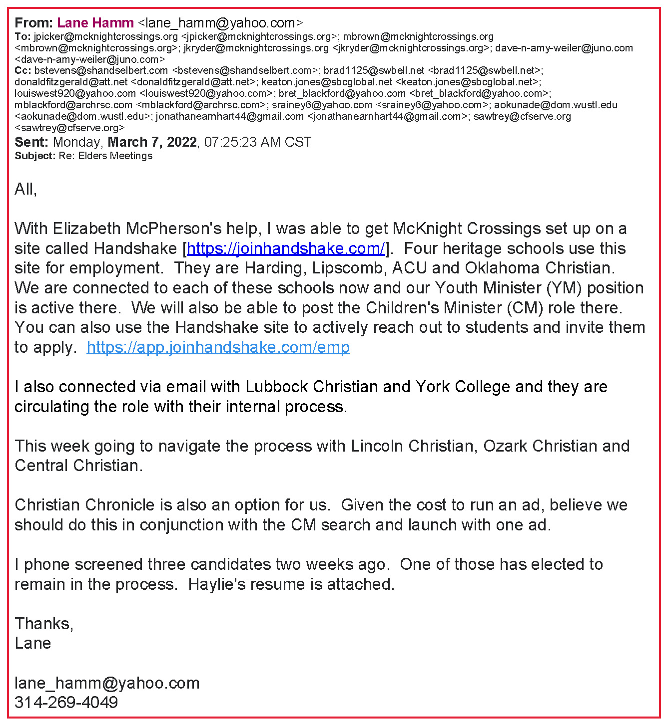

**Attachment A.2**

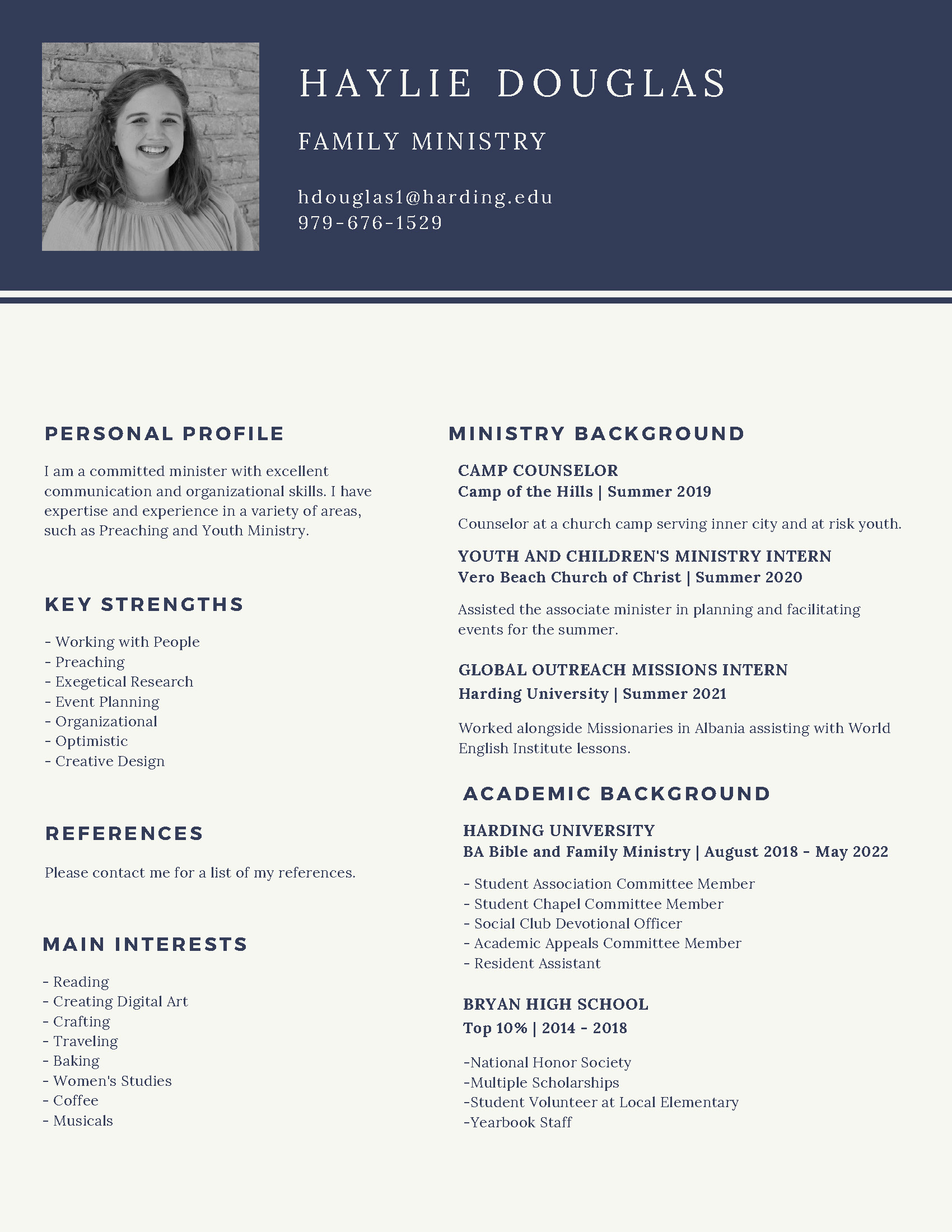

**Attachment A.3**

Below is the <https://joinhandshake.com/> page for McKnight Crossings as of March 8, 2022

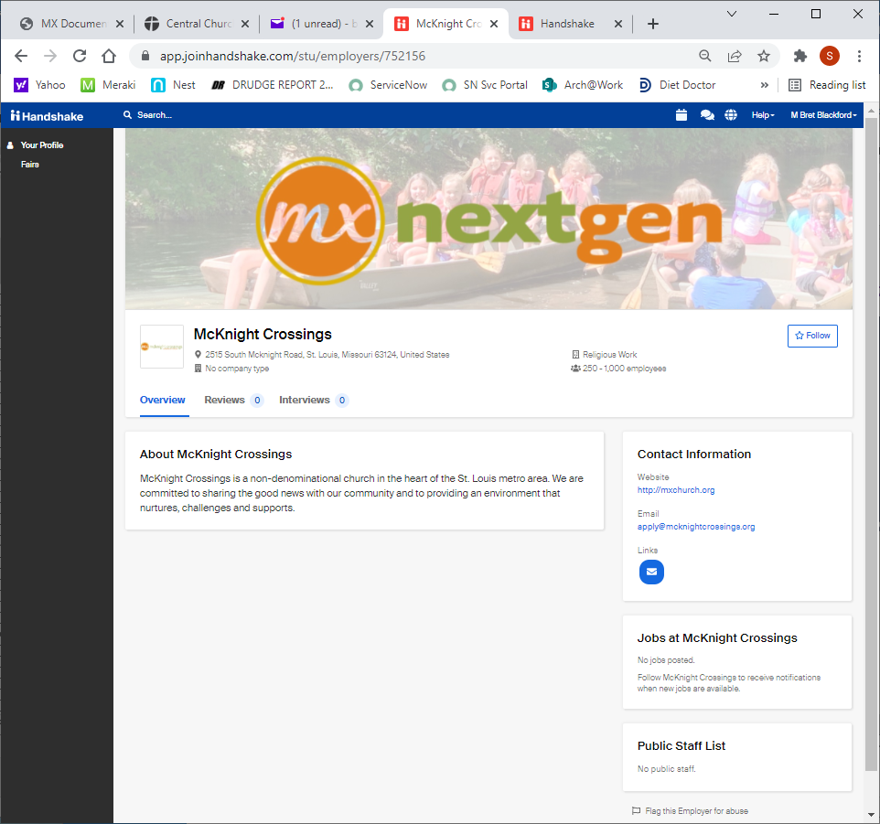

**Attachment B.1**

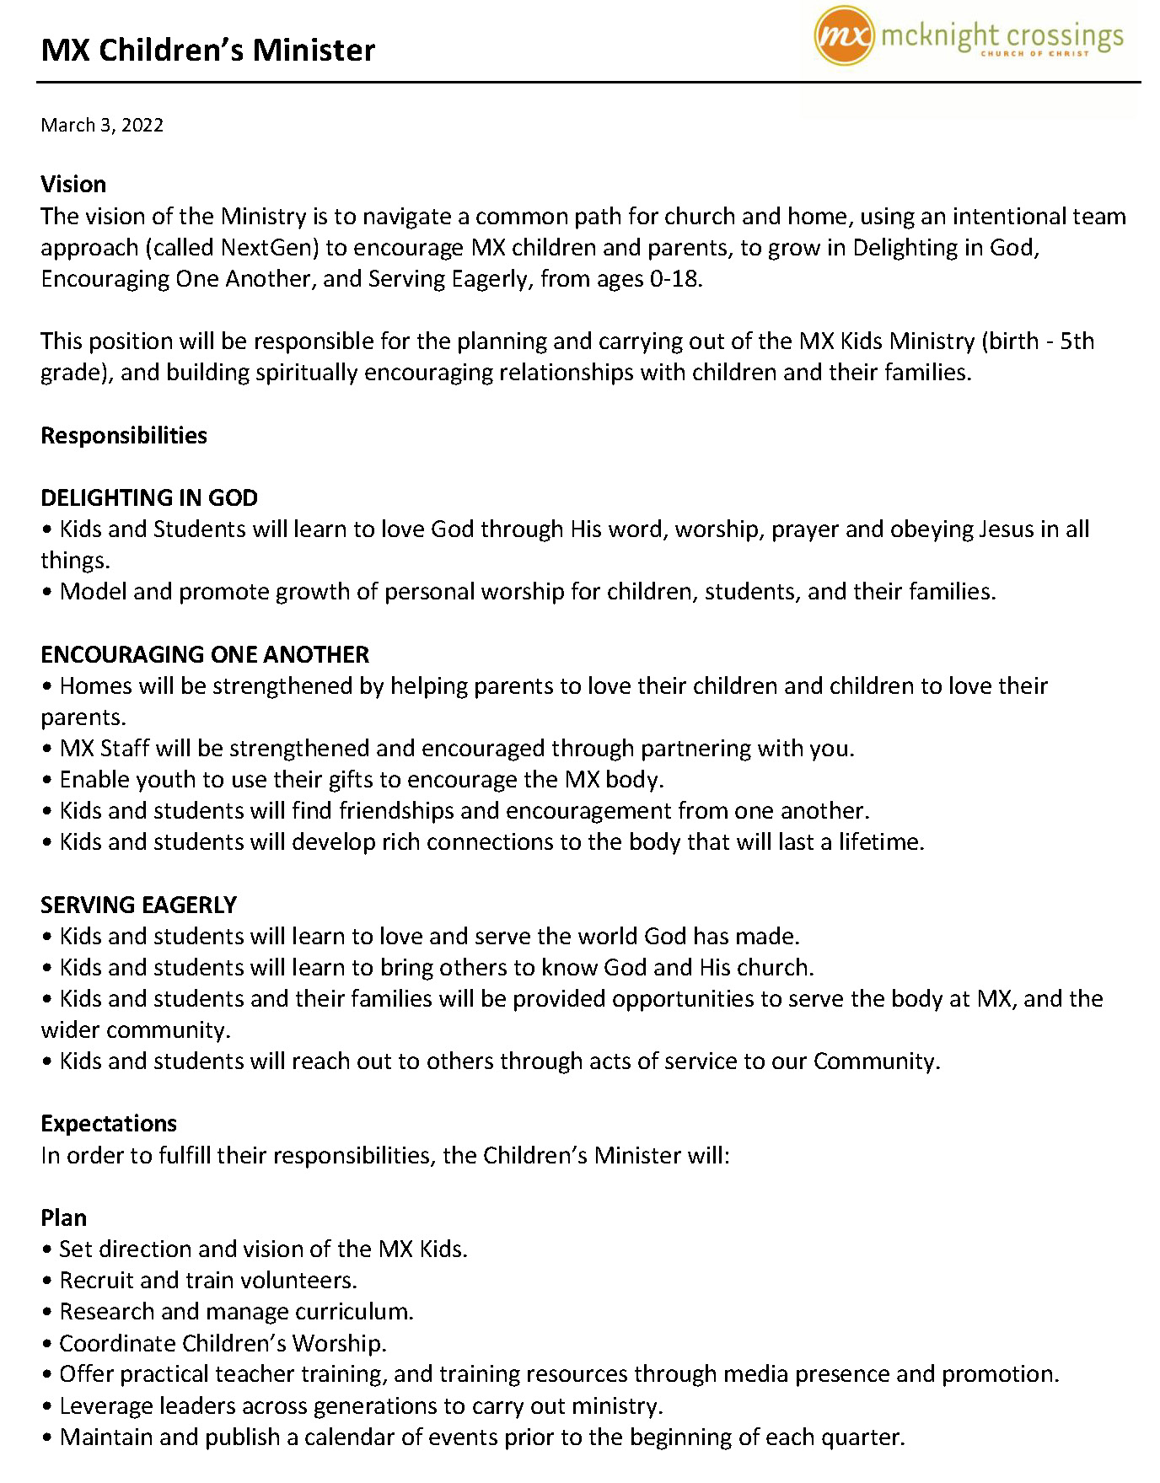

**Attachment B.2**

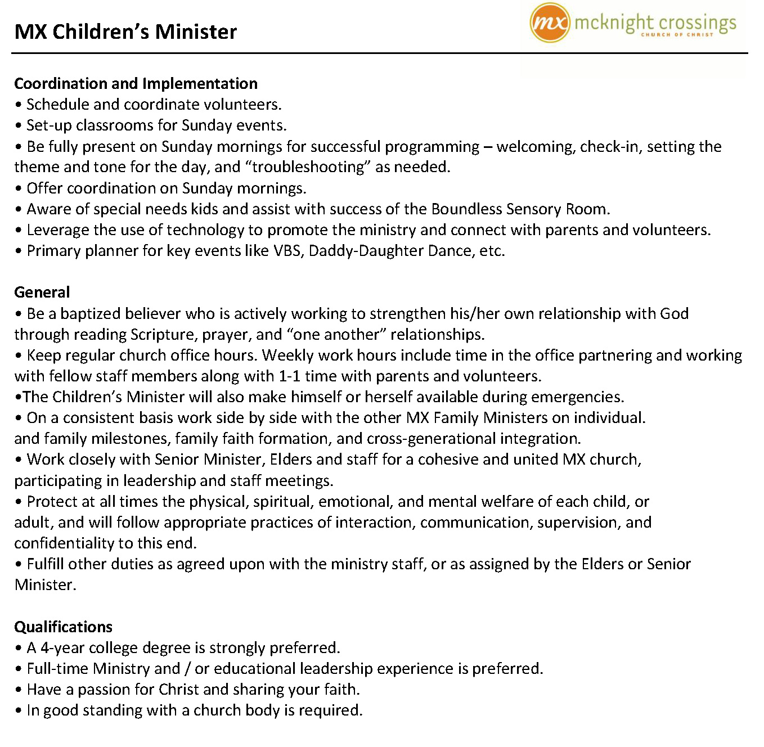

**Attachment C**

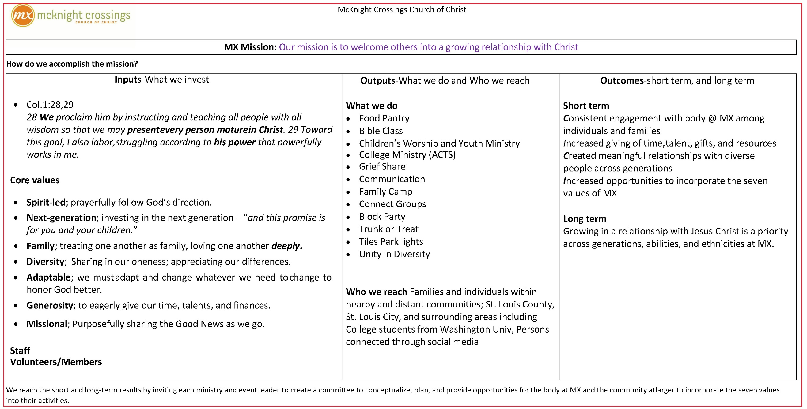

**Attachment D**

**How should McKnight church engage in world events?**

This question raised a good amount of discussion at the March 7, 2022 Elder’s meeting. As I interpret the discussion[1] and the issue I would summarize with the following questions:

* What events should warrant a response by the church?
  + What type of response is appropriate: prayers, announcement, bulletin, link on MX webpage, etc.?
* How should an event be raised to the attention of the church leaders (Ministers/Elders)?
* How to decide when an event warrants attention – who can approve a notice in an email, bulletin, announcement, etc. Can/should this be allowed unilaterally or does some discussion need to occur?
* What responsibility does church leadership have in vetting any NGO or other 3rd party we link to or send resources to prove not a scam or inefficient, etc.?

Types of events which may cause concern and lead to requests for action (by MX member or ministers):

* Disasters: floods, drought, fires, tornadoes, tsunamis, earthquakes, mudslides
* Disease: COVID, malaria, typhoid,
* Geopolitical: War, elections, apartheid/segregation, ethnic/cultural issues, famine, climate change

Of the above tragedies how does McKnight Crossings church choose to respond? Is response based on some connection, some extreme tragedy, some clarity as to how McKnight can effectively engage and make a difference? The question is more than a hypothetical exercise, as the members of MX have various feeling on many issues. Some feel very strongly about a position and want a heightened awareness. How do we address these sometimes-conflicting concerns in an equitable manner?

Mid-County used to have a “***Think globally act locally***” approach, where most efforts were directed to incidents in the local community.

The above addresses some of the complexity involved in church decision making, especially in events outside of the local community where the church serves. Lots of questions with few clear answers. No clarity on the above is expected anytime soon – just collecting some of the dialog.

In some respects, it was thought that when and how to respond to an event will be subjective and decided by gut feel (or Spirit led). This is an appropriate response but difficult to document. It may be like the approach/definition to “civilization” – you can’t define it but you know it when you see it.

1. This page is not dictation of what was literally said but my understanding of the underlying concept and concerns.